REGENSBURG, GERMANY 1257

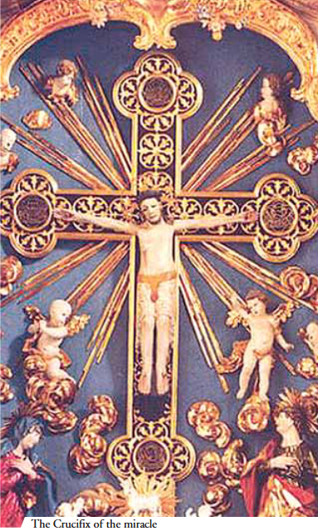
A priest was celebrating the Holy Mass in a little chapel, when he was struck by doubt regarding the Real Presence of Jesus in the Eucharist. He delayed, therefore, in elevating the chalice and suddenly heard a light noise come from the altar. From the wooden crucifix above the altar, the Lord slowly extended his arms to the priest, took the chalice from his hand and exhibited the Bless Sacrament for the adoration of the faithful. The priest, repentant, fell to his knees and begged forgiveness for having doubted. The Lord returned the chalice to him as a sign of pardon. The miraculous crucifix is still preserved to this day in the nearby town of Regensburg and many of the faithful go to the place every year in pilgimage.

