ROSANO, ITALY 1948

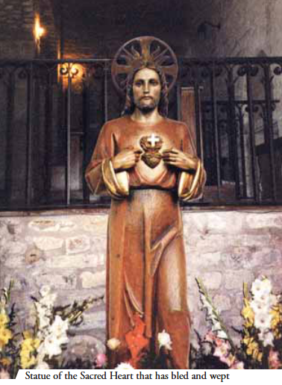
In the evening of April 4 1948, the first Sunday after Easter, during the chanting of vespers, people noticed for the first time that drops as if of blood were falling from the eyes of the statue of the Sacred Heart donated by a devout person to fulfill a promise made during World War II. In June of that year, another stunning and unexpected miracle occurred –the flow of blood. These events occurred repeatedly between 1948 and 1950.

