ZARAGOZA, SPAIN 1427

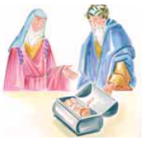
A married woman consulted an evil sorcerer for a remedy to cure her husband of his violent nature and make him treat her more gently. The sorcerer told her to get a consecrated Host. The woman went to the church of St. Michael and received the Eucharist. She took the Host from her mouth and hid it in a small coffer then took it immediately to the sorcerer. When they open the coffer, instead of the Host they saw, with great terror, a little Baby surrounded by light. The sorcerer told the woman to take the coffer home, burn the Holy Eucharist, and bring the ashes to him. The woman did as she was told, but although the coffer was completely burned, the Baby remained unharmed. Stricken with terror, the woman ran to the house of the sorcerer to tell him what happened. They went to confess their sin to the bishop and asked for baptism.

