|  |  |
| --- | --- |
| 1 | Java Setup |
| 2 | Maven Setup |

|  |  |
| --- | --- |
| |  | | --- | | Note: Please view this image in “Web Layout” to see the complete image,  right side bottom of the word doc. | |

**JAVA Setup:**

Google search for “jdk download” Click on the below java downloads link.

<https://www.oracle.com/in/java/technologies/javase/javase-jdk8-downloads.html>

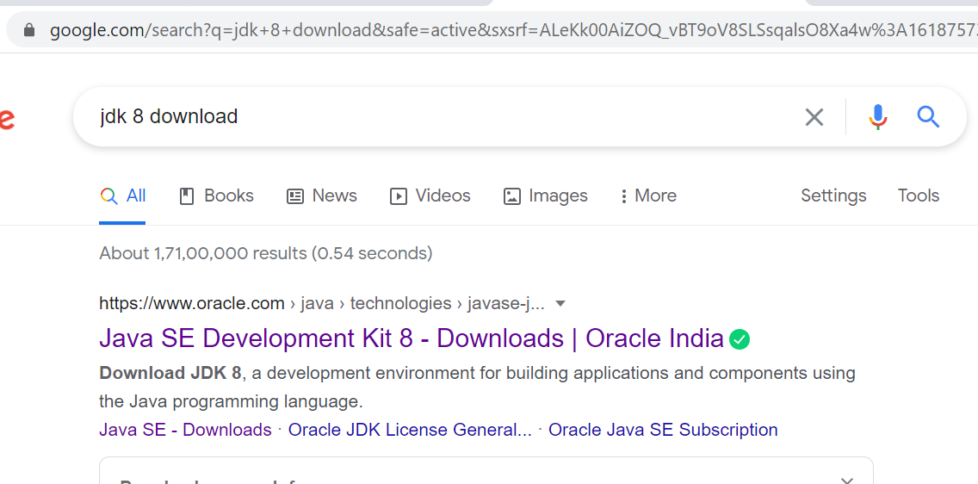

Download the windows compatible version

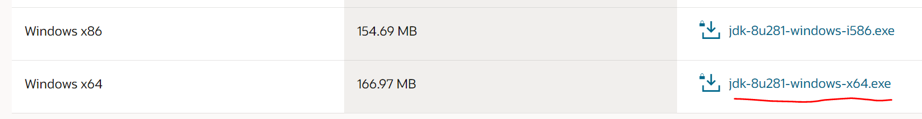

Choose the version you want to install: Accept the terms.

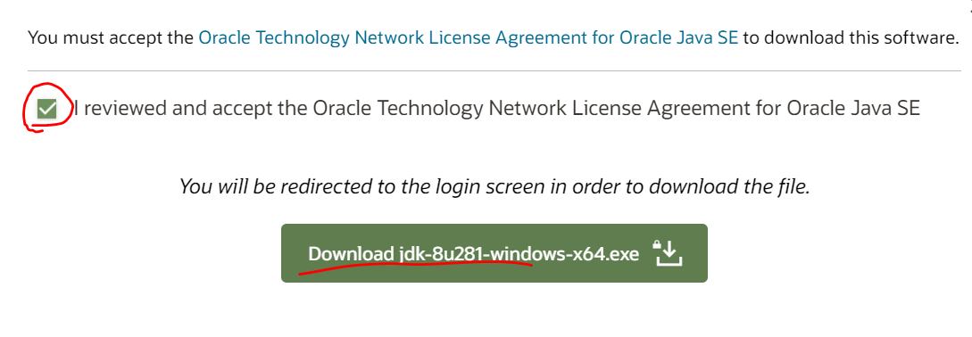

Enter the oracle creds. If you don’t have an account, create and try download again.

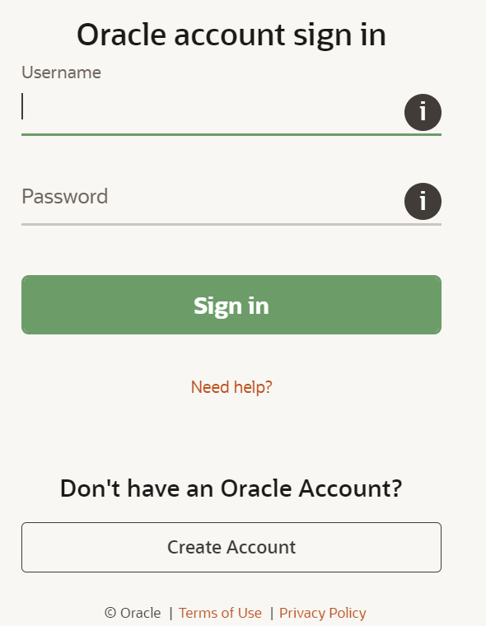

Downloading status:



Go to downloads and double click on the JDK exe file to proceed with installation: Just click on Next in all the windows, no need custom setup.

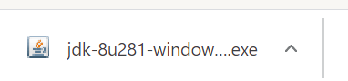

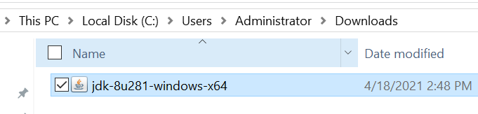

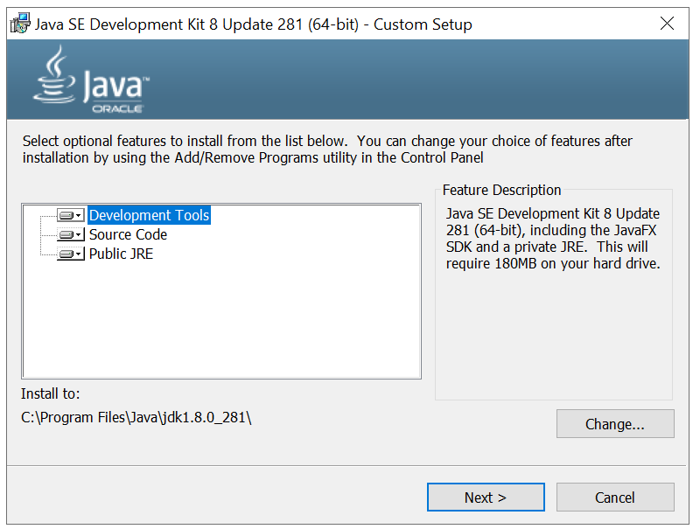

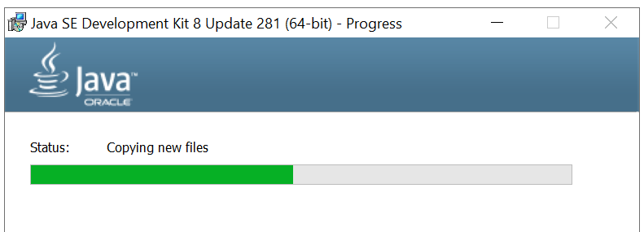

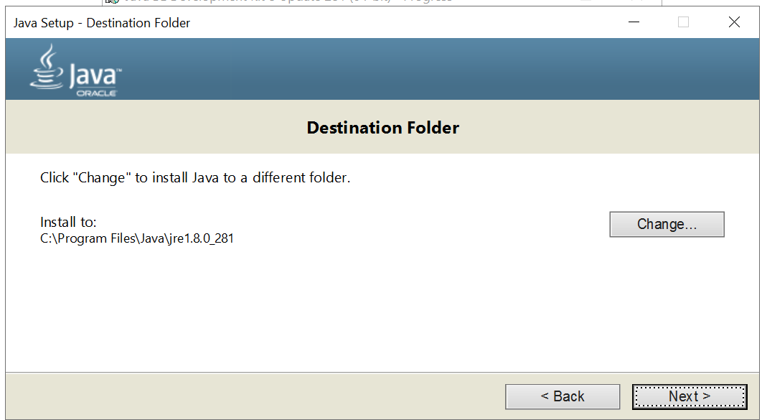

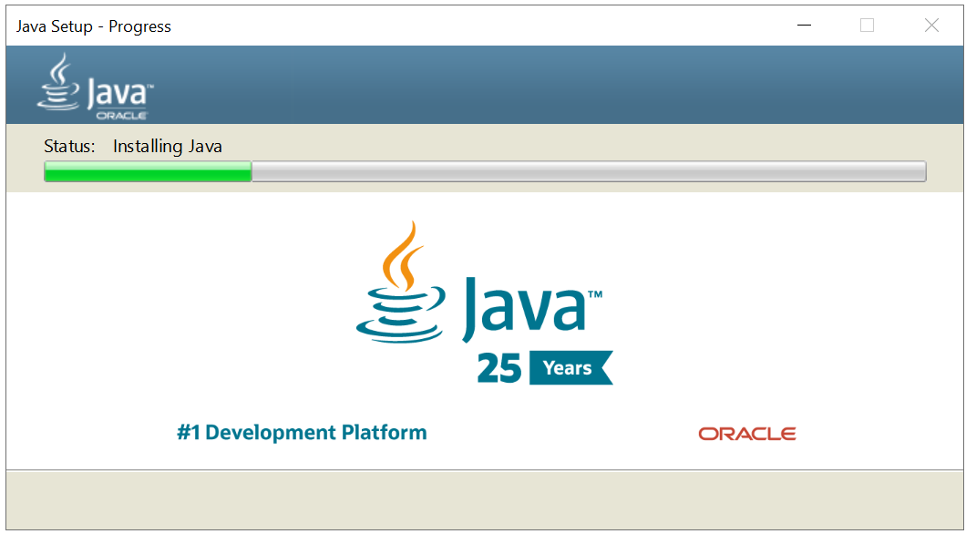

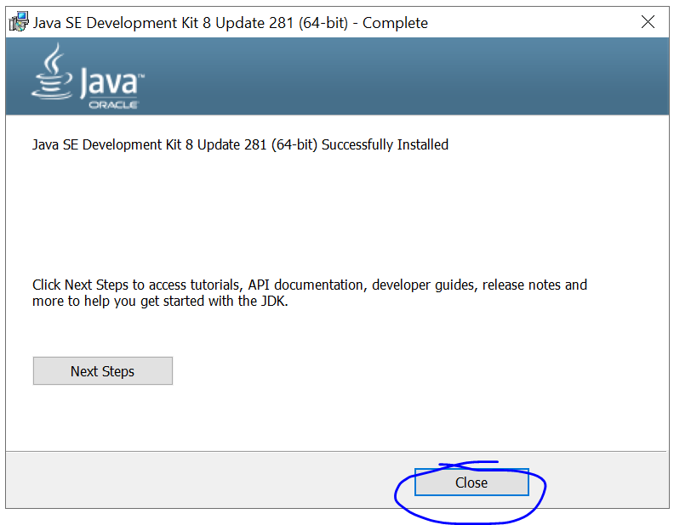

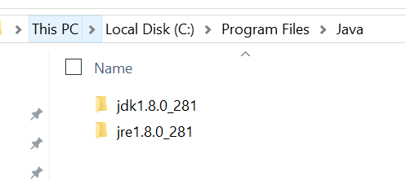

Setup Java Home path in environment variables.

C:\Program Files\Java\jdk1.8.0_281\bin

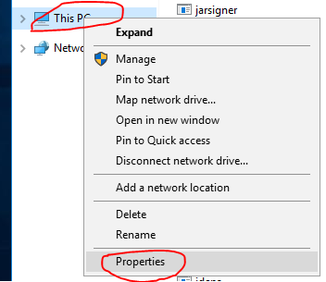

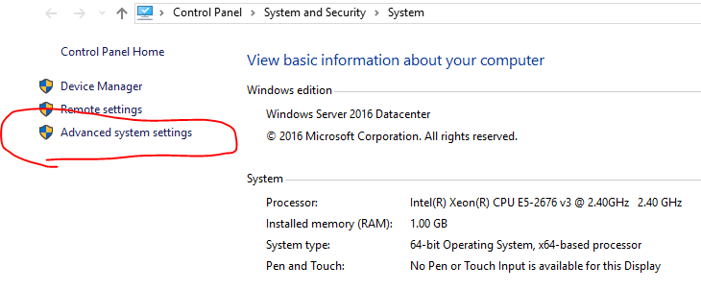

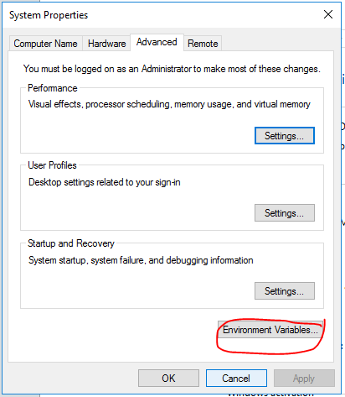

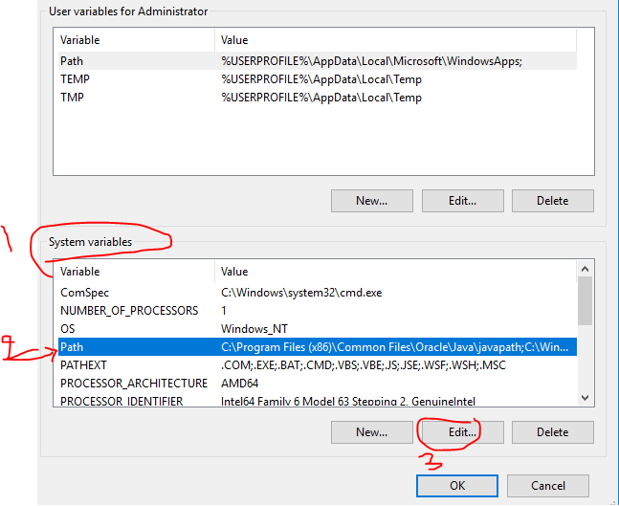

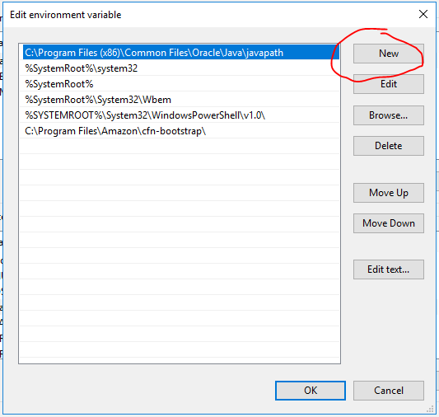

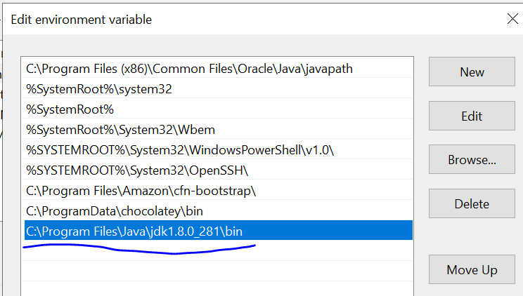

Create new system variable for JAVA_HOME: C:\Program Files\Java\jdk1.8.0_281 (without the bin folder)

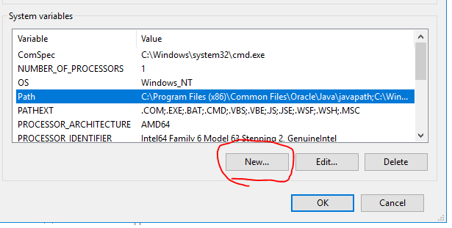

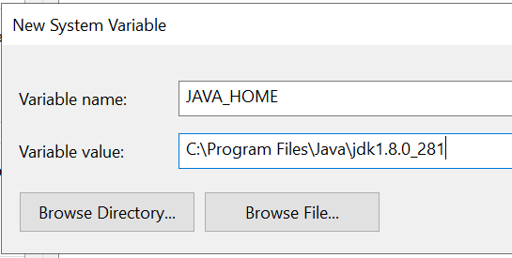

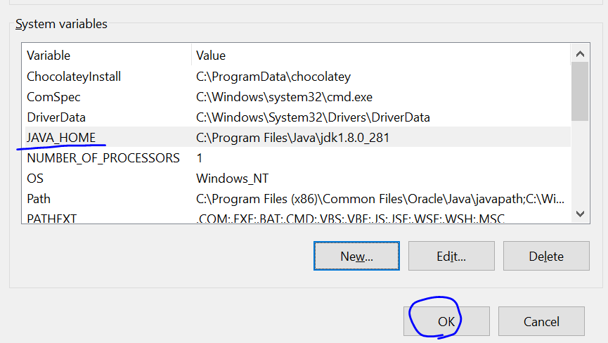

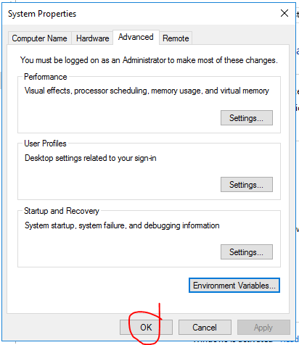

Check whether the java installed & setup properly or not:

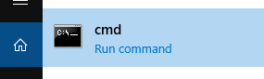

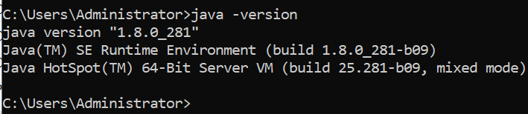

**Maven Setup:** [**https://maven.apache.org/download.cgi**](https://maven.apache.org/download.cgi)

**Search for “Download maven”**

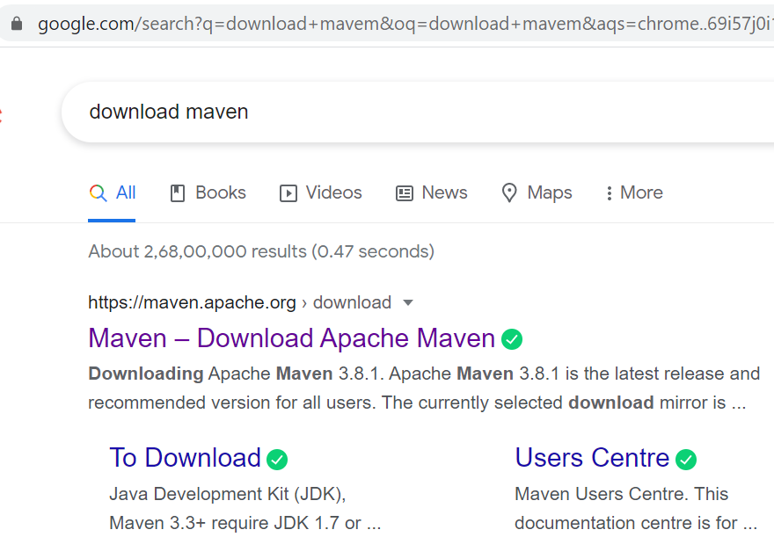

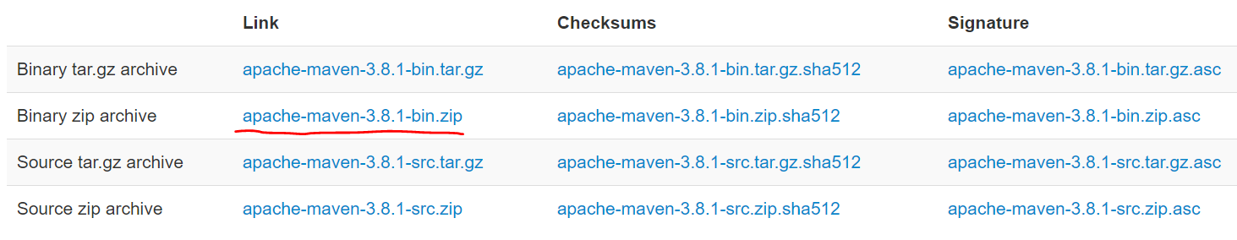

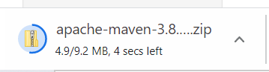

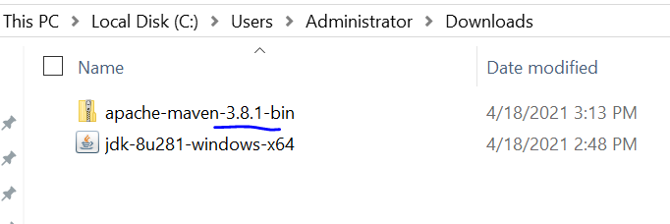

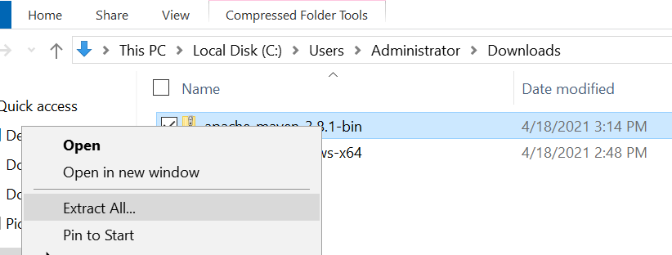

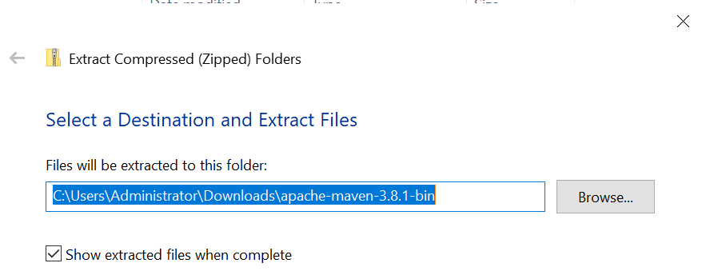

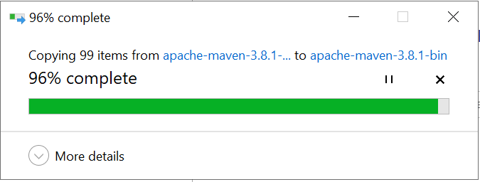

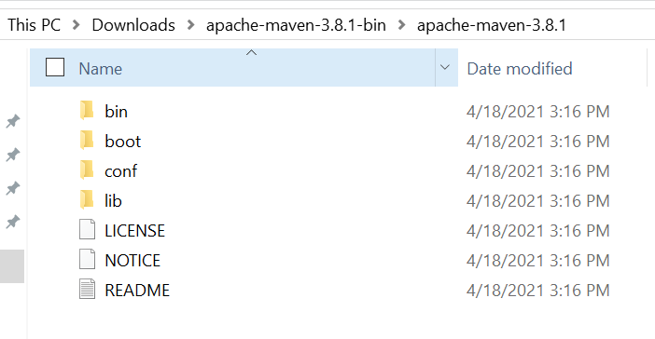

You can proceed with downloads maven path as shown above. Or you can keep the maven folder in any location in your system and then setup the path. Here, I am copying the maven to different folder.

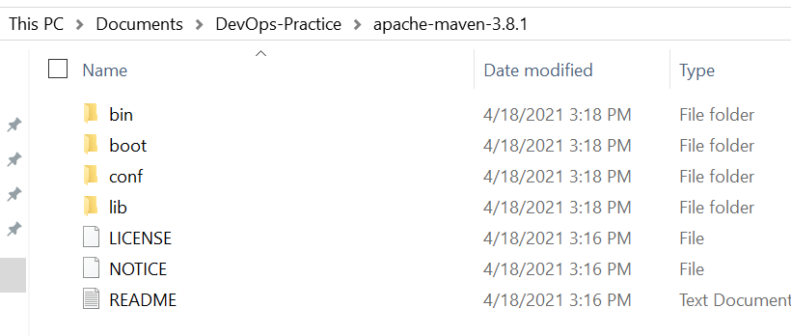

Now maven is here C:\Users\Administrator\Documents\DevOps-Practice\apache-maven-3.8.1, we need to set the class path.

C:\Users\Administrator\Documents\DevOps-Practice\apache-maven-3.8.1\bin

Repeat the above steps to setup the java path to system variables.

Right click on computer or This PC 🡪 Advanced system settings 🡪 Environment Variables 🡪 Edit the ‘path’ under the system variables 🡪 new 🡪 add the maven path as mentioned in below image.











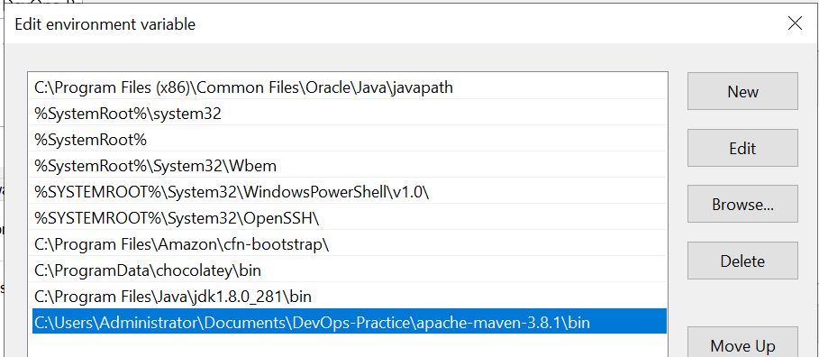

Open the command prompt and run the command “mvn -v”

