GMRS :- Gas Malaysia Retail Services

Modules
- Master Set Up
- Mapping query’s :- MeterBrandModel,MeterBrabdModelDialLength,GRatingconnsize,bodylen setup
- User setup
- Meter Management
- Route Management
- Tariff Management
- Consumer Management
- Billing Management
- Cylinder billing management
- Payment Management
- Deposit Management
- Open items
- Work order
- Remainder .
- Non Bill
- Supply comment
- Reporting

- Data Base Migration Script link below
- https://drive.google.com/file/d/1F7K4iaBxOjKCLsOAnJeYLf-gy-fbuH27/view?usp=drive_link

NOTE
- T_billtax table isactive flag always true
- In meterbrandmodel and meterbrandmodeldialength should not be null values.
- In citygate and cv should not be null values.

- Master Set Up Query’s for User Defined:-

Execute all the script for this tables and change in declaration statement like company id,servicelocation id and created by and modified by
- Zone
- Block
- Meter Size

- MeterType
- Meter Brand
- Meter Model
- Meter UOM
- Meter Grating
- Meter Dial Length
- Tariff Code
- Meter PUnit
- City gate
- CV

ER Diagram - Master Module
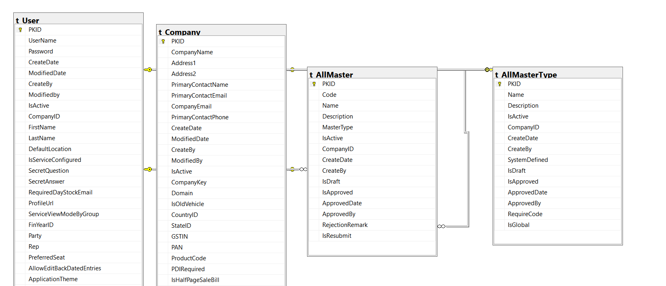

2. Mapping query’s :-
- Execute the query’s line by line.
- MeterBrandModel
- MeterBrandModelDialLength.
- Meter grateing maping
- cityGateCV.
- Eventtypegroupcontrol
- Eventcodecontrol
- Reparea mapping

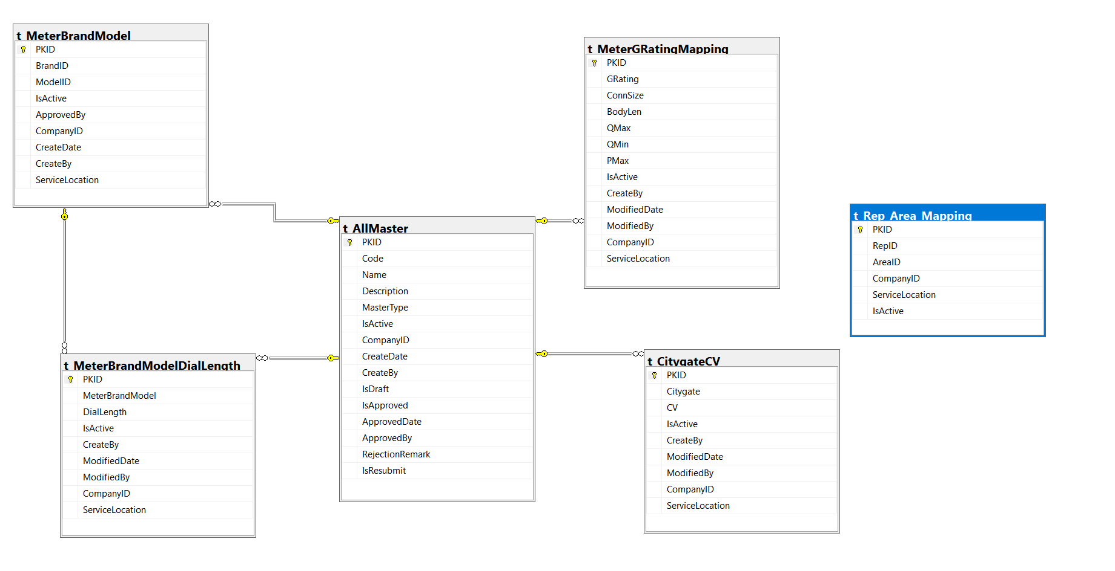

- User Module
- Excute the script for t_user table
- Insert the data into t_userrole table using t_user script
- Insert the data into t_userservicelocation using t_userservicelocation script
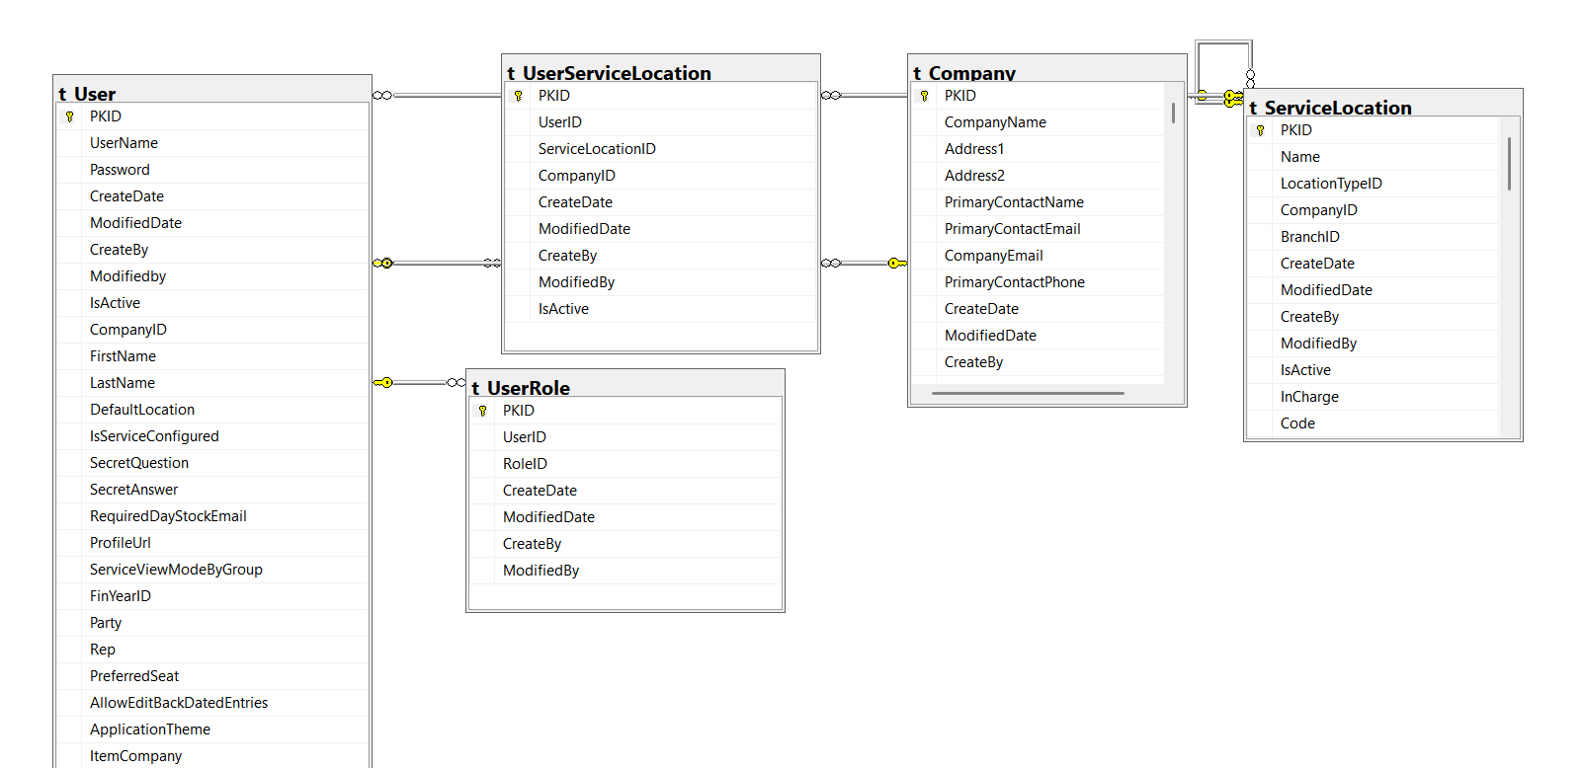

- Meter Management Module
- Update the meter status in the source table as per the client’s requirement.
(Reference: Revenue Billing Google Drive)
- Prepare the SQL scripts using the mapping document.
- Execute the queries line by line.
- Insert the meter purchase data using the t_meterpurchase script.
- Insert the meter details using the t_meterdetail script.
- Update the meter_id in the Meter Purchase table using the update script.
- Insert the data into t_installedMeter.
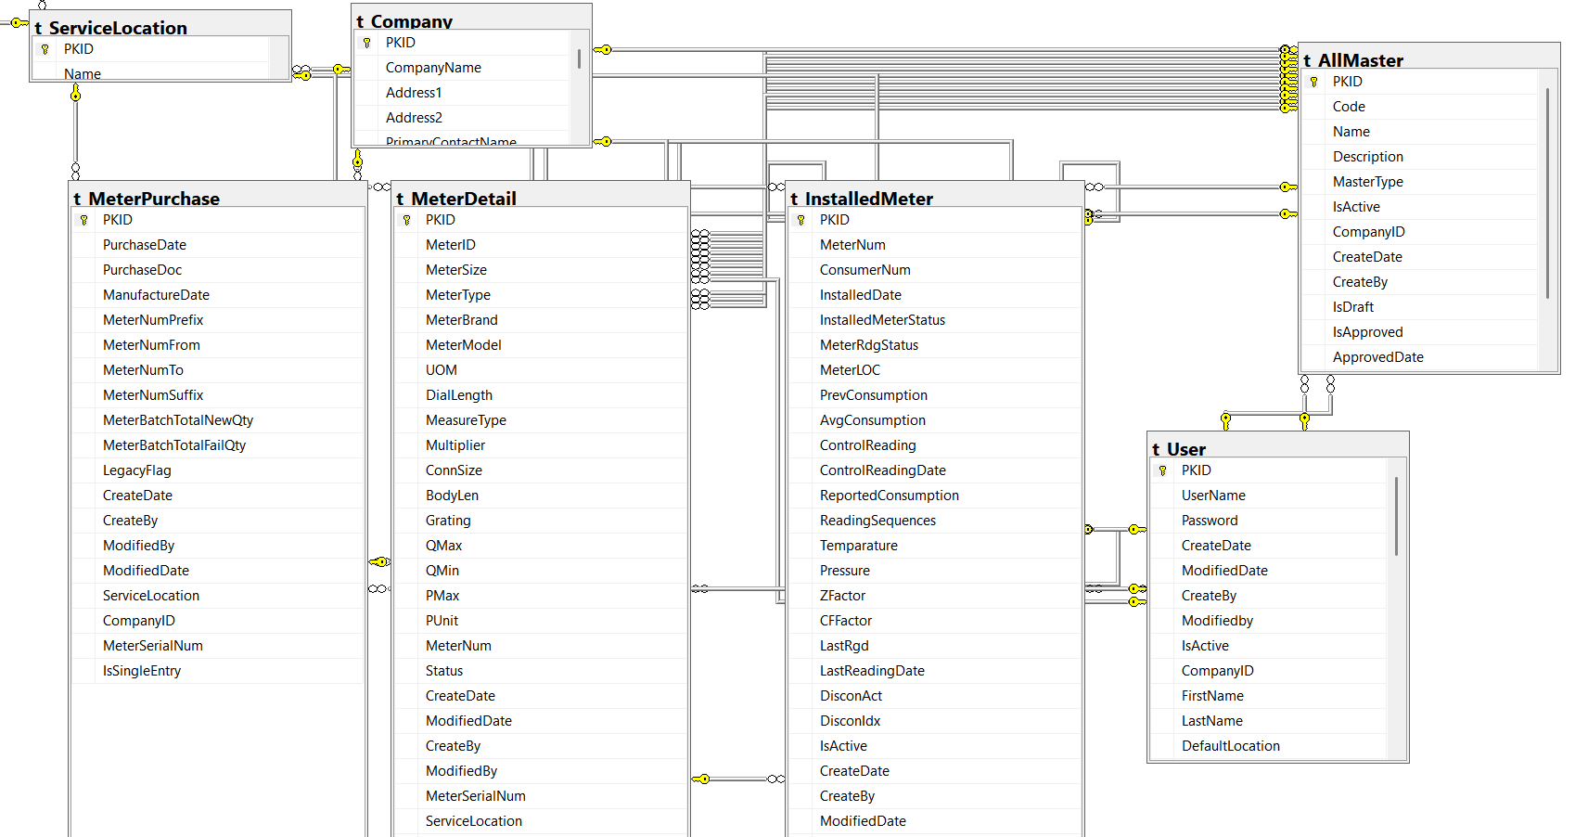

5 . Route Management
- Using mapping document prepare the sql script .
- Execute the query’s line by line.
- Insert the data into t_Rep_Area
- Insert the data into route table using t_route script.
- Insert the data into routecharges using t_routecharges script.
- Update the route id in routecharge table.
- Insert the data into routediscount using t_routediscount script
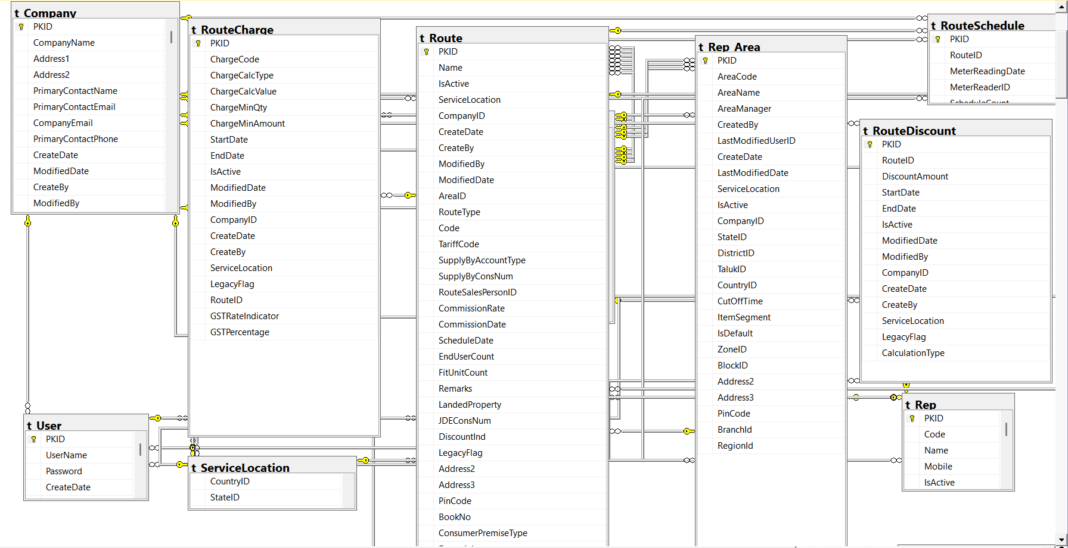

6. Tariff Management
- Using mapping document prepare the sql script .
- xecute the query’s line by line.
- Insert the data using t_TariffControl script.
- Create the t_TariffRevisiontemp table
- Insert the data into t_TariffRevisiontemp table
- Update the t_TariffRevisiontemp table.
- Insert the data into t_TariffRevision table.
- Insert the data into t_tariffrevisionslabtemp.
- Insert the data into t_tariffrevisionslab.
- Insert the data into t_tariffrevisionapproval

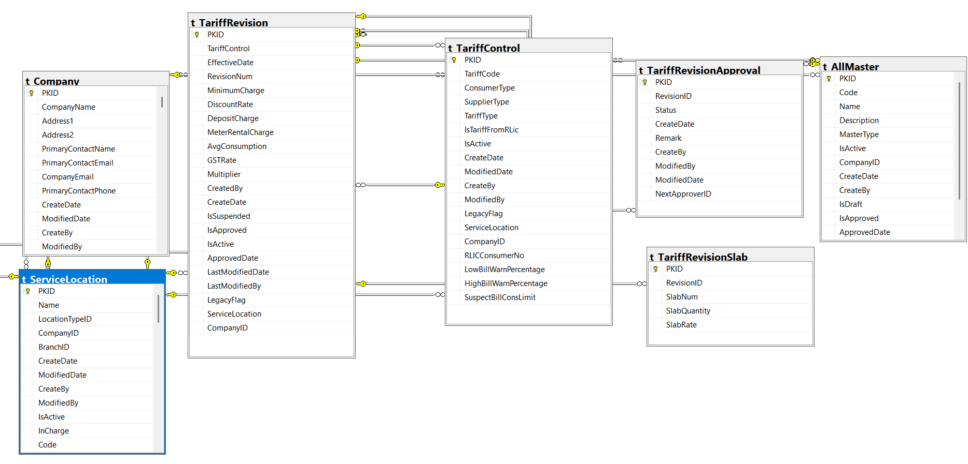

7. Consumer Management.

- Using mapping document prepare the sql script .
- Execute the query’s line by line.
- Execute the query’s of t_party table.
- Execute the query’s of t_party_area table.
- Execute the query’s of t_application table.
- Excute the queerys of t_applicationGroup table.
- Excute the querys of t_consumerAccount table.
- Excute the querys of t_ConsumerGasLicenseDetail table.
- Excute the querys of t_ConsumerJDEAccountDetail table.
- Excute the queerys of t_ConsumerPOSAddress table.
- Excute the querys of t_consumertaxdetails table.
- Excute the querys of t_ConsumerGasLicenseContract table.
- Update the column ApplGroupNum from t_ApplicationGroup to t_Application table.
- Update the applicationtype column to party table using query’s.
- Update the JDEConsumernum,routeid and area id to party table

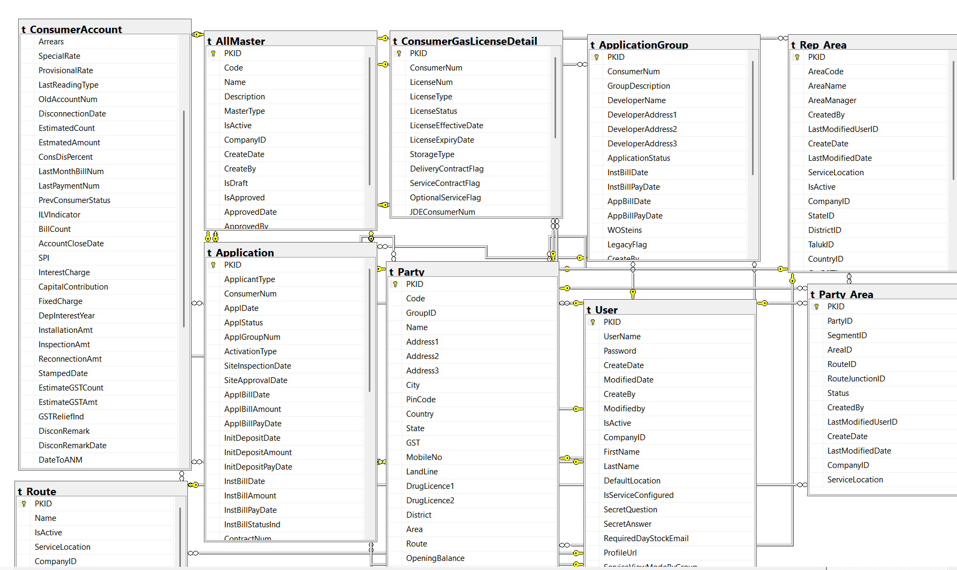

- Billing Management

- Insert the data into t_eventtypegroupcontrol table using t_eventtypegroup script.
- Insert the data into t_bill table using t_bill script
- Insert the data into t_billdetail table using t_billdetail
- Insert the data into t_billmeterreading table using t_billmeterreading.
- Update the tariff type using t_bill table from t_billdetail table.
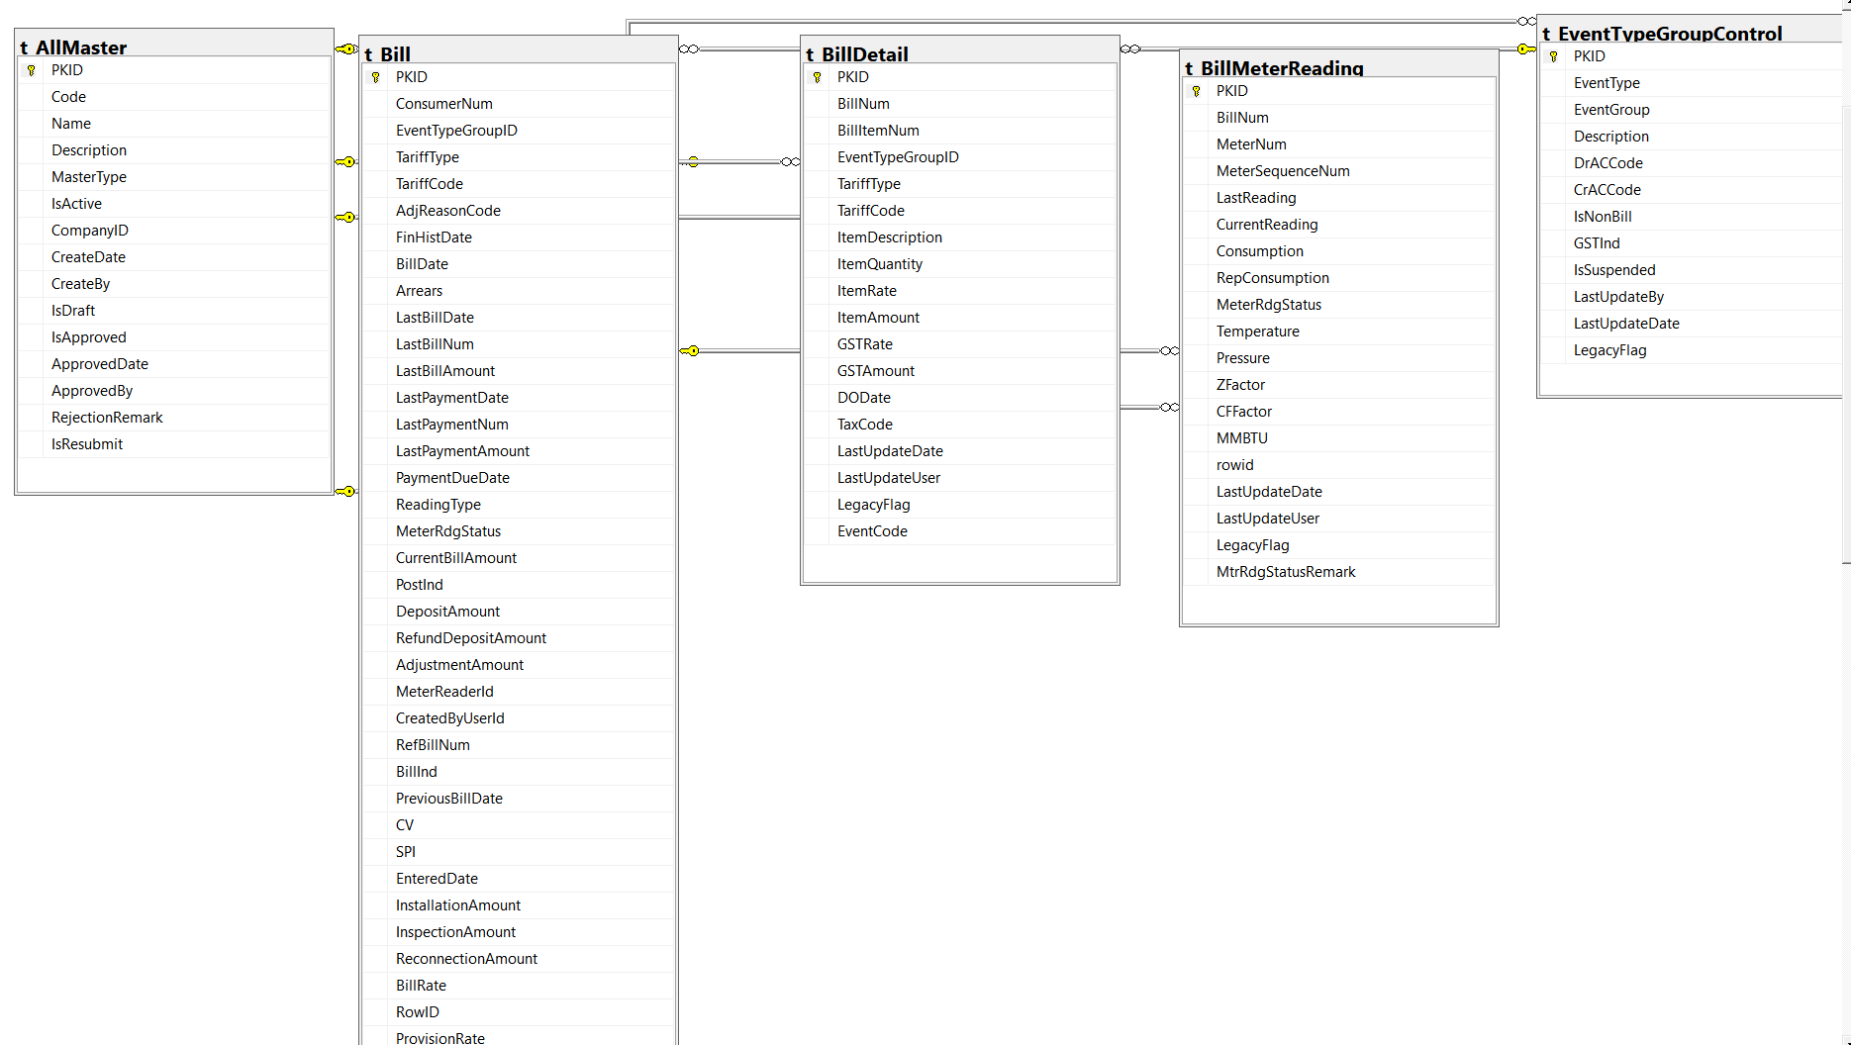

- Cylinderbilling Management

- Insert the data into t_cylinderbillrequest table using t_cylinderbillrequest script.
- Insert the data into t_cylindertariffcontrol table using t_cylindertariffcontrol script.
- Insert the data into t_cylTariffRevision table using t_cylTariffRevision scirpt.
- Insert the data into t_CylTariffRevisionApproval using t_CylTariffRevisionApproval script.
- Insert the data into t_Gassupplier table using t_GasSupplier script.
- Insert the data into t_GasSupplierConv table using t_GasSupplierConv script
- Insert the data into t_CylinderDeliveryOrder table using t_CylinderDeliveryOrder script.
- Update the column DOQtyUOM in t_CylinderDeliveryOrder table.
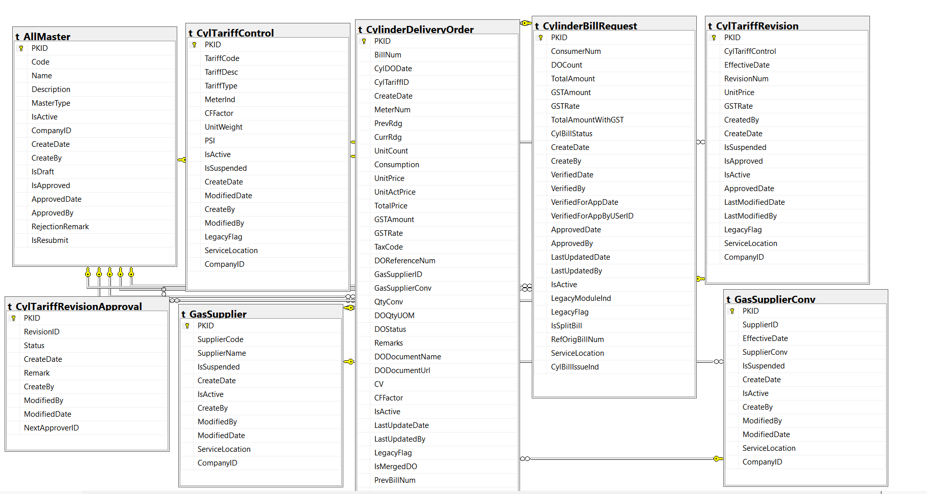

- Payment Management
- Insert the data into t_paymentStubheader table using t_paymentStubheader script.
- Insert the data into t_Paymentstubdetail table using t_paymentstubdetail script.
- Insert the data into t_paymentbatch table using t_paymentbatch script
- Insert the data into t_billpayment table using t_billpayament script
- Update the PaymentBatchId to t_BillPayment table and SourceBatchId to t_paymentbatch script.

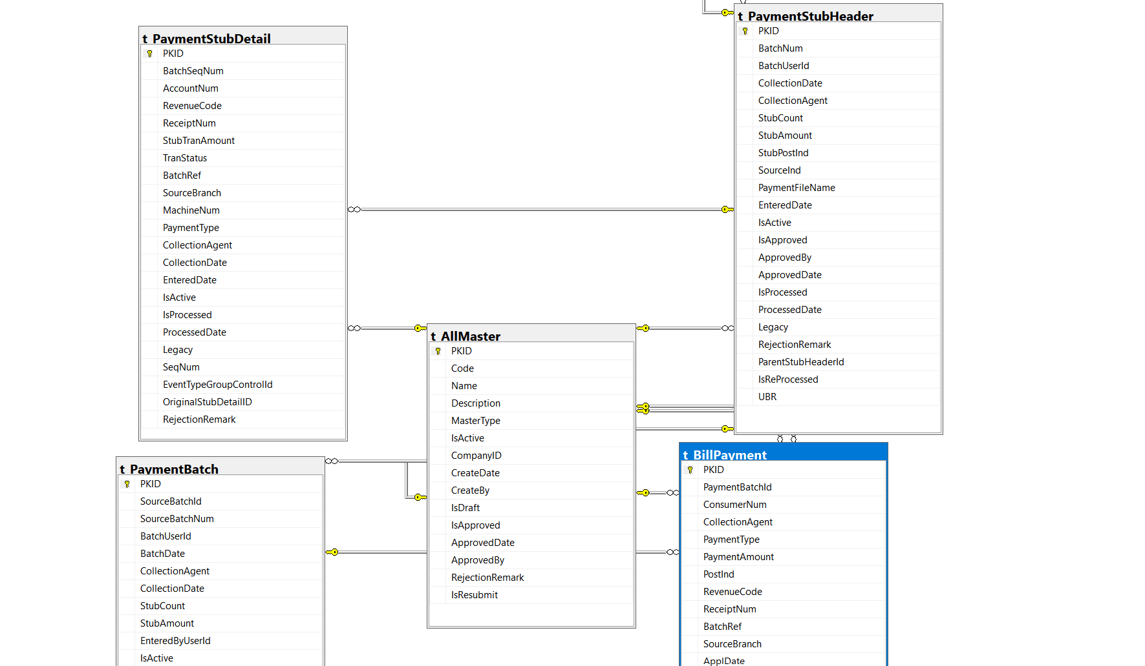

- Deposit Management

- Insert the data into t_bank table using t_bank script
- Insert the data into t_bankGuyrantee table t_bankGuyrantee script.
- Insert the data into t_ConsumerDepositStatement table using t_ConsumerDepositStatement script
- Insert the data into t_depost table t_deposit script.
- Insert the data into t_depositbatch table using t_depositbatch script.
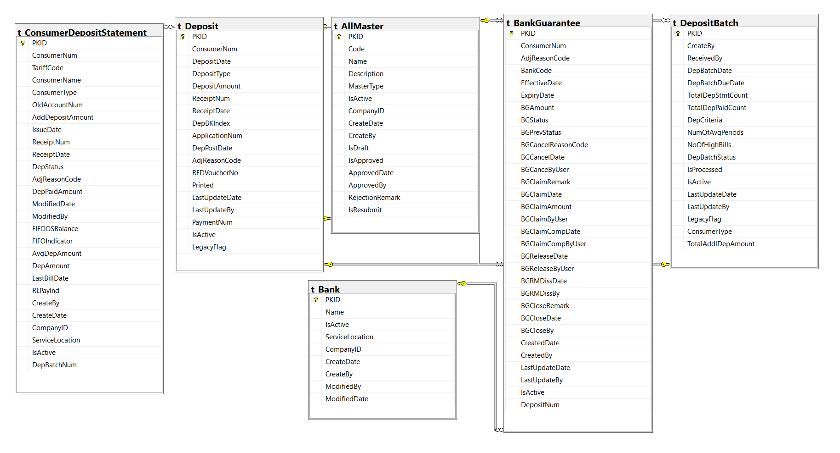

- Open Items
- Insert the data into t_openitem table using t_openitem script.
- 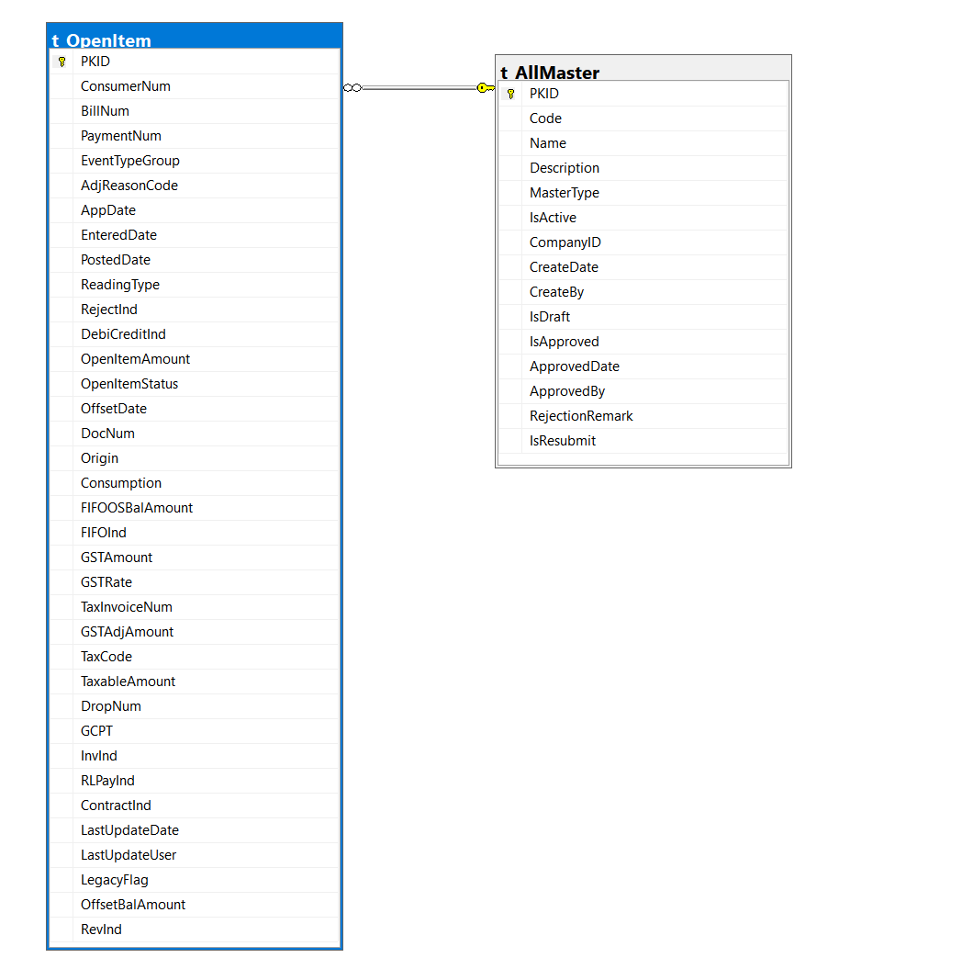

- Disconnection Management
- Insert the data into t_disconnectionbatch table using t_disconnectionbatch script
- Insert the data into t_disconnectionbatchdetails table using t_disconnectionbathcdetails script.

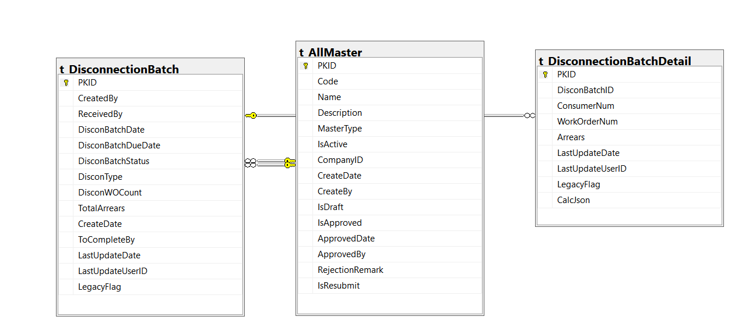

- Work order management
- Insert the data into t_workorder table using workorder script
- Insert the data into t_workordercharge table using workordercharge script.
- Insert the data into t_wometerchange table using t_wometerchange script.
- Insert the data into t_wometerinspection table using t_wometerinspection scirpt.
- Insert the data into t_wometerreading table using t_wometerreading script.
- Insert the data into t_WoReadingadjustement table using t_WoMeterReadingAdistement script
- Insert the data into t_WositeInspection table using t_WoSiteInspection script.
- Insert the data into t_WoDisconnectMeter table using t_WoDisconnectMeter script.
- Insert the data into t_WONewMeterInstallation tabke using t_WONewMeterInstallation script.
- Update the meter number for t_WONewMeterInstallation, t_WODisconnectMeter, t_WOReadingAdjustment,t_WOMeterReading tables.
- Update the oldmeternum and newmeternum for t_WOMeterChange table.
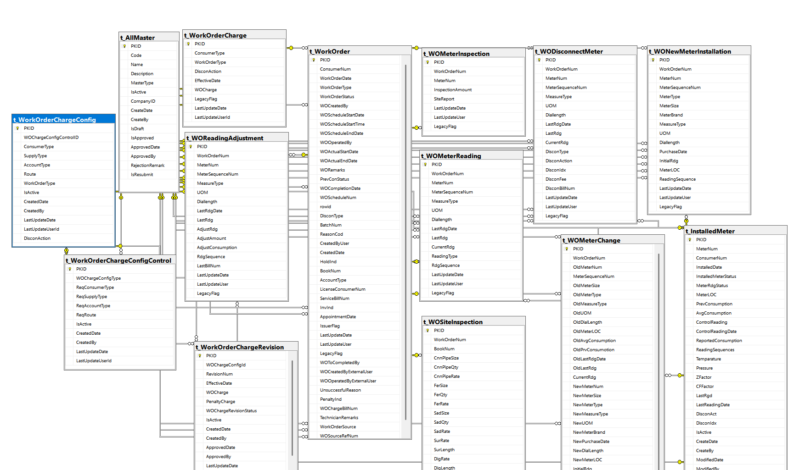

- Remainder management
- Insert the data into t_remainder table using t_remainder script.
- Insert the data into t_remainderbatch table using t_remainderbatch script.
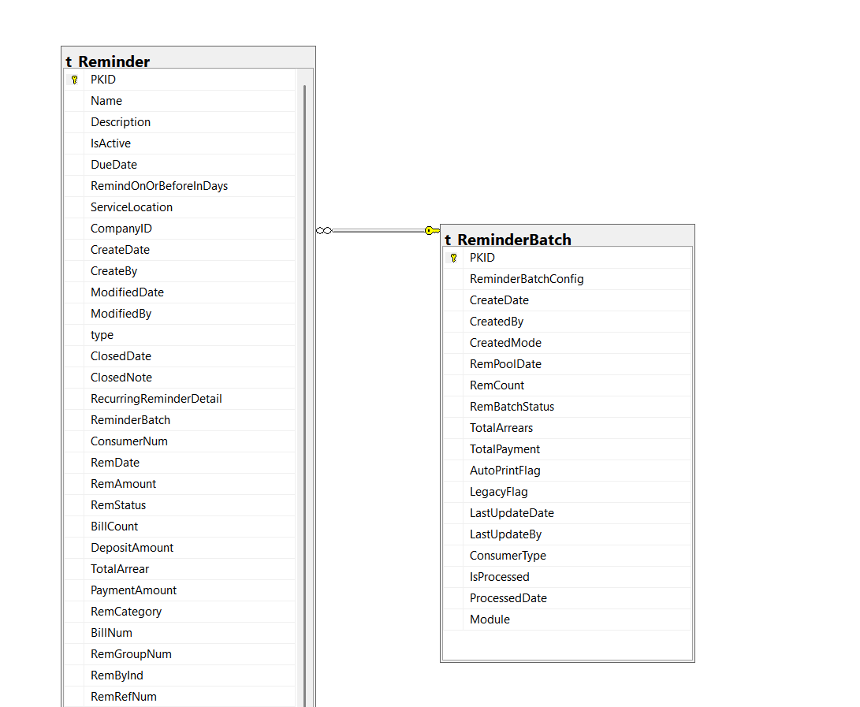
- Close batch
- Insert the data into t_CloseAccountBatch table using t_closeAccountbatch script.
- Insert the data into t_closeaccountdetail table using t_closeAccountdetail scrpit.

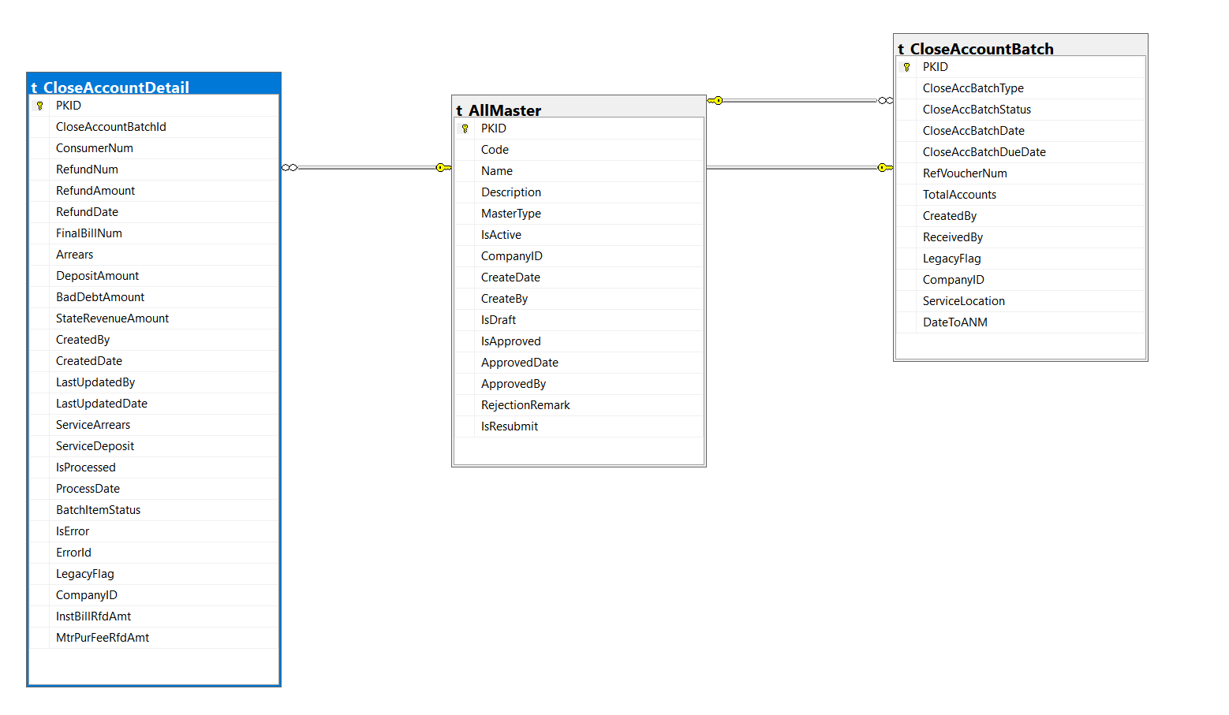

- Non Billing Management
- insert the data into t_nonbill tabke using t_nonbill script.
- Insert the data into t_nonbillPayment using t_nonbillpayment script.

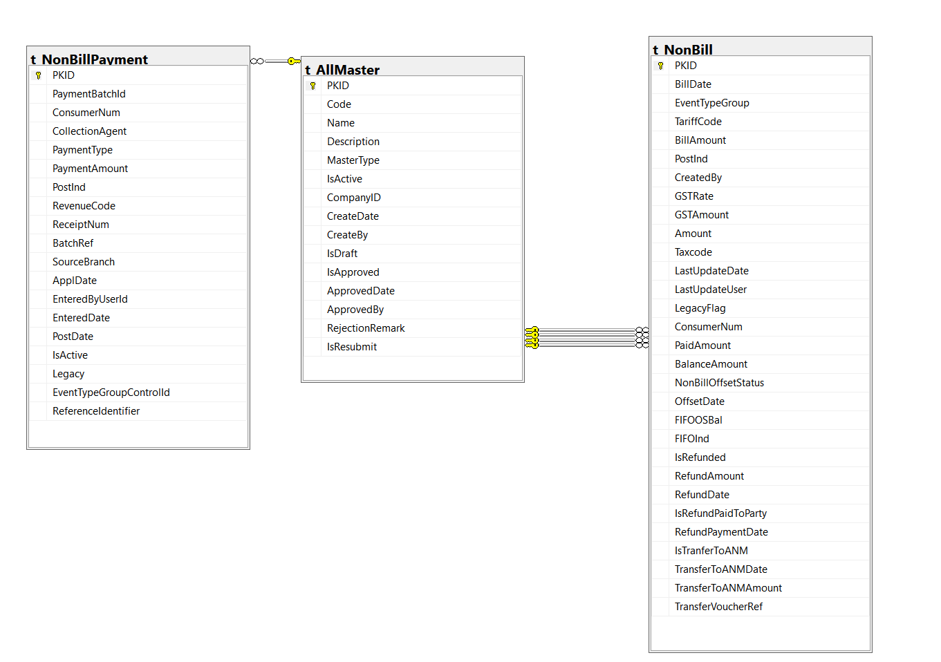

- Report
- Insert the data into t_MonthEndAgeDetails table using t_MonthEndAgeDetails script.
- Insert the data into t_Monthlysalessummaryreport table using CONSOLIDATED_REPORT_QUERY_BY_ZONEV2 script.

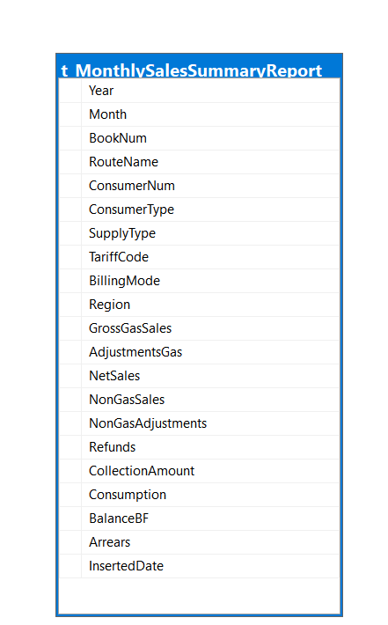

- Supply comment and RLinvoice Rate
- Insert the data into t_supply comment table using t_supplycomment values.
- Insert the data into t_Rlinvoicerate table using t_rlinvoicerate

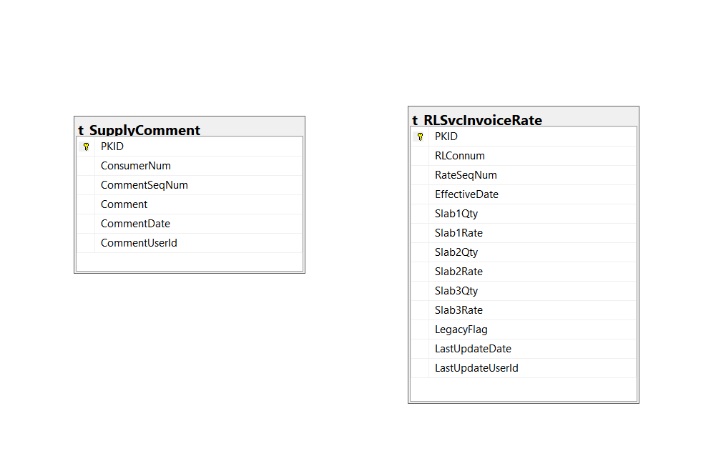

- Adjustment Module

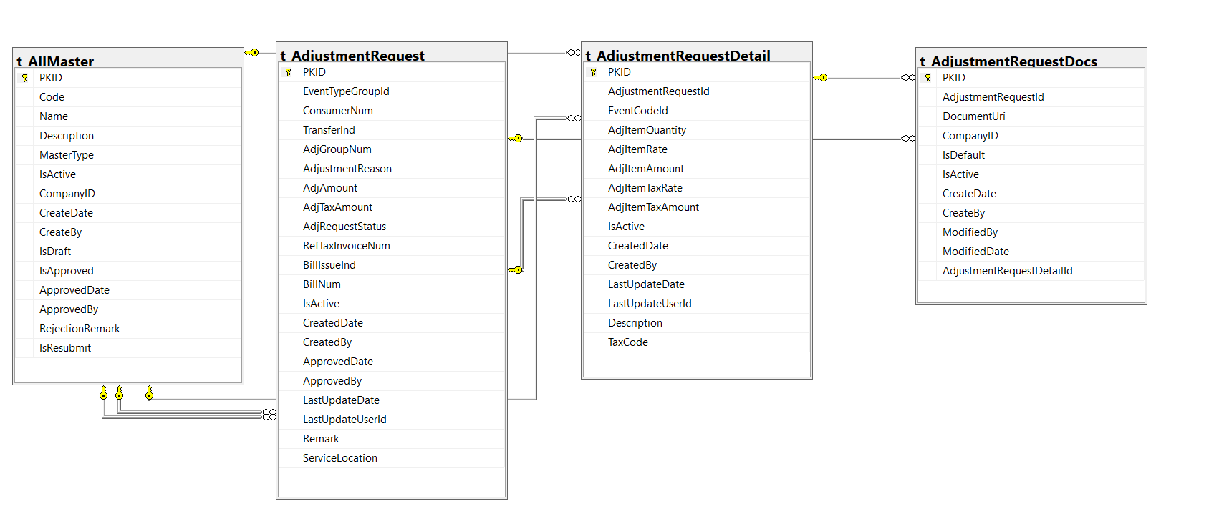

- Terminate DRR Request
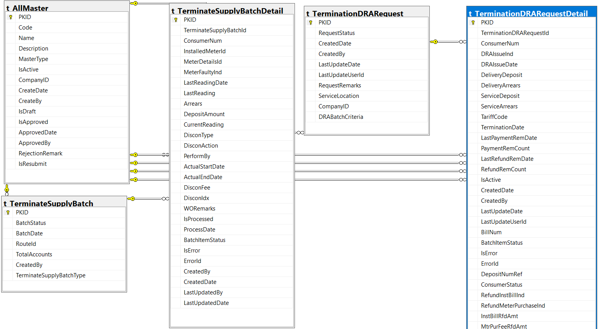

Querrys

Finding the table name

SELECT name
FROM sys.tables
WHERE name LIKE '%tbn%';

select top 10 * from TBNONBILL

select distinct taxcode from tbnonbill

--------------------------------------------------------------------------------
select DISTINCT WorkOrderStatus FROM T_WORKORDER

SELECT * FROM T_ALLMASTERTYPE WHERE PKID=506

SELECT * FROM T_ALLMASTER WHERE MASTERTYPE=506

SELECT WorkOrderStatus, COUNT(*) AS TotalOrders
FROM T_WORKORDER
GROUP BY WorkOrderStatus;

SELECT * FROM T_ALLMASTER WHERE PKID IN(3298,3299,3300)

SELECT * FROM T_PARTY A WHERE CONSTA='01' AND YEAR(SUPDAT)=2025 AND MONTH(SUPDAT)=07 AND BILMOD='SB' AND NOT EXISTS(SELECT 1 FROM TBBILL B WHERE B.CONNUM=A.CONNUM AND EVNTYP=0 AND EVNGRP='01' ) ORDER BY SUPDAT DESC

SELECT
c.table_name,
c.column_name,
c.data_type,
c.is_nullable,
fk.constraint_name AS foreign_key,
fk_referenced.table_name AS foreign_table,
fk_referenced.column_name AS foreign_column
FROM
INFORMATION_SCHEMA.COLUMNS AS c
LEFT JOIN
INFORMATION_SCHEMA.KEY_COLUMN_USAGE AS fk
ON c.column_name = fk.column_name
AND c.table_name = fk.table_name
AND c.table_schema = fk.table_schema
LEFT JOIN
INFORMATION_SCHEMA.TABLE_CONSTRAINTS AS tc
ON fk.constraint_name = tc.constraint_name
AND tc.constraint_type = 'FOREIGN KEY'
LEFT JOIN
INFORMATION_SCHEMA.REFERENTIAL_CONSTRAINTS AS rc
ON tc.constraint_name = rc.constraint_name
LEFT JOIN
INFORMATION_SCHEMA.KEY_COLUMN_USAGE AS fk_referenced
ON rc.unique_constraint_name = fk_referenced.constraint_name
AND rc.unique_constraint_schema = fk_referenced.table_schema
AND fk_referenced.ordinal_position = fk.ordinal_position
WHERE
c.table_name = 't_MeterPurchase'
AND c.table_schema = 'dbo';
---------------------------------------------------------------------------------------------------------

User allocating menus

select * from contacts

select * from employee where contactid=189

select * from DesignationActivityAllocation where OfficeDepartmentDesignationAllocationID=2

select * from Designation where

INSERT INTO DesignationActivityAllocation (ActivityID, OfficeDepartmentDesignationAllocationID, LastUpdatedBy, LastUpdatedOn, LastUpdatedTerminal, createe, Vieww, Modifyy) VALUES (180, 2, null, null, null, 0, 1, 0);

select * from OfficeDepartmentAllocation where OfficeID=1 and DepartmentID=3

select * from OfficeDepartmentDesignationAllocation where DesignationID=2

select * from ODLDAllocation where ODLDID=18

select * from OfficeDepartmentDesignationAllocation
select * from ActivityMenuAllocation

select * from activity

select max(pkid) from t_allmaster

select * from t_allmaster where mastertype=558

SELECT * FROM t_TaxCategory

INSERT INTO t_TaxCategory (PKID, Name, Percentage, CreateDate, ModifiedDate, CreateBy, ModifiedBy, CompanyID, EffectiveDate, TaxCode) VALUES (7, 'SSD', 6, '2020-08-07 02:28:39.4', '2024-07-07 02:28:39.4', 1, 1, 98, '2024-07-01', 3879);

INSERT INTO t_AllMaster (PKID, Code, Name, Description, MasterType, IsActive, CompanyID, CreateDate, CreateBy, IsDraft, IsApproved, ApprovedDate, ApprovedBy, RejectionRemark, IsResubmit) VALUES (3879, 'SSD', 'SSD', 'SSD-SSD', 558, 1, 98, '2025-08-08 10:16:22.023', 90, 0, 1, '2025-08-08 15:46:22.023', 90, null, null);

Billing Mode PB
SELECT A.PKID AS COSNUMERNUM,A.NAME AS CONSUMERNAME, BookNo AS ROUTENUM,B.NAME AS ROUTENAME,C.Code AS 'BILLING MODE'
FROM T_PARTY A , T_ROUTE B,t_AllMaster C,T_ALLMASTERTYPE D
WHERE A.ROUTE=B.PKID AND C.PKID=A.BillingMode
AND C.MasterType=D.PKID AND D.NAME LIKE 'BILLING MODE' AND C.CODE='PB'

FINDING THE MISSING ID’S
SELECT t1.PKID + 1 AS MissingID
FROM t_SupplyComment t1
LEFT JOIN t_SupplyComment t2
ON t1.PKID + 1 = t2.PKID
WHERE t2.PKID IS NULL
ORDER BY MissingID;

