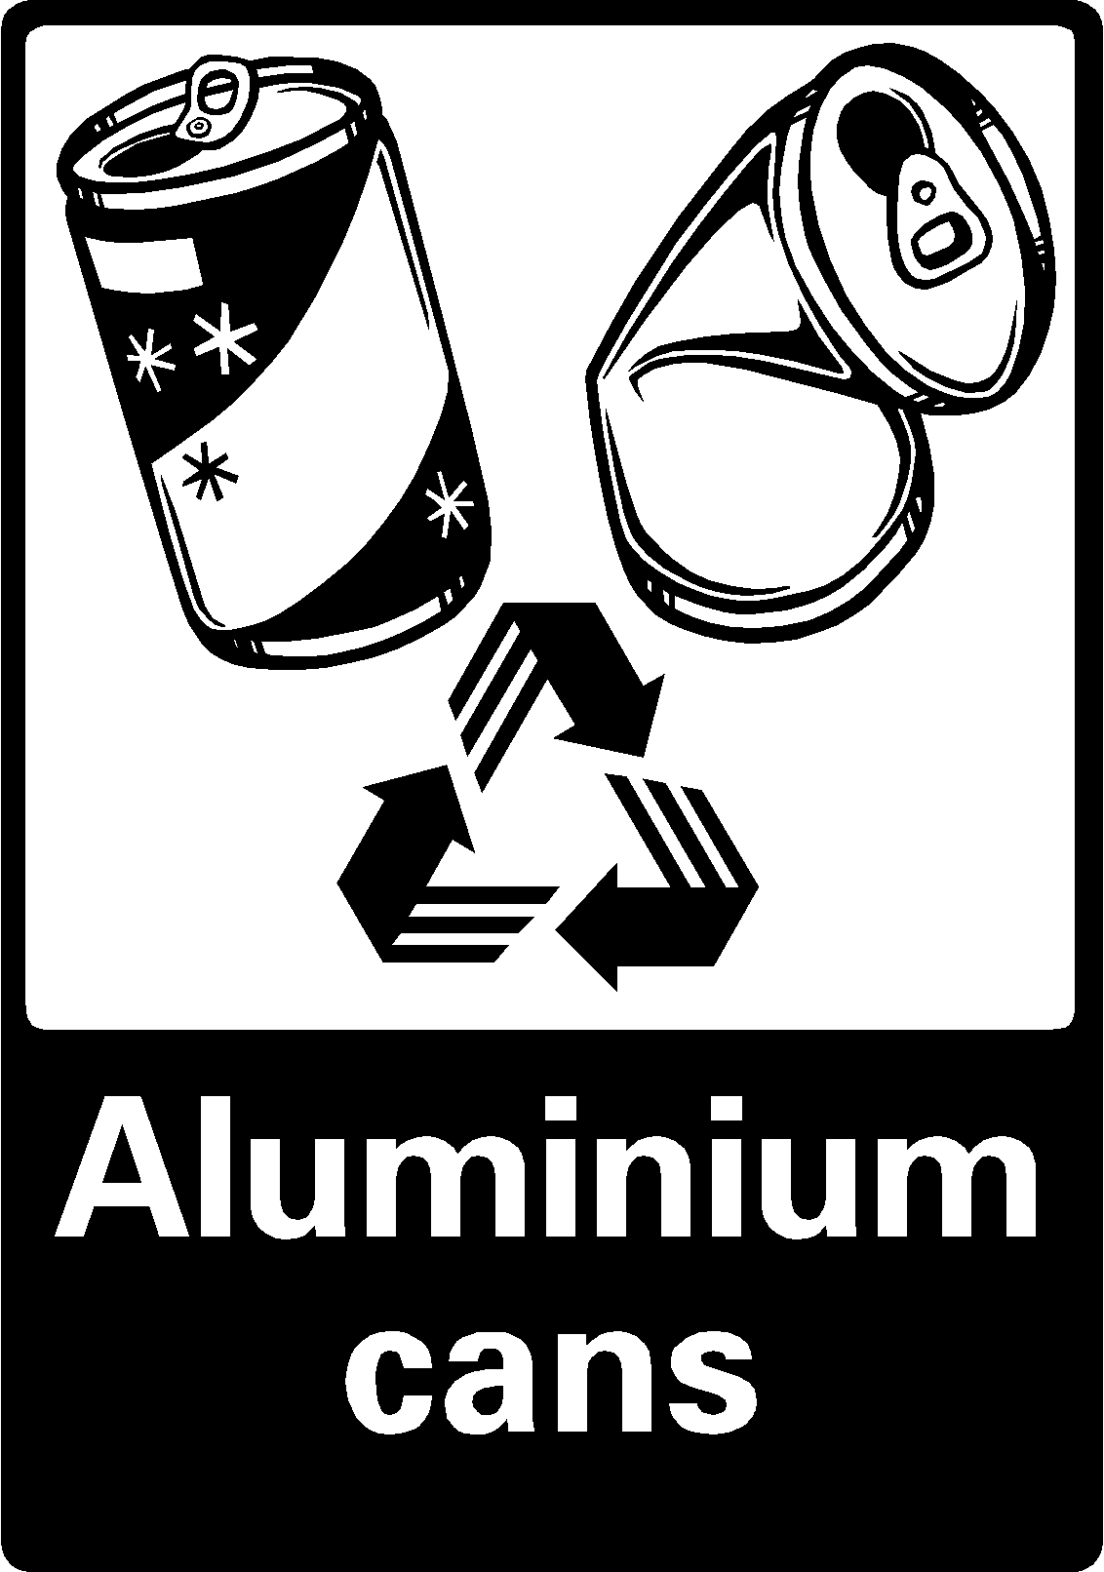 | 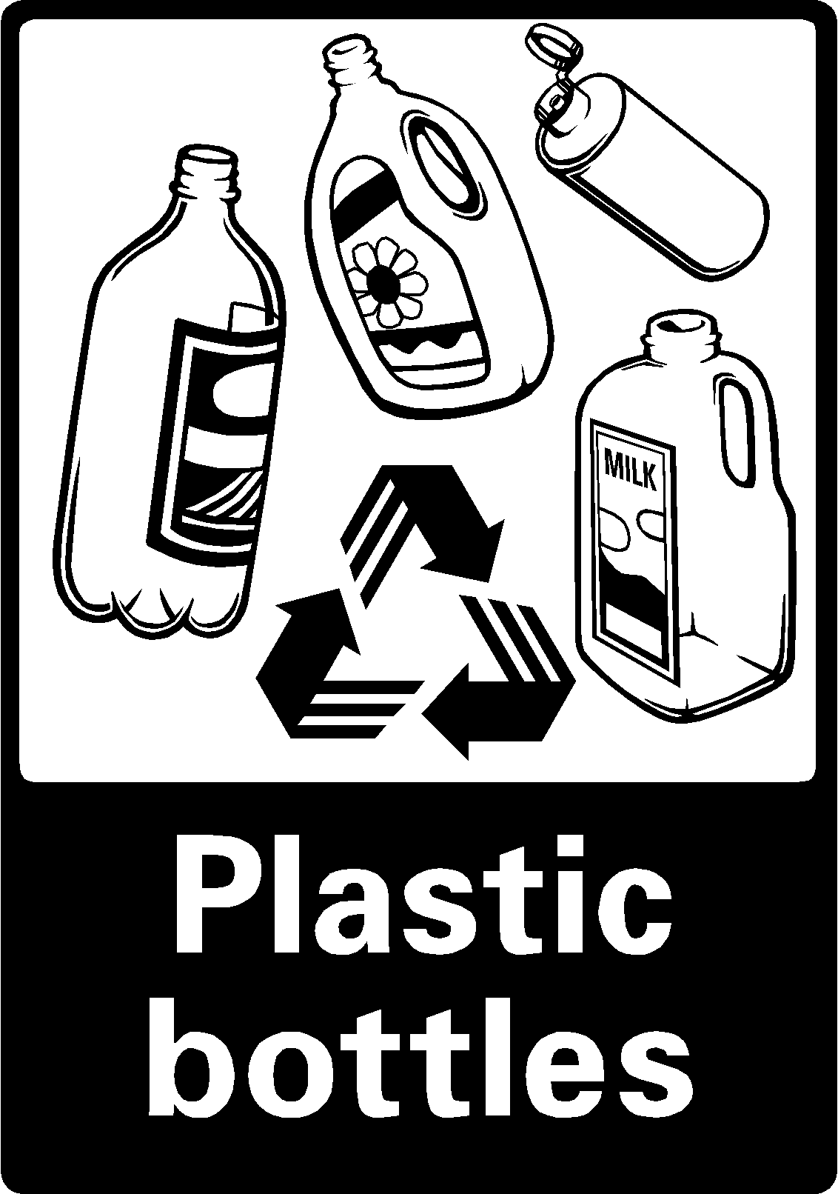

Aluminum / Plastic

Aluminum drink cans

Plastic bottles
Jugs
other types of plastic that has

PETE #1 or HDPE #2
(you know those numbers stamped into the bottom of the bottle
the ones inside the little recycling logo)

PLEASE NO PLASTI C BAGS!!!

