Mixed Paper/
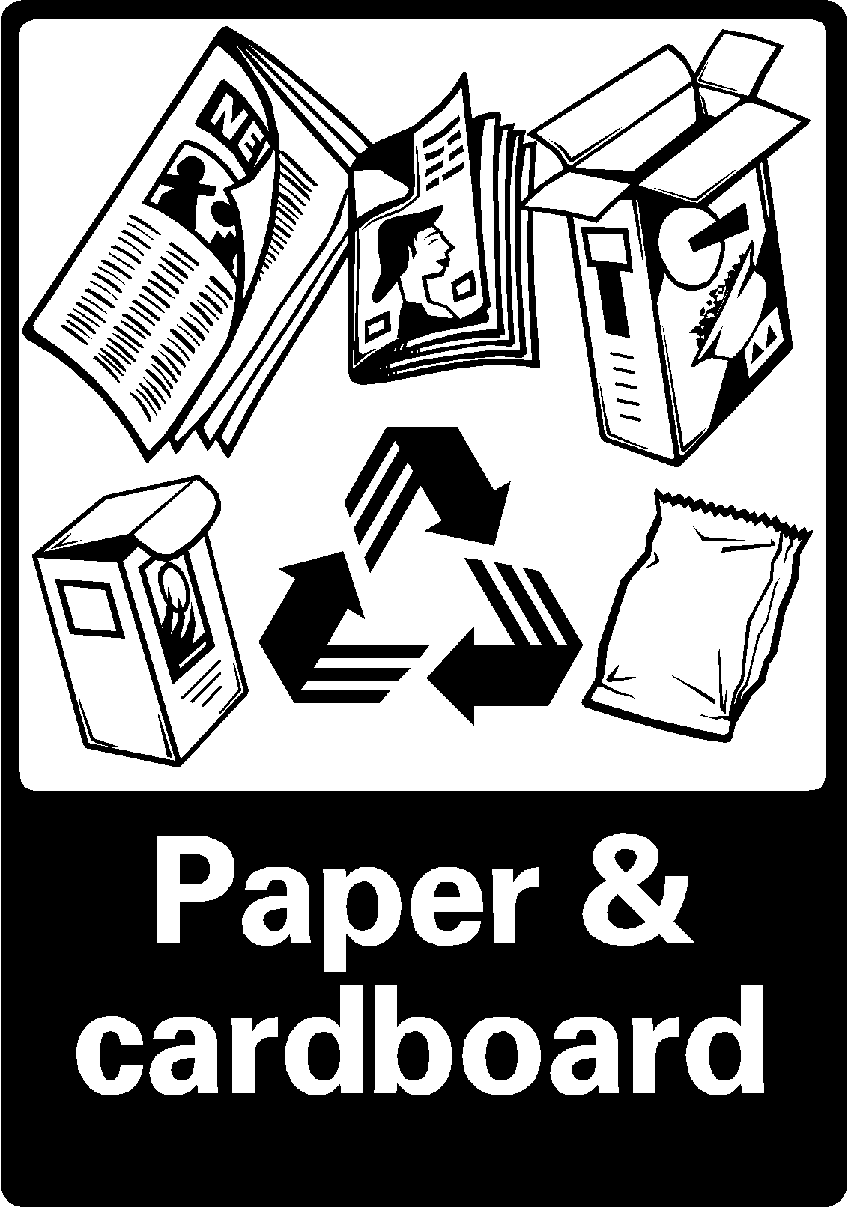

Newspaper

Anything

100% paper
white paper
newspaper
junk mail
colored paper
magazines
phone books
cereal boxes
paperback books
posters (please remove tape)...
staples are okay
NO dirty food wrappers
NO corrugated cardboard

