**Modeling Amdahl’s Law : Project 1**

CST-305: Principles of Modeling and Simulation

*_____________________________________________________________*

WF1100A Prof. Citro

Dayana Gonzalez Cruz

September 17th, 2023

**Amdahl’s Law**

__________________________

Amdahl’s Law models the speedup or efficiency improvement of a task from a change in computer architecture or organization (Stallings, 2019).

$Speedup=\frac{Performance after enhancement}{Performance before enhancement}= \frac{Execution time before enhancement}{Execution time after enhancement}$ $Speedup=\frac{1}{\left(1-f\right)+f/N}$

In this equation, f can refer to the portion of a task that will be affected by the change and N refers to a speedup constant. Furthermore, it can refer to the portion of a processing unit’s instructions or tasks that can be parallelized or performed independently at the same time. N can refer to the number of processors in a processing unit. In modeling this, the maximum speedup possible from a given number of processors in a unit can be observed. Moreover, illustrating that processors have a diminishing impact on speedup.

*Issue Solved :A designer can use this model to see the benefit of a multiple processors for their system and to what extent it will be beneficial to parallelize their tasks and instructions.*

**Approach**

__________________________

*Mathematical:* To solve and represent this model, the model is set up with an initial value for parallelizable portion of a system and an initial value for number of processors. Then, the problem is evaluated for the speedup- the solution.

*Code:*

**Screenshots of Project.py**

__________________________

Program was written in python using notepad text editor and run in a Ubuntu wsl terminal.

1.

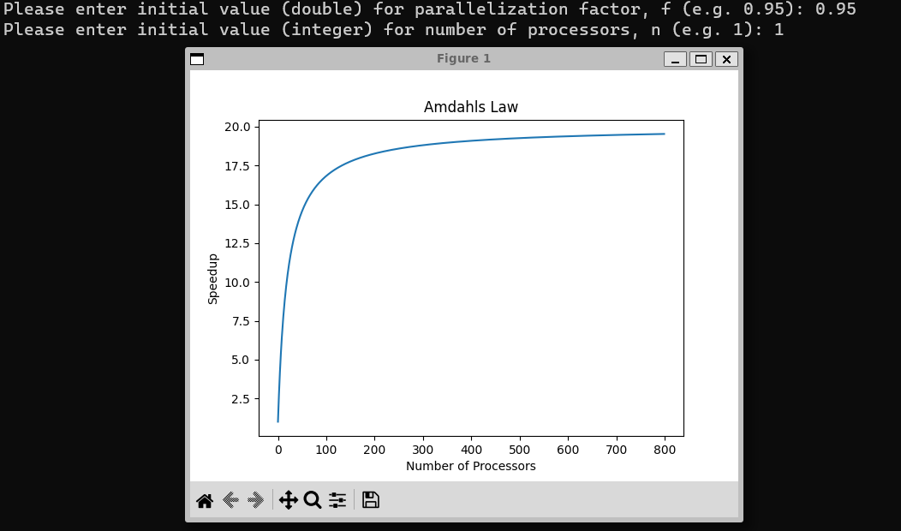

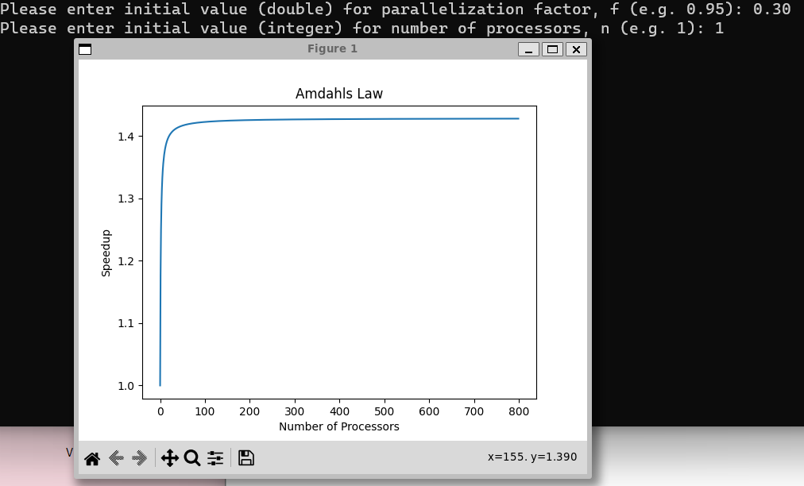2.

**Reference**

Stallings, W. (2019). Computer Organization and Architecture (11th ed.). Pearson: Hoboken, NJ. ISBN-13: 9780135205129