**Technologies**

1. .NET Core 3.1 (netcoreapp3.1/netstandard2.1)
2. EntityFramework Core 3.1.3
3. EntityFramework Core SqlServer 3.1.3
4. MSSQL Server
5. Microsoft.Extensions.DependencyInjection
6. MOQ
7. XUnit

**Design Patterns & Principles**

1. Generic Repository
2. Repository Pattern
3. Service Layer
4. Dependency Inversion
5. SOLID Principles
6. AAA
7. F.I.R.S.T Principles

**Database schema diagram**

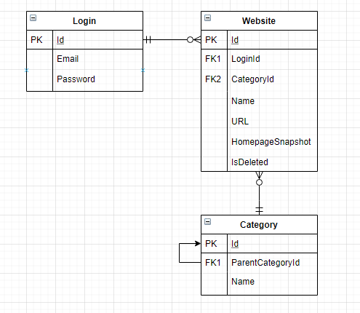

**Multilayered application diagram**

