Step 1 : Create a new Repository in GIT.

Step 2 : Clone the created repo into local.

Step3 : create a branch.

Step 4 : create one file into development branch and push the file into it.

Step 5 : create a tag for the development branch.

Step-6: release from feature to production.

Step7 : create a pull request from development to main.

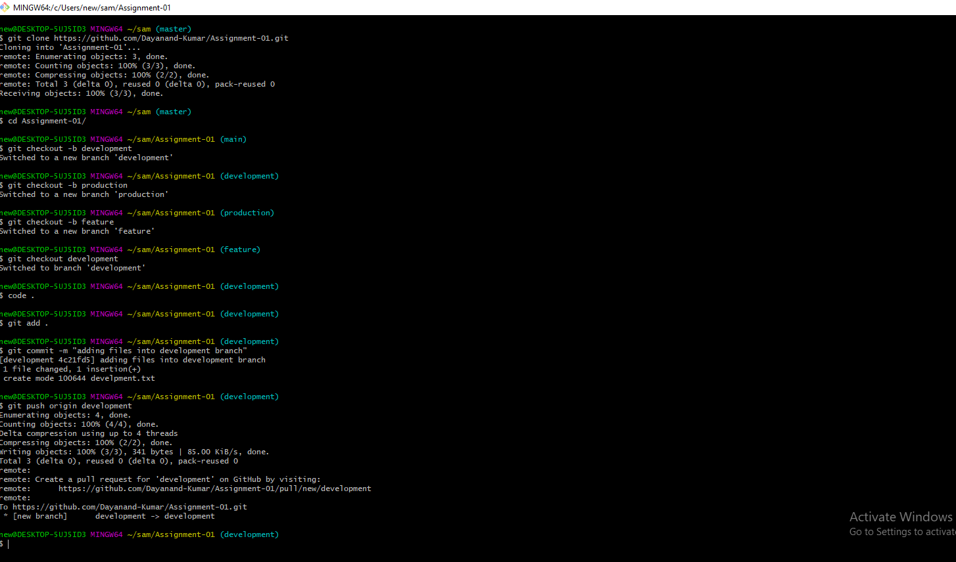

Branches to Push

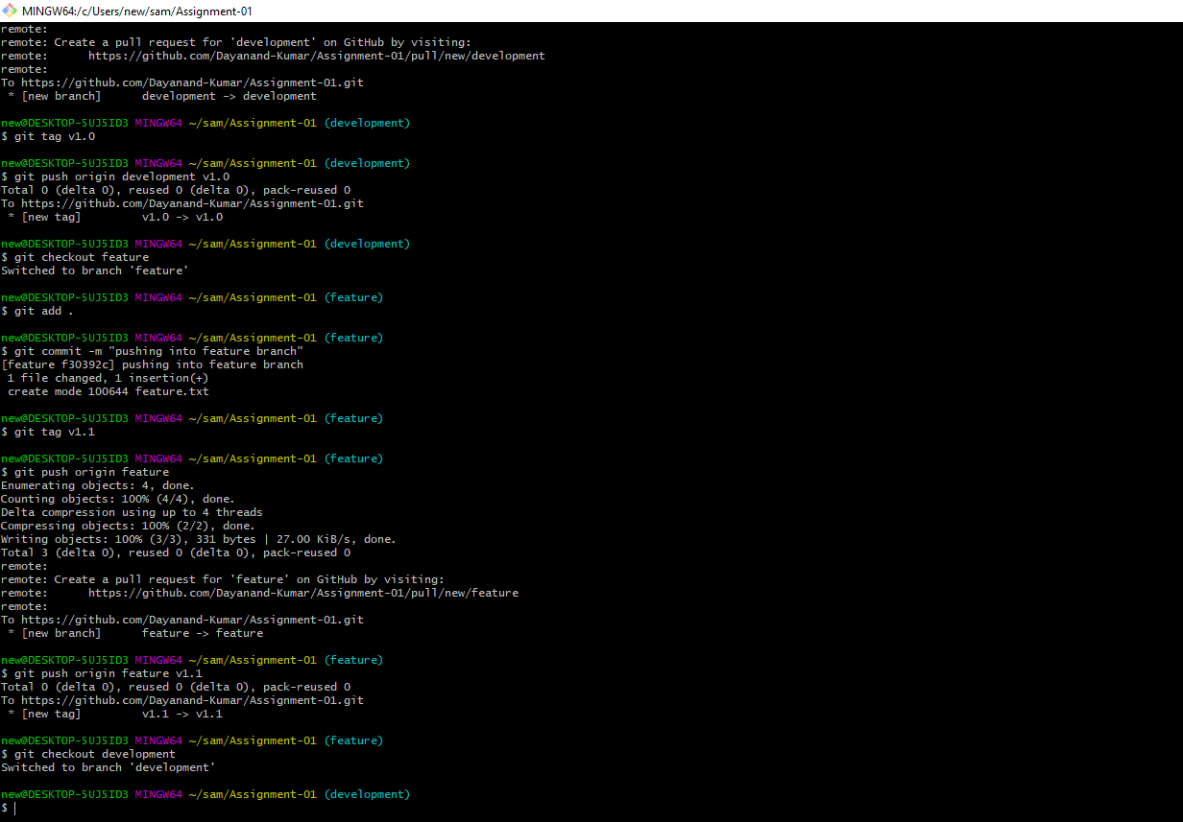

Production to push

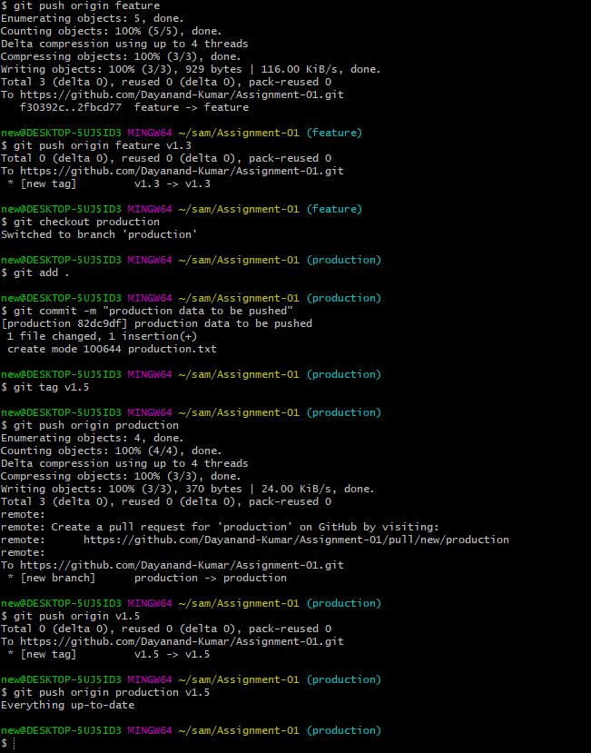

First release:

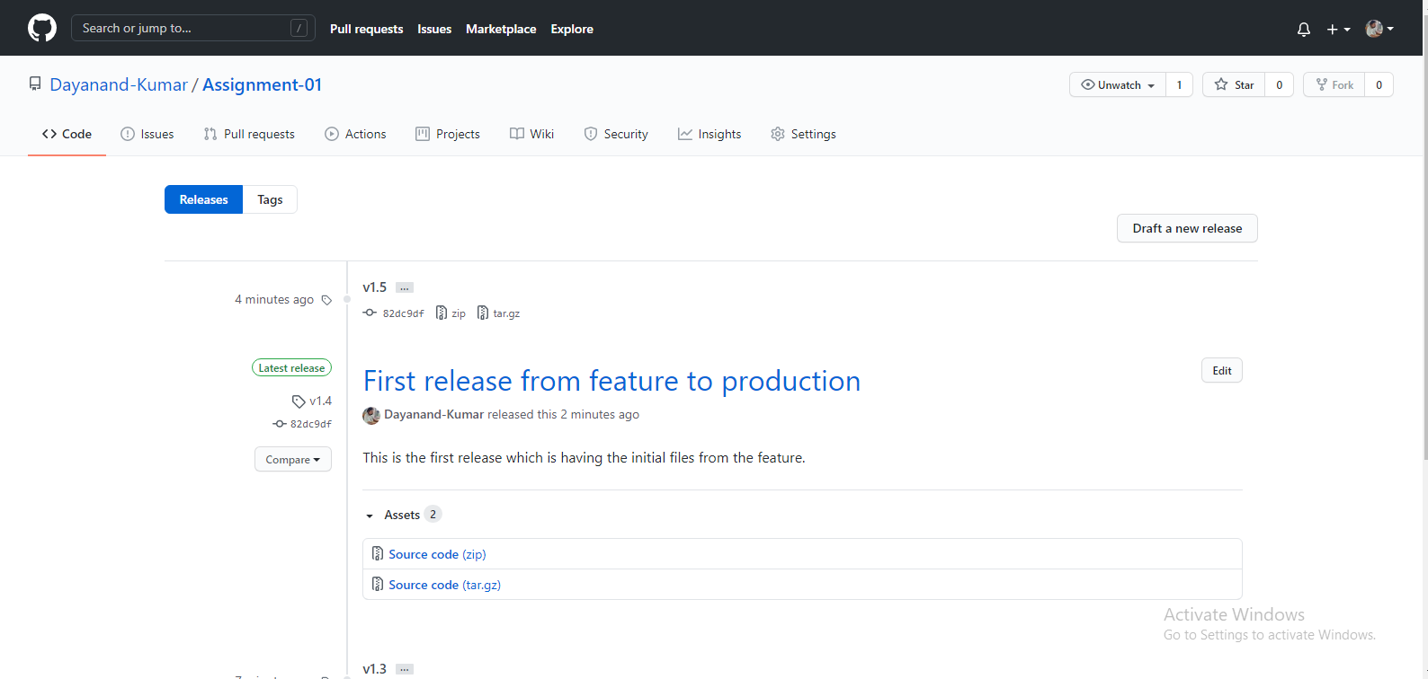

Merge Request:

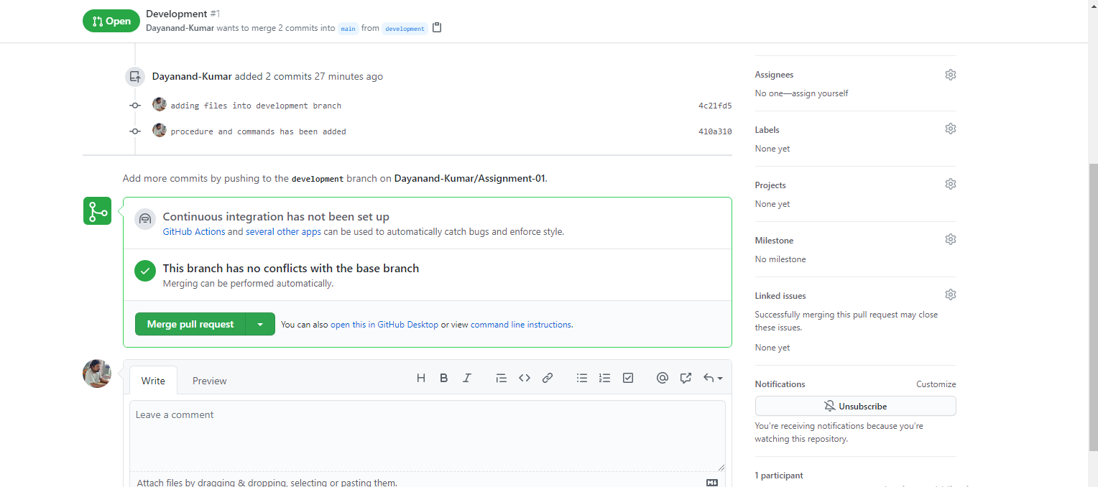

Tags :

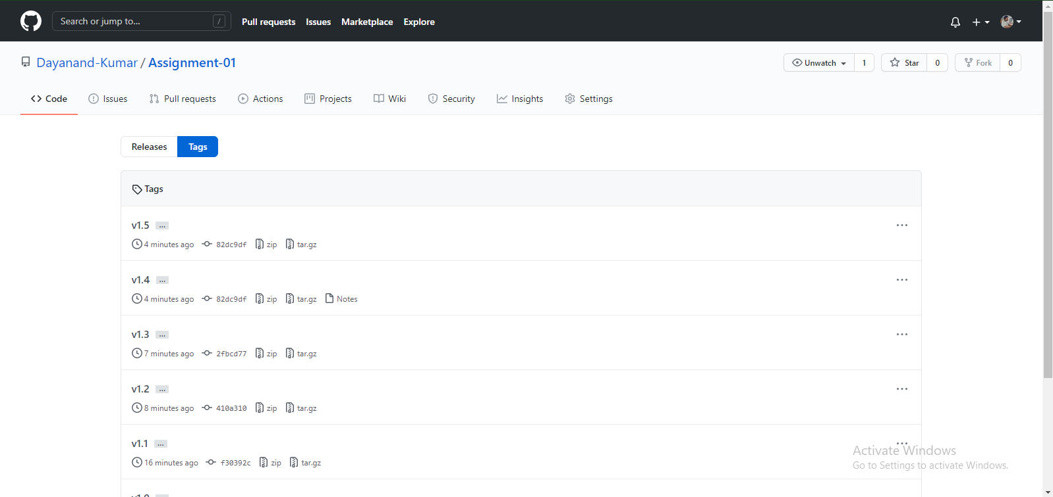

Overview :

