**Machine Learning**

**Project Report**

**By**

**Dayanand Jajodia, Dhiraj Agarwal, Arnab Saha, Md. Haider Parwez**

**2ND year student of**

**Siliguri Institute of Technology**



**Under the supervision of**

**Mr. Biprosom Majumder**

**Department of Computer Science & Engineering**

Date:

I hereby forward the documentation prepared by Group of 4 memberunder the supervision of Mr. Biprosom Majumder Sir entitled **Result Management System Website/Portal** accepted as fulfillment of the requirement for the Degree of Bachelor of Computer Science & Engineering (B.TECH) in **Computer Science & Engineering** from **Siliguri Institute Of Technology** affiliated to **Maulana Abul Kalam Azad University of Technology** (**MAKAUT**) .

|  |
| --- |
| ______________________________  Mr. Biprosom Majumder  **Project Guide** |
|  |

**TRAFFIC SIGNAL RECOGNITION**

**by**

**Dayanand Jajodia, Dhiraj Agarwal, Arnab Saha, Md. Haider Parwez**

UNDER THE GUIDANCE OF

**Mr. Biprosom Majumder**

**Project Guide**

THIS SUBMITTED IN FULFILLMENT OF THE REQUIREMENTS FOR THE DEGREE OF

**B.TECH**

IN

COMPUTER SCIENCE & ENGINEERING

**SILIGURI INSTITUTE OF TECHNOLOGY**

**AFFILIATED TO**

**Maulana Abul Kalam Azad University of Technology**

**Certificate of Approval**

The foregoing project is hereby approved as a creditable study for the BTECH in Computer Science & Engineering and presented in a manner of satisfactory to warrant its acceptance as a prerequisite to the degree for which it has been submitted. It is understood that by this approval the undersigned do not necessarily endorsed or approved any statement made, opinion express or conclusion therein but approve this project only for the purpose for which it is submitted.

Final Examination for

Evaluation of the Project ----------------------------------------

--------------------------------------

Signatures of Examiners

**ABSTRACT**

**Traffic signal detection** is a crucial task in the field of computer vision and transportation engineering. The objective of this task is to detect traffic signals accurately and in real-time, which can help reduce accidents, improve traffic flow, and enhance overall safety on roads. In recent years, there has been significant progress in developing deep learning-based approaches for traffic signal detection. These approaches leverage the power of convolutional neural networks (CNNs) to detect traffic signals in images captured by cameras mounted on vehicles or at intersections. This code provides an overview of the state-of-the-art in traffic signal detection, including a discussion of the challenges and recent advances in this field.

**ACKNOWLEDGEMENT**

It is a great pleasure for me to acknowledge the assistance and participation of a large number of individuals to this attempt. Our project report has been structured under the valued suggestion, support and guidance of **Mr. Biprosom Majumder** . Under his guidance we have accomplished the challenging task in a very short time.

Finally, we express our sincere thankfulness to our family members for inspiring me all throughout and always encouraging us.

**Computer Science & Engineering**

**TABLE OF CONTENTS**

1. Chapter 1: Introduction
   * 1: Introduction
2. Chapter 2: Libraries Used
   * 2.1: Python
   * 2.2: Sklearn
   * 2.3: Matplotlib
   * 2.4:PIL
   * 2.5: Pandas
   * 2.6 Tkinter
3. Dataset
   * Data reading
   * Data manipulation
4. Chapter 4: Output
   * Graph
5. Chapter 5: Conclusion

**1.INTRODUCTION**

Traffic signs are devices placed along, besides, or above a highway, roadway, pathway, or other route to guide, warn, and regulate the flow of traffic, including motor vehicles, bicycles, pedestrians, equestrians, and other travelers. Since safety becomes more important for customers, Traffic Sign Recognition (TSR) becomes one of today’s research subjects aiming to improve safety of driving.

**2. Libraries Used**

1. **2 Python**

The Python version used in the program is 3.11.0. The editor used is visual studio code

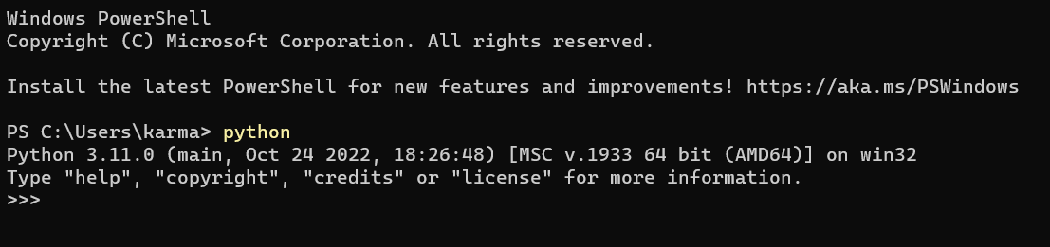

1. **SKLEARN**

We used Sklearn to perform calculations such as finding mean squared errors, split the given data into train and test and to form a linear regression model.

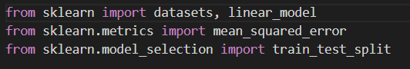

1. **MATPLOTLIB**

This library is used for graphical representation of data.

**math**

1. **PIL**

The Python Imaging Library adds image processing capabilities to your Python interpreter. This library provides extensive file format support, an efficient internal representation, and fairly powerful image processing capabilities. The core image library is designed for fast access to data stored in a few basic pixel formats. It should provide a solid foundation for a general image processing tool. 

1. **PANDAS**

Pandas is a game changer, and it is one of the most popular and commonly used tools in data analytics. Pandas is that it takes data from a CSV or TSV file or a SQL database and generates a Python object with rows and columns called a data frame, which looks remarkably similar to a table in statistics tools like Excel. Working with this is far more convenient than dealing with lists and/or dictionaries.

**pandas**

1. **Tkinter**

Tkinter is the de facto way in Python to create Graphical User interfaces (GUIs) and is included in all standard Python Distributions. In fact, it’s the only framework built into the Python standard library. This Python framework provides an interface to the Tk toolkit and works as a thin objectoriented layer on top of Tk. The Tk toolkit is a crossplatform collection of ‘graphical control elements’, aka widgets, for building application interfaces.

**3.DATASETS**

The data we have used in this project was in csv.file. It was taken from traffic.com . The dataset consists of 720 rows and 8 columns with no null values. Column data consist of independent Features. The independent features contain both categorical and numeric values.

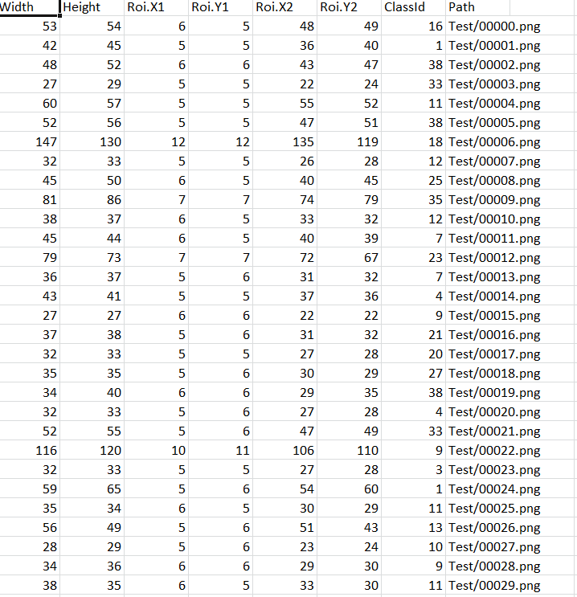

**DATA READING**

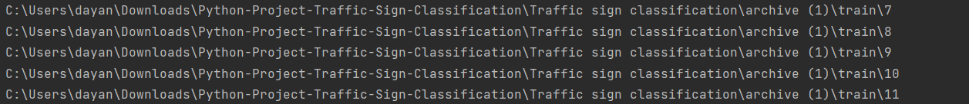

**DATA MANIPULATION**

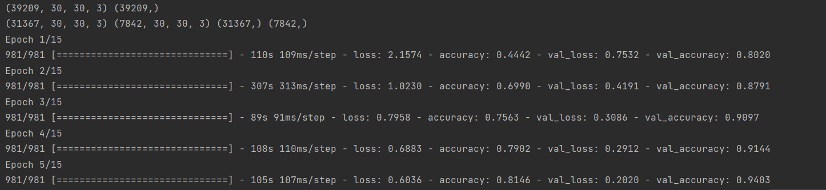

**OUTPUT**

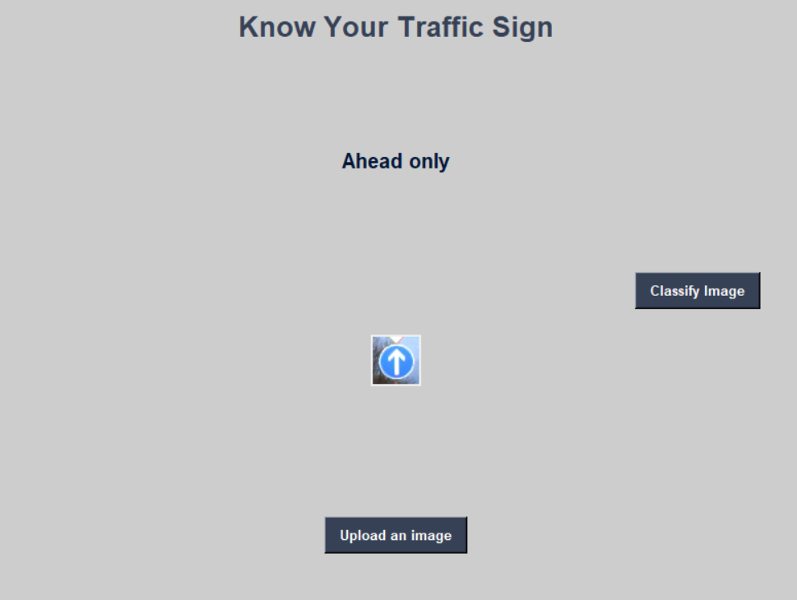

**GRAPH**

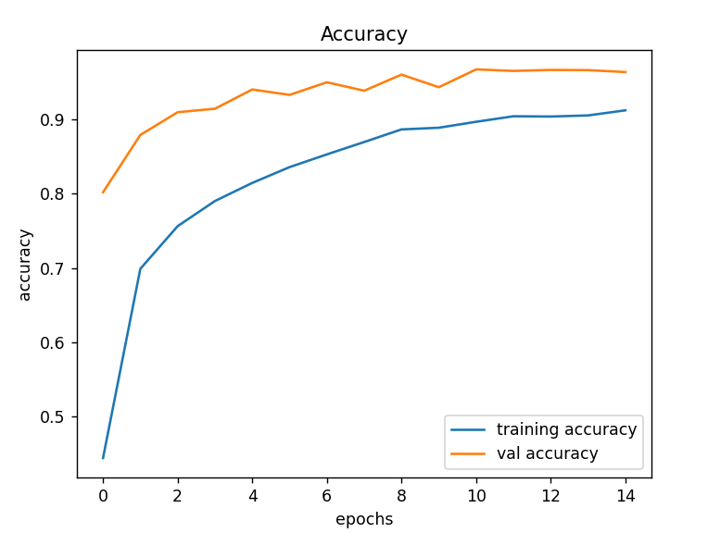

1. **CONCLUSION**

In this python project, we have successfully classified the traffic sign classifier with 90% accuracy and loss changes with time, which is pretty good from a simple CNN module