Big Data Analytics and Apps

Lab - 2

Dayananda Saraswathi, Ampapathina

Manohar Reddy, Dyapa

In this lab we have used pearson kitchen manager API, this takes ingredients as coma separated value input and gives us the list of cuisines we can make with those ingredients.

API Link:-

“[http://api.pearson.com:80/kitchen-manager/v1/recipes](http://api.pearson.com/kitchen-manager/v1/recipes)?ingredients-all=milk,cheese,eggs”

“[http://api.pearson.com:80/kitchen-manager/v1/recipes](http://api.pearson.com/kitchen-manager/v1/recipes)?ingredients-all=chicken,garlic”

Main idea is when we give speech instructions to Romo it will take all the ingredients and searches for the required cuisines or recipes to make.

This API causing SSL certificate expire problem while downloading the image using UIImageView+AFNetworking.m category.So, we are using default images for all cuisines.

App Screen shots:

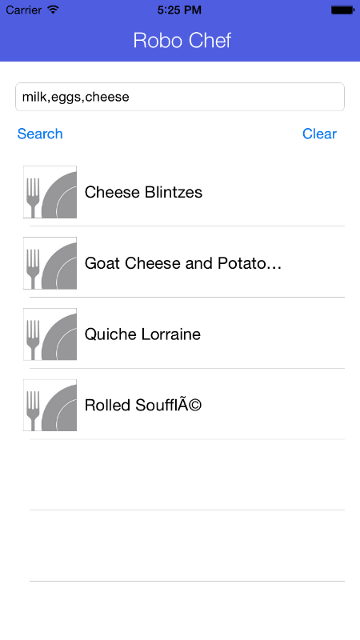 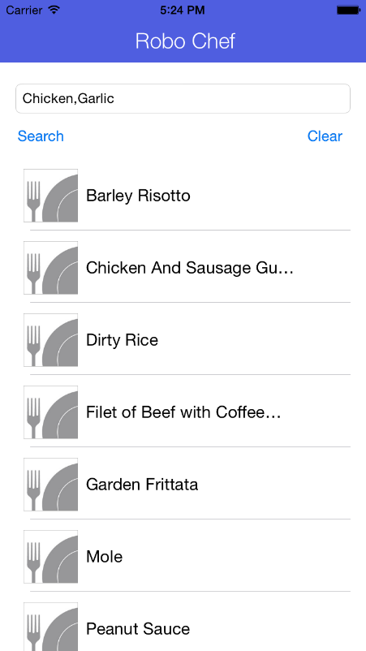

Code Screen Shots: 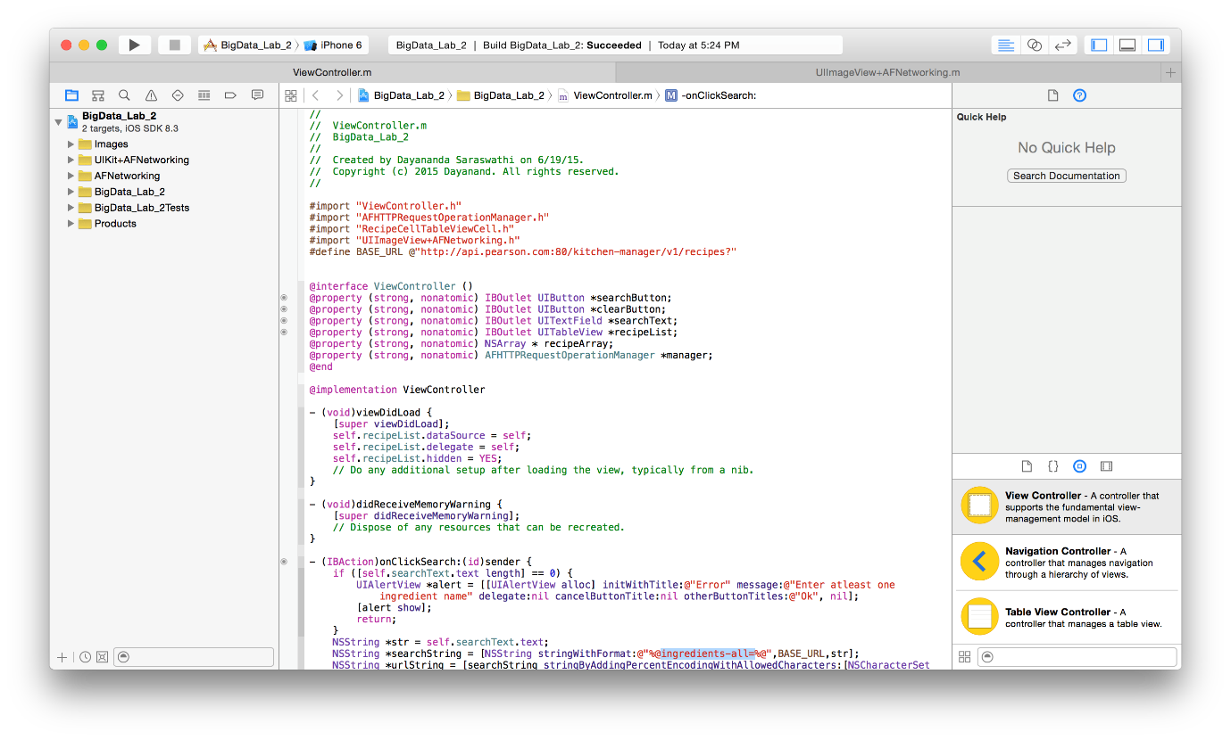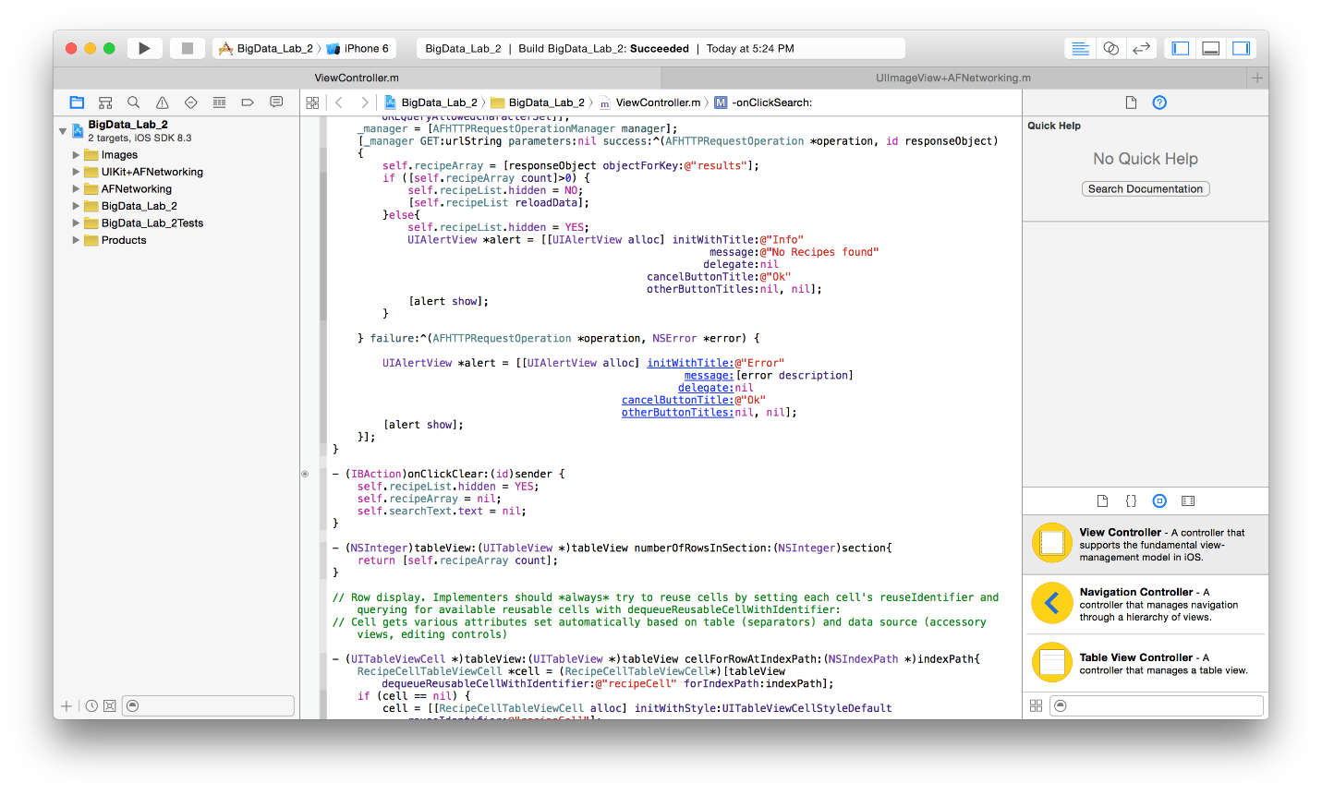

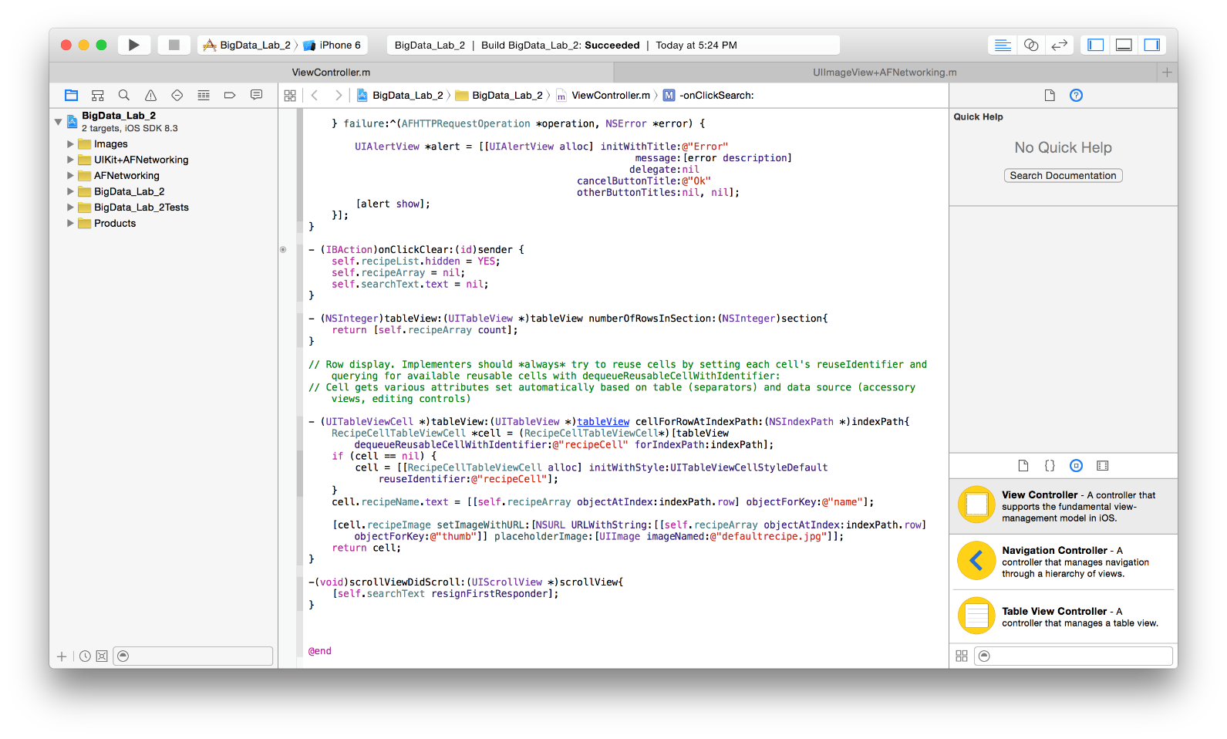

Git Hub URL

<https://github.com/Dayananda87/BigDataLabs>

Please download ” [BigData_Lab_2](https://github.com/Dayananda87/BigDataLabs/tree/master/BigData_Lab_2)” from above link