 **KGiSL Institute of Technology**

(Affiliated to ANNA University, Chennai and Approved by AICTE, New Delhi)

365, KGiSL Campus, Thudiyalur Road, Saravanampatti Coimbatore – 641035

**Department of Artificial**

**Intelligence and Data Science**



**NAAN MUDHALVAN -INTERNET OF THINGS**

**PROJECT TITLE : PUBLIC TRANSPORT OPTIMIZATION**

**REGISTER NUMBER :711721243020**

**NAME : DAYANITHI E**

**GMAIL ID :idayanithie@gmail.com**

**MENTOR : MOHANKUMAR.M**

**EVALUATOR :AKILANDESWARI.M**

**Abstract:**

The project is designed to develop a density based dynamic traffic signal system. The signal timing changes automatically on sensing the traffic density at the junction. Traffic congestion is a severe problem in many major cities across the world and it has become a nightmare for the commuters in these cities. Conventional traffic light system is based on fixed time concept allotted to each side of the junction which cannot be varied as per varying traffic density. Junction timings allotted are fixed. Sometimes higher traffic density at one side of the junction demands longer green time as compared to standard allotted time. The image captured in the traffic signal is processed and converted into grayscale image then its threshold is calculated based on which the contour has been drawn in order to calculate the number of vehicles present in the image. After calculating the number of vehicles we will came to know in which side the density is high based on which signals will be allotted for a particular side. Raspberry pi is used as a microcontroller which provides the signal timing based on the traffic density. Traffic is increasing in proportion to the population especially in a developing country like India. Hence there is a great need to have a well coordination of the traffic signals for the smooth control of traffic especially in busy traffic hours. Traffic congestion monitoring and controlling is one of the biggest challenges in many cities and this may affect the environmental life and disturbs our daily life routine. Due to increasing population, the number of roads and vehicles has considerably increased which have created many problems such as travel time delay, fuel wastage, air pollution and transport related issues. The main aim of the invention is to reduce traffic congestion in cities. Many sensors have been selected for this purpose like IR sensors, Ultrasonic sensors but at the end we chose IR sensors because of the efficiency of the IR sensors. These sensors are used to detect the distance between the vehicles and hence can be used for an automatic traffic signaling system which can lay the foundation in the construction of a Smart city.

**Flow Chart:**

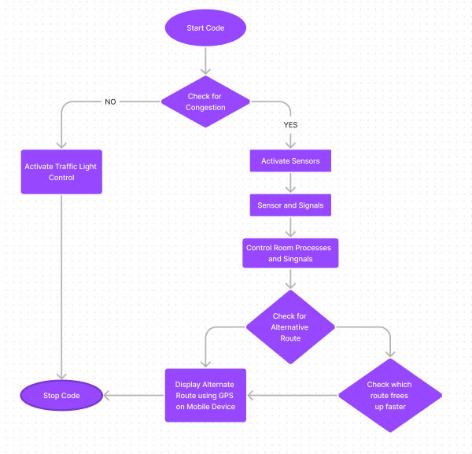

**Procedure Traffic_Control_System()**

Step 1:Start

Step 2: Check whether the vehicle is Emergency vehicle or not.

Step 3: If the vehicle is an Emergency vehicle then note down the LCD screen number of that vehicle and display an LED.

Step 4: Else for an ordinary vehicle check the distance of the vehicle from the traffic signal

using an IR sensor.

Step 5: The distance value is then compared with the values generated by other IR sensors.

Step 6: The sensor which has generated least value indicates that traffic is nearer to them and hence is given priority.

Step 7: The topmost priority sensor then initiates the Arduino board to glow a Green led so that the traffic can go smoothly and hence reduces traffic congestion.

Step 8: A yellow led and a red led glows automatically after the glowing of the green led.

Step 9: The whole process is repeated again and again until the power is off.

Step 10: Stop

**Conclusion:**

This Project Helps to develop a density based dynamic traffic signal system. The signal timing changes automatically on sensing the traffic density at the junction