**KGiSL Institute of Technology** 

(Affiliated to ANNA University, Chennai and Approved by AICTE, New Delhi)

365, KGiSL Campus, Thudiyalur Road, Saravanampatti Coimbatore – 641035

**Department of Artificial**

**Intelligence and Data Science**  

**NAAN MUDHALVAN**

**INTERNET OF THINGS**

**PROJECT TITLE : PUBLIC TRANSPORT OPTIMIZATION**

**REGISTER NUMBER :711721243020**

**NAME : DAYANITHI E**

**GMAIL ID :idayanithie@gmail.com**

**MENTOR : MOHANKUMAR.M**

**EVALUATOR :AKILANDESWARI.M**

## Implementation of a Smart Traffic Management System – Key Elements:

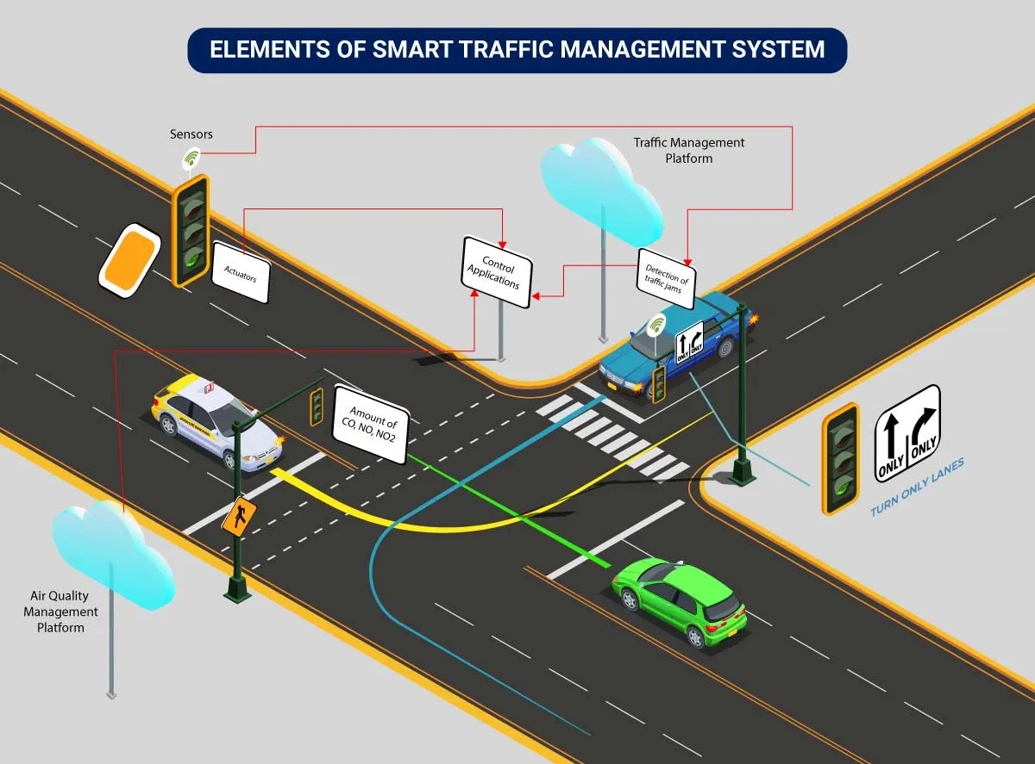

Here’s an implementation plan for building a scalable traffic control system using IoT capabilities:

A basic architecture that serves as a launchpad for feature enhancements and service upgrades will integrate the following components:

* **Sensors** for collecting data and sending it to a centralized cloud platform
* **Actuators** for physical devices to make necessary adjustments like – restricting the water supply in pipelines with leakages or dimming & brightening streetlights based on weather conditions.
* **Field gateways** to collect & compress data before moving it to a cloud platform.
* **Cloud gateways** enable secure data transfer between field gateways & the cloud storage of the traffic management system
* A data lake to store the raw, unstructured information before it is cleansed, processed, transformed & moved to a data warehouse for extracting actionable insights
* **Data warehouse** stores contextual information about connected objects and devices installed with sensors and actuators.
* **Data analytics** for analyzing the data from streetlight sensors on a centralized dashboard to adjust the intensity of lights
* **ML algorithms** to analyze traffic patterns & trends from historical data – stored in the data warehouse. The identified trends are then used to build predictive models for control apps. These apps modify the average vehicle speed to avoid congestion.
* Rules to enable actuators to automate the functioning & control of smart city objects and devices. These rules are manually defined to tell actuators what needs to be done to solve a specific problem.
* **User applications** that allow citizens to receive instant notifications in case of traffic jams and congested routes. Desktop user apps for control rooms send commands to actuators for altering traffic signals. It helps to relieve congestion and optimize routes.

Cities of all sizes can leverage this approach. Depending on the budgetary and procurement constraints, they can start small. It would be with solutions like – a littering offense ticketing system or a smart parking app. Later they can expand the range of services.

**Program:**

|  |
| --- |
| **from tracking.centroidtracker import CentroidTracker from tracking.trackableobject import TrackableObject import tensornets as nets import cv2 import numpy as np import time import dlib import tensorflow.compat.v1 as tf import os import threading  def countVehicles(param):  # param -> path of the video  # list -> number of vehicles will be written in the list  # index ->Index at which data has to be written   tf.disable_v2_behavior()   # Image size must be '416x416' as YoloV3 network expects that specific image size as input  img_size = 416  inputs = tf.placeholder(tf.float32, [None, img_size, img_size, 3])  model = nets.YOLOv3COCO(inputs, nets.Darknet19)   ct = CentroidTracker(maxDisappeared=5, maxDistance=50) # Look into 'CentroidTracker' for further info about parameters  trackers = [] # List of all dlib trackers  trackableObjects = {} # Dictionary of trackable objects containing object's ID and its' corresponding centroid/s  skip_frames = 10 # Numbers of frames to skip from detecting  confidence_level = 0.40 # The confidence level of a detection  total = 0 # Total number of detected objects from classes of interest  use_original_video_size_as_output_size = True # Shows original video as output and not the 416x416 image that is used as yolov3 input (NOTE: Detection still happens with 416x416 img size but the output is displayed in original video size if this parameter is True)   video_path = os.getcwd() + param # "/videos/4.mp4"  video_name = os.path.basename(video_path)   # print("Loading video {video_path}...".format(video_path=video_path))  if not os.path.exists(video_path):  print("File does not exist. Exited.")  exit()   # YoloV3 detects 80 classes represented below  all_classes = ["person", "bicycle", "car", "motorbike", "aeroplane", "bus", "train", "truck", \  "boat", "traffic light", "fire hydrant", "stop sign", "parking meter", "bench", \  "bird", "cat", "dog", "horse", "sheep", "cow", "elephant", "bear", "zebra", "giraffe", \  "backpack", "umbrella", "handbag", "tie", "suitcase", "frisbee", "skis", "snowboard", \  "sports ball", "kite", "baseball bat", "baseball glove", "skateboard", "surfboard", \  "tennis racket", "bottle", "wine glass", "cup", "fork", "knife", "spoon", "bowl", "banana", \  "apple", "sandwich", "orange", "broccoli", "carrot", "hot dog", "pizza", "donut", "cake", \  "chair", "sofa", "pottedplant", "bed", "diningtable", "toilet", "tvmonitor", "laptop", "mouse", \  "remote", "keyboard", "cell phone", "microwave", "oven", "toaster", "sink", "refrigerator", \  "book", "clock", "vase", "scissors", "teddy bear", "hair drier", "toothbrush"]   # Classes of interest (with their corresponding indexes for easier looping)  classes = { 1 : 'bicycle', 2 : 'car', 3 : 'motorbike', 5 : 'bus', 7 : 'truck' }   with tf.Session() as sess:  sess.run(model.pretrained())  cap = cv2.VideoCapture(video_path)   # Get video size (just for log purposes)  width = int(cap.get(cv2.CAP_PROP_FRAME_WIDTH))  height = int(cap.get(cv2.CAP_PROP_FRAME_HEIGHT))   # Scale used for output window size and net size  width_scale = 1  height_scale = 1   if use_original_video_size_as_output_size:  width_scale = width / img_size  height_scale = height / img_size   def drawRectangleCV2(img, pt1, pt2, color, thickness, width_scale=width_scale, height_scale=height_scale):  point1 = (int(pt1[0] * width_scale), int(pt1[1] * height_scale))  point2 = (int(pt2[0] * width_scale), int(pt2[1] * height_scale))  return cv2.rectangle(img, point1, point2, color, thickness)   def drawTextCV2(img, text, pt, font, font_scale, color, lineType, width_scale=width_scale, height_scale=height_scale):  pt = (int(pt[0] * width_scale), int(pt[1] * height_scale))  cv2.putText(img, text, pt, font, font_scale, color, lineType)   def drawCircleCV2(img, center, radius, color, thickness, width_scale=width_scale, height_scale=height_scale):  center = (int(center[0] * width_scale), int(center[1] * height_scale))  cv2.circle(img, center, radius, color, thickness)   # Python 3.5.6 does not support f-strings (next line will generate syntax error)  #print(f"Loaded {video_path}. Width: {width}, Height: {height}")  # print("Loaded {video_path}. Width: {width}, Height: {height}".format(video_path=video_path, width=width, height=height))   skipped_frames_counter = 0   while(cap.isOpened()):  try :  ret, frame = cap.read()  img = cv2.resize(frame, (img_size, img_size))  except:  print(total_str)     output_img = frame if use_original_video_size_as_output_size else img   tracker_rects = []   if skipped_frames_counter == skip_frames:   # Detecting happens after number of frames have passes specified by 'skip_frames' variable value  # print("[DETECTING]")   trackers = []  skipped_frames_counter = 0 # reset counter   np_img = np.array(img).reshape(-1, img_size, img_size, 3)   start_time=time.time()  predictions = sess.run(model.preds, {inputs: model.preprocess(np_img)})  # print("Detection took %s seconds" % (time.time() - start_time))   # model.get_boxes returns a 80 element array containing information about detected classes  # each element contains a list of detected boxes, confidence level ...  detections = model.get_boxes(predictions, np_img.shape[1:3])  np_detections = np.array(detections)   # Loop only through classes we are interested in  for class_index in classes.keys():  local_count = 0  class_name = classes[class_index]   # Loop through detected infos of a class we are interested in  for i in range(len(np_detections[class_index])):  box = np_detections[class_index][i]   if np_detections[class_index][i][4] >= confidence_level:  # print("Detected ", class_name, " with confidence of ", np_detections[class_index][i][4])   local_count += 1  startX, startY, endX, endY = box[0], box[1], box[2], box[3]   drawRectangleCV2(output_img, (startX, startY), (endX, endY), (0, 255, 0), 1)  drawTextCV2(output_img, class_name, (startX, startY), cv2.FONT_HERSHEY_SIMPLEX, .5, (0, 0, 255), 1)   # Construct a dlib rectangle object from the bounding box coordinates and then start the dlib correlation  tracker = dlib.correlation_tracker()  rect = dlib.rectangle(int(startX), int(startY), int(endX), int(endY))  tracker.start_track(img, rect)   # Add the tracker to our list of trackers so we can utilize it during skip frames  trackers.append(tracker)   # Write the total number of detected objects for a given class on this frame  # print(class_name," : ", local_count)  else:   # If detection is not happening then track previously detected objects (if any)  # print("[TRACKING]")   skipped_frames_counter += 1 # Increase the number frames for which we did not use detection   # Loop through tracker, update each of them and display their rectangle  for tracker in trackers:  tracker.update(img)  pos = tracker.get_position()   # Unpack the position object  startX = int(pos.left())  startY = int(pos.top())  endX = int(pos.right())  endY = int(pos.bottom())   # Add the bounding box coordinates to the tracking rectangles list  tracker_rects.append((startX, startY, endX, endY))   # Draw tracking rectangles  drawRectangleCV2(output_img, (startX, startY), (endX, endY), (255, 0, 0), 1)     # Use the centroid tracker to associate the (1) old object centroids with (2) the newly computed object centroids  objects = ct.update(tracker_rects)   # Loop over the tracked objects  for (objectID, centroid) in objects.items():  # Check to see if a trackable object exists for the current object ID  to = trackableObjects.get(objectID, None)   if to is None:  # If there is no existing trackable object, create one  to = TrackableObject(objectID, centroid)  else:  to.centroids.append(centroid)   # If the object has not been counted, count it and mark it as counted  if not to.counted:  total += 1  to.counted = True   # Store the trackable object in our dictionary  trackableObjects[objectID] = to   # Draw both the ID of the object and the centroid of the object on the output frame  object_id = "ID {}".format(objectID)  drawTextCV2(output_img, object_id, (centroid[0] - 10, centroid[1] - 10), cv2.FONT_HERSHEY_SIMPLEX, 0.5, (0, 255, 0), 1)  drawCircleCV2(output_img, (centroid[0], centroid[1]), 2, (0, 255, 0), -1)   # Display the total count so far  total_str = str(total)  drawTextCV2(output_img, total_str, (10, 30), cv2.FONT_HERSHEY_SIMPLEX, 0.6, (0, 0, 255), 2)   # Display the current frame (with all annotations drawn up to this point)  cv2.imshow(video_name, output_img)   key = cv2.waitKey(1) & 0xFF  if key == ord('q'): # QUIT (exits)  break  elif key == ord('p'):  cv2.waitKey(0) # PAUSE (Enter any key to continue)   cap.release()  cv2.destroyAllWindows()  print("Exited")   """  function which will run our code   will write the number of veicles in the list provided  """  if __name__ == "__main__":      countVehicles("/videos/test.mp4")   # Logic for setting the time for each signal** |