

**KGiSL INSTITUTE OF TECHNOLOGY**

(Approved By AICTE, New Delhi, Affiliate to Anna University

Recognized by UGC, Accredited by NBA(IT)

265, KGISL Campus, Thudiyalur Road, Saravanampatti, Coimbatore-641035**.)**

**DEPARTMENT OF**

**ARTIFICIAL INTELLIGENCE AND DATA SCIENCE**

**NAAN MUDHALVAN - INTERNET OF THINGS**

**PUBLIC TRANSPORT OPTIMIZATION**

**NAME:** DAYANITHI E

**REG NO:** 711721243020

**NM ID:** au711721243020

**MAIL ID:** idayanithie@gmail.com

**TEAM MENTOR:** Mr**.** Mohankumar M

**TEAM EVALUATOR:** Ms. Akilandeeshwari M

**Phase 5:  Project Documentation & Submission**

**Problem Statement:**

Our challenge is to create a smart public transport automation system using IoT technology. We aim to monitor real-time vehicle availability, offer dynamic route guidance to users, and seamlessly integrate these features into a mobile app. The ultimate goal is to enhance the efficiency and convenience of public transportation services, alleviating the common difficulties of finding available vehicles and navigating public transit in urban areas.

**PROCEDURE:**

**Step 1: Define Requirements**

Clarify project objectives and key features.

**Step 2: Hardware Setup**

Select IoT sensors.

Install sensors and ensure connectivity.

**Step 3: Data Transmission and Collection**

Define data transmission protocol.

Set up data processing on a server or cloud service.

**Step 4: Data Storage and Management**

Create a database for data storage.

Implement data cleansing and transformation.

**Step 5: Real-time Data Analysis**

Develop algorithms for real-time data analysis.

**Step 6: API Development**

Build APIs for mobile app data access.

**Step 7: Mobile App Development**

Design a user-friendly mobile app.

Integrate with IoT data.

**Step 8: User Testing and Feedback**

Thoroughly test the system.

Gather user feedback for improvements.

**Step 9: Deployment and Maintenance**

Deploy the system.

Implement maintenance and updates.

**Step 10: Scalability and Optimization**

Plan for system scalability.

Continuously optimize the system for better performance.

**IOT REQUIRMENTS:**

**GPS-Enabled Vehicles:** Each public transport vehicle (buses, trams, etc.) should be equipped with GPS devices or GPS-enabled IoT modules to track their real-time location.

**Sensors for Vehicle Data:** Collect various vehicle data, such as passenger load, fuel levels, engine health, temperature, and other relevant information using IoT sensors.

**Wireless Communication:** Vehicles need to communicate their real-time data to a central server. You can use cellular networks, Wi-Fi, or other wireless communication protocols.

**Central Server:** Set up a central server that collects and processes real-time data from all vehicles. The server should be equipped with a database to store the data.

**Mobile App/Website:** Develop a mobile application and/or a website for passengers to access real-time information. This could include vehicle locations, estimated arrival times, and dynamic route planning.

**Route Optimization Algorithm:** Implement a route optimization algorithm that considers real-time data to determine the most efficient routes for each vehicle. Algorithms like Dijkstra's or A* can be adapted for this purpose.

**User Authentication:** Implement user authentication and authorization to access the system, allowing passengers to create accounts, make reservations, and receive personalized offers.

**Push Notifications:** Integrate push notification services to notify passengers of changes in vehicle availability, route updates, and special offers.

**Data Analytics:**Implement data analytics tools to analyze historical data and make predictions for demand and supply, which can be used for optimizing routes and vehicle allocation.

**Emergency Features:** Include features for emergency situations, such as panic buttons on vehicles, and real-time alerts to authorities and passengers.

|  |  |
| --- | --- |
|  |  |
|  |  |

**CODE:**

function install_app() {

var baseURL = location.href.substring(0, location.href.lastIndexOf("/"));

var canInstall = !!(navigator.mozApps && navigator.mozApps.install);

if (canInstall) {

var req = navigator.mozApps.install(baseURL + '/manifest.webapp');

req.onsuccess = function() {

$("#toastModal .modal-body").text("Installation complete.");

$("#toastModal").modal('show');

};

req.onerror = function() {

$("#toastModal .modal-body").text("Installation failed: "+this.error.name);

$("#toastModal").modal('show');

};

} else {

$("#toastModal .modal-body").text("Open web apps are not supported on this platform. Try FirefoxOS devices from Mozilla.");

$("#toastModal").modal('show');

}

return false;

}

add_onclick("install_app", install_app);

function maybe_show_install_app() {

var baseURL = location.href.substring(0, location.href.lastIndexOf("/"));

var canCheckInstall = !!(navigator.mozApps && navigator.mozApps.checkInstalled);

var installCheck, appSelf;

if (canCheckInstall) {

installCheck = navigator.mozApps.checkInstalled(baseURL + '/manifest.webapp');

installCheck.onsuccess = function() {

if (installCheck.result == null) {

appSelf = navigator.mozApps.getSelf();

appSelf.onsuccess = function() {

if (appSelf.result == null) {

$(".install-btn").removeClass("hidden", installCheck.result);

}

};

};

};

}

}

function set_line_station(obj, station, route) {

set_line(obj, route);

set_station(obj, station, route);

}

function load_times(data) {

var index = 0;

var station_template, line_template;

line_template = prepare_template(

$(".table-times thead"),

$(".table-times thead .template"));

add_new_row(line_template, set_line_station, data.stops[0], data.route);

station_template = prepare_template(

$(".table-times tbody"),

$(".table-times tbody .template"));

for (index = 1; index < data.stops.length; index++) {

add_new_row(station_template, set_station, data.stops[index], data.route);

}

$(".loading-spinner").addClass("hidden");

$(".table-times").removeClass("hidden");

$(".actions-times").removeClass("hidden");

update_station_times();

}

function line_row_onclick(route_id) {

start_loading();

$(".actions-times").removeClass("hidden");

get_route_times(route_id, load_times);

}

add_onclick("line_row_onclick", line_row_onclick);

function setup_control() {

load_favorites();

setup_onclick();

maybe_show_install_app();

}

$(setup_control);

<!DOCTYPE html>

<html lang="en">

<head>

<meta charset="utf-8">

<meta http-equiv="X-UA-Compatible" content="IE=edge">

<meta name="viewport" content="width=device-width, initial-scale=1, user-scalable=no">

<title>Timisoara public transport</title>

<!-- Bootstrap -->

<link href="css/bootstrap.min.css" rel="stylesheet">

<link href="css/bs-theme.css" rel="stylesheet">

<script src="https://oss.maxcdn.com/libs/html5shiv/3.7.0/html5shiv.js"></script>

<script src="https://oss.maxcdn.com/libs/respond.js/1.4.2/respond.min.js"></script>

<![endif]-->

</head>

<body>

<div class="container theme-page" role="main">

<!-- Fixed navbar -->

<div class="navbar navbar-inverse navbar-fixed-top" role="navigation">

<div class="container">

<div class="navbar-header">

<button type="button" class="navbar-toggle" data-toggle="collapse" data-target=".navbar-collapse">

<span class="sr-only">Toggle navigation</span>

<span class="icon-bar"></span>

<span class="icon-bar"></span>

<span class="icon-bar"></span>

</button>

<a class="navbar-back-icon navbar-action-icon hidden" data-onclick="load_favorites" href="#"></a>

<a class="navbar-brand-icon navbar-action-icon" data-onclick="load_favorites" href="#"></a>

<a class="navbar-brand" data-onclick="load_favorites">Public transport<br>Timisoara</a>

</div>

<div class="navbar-collapse collapse">

<ul class="nav navbar-nav">

<li><a class="view-app-btn" href="index.html">View App</a></li>

<li><a href="#about" data-toggle="modal" data-target="#aboutModal">About</a></li>

<li><a href="https://github.com/MihaiBalint/TimisoaraPublicTransport" target="_blank">Developer</a></li>

</ul>

</div><!--/.nav-collapse -->

</div>

</div>

<!-- Fixed navbar -->

<div class="navbar navbar-inverse navbar-fixed-bottom" role="navigation">

<div class="container">

<div class="navbar-header">

<div class="actions-container actions-lines">

<a class="navbar-action-icon tram-kinds" data-onclick="load_trams" href="#"></a>

<a class="navbar-action-icon trolleybus-kinds" data-onclick="load_trolleybuses" href="#"></a>

<a class="navbar-action-icon bus-kinds" data-onclick="load_busses" href="#"></a>

</div>

<div class="actions-container actions-times hidden">

<a class="navbar-action-icon update-times" data-onclick="update_station_times" href="#"></a>

</div>

</div>

</div>

</div>

</div>

<div class="loading-spinner">

Loading...

</div>

<table class="table table-striped table-lines hidden">

<tbody>

<tr class="template" data-onclick="line_row_onclick">

<td class="vehicle-col">

<div><a href="#" class="vehicle-name">E33</a></div>

<div class="vehicle-type">autobuz</div>

</td>

<td class="departure-col">

<span class="departure-label">Catedrala</span>

</td>

<td class="dir-arrow-col">

<div class="icon-arrow-to"></div>

</td>

<td class="destination-col">

<span class="destination-label">Sagului</span>

</td>

</tr>

</tbody>

</table>

<table class="table table-striped table-times hidden">

<thead>

<tr class="template">

<th class="vehicle-col">

<div class="vehicle-name">E33</div>

<div class="vehicle-type">autobuz</div>

</th>

<th class="route-col">

<todo />

</th>

<th class="departure-col">

<div class="departure-label">Catedrala</div>

<div class="station-time">7 min</div>

</th>

<th class="dir-arrow-col">

<div class="icon-arrow-to"></div>

</th>

<th class="destination-col">

<span class="destination-label">Sagului</span>

</th>

</tr>

</thead>

<tbody>

<tr class="template">

<td class="vehicle-col"></td>

<td class="route-col">

<todo />

</td>

<td class="station-col" colspan="3">

<div class="station-label">Catedrala</div>

<div class="station-time">7 min</div>

</td>

</tr>

</tbody>

</table>

<!-- About Modal -->

<div class="modal fade" id="aboutModal" tabindex="-1" role="dialog" aria-labelledby="aboutModalLabel" aria-hidden="true">

<div class="modal-dialog">

<div class="modal-content">

<div class="modal-header">

<button type="button" class="close" data-dismiss="modal" aria-hidden="true">&times;</button>

<h4 class="modal-title" id="aboutModalLabel">About app</h4>

</div>

<div class="modal-body">

</div>

<div class="modal-footer">

<button type="button" class="btn btn-default btn-primary" data-dismiss="modal">Ok</button>

</div>

</div>

</div>

</div>

<!-- Toaster Modal -->

<div class="modal fade" id="toastModal" tabindex="-1" role="dialog" aria-labelledby="toastModalLabel" aria-hidden="true">

<div class="modal-dialog">

<div class="modal-content">

<div class="modal-header">

<button type="button" class="close" data-dismiss="modal" aria-hidden="true">&times;</button>

<h4 class="modal-title" id="toastModalLabel">Message</h4>

</div>

<div class="modal-body">

Everything ok!

</div>

<div class="modal-footer">

<button type="button" class="btn btn-default btn-primary" data-dismiss="modal">Ok</button>

</div>

</div>

</div>

</div>

<!-- jQuery (necessary for Bootstrap's JavaScript plugins) -->

<script src="https://code.jquery.com/jquery.js"></script>

<script src="js/bootstrap.min.js"></script>

<script src="js/live_data.js"></script>

<script src="js/common.js"></script>

<script src="js/editor.js"></script>

</body>

</html>

**PROJECT SCREENSHOTS:**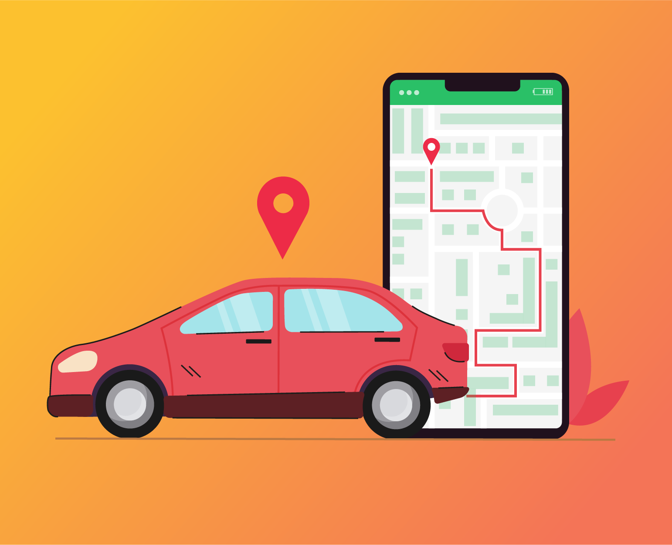

GPS vehicals

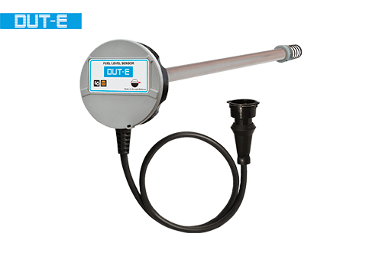

DUT-E fuel level sensor

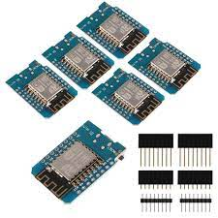

**CONCLUSION:**

This project involves creating an IoT-driven public transportation optimization system by deploying sensors in vehicles to capture real-time location and ridership data. This data is sent to a central platform via a Python script for real-time monitoring, route optimization, and data analysis, enhancing public transportation efficiency and service quality.