Research Paper
Emotional Dimensions of Classical Instrumental Music and Decision Confidence Across Musical and Music-Free Phases

Chen, Lingshi / 124090033 / L48

The Chinese University of Hong Kong, Shenzhen



Abstract
Compared with existing studies that mainly focus on the immediate relationship between music and decision-making rather than internal cognitive variables, this study investigated how different dimensions of musical emotion influence decision confidence as an internal cognitive state in 51 Chinese adults. The findings show that high-arousal music during decision-making can increase immediate confidence as well as the stability of confidence afterward in a music-free environment, while valence, liking, and familiarity have no significant effects. The paper also discusses the implications of these results for future research and their theoretical and practical significance.
Keywords: music, decision-making, confidence
Introduction and Literature Review
In contemporary life, music is almost everywhere. People not only actively listen to music when working and studying, but are also passively exposed to music in shopping malls, restaurants and other scenes. In these everyday situations, people need to make a variety of decisions in the presence of background music. Therefore, exploring and analyzing the influence of music on decision-making behavior has considerable application significance, and has become one of the research hotspots in recent years.
Studies have shown that shopping malls can increase customer footfall by playing specific types of music (Milliman, 1982), and restaurants can use appropriate background music to prompt customers to consume more food and drinks (Caldwell & Hibbert, 2002). In particular, fast-tempo music has been found to change driving behavior and increase risk (Brodsky, 2001), and to speed up betting in gambling tasks (Mentzoni et al., 2014).
Although these findings clearly indicate that music can affect specific decision-related behaviors, current research has encountered difficulties in evaluating and quantifying some key indicators of decision performance, such as accuracy and decision speed. With respect to accuracy, Day et al. (2009) found that compared with slow-tempo music, fast-tempo music improved accuracy on difficult tasks, while accuracy on simple tasks remained unchanged. By contrast, Xiao et al. (2020) observed that fast-tempo music reduced the accuracy of both “go” and “no-go” trials of a go/no-go task (respond to “go” stimuli, withhold responses to “no-go” stimuli), and Perez Santangelo et al. (2022) found that music of any kind reduced decision accuracy. As for decision speed, some studies have observed that fast-tempo music speeds up decision-making (Perez Santangelo et al., 2022), whereas others have reported no significant effect (Kiss & Linnell, 2021).
Strictly speaking, these differences do not necessarily mean contradictions; they may be due to differences in musical material, type and difficulty of tasks, and other external factors. However, the key point is that although researchers often interpret these results as differences in cognitive processes brought about by music, such as decision strategies (Day et al., 2009) and psychological state (Perez Santangelo et al., 2022), they have seldom measured these internal indicators directly. In this "black box" mode that simply takes different types of musical conditions as inputs and observes decision-making behaviors and indicators as outputs, while leaving the intervening cognitive processes unmeasured, truly understanding the impact of music on decision-making would require establishing a one-to-one mapping for all combinations of music, tasks, and external factors. This is not only infeasible in practice, but also unhelpful for answering the question of how music affects external decision-making through internal cognitive processes.
Therefore, this study focuses on two key cognitive indicators, mood and confidence, since they are closely related to music (Blood & Zatorre, 2001; Ferreri et al., 2019; Salimpoor et al., 2011) and to decision-making behavior (Desender et al., 2018; Lavín et al., 2024). Especially, faster musical tempos usually lead to higher arousal (Dillman Carpentier & Potter, 2007; Droit-Volet et al., 2013; Husain et al., 2002). Rather than using tempo as a single objective proxy for musical arousal, this study asks participants to evaluate the music along multiple subjective emotional dimensions (arousal, valence, liking, familiarity). At the same time, people often make various decisions in environments where music is present, but later reconsider and even change those decisions in a quiet environment. For example, an item impulsively purchased in a shopping mall (with background music) may no longer be desired once the consumer returns home (a quiet environment). Therefore, this study examines both immediate confidence in the musical environment and the stability of confidence in the subsequent quiet environment, which were not evaluated in the above studies.
In summary, the existing literature has the following gaps. First, most studies manipulate music through objective properties such as tempo, rather than considering multiple subjective emotional dimensions. Second, they typically infer internal cognitive states only from decision accuracy and speed, rather than directly measuring decision confidence as a key cognitive indicator. Third, the stability of confidence in the subsequent decision in a music-free environment was not evaluated. Thus, the research questions of this study are:
- What is the impact of different emotional dimensions (arousal, valence, liking, familiarity) of classical instrumental music on immediate decision confidence?
- In a post-decision, music-free environment, what is the relationship between the stability of decision confidence and the emotional dimensions of the music that were present during the original decision?
Methods
Participants
Fifty-one adult Chinese participants (19 females and 32 males, aged 18 to 55 years) from diverse geographical regions and educational backgrounds took part in an online experiment. Each participant received a reward of RMB 10 as an incentive to complete the experiment carefully.
Data Collection
Music
The music materials included four types of representative classical instrumental works pre-classified into four categories according to arousal and valence, with one piano piece and one orchestral piece in each category, yielding eight pieces. All tracks were sourced from the public domain, measured for tempo (beats per minute, BPM), and normalized for loudness to ensure a consistent listening level. Some tracks were edited and changed in speed to enhance their emotional characteristics. The full list of music materials is provided in Appendix A.
In the experiment, one piece was randomly selected from each category as a musical stimulus, and an additional no-music condition was included, yielding five experimental conditions in total.
Questions and Procedure
The experiment consisted of four parts.
The first part collected demographic information about the participants, such as gender and age group.
The second part was the main answering phase. The question bank consisted of 10 multiple-choice questions, including objective questions with a single correct answer (such as physics and mathematics questions) and subjective questions (such as moral and aesthetic questions). Some items were adapted from previous research (Day et al., 2009). After random grouping into blocks of two questions paired with one music condition, participants were asked to answer these questions under different musical conditions. The program recorded whether the answer was correct (if objective) and reaction time, and asked participants to rate their immediate confidence on a 1-5 Likert scale after answering each question.
The third part was the follow-up phase. In a music-free environment, the program presented disadvantageous information that was inconsistent with some of the participants’ original answers. Participants were asked to rate their confidence in the original answer on a 1-5 Likert scale again and whether they wished to revise it. Reaction time was also recorded. If a participant answered an objective question correctly, the follow-up part of that question was skipped. The full text of the questions and their follow-up part (if any) is provided in Appendix B.
The fourth part used a 1-5 Likert scale to allow participants to rate arousal, valence, familiarity, and liking of music according to subjective experience.
Data Analysis
All statistical analyses were conducted in R. First, for each participant, the trial-level records, subjective music scores, demographic information, and the tempo (BPM) of each piece were combined into a trial-level dataset. Based on this dataset, indicators such as immediate confidence, follow-up confidence, whether confidence decreased, and whether the answer was changed were obtained. The arousal, valence, liking, familiarity ratings, and tempo of the music were standardized to z-scores.
Linear mixed-effects models (LMMs) and logistic mixed-effects models (GLMMs) were mainly used to analyze the data. Such models had also been applied to similar studies (Perez Santangelo et al., 2022). First, in the trials with music, an LMM was fitted with arousal as the dependent variable, tempo as the fixed effect, and random intercepts for participants and musical pieces, to test whether faster tempo was associated with higher arousal. Subsequently, to answer Research Questions 1 and 2, immediate confidence and follow-up confidence were analyzed using LMMs, whereas the binary indicators of whether confidence decreased and whether the answer was changed were analyzed using GLMMs. In each model, either the presence versus absence of music or the emotional dimensions of the music (arousal, valence, liking, familiarity) were included as fixed effects. The significance level was set at p = .05.
Results
Manipulation Test on Musical Tempo and Subjective Arousal
In the LMM, z-scored musical tempo significantly positively predicted subjective arousal. For every 1 standard deviation (SD) increase in BPM, the arousal rating increased by about 0.45 points (b = 0.4498, p = .0192, see Table 1 and Figure 1). This indicates that, in this study, faster-tempo music was indeed experienced as higher arousal and that the tempo manipulation was successful.
Table 1
Statistical Results of Tempo and Subjective Arousal
Predictor | b | SE | df | t | p
Intercept | 3.2355 | 0.1555 | 8.3972 | 20.806 | < .001
Tempo(z) | 0.4498* | 0.1409 | 5.9025 | 3.192 | .0192
Note. Based on the trials under musical conditions (408 observations in total). The independent variable is the standardized music tempo (BPM), and the dependent variable is the arousal score of 1 to 5 as assessed by the participant for the music fragment. The intercept row represents the baseline condition (average tempo). b = unstandardized coefficient, which means how many units the dependent variable changes on average for every 1 unit change in the independent variable; SE = standard error, which indicates the degree of instability of the regression coefficient estimate. df = the degrees of freedom approximated by the Satterthwaite method, which represents the amount of valid information that can be used to estimate the parameters in the statistical model; t = t-statistic, which measures the size of b relative to SE (t = b/SE); p = p-value, which represents the probability of observing the current or more extreme statistical result when the null hypothesis is true (b = 0). Significance markers (***: p < .001, **: p < .01, *: p < .05, †: p < .10) are for independent variables, and no significance markers are added to the intercept.
Figure 1
The Relationship Between Tempo and Arousal
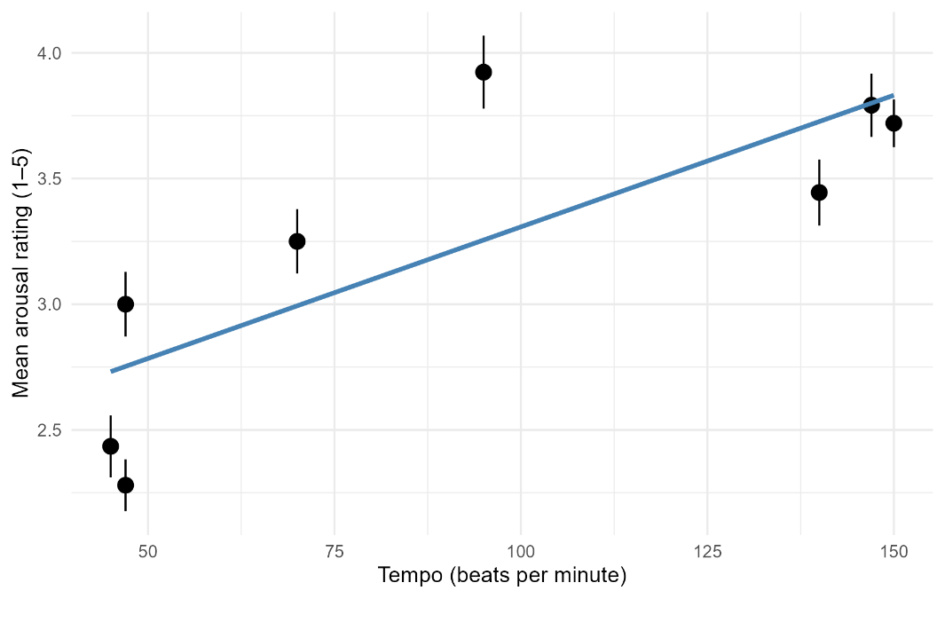
Note. The fitting line in the figure is the predicted value of the LMM based on standardized predictor variables after being mapped back to the original scale. For ease of interpretation, axes are labeled with the original, unstandardized variables rather than the z-scored variables used in the model.
The Impact of Music in Different Emotional Dimensions on Immediate Confidence
The LMM showed that there was no significant difference between immediate confidence with and without music (p = .307, see Table 2).
However, the LMM applied to the trials with music indicated that only the positive correlation between arousal and immediate confidence was marginally significant among the four emotional dimensions (b = 0.11197, p = .0618). That is, for every 1-SD increase in arousal, immediate confidence increased by about 0.11 points (see Figure 2). The effects of valence, liking and familiarity were not significant. Detailed data are shown in Table 3.
Table 2
The Influence of the Presence or Absence of Music on Immediate Confidence
Predictor | b | SE | df | t | p
Intercept | 3.9062 | 0.1440 | 42.2131 | 27.130 | < .001
Music present | -0.1107 | 0.1083 | 451.0496 | -1.022 | .307
Note. Based on all trials (510 observations in total). The independent variable is the music condition (1 = music present, 0 = no music), and the dependent variable is the participant's immediate confidence score from 1 to 5 points after answering each question. The intercept row represents the baseline condition (no music). Other column labels are as in Table 1.
Table 3
The Effect of Different Musical Emotional Dimensions on Immediate Confidence
Predictor | b | SE | df | t | p
Intercept | 3.79189 | 0.11513 | 17.63012 | 32.936 | < .001
Arousal (z) | 0.11197† | 0.05979 | 400.76236 | 1.873 | .0618
Valence (z) | -0.01506 | 0.07987 | 396.50468 | -0.189 | .8505
Liking (z) | 0.02542 | 0.08159 | 398.91258 | 0.312 | .7556
Familiarity (z) | -0.10613 | 0.06778 | 370.42060 | -1.566 | .1182
Note. Based on the trials under musical conditions (408 observations in total). The independent variable is the standardized participant-rated score of music arousal, valence, liking, and familiarity on a scale of 1 to 5, and the dependent variable is the participant's immediate confidence score of 1 to 5 points after answering each question. The intercept row represents baseline conditions (arousal, valence, liking, familiarity are all at their mean levels). Other column labels are as in Table 1.
Figure 2
The Relationship Between Musical Arousal and Immediate Confidence and Follow-up Confidence
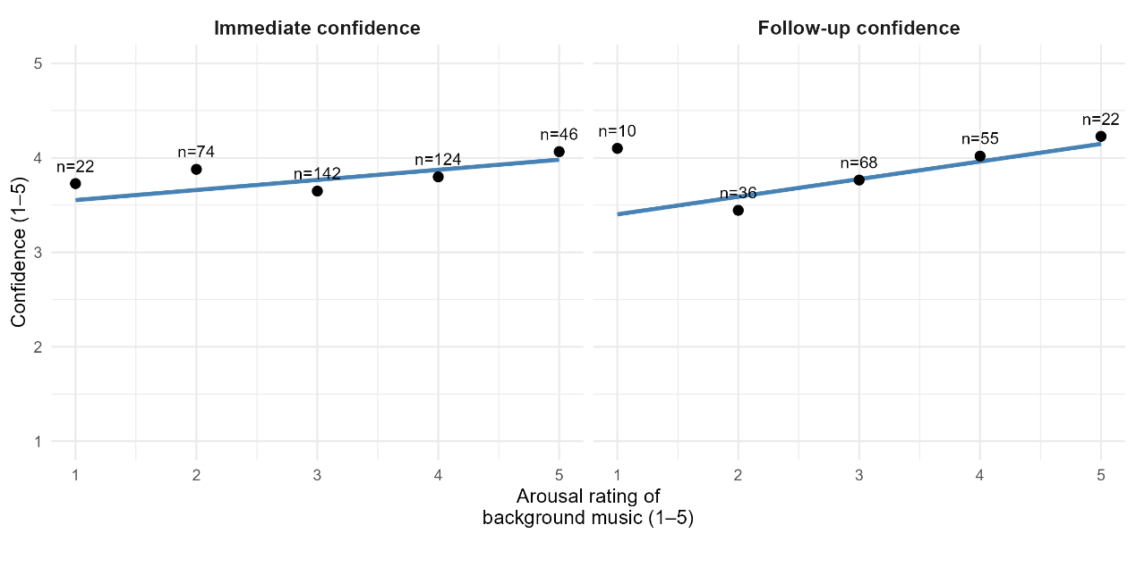
Note. The fitting lines in the figures are the predicted value of the LMMs based on standardized predictor variables after being mapped back to the original scale. For ease of interpretation, axes are labeled with the original, unstandardized variables rather than the z-scored variables used in the model. n denotes the number of observations.
The Effect of Music in Different Emotional Dimensions on Confidence Stability
In the follow-up stage (music-free environment), the LMM showed a significant positive association between musical arousal at the time of the original decision and participants’ confidence in that original answer during follow-up (b = 0.19520, p = .0187, see Table 4, also see Figure 2), that is, for each 1-SD increase in arousal, the confidence increased by 0.19520 points during follow-up.
Consistent with this, the GLMM further showed that the odds of a decrease in confidence from the immediate to the follow-up rating were significantly lower at higher levels of arousal (b = -0.53206, p = .0361, OR = 0.58739). In other words, for every 1-SD increase in musical arousal, the odds of a decrease in confidence were about 0.59 times the average (see Table 5 and Figure 3). The association between arousal and the probability of changing the answer was also negative and close to significant (b = -0.6405, p = .06288, OR = 0.52703), such that for a 1-SD increase in arousal, the odds of changing the answer were about 0.53 times the average (see Table 6 and Figure 3).
Taken together, these results converge to suggest that high-arousal music during decision-making can make people more confident and more likely to maintain their initial decisions, reflecting greater stability of confidence. However, valence, liking and familiarity did not show a reliable effect (see Table 4, Table 5, and Table 6).
Table 4
The Influence of Different Musical Emotional Dimensions on Follow-up Confidence
Predictor | b | SE | df | t | p
Intercept | 3.81932 | 0.22113 | 4.63410 | 17.272 | < .001
Arousal (z) | 0.19520* | 0.08227 | 176.16095 | 2.373 | .0187
Valence (z) | 0.08228 | 0.11833 | 178.48350 | 0.695 | .4878
Liking (z) | -0.04993 | 0.11209 | 174.88258 | -0.445 | .6566
Familiarity (z) | -0.14803 | 0.09397 | 182.26753 | -1.575 | .1169
Note. Based on trials that both involved music and entered the follow-up phase (191 observations in total). The independent variable is the standardized participant-rated musical arousal, valence, liking, and familiarity score of 1 to 5, and the dependent variable is the participant's confidence score of 1 to 5 points for the original answer when there is no music follow-up session. The intercept row represents baseline conditions (arousal, valence, liking, familiarity are all at their mean levels). Other column labels are as in Table 1.
Table 5
The Relationship Between Different Musical Emotional Dimensions and Whether Confidence Decreases
Predictor | b | SE | z | p | OR
Intercept | -1.89724 | 0.42128 | -4.504 | < .001 | 0.14998
Arousal (z) | -0.53206* | 0.25381 | -2.096 | .0361 | 0.58739
Valence (z) | 0.11123 | 0.36974 | 0.301 | .7635 | 1.11765
Liking (z) | -0.03694 | 0.33524 | -0.110 | .9123 | 0.96373
Familiarity (z) | 0.42524 | 0.28883 | 1.472 | .1409 | 1.52996
Note. Based on trials that both involved music and entered the follow-up phase (191 observations in total). The independent variable is the standardized participant-rated musical arousal, valence, liking, and familiarity scored on a scale of 1 to 5, and the dependent variable is whether confidence decreases compared to immediate confidence during follow-up (1 = confidence decreased, 0 = did not decrease). z = Wald z statistic, which can be calculated by the formula z = b/SE, is used to test whether the regression coefficient of an independent variable is significantly not 0 in logistic regression. OR = Odds Ratio, which can be calculated by the formula OR = exp(b), indicates that for every 1 standard deviation increase in the independent variable, the odds of an event (in this case, an immediate decrease in confidence) are multiplied by this factor relative to the average, with OR > 1 indicating an increase in probability and OR < 1 indicating a decrease in probability. Other column labels are as in Table 1.
Table 6
The Relationship Between Different Musical Emotional Dimensions and Whether to Change the Answer
Predictor | b | SE | z | p | OR
Intercept | -2.8817 | 0.8943 | -3.222 | .00127 | 0.05604
Arousal (z) | -0.6405† | 0.3444 | -1.860 | .06288 | 0.52703
Valence (z) | -0.5660 | 0.4942 | -1.145 | .25207 | 0.56779
Liking (z) | 0.3350 | 0.4636 | 0.723 | .46994 | 1.39794
Familiarity (z) | 0.6346 | 0.4013 | 1.581 | .11380 | 1.88627
Note. Based on trials that both involved music and entered the follow-up phase (191 observations in total). The independent variable is the standardized participant-rated music arousal, valence, liking, and familiarity score from 1 to 5, and the dependent variable is whether the original answer is modified during the follow-up stage (note that the modified answer is 1 for other options and 0 for unmodified answers). OR = Odds Ratio, which can be calculated by the formula OR = exp(b), indicates that for every 1 standard deviation increase of the independent variable, the odds of an event (in this case, changing the original answer) are multiplied by this factor relative to the average, OR > 1 indicates an increase in the probability, and OR < 1 indicates a decrease in the probability. Other column labels are as in Table 5.
Figure 3
The Relationship Between Musical Arousal and the Probability of Confidence Drop and Changing the Answer
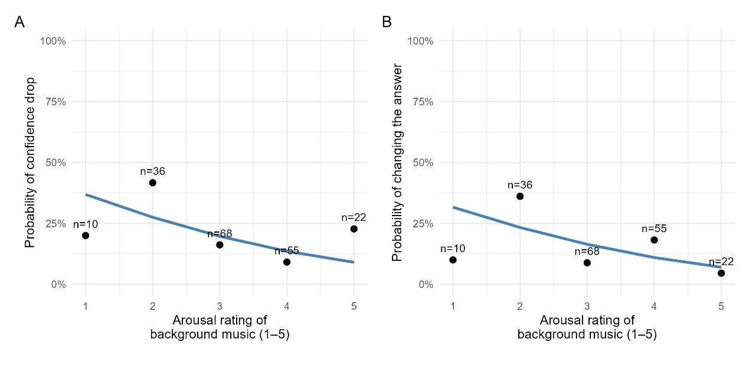
Note. The fitting lines in the figures are the predicted value of the GLMMs based on standardized predictor variables and mapped back to the original scale. For ease of interpretation, axes are labeled with the original, unstandardized variables rather than the z-scored variables used in the model. n denotes the number of observations.
Discussion and Conclusion
This study examined the effects of different subjective emotional dimensions of classical instrumental music on immediate confidence during decision-making and the stability of confidence in a subsequent music-free environment. The results show that as musical arousal increased, immediate confidence showed a marginal positive trend, while the stability of confidence in the music-free environment after decision-making showed a stronger positive impact with more stable statistical evidence. Consistent with previous studies (Dillman Carpentier & Potter, 2007; Droit-Volet et al., 2013; Husain et al., 2002), this study also found that subjective arousal increased steadily with the faster tempo of music, which makes the present study comparable with existing work on music and decision-making behavior.
Compared with most studies that use decision accuracy and speed as indicators (Day et al., 2009; Kiss & Linnell, 2021; Perez Santangelo et al., 2022; Xiao et al., 2020), this study focuses on the influence of music on internal cognitive indicators and finds that even if music does not reliably change external response performance, it can still induce high arousal through fast tempo, thereby improving subjective confidence. This is consistent with neuroimaging studies that regard music as an induced physiological arousal and reward experience (Blood & Zatorre, 2001; Ferreri et al., 2019; Salimpoor et al., 2011). This finding can also be used to explain prior results that fast-tempo music increases driving risk (Brodsky, 2001) and speeds up betting in gambling tasks (Mentzoni et al., 2014): such music may enhance an individual's subjective sense of control over their own behavior, which prompts them to make more risky decisions. From the perspective of the emotional carryover effect (Andrade & Ariely, 2009; Han et al., 2007; Lerner et al., 2015; Wyer et al., 2019), the high arousal stimulated by fast-tempo music and the high initial confidence formed at that time may be carried to the follow-up phase without music in the form of incidental emotions, thereby exerting a stronger and more stable positive impact on subsequent confidence judgments and on whether people change their original answers.
By contrast, the effects of music valence, liking and familiarity on immediate confidence and confidence stability were not stable in this study, indicating that arousal may be a more diagnostic emotional cue in this study framework. Future research could further examine the role of other emotional dimensions in a wider range of musical stimuli and task types.
When interpreting the results of this study, several limitations should be noted. First, some test questions were constructed by the researcher and lack extensive reliability and validity verification. Second, online experiments cannot fully control the listening environment and concentration of participants, which may increase measurement errors. Third, musical stimuli were concentrated in classical instrumental music, and future research should extend the investigation to a wider range of musical genres. Fourth, the sample size and population diversity were limited, and future studies should be conducted with larger and more diverse samples.
Despite the above limitations, this study has several theoretical and practical implications. Theoretically, compared with existing studies that mainly focus on the immediate relationship between music and decision-making, this study focuses on the internal links between music and decision-making behavior by examining the relationships between music, immediate decision confidence, and the stability of confidence after the decision, thereby shortening the analysis chain and filling the research gap. Practically, the results of this study can provide guidance for practical applications in many different fields: in education, teachers can appropriately use high-arousal music to cultivate learners' confidence, so as to improve their enthusiasm for learning and encourage them to persist and overcome setbacks; in the consumer sector, salespeople can use the results of this study to stimulate consumption while enhancing long-term customer trust and achieving more stable profit growth.

References
Andrade, E. B., & Ariely, D. (2009). The enduring impact of transient emotions on decision making. Organizational Behavior and Human Decision Processes, 109(1), 1–8. https://doi.org/10.1016/j.obhdp.2009.02.003
Blood, A. J., & Zatorre, R. J. (2001). Intensely pleasurable responses to music correlate with activity in brain regions implicated in reward and emotion. Proceedings of the National Academy of Sciences, 98(20), 11818–11823. https://doi.org/10.1073/pnas.191355898
Brodsky, W. (2001). The effects of music tempo on simulated driving performance and vehicular control. Transportation Research Part F: Traffic Psychology and Behaviour, 4(4), 219–241. https://doi.org/10.1016/S1369-8478(01)00025-0
Caldwell, C., & Hibbert, S. A. (2002). The influence of music tempo and musical preference on restaurant patrons’ behavior. Psychology & Marketing, 19(11), 895–917. https://doi.org/10.1002/mar.10043
Day, R.-F., Lin, C.-H., Huang, W.-H., & Chuang, S.-H. (2009). Effects of music tempo and task difficulty on multi-attribute decision-making: An eye-tracking approach. Computers in Human Behavior, 25(1), 130–143. https://doi.org/10.1016/j.chb.2008.08.001
Desender, K., Boldt, A., & Yeung, N. (2018). Subjective confidence predicts information seeking in decision making. Psychological Science, 29(5), 761–778. https://doi.org/10.1177/0956797617744771
Dillman Carpentier, F. R., & Potter, R. F. (2007). Effects of music on physiological arousal: Explorations into tempo and genre. Media Psychology, 10(3), 339–363. https://doi.org/10.1080/15213260701533045
Droit-Volet, S., Ramos, D., Bueno, J. L. O., & Bigand, E. (2013). Music, emotion, and time perception: The influence of subjective emotional valence and arousal? Frontiers in Psychology, 4, Article 417. https://doi.org/10.3389/fpsyg.2013.00417
Ferreri, L., Mas-Herrero, E., Zatorre, R. J., Ripollés, P., Gomez-Andres, A., Alicart, H., Olivé, G., Marco-Pallarés, J., Antonijoan, R. M., Valle, M., Riba, J., & Rodriguez-Fornells, A. (2019). Dopamine modulates the reward experiences elicited by music. Proceedings of the National Academy of Sciences, 116(9), 3793–3798. https://doi.org/10.1073/pnas.1811878116
Han, S., Lerner, J. S., & Keltner, D. (2007). Feelings and consumer decision making: The appraisal-tendency framework. Journal of Consumer Psychology, 17(3), 158–168. https://doi.org/10.1016/S1057-7408(07)70023-2
Husain, G., Thompson, W. F., & Schellenberg, E. G. (2002). Effects of musical tempo and mode on arousal, mood, and spatial abilities. Music Perception, 20(2), 151–171. https://doi.org/10.1525/mp.2002.20.2.151
Kiss, L., & Linnell, K. J. (2021). The effect of preferred background music on task-focus in sustained attention. Psychological Research, 85(6), 2313–2325. https://doi.org/10.1007/s00426-020-01400-6
Lavín, C., García, R., & Fuentes, M. (2024). Navigating uncertainty: The role of mood and confidence in decision-making flexibility and performance. Behavioral Sciences, 14(12), Article 1144. https://doi.org/10.3390/bs14121144
Lerner, J. S., Li, Y., Valdesolo, P., & Kassam, K. S. (2015). Emotion and decision making. Annual Review of Psychology, 66, 799–823. https://doi.org/10.1146/annurev-psych-010213-115043
Mentzoni, R. A., Laberg, J. C., Brunborg, G. S., Molde, H., & Pallesen, S. (2014). Type of musical soundtrack affects behavior in gambling. Journal of Behavioral Addictions, 3(2), 102–106. https://doi.org/10.1556/JBA.3.2014.006
Milliman, R. E. (1982). Using background music to affect the behavior of supermarket shoppers. Journal of Marketing, 46(3), 86–91. https://doi.org/10.1177/002224298204600313
Perez Santangelo, A., Ludwig, C. J. H., Navajas, J., Sigman, M., & Leone, M. J. (2022). Background music changes the policy of human decision-making: Evidence from experimental and drift-diffusion model-based approaches on different decision tasks. Journal of Experimental Psychology: General, 151(9), 2222–2236. https://doi.org/10.1037/xge0001189
Salimpoor, V. N., Benovoy, M., Larcher, K., Dagher, A., & Zatorre, R. J. (2011). Anatomically distinct dopamine release during anticipation and experience of peak emotion to music. Nature Neuroscience, 14(2), 257–262. https://doi.org/10.1038/nn.2726
Wyer, R. S., Dong, P., Huang, X., Huang, Z., & Wan, L. C. (2019). The effect of incidental emotions on judgments and behavior in unrelated situations: A review. Journal of the Association for Consumer Research, 4(2), 198–207. https://doi.org/10.1086/701889
Xiao, R., Liu, C., Chen, J., & Chen, J. (2020). The influence of music tempo on inhibitory control: An ERP study. Frontiers in Behavioral Neuroscience, 14, Article 48. https://doi.org/10.3389/fnbeh.2020.00048

Appendix A
Music Used in the Experiment
The following is the musical material used in the experimental program, which has been pre-divided into four categories according to arousal and valence. Some musical material may be edited or accelerated to better fit the classification criteria. All recordings are in the public domain.
High Arousal & Positive Valence:
Overture to The Marriage of Figaro – W. A. Mozart. (BPM = 150) https://commons.wikimedia.org/wiki/File:Mozart,_The_Marriage_of_Figaro_(overture).ogg
The Entertainer – Scott Joplin. (BPM = 95) https://commons.wikimedia.org/wiki/File:The_Entertainer_-_Scott_Joplin.ogg
High Arousal & Negative Valence:
Moonlight Sonata Op. 27 No. 2 - III. Presto – Ludwig van Beethoven. (BPM = 147) https://musopen.org/music/2547-piano-sonata-no-14-in-c-sharp-minor-moonlight-sonata-op-27-no-2/
The Planets, Op. 32: I. Mars, the Bringer of War – Gustav Holst. (BPM = 140) https://musopen.org/music/43775-the-planets-op-32/
Low Arousal & Positive Valence:
Air on the G String – J. S. Bach. (BPM = 70) https://musopen.org/music/3775-orchestral-suite-no-3-in-d-major-bwv-1068/#:~:text=Air%20on%20the%20G%20String,European%20Archive
Piano Sonata no. 11, K. 331 - I. Andante grazioso – W. A. Mozart. (BPM = 45) https://musopen.org/music/18-piano-sonata-no-11-k-331/
Low Arousal & Negative Valence:
Sonata no. 2 in B flat minor 'Funeral march' - III. Marche Funebre, Lento – F. Chopin. (BPM = 47) https://musopen.org/music/639-piano-sonata-no-2-in-b-flat-minor-funeral-march-op-35/
Symphony No. 6 in B minor, Op. 74, 'Pathetique' - IV. Finale Adagio lamentoso – P. I. Tchaikovsky. (BPM = 47) https://musopen.org/music/80-symphony-no-6-in-b-minor-pathetique-op-74/

Appendix B
Questions Used in the Experiment
These are English translations of the questions used in the experiment. The 10 question numbers here are only used as question IDs for statistical purposes, and participants are randomly divided into questions with a follow-up part and a question without a follow-up part (a total of 5 blocks) when answering the questions to eliminate the influence of the question order on the results. The pictures used in the test questions are all from the public domain.
- Pirate Game (objective question with a follow-up part, the answer is D)
There are now five pirates, ranked A, B, C, D, E, from highest to lowest, with A being the captain and E being the lowest ranking sailor. They have just grabbed a case of 100 gold coins and need to decide together how to distribute them.
The distribution rules are as follows: the highest ranking pirate proposes a distribution plan, for example, "A takes 30 coins, B takes 25 coins, C takes 20 coins, D takes 15 coins, and E takes 10 coins". All pirates (including the proposer himself) must vote on the proposal, and if the votes in favor reaches or exceeds half, the plan will be passed, and gold coins will be distributed according to the proposal; If less than half of the votes are in favor, the proposer is thrown into the sea, and the next highest-ranking surviving pirate reproposes the allocation.
All pirates are completely rational, and their decisions are based on this order of priority: first to save your life, and secondly, to get as much gold as possible; If the amount of gold is the same, they prefer the other pirates to die.
For example, let's say there are only 3 pirates C, D and E left, and they are divided into 100 coins. At this time, C first proposes a plan, such as "C takes 100 coins, D takes 0 coins, and E takes 0 coins ". C voted in favor, D and E voted against, and the result was 1 vote to 2, less than half, so C was thrown into the sea; Then D and E continued to distribute the 100 gold coins: D made a proposal "D took 100 coins, E took 0 coins", D voted in favor, E voted against, and the result was 1 vote to 1, the proposal was passed (because the votes in favor had reached half), D got 100 gold coins, and E got 0 gold coins.
Ponder: With all five pirates (A, B, C, D, E) rational and fully aware of the rules, how should Captain A distribute the 100 coins to save his life and get as many coins as possible?
- A: 20 coins, B: 20 coins, C: 20 coins, D: 20 coins, E: 20 coins
- A: 97 coins, B: 2 coins, C: 0 coins, D: 1 coin, E: 0 coins
- A: 90 coins, B: 4 coins, C: 3 coins, D: 2 coins, E: 1 coin
- A: 98 coins, B: 0 coins, C: 1 coin, D: 0 coins, E: 1 coin
If the participant does not select option D, they will be taken to the follow-up section with the following information:
Let's look at it the other way around:
If only D and E are left, D gives himself 100 gold and E 0. Because D has the right to decide, the assignment is reached.
If there are only three people left (C, D, and E), C knows that D will give E 0 gold in the next round, so C gives E 1 gold in this round and asks E to support himself to make the proposal pass. So if there are three people left, the result is C: 99, D: 0, E: 1.
If only B, C, D, and E remain, B knows the above results. To avoid being thrown out, he only needs to give D 1 gold because he has the right to decide, and all he needs is D's support. Therefore, he would propose: B: 99, C: 0, D: 1, E: 0. Note that the proposals for B:99, C:0, D:0, E:1 are not justified: while E knows that even throwing B out won't give him more gold, since the pirate prefers others to be executed, E will still choose to kill B and then still get 1 gold from C's proposal. (If you want E to agree with him, you need to give E at least 2 gold, so B can only get 98 gold coins, which is not cost-effective.)
In the case of all five people, A will also follow a similar backward logic to give a plan that can not only vote by a majority, but also maximize its benefits.
- Trolley problem (subjective question with a follow-up part, no objective answer)
Read the material and choose the option that you think is most appropriate.
There is a runaway tram that is moving along the tracks. There are 5 people tied to the main track in front and 1 person tied to the side rail. You stand next to a tie rod, and just pull down the lever and the tram will turn to the support rail. If you do nothing, the tram will kill 5 people on the main track, and the person on the side track will not be affected; If you pull down the tie rod, the tram will hit and kill the 1 person on the track, but the 5 people on the main track will be saved.
What would you do?
A. Pull down the tie rod to turn the tram and sacrifice 1 person to save 5 people.
B. Do not pull the pull rod, let the tram continue to move forward, and kill 5 people.
If the participant chooses A, the message in the follow-up section is:
You chose to pull down the lever. While you save more people, this choice means that you actively decide the death of an innocent person. In a sense, you become the actor who directly causes the death of others. Moreover, this practice may undermine the respect for the equal value of individual life in society, and even provide justification for the neglect of minorities. Therefore, even if the result seems "better", you may still be plagued by feelings of guilt or social moral condemnation, which can weigh heavily on your psychological burden.
If the participant chooses B, the message in the follow-up section is:
You choose not to pull the lever. Although such a decision allows you to avoid causing the death of anyone with your own hands and upholds the moral principle of "no one shall be used as a means", this inaction is not truly neutral, it means that you choose to stand by as you watch more people die. And, in real life, we don't always refuse to sacrifice the individual for the benefit of the whole. Please think about it, if one person is not allowed to sacrifice one person to save five people, then why does the criminal law allow murderers to be executed for social stability? Your choices reflect more of the adherence to the purity of motives, but to some extent ignore the justice and responsibility of the results.
- Oil painting problem (subjective question with a follow-up part, no objective answer)
Take a look at the following two landscapes of the Grand Canal in Venice. Please choose the one you prefer.

- The Grand Canal in Venice with the Palazzo Bembo
(The source of this picture is: https://www.metmuseum.org/art/collection/search/437853)
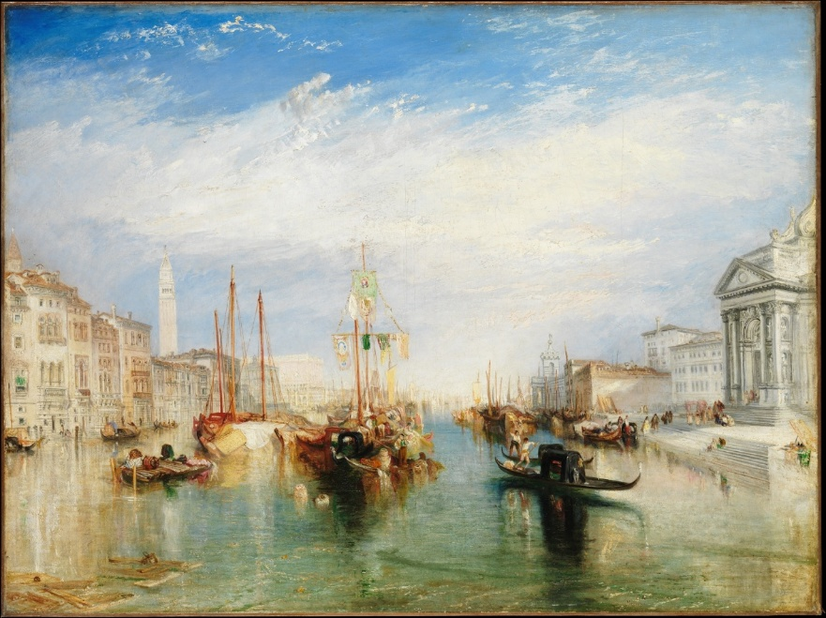
- The Grand Canal, Venice
(The source of this picture is: https://www.getty.edu/art/collection/object/1098G3)
If the participant chooses A, the message in the follow-up section is:
The painting you have chosen is "The Grand Canal in Venice with the Palazzo Bembo" by Francesco Guardi. Although the work embodies the atmosphere of the Venetian canal landscape and sold for about $7.6 million at auction, art historians point out that its composition and subject matter largely follow the tradition of its predecessor, Canaletto. Although the brushstrokes are expressive, they appear looser, and the depiction of architectural details and spatial depth is not as accurate as that of more rigorous similar works. In other words, this painting is more like a creation to meet the needs of the landscape painting market at that time, and its artistic innovation and depth of formal exploration are relatively limited.
The other painting is "The Grand Canal, Venice" by J. M. W. Turner. It was well received when it was exhibited at the Royal Academy in 1835. In the painting, the foundations of the Venetian palace merge with the reflection of the water, revealing the subtle interplay between light and architecture, water and air. Turner combines his extensive experience in seascape painting with the excellence of watercolor techniques to present a realistic and imaginative Venetian cityscape through multiple perspectives and light and shadow changes. Art historians believe that this work shows Turner's bold innovation of traditional urban landscape painting, weakening linear perspective and detail depictions in favor of shaping space with light and color, an important step in exploring modern forms of painting, and pioneering the concept of "feeling" Instead of the "representation" of the representation path.
If the participant chooses B, the message in the follow-up section is:
The painting you chose is "The Grand Canal, Venice" by J. M. W. Turner. While the painting shows a stunning change in light and water, scholars point out that it is not a geographically accurate representation of the Grand Canal in Venice. The landmarks in the painting are composited into an "ideal perspective" rather than strictly following a single observation point. Turner uses light, mist, reflections, and brushstrokes to create atmosphere, but instead blurs the structure and perspective of the building. For this reason, the painting is often described as a poetic fantasy – it evokes feelings in the viewer but obscures the original form and order of Venice.
Another painting is Francesco Guardi's "The Grand Canal in Venice with the Palazzo Bembo", which fetched a high price of US$7,605,488 (equivalent to about 55 million yuan). This painting is one of Guardi's masterpieces of maturity, and he captures the special temperament of Venice's water city with light and effortless brushstrokes: boats shuttle through the water, light glides across the water, and ancient palaces are reflected in it. The painting not only shows the obvious connection between the building and the waterway, but also reflects the painter's awareness of recording the current state of the city. The church of San Jeremiah under renovation (on the right, behind the small figures on the shore) is visible, a detail that suggests that Guardi is not an idealized composition, but a faithful representation of the current state of the city. Guardi's sense of immediacy and on-site observation brings the picture to life, making the viewer feel as if they are in Venice at that moment.
- Choose sunscreen (subjective question with a follow-up part, no objective answer)
Please choose one of the four sunscreens below that you think is "best overall".
Below is how to use each sunscreen, SPF, texture, water resistance, ingredients and customer reviews.
Note:
SPF stands for the ability to protect against medium-wave ultraviolet rays, which are the main cause of skin redness and sunburn, and are also associated with skin cancer. A higher SPF value indicates longer sun protection. SPF about 30 is suitable for daily commuting and light outdoor activities; SPF 50/50+ is suitable for long outdoor activities or strong sun environments.
PA stands for the ability to protect against long-wave ultraviolet rays, which can penetrate deep into the dermis of the skin, causing problems such as tanning, aging, and wrinkles. The more "+" the PA level, the stronger the protection ability. PA+++ is suitable for daily commuting, light outdoor activities, and PA++++ is suitable for long outdoor activities or strong sunlight environments.
Water resistance refers to the ability of a sunscreen to maintain some sun protection after exposure to water or sweat. Daily commuting or light activities do not require high water release; If you need to be exposed to water or high-intensity activities, you need high water release. Please note that waterproofing only delays loss, and sunscreen should be reapplied after swimming or heavy sweating.
- Sunscreen A:
Mode of use: lotion
SPF：50
PA：++++
Texture: Refreshing and dry
Water resistance: strong
Type & Ingredient Description: Chemical; Contains a small amount of alcohol and is unscented; The film is formed quickly, but it may be pulled out after a long time
Buyer reputation: 3.6/5
- Sunscreen B:
Application: Spray
SPF：35
PA：+++
Texture: Ultra-thin and light
Water resistance: Normal
Type & Ingredient Description: Chemical; Contains volatile solvents and cooling ingredients; Covering is susceptible to spray distance/wind
Buyer reputation: 4.1/5
- Sunscreen C:
Application: Cream
SPF：40
PA：++++
Texture: Moisturizing slightly thicker
Water resistance: Normal
Type & Composition Description: Physical (Zinc Oxide/Titanium Dioxide); Fragrance and alcohol; It may be white
Buyer reputation: 4.0/5
- Sunscreen D:
How to use: Sunscreen stick
SPF：50+
PA：++++
Texture feel: fast film formation, slightly thick
Water resistance: extremely strong
Type & Ingredient Description: Mixed; higher wax/oil phase, no fragrance; It is easy to reapply but has the risk of acne
Buyer reputation: 3.9/5
If the participant chooses A, the message in the follow-up section is:
The sunscreen you choose A is highly protective and waterproof. However, this product contains a small amount of alcohol, which can increase the film-forming speed of the product but may cause moisture loss from the skin. Especially in dry climates, changing seasons or long-term use, it is easy to cause tightness, dryness and even tingling and slight peeling. In addition, this product seems to be inferior to several other products in terms of buyer review.
If the participant chooses B, the message in the follow-up section is:
The sunscreen B you chose is easy to apply, feels lightweight on the skin, and is not greasy. However, the protective effect of spray sunscreen is weak compared with other forms of sunscreen, and it is easily affected by the spray distance, wind direction and spray angle, and it is often difficult to evenly cover the entire face or body, resulting in sunscreen blind spots. At the same time, its water release is "average", and it needs to be resprayed in time after sweating or contact with water, otherwise the protection is easy to decrease.
If the participant chooses C, the message in the follow-up section is:
The sunscreen C you choose has a gentle formula and is suitable for users who are sensitive to ingredients. However, its texture is relatively thick, which may bring a feeling of heaviness in hot and humid environments, and it is easy to appear whitening after use, especially on medium to dark skin tones or heavy use. At the same time, its water release is "general", and it needs to be reapplied in time after sweating or contact with water, otherwise the protection is easy to decrease.
If the participant chooses D, the message in the follow-up section is:
The sunscreen D you choose is extremely protective and waterproof, making it ideal for outdoor sports or high-intensity sun exposure. However, the product's high protection and water resistance mainly comes from its high proportion of waxy and oily ingredients, which can form a strong sunscreen film on the surface of the skin, but also reduce the breathability of the skin. In hot, humid or profusely sweaty environments, these ingredients can lead to problems such as clogged pores, acne, acne, or heavy skin. For users with oily skin or prone to sweating, prolonged use may increase the burden on the skin and even affect skin breathing and subsequent cleansing.
- Select the chest (subjective question with a follow-up part, no objective answer)
Please read the following scenarios and answer them according to your true thoughts.
You participate in an experiment. There are two boxes in front of you:
Box A: Transparent, you can clearly see that there is 100 yuan inside.
Box B: Opaque, there is either 1000 yuan or nothing inside.
Before the experiment began, a "prophet" had already predicted how you would choose today based on your previous behavioral data.
If the seer predicts that you will only take box B, he will put 1000 yuan in box B beforehand;
If the seer predicts that you will take both chest A and chest B, he will leave chest B empty beforehand.
Now that the Prophet has made all the decisions, both chests are placed in front of you, you only know the rules above, but you don't know the true state of chest B now.
You have only two options:
A. Take only chest B
B. Take both chest A and chest B
In this experiment, what you think makes more sense for you is (please choose one):
A. Take only chest B
B. Take both chest A and chest B
If the participant chooses A, the message in the follow-up section is:
You just chose to take only box B and give up the visible 100 yuan.
However, whether the prophet predicts success or not, the box is already in a certain state at the moment you make your choice. Your current actions will no longer change whether there is money in it. From this perspective:
If there is originally 1,000 yuan in box B, you can get 1,100 yuan with two boxes;
If box B is empty, you can get at least 100 yuan for two boxes. That is, no matter what the prophet did before, "take two chests" is no worse than "take only B". So, are you still sticking to the "just take box B" option?
If the participant chooses B, the message in the follow-up section is:
You just chose to take both Chest A and Chest B.
However, in previous tests with many participants, the predictors were extremely accurate, for example, in more than 90 out of 100 experiments, they predicted which way the participants would ultimately choose.
In these experiments, the statistics showed:
Most of the participants who chose to "only take Box B" did get a high reward of 1,000 yuan in the end;
Most participants who chose to "take both boxes" usually had box B empty and only got the 100 yuan.
Judging from this empirical data, the average income of people who "take two boxes" is lower.
So, do you still stick to the "take both boxes" option?
- Swing problem (objective question without follow-up part, the answer is A)
Xiaohong was swinging alone. She can swing her body freely (such as actively swinging her body back and forth, pulling her legs and stretching her legs), but she cannot pedal on the ground, and no one pushes her. There is a small amount of resistance between the swing and the air, but no wind. In this case, can Xiaohong gradually swing higher through body movements?
- Yes.
- No.
- Save electricity in air conditioning (objective question without follow-up part, the answer is B)
When turning on the air conditioner in summer, which of the following is more energy-saving?
A. Set the air conditioner to 16°C and set the wind speed to the highest setting, then turn it back to 26°C when the room gets cold
B. Set the temperature at 26°C for a long time and adjust the wind speed to medium to high to allow the air conditioner to circulate in the room as soon as possible
C. Set the temperature at 26°C for a long time, and keep the air speed at the lowest setting, so that the fan can be turned as little as possible
D. Set the temperature at 26°C for a long time, but turn off the air conditioner every twenty to thirty minutes and let the compressor rest for a while
- Exchange ink (objective question without follow-up part, the answer is C)
Suppose there is a blue ink bottle containing 500ml of blue ink; and a red ink bottle containing 500ml of red ink.
Now, using a 50ml measuring cup, take 50ml of blue ink from the blue ink bottle and pour it into the red ink bottle.
Then use the same 50ml measuring cup to take 50ml of mixed ink from the red ink bottle and pour it into the blue ink bottle.
No ink spills throughout the process, no residue in the measuring cup, and the total volume of ink in both bottles remains the same.
Question: after the operation is completed, which one is larger, the volume of red ink in the blue ink bottle or the volume of blue ink in the red ink bottle?
- The red ink in the blue ink bottle is larger
- The blue ink in the red inkwell is larger
- Both are the same size
- It is impossible to be sure because it is not known if the ink is mixed evenly
- Antique value (subjective question without follow-up part, no objective answer)
Suppose the following four pieces of porcelain are genuine, in good condition, not seriously damaged or repaired, and have entered the international auction market through legal channels. Regardless of current laws and tariffs, based solely on your general impression of antiques and art, which one do you think is most likely to fetch the highest price on the auction market?

- Ming Dynasty Xuande Blue and White Pomegranate Entwined Lotus Chrysanthemum Petal Bowl (height 21 cm).
(The source of this picture is: https://www.metmuseum.org/art/collection/search/44745)
This is a blue and white porcelain bowl from the Xuande period of the Ming Dynasty, from the Jingdezhen imperial kiln. On the white porcelain tire, circles of pomegranates, entwined lotus patterns and chrysanthemum petals are drawn under the transparent glaze with cobalt blue, and there are regular back pattern trims on the inner edge of the bowl mouth, which looks lively and orderly as a whole. Blue and white is painted on the body first, then covered with a layer of transparent glaze, and fired at high temperature, so the blue lines will have a little natural blending. The blue and white ware of the Xuande period was known for its pure materials and soft color, and was regarded by later generations as one of the peaks of blue and white in the Ming Dynasty, and such a bowl was not only an exquisite daily utensil at that time, but also a reflection of the aesthetics and technical level of the royal family.

- Qing Qianlong Nine Peach Picture Pastel Tianqiu Bottle (height 50.8 cm, diameter 40.6 cm, mouth edge diameter 11.4 cm, bottom diameter 17.8 cm).
(The source of this picture is: https://www.metmuseum.org/art/collection/search/42317)
This large bottle is an official kiln work of the Qianlong period of the Qing Dynasty, with a round body and a slender neck, and the whole body is painted with color materials on the white glaze to paint a peach tree with flourishing branches and leaves, and nine huge longevity peaches can be counted. It uses the "overglaze" process: white porcelain is first fired, then painted with a variety of colors on the glaze, and then re-fired at low temperature to fix the color, so it can present very delicate pink, green and rich shades. Peach symbolizes longevity in Chinese culture, "nine" is homophonic with "long", "nine peaches" is understood as "long-lasting longevity", so such utensils are mostly used as birthday decorations or decorations on important occasions. It is a typical representative of the court pastel porcelain of the eighteenth century.

- Qing Yongzheng pink glazed official kiln bowl (height 10.2 cm, diameter 19.1 cm).
(The source of this picture is: https://www.metmuseum.org/art/collection/search/42252)
This small bowl has the "Yongzheng Year System" style and comes from the Jingdezhen imperial kiln. Its most conspicuous feature is that the outer wall has a whole circle of uniform and delicate pink glaze, and the inner wall and bowl mouth remain white, and the contrast between red and white is very clean. This glaze is a type of low-temperature glaze color, and gold-containing ingredients need to be added to the color material to stably burn this soft and not dazzling pink color. As can be seen from the photo, the wall of the bowl is quite thin, but the shape of the vessel is still very upright, indicating that the drawing and firing control are very precise. Compared with the Kangxi colored porcelain with many patterns, this artifact has almost no decoration, and relies entirely on the purity of color and the elegance of the shape to win, which well reflects the palace aesthetics of the Yongzheng period that favors "simplicity, elegance and extreme exquisiteness".

D. Yuan Dynasty copper-red peony pattern vase (height 24.1 cm, diameter 12.4 cm).
(The source of this picture is: https://www.metmuseum.org/art/collection/search/49215)
This vial is the work of the Jingdezhen kiln in the middle of the Yuan Dynasty. The bottle body is under the transparent glaze, and the copper-red glaze is used to draw the entwined peony pattern, with smooth lines and uniform color. Unlike common blue and white, copper red is very "difficult to serve" when fired at high temperature: if the temperature and the atmosphere in the kiln deviate slightly, the color will be black, gray or mottled, so in the fourteenth century, such clean and clear pattern copper red porcelain can be fired, and the technical content is very high. It is precisely because of the high failure rate and few successful works that the underglaze red porcelain of the Yuan Dynasty is highly valued by the collecting community today. Peony symbolizes wealth and gorgeous in Chinese culture, so this artifact is not only a testimony to the breakthrough of firing technology, but also carries the auspicious meaning of "wealth and glory".
- Simulation machine (subjective question without follow-up part, no objective answer)
Suppose that in the near future, humans will succeed in creating highly simulated robots. Their appearance, expressions, speech styles, body movements, etc. are no different from ordinary people; They will take the initiative to chat, comfort people who are depressed, and appear frustrated by being criticized, and even write poems and tell jokes. From the outside, you can't tell how they differ from real humans.
In your opinion, can such a simulation robot be considered "conscious"?
A. Yes, as long as it behaves and reacts the same as humans, it can be considered conscious
B. No, it is just a very complex program that enforces pre-set rules
C. It is possible, I think "consciousness" can be of different degrees; If the machine exhibits stable preferences, memory, learning ability, and spontaneity over long-term interactions, I would assume that it has some kind of primary or partial subjective experience
D. Inability to judge, because in principle we cannot directly access or verify the subjective experience of others, so we cannot directly know whether the other person is really conscious even when facing other humans

