LAB Logbook

Lab 1
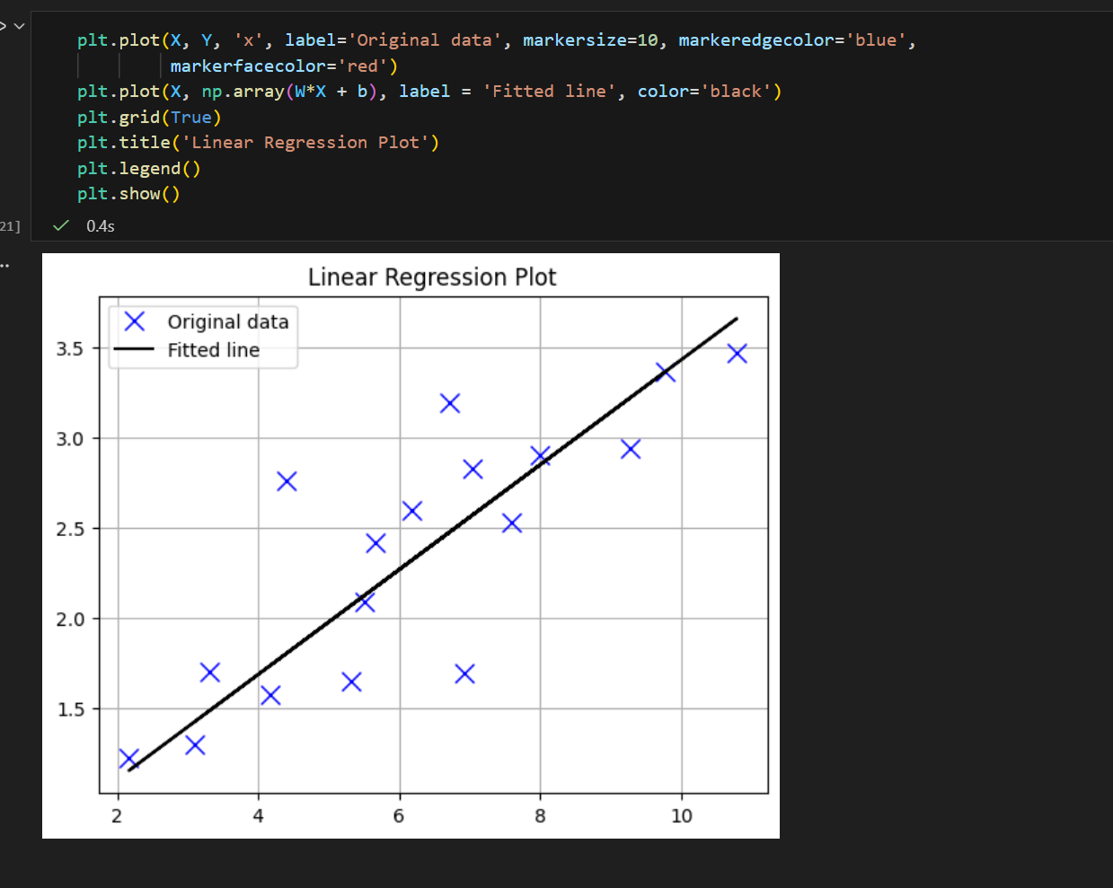
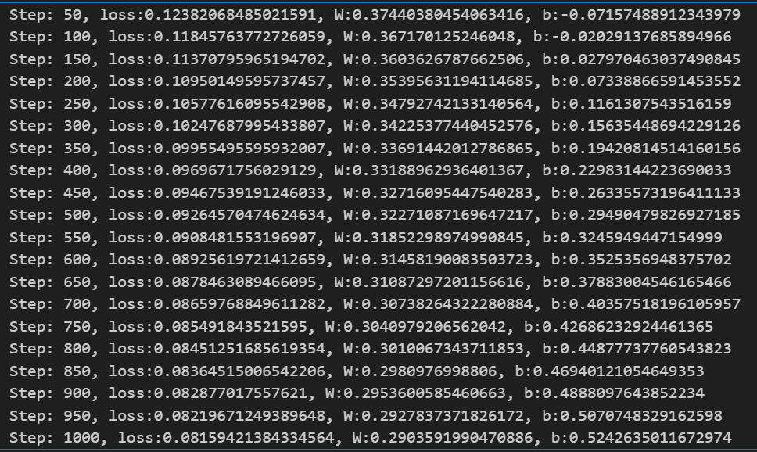

Lab 2
Model Accuracy -0.957
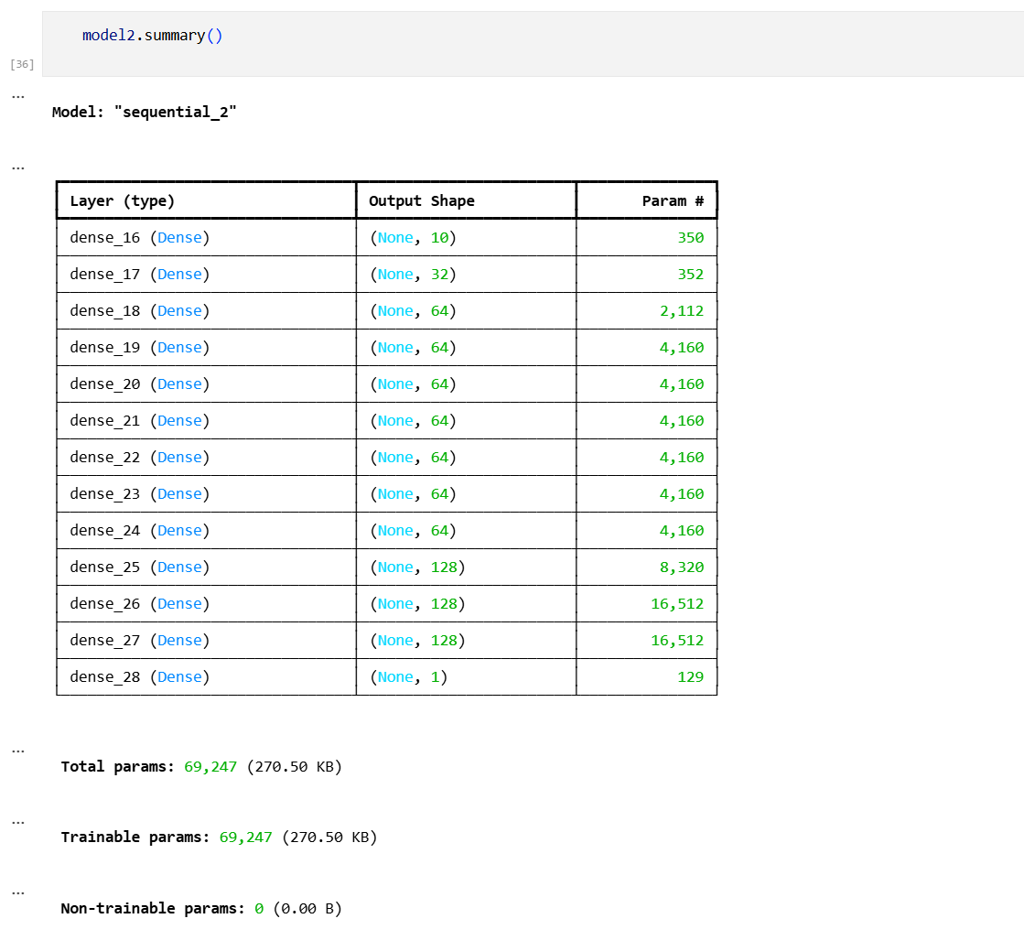
Solution from task 2- 0.8

Lab 3
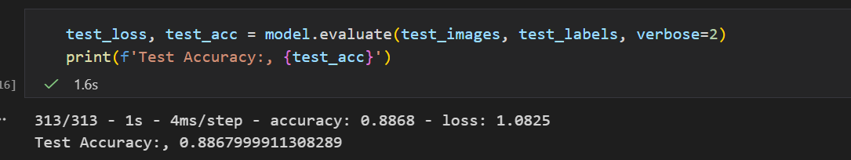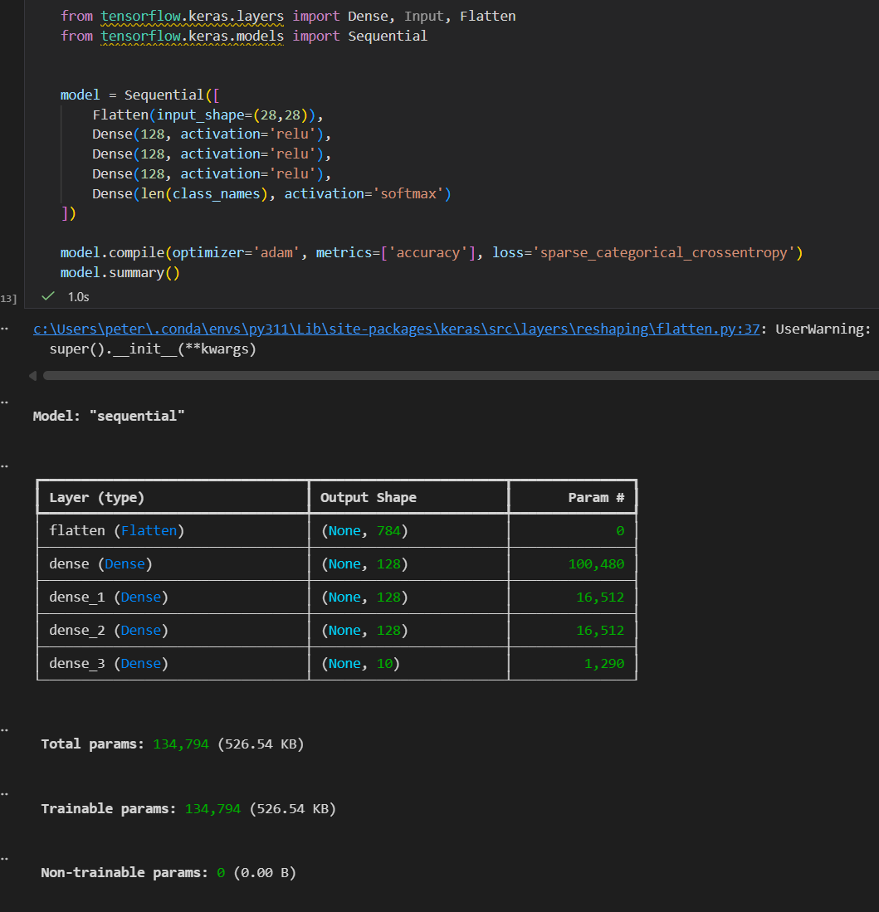

Lab 4
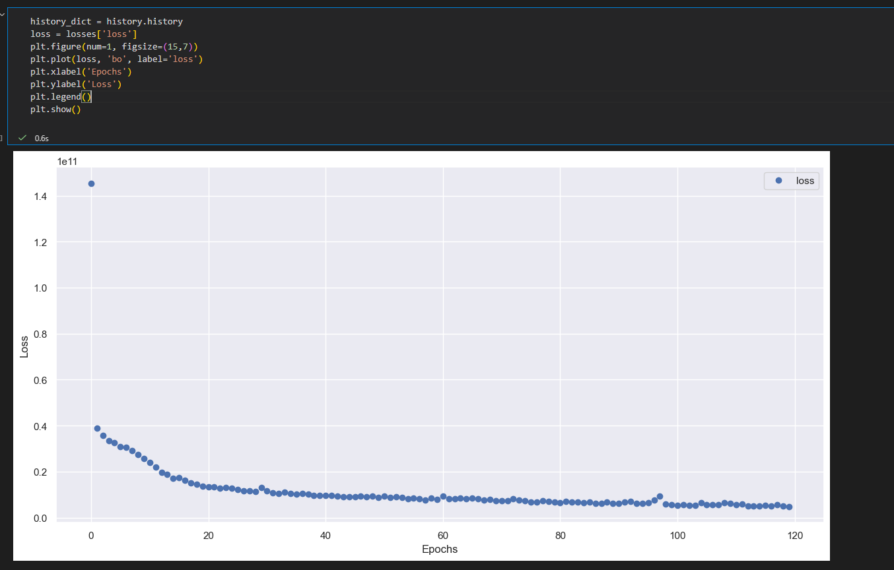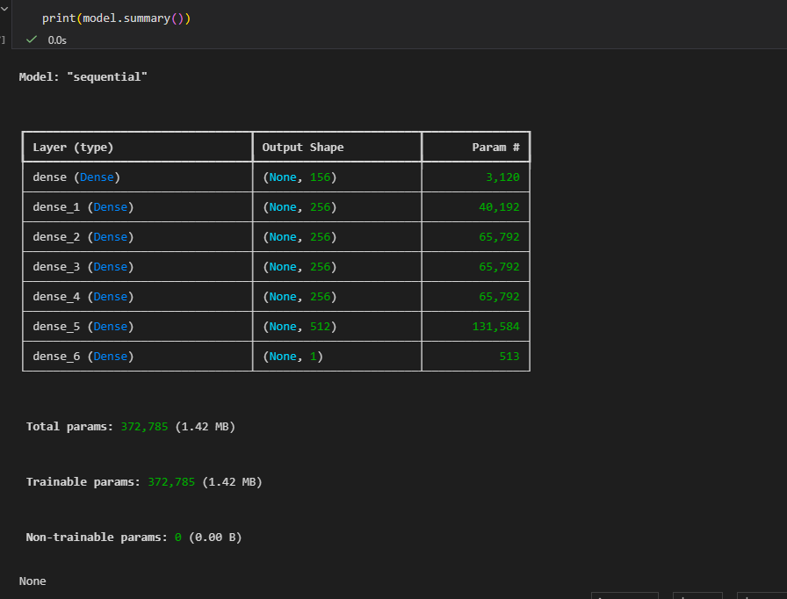

Lab 5

Lab 6

Lab 7

Lab 8

Lab 9

Lab 10

Lab 11

Lab 12

