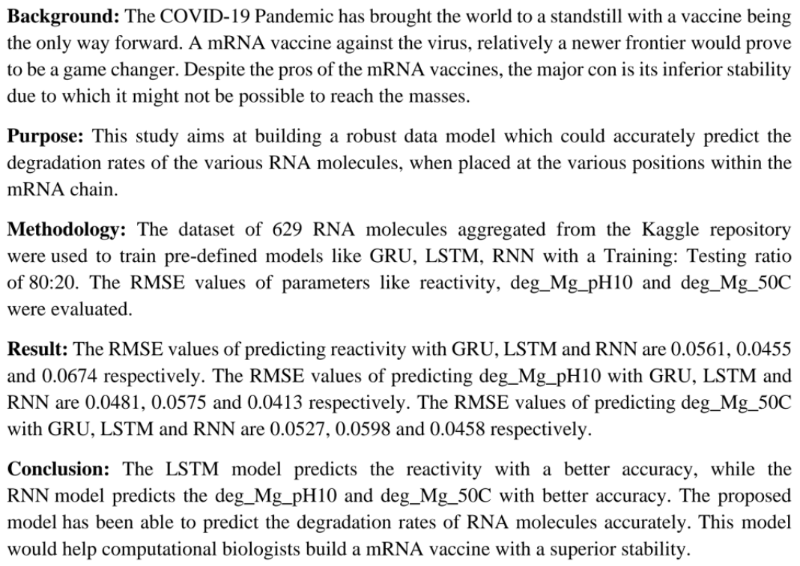

Files
- train.json - the training data
- test.json - the test set, without any columns associated with the ground truth.
- sample_submission.csv - a sample submission file in the correct format

Columns
- id - An arbitrary identifier for each sample.
- seq_scored - (68 in Train and Public Test, 91 in Private Test) Integer value denoting the number of positions used in scoring with predicted values. This should match the length of reactivity, deg_* and *_error_* columns. Note that molecules used for the Private Test will be longer than those in the Train and Public Test data, so the size of this vector will be different.
- seq_length - (107 in Train and Public Test, 130 in Private Test) Integer values, denotes the length of sequence. Note that molecules used for the Private Test will be longer than those in the Train and Public Test data, so the size of this vector will be different.
- sequence - (1x107 string in Train and Public Test, 130 in Private Test) Describes the RNA sequence, a combination of A, G, U, and C for each sample. Should be 107 characters long, and the first 68 bases should correspond to the 68 positions specified in seq_scored (note: indexed starting at 0).
- structure - (1x107 string in Train and Public Test, 130 in Private Test) An array of (, ), and . characters that describe whether a base is estimated to be paired or unpaired. Paired bases are denoted by opening and closing parentheses e.g. (....) means that base 0 is paired to base 5, and bases 1-4 are unpaired.
- reactivity - (1x68 vector in Train and Public Test, 1x91 in Private Test) An array of floating point numbers, should have the same length as seq_scored. These numbers are reactivity values for the first 68 bases as denoted in sequence, and used to determine the likely secondary structure of the RNA sample.
- deg_pH10 - (1x68 vector in Train and Public Test, 1x91 in Private Test) An array of floating point numbers, should have the same length as seq_scored. These numbers are reactivity values for the first 68 bases as denoted in sequence, and used to determine the likelihood of degradation at the base/linkage after incubating without magnesium at high pH (pH 10).
- deg_Mg_pH10 - (1x68 vector in Train and Public Test, 1x91 in Private Test) An array of floating point numbers, should have the same length as seq_scored. These numbers are reactivity values for the first 68 bases as denoted in sequence, and used to determine the likelihood of degradation at the base/linkage after incubating with magnesium in high pH (pH 10).
- deg_50C - (1x68 vector in Train and Public Test, 1x91 in Private Test) An array of floating point numbers, should have the same length as seq_scored. These numbers are reactivity values for the first 68 bases as denoted in sequence, and used to determine the likelihood of degradation at the base/linkage after incubating without magnesium at high temperature (50 degrees Celsius).
- deg_Mg_50C - (1x68 vector in Train and Public Test, 1x91 in Private Test) An array of floating point numbers, should have the same length as seq_scored. These numbers are reactivity values for the first 68 bases as denoted in sequence, and used to determine the likelihood of degradation at the base/linkage after incubating with magnesium at high temperature (50 degrees Celsius).
- *_error_* - An array of floating point numbers, should have the same length as the corresponding reactivity or deg_* columns, calculated errors in experimental values obtained in reactivity and deg_* columns.
- predicted_loop_type - (1x107 string) Describes the structural context (also referred to as 'loop type')of each character in sequence. Loop types assigned by bpRNA from Vienna RNAfold 2 structure. From the bpRNA_documentation: S: paired "Stem" M: Multiloop I: Internal loop B: Bulge H: Hairpin loop E: dangling End X: eXternal loop

S/N filter Indicates if the sample passed filters

Introduction
Winning the fight against the COVID-19 pandemic will require an effective vaccine that can be equitably and widely distributed. Building upon decades of research has allowed scientists to accelerate the search for a vaccine against COVID-19, but every day that goes by without a vaccine has enormous costs for the world nonetheless. We need new, fresh ideas from all corners of the world. Could online gaming and crowdsourcing help solve a worldwide pandemic? Pairing scientific and crowdsourced intelligence could help computational biochemists make measurable progress.
mRNA vaccines have taken the lead as the fastest vaccine candidates for COVID-19, but currently, they face key potential limitations. One of the biggest challenges right now is how to design super stable messenger RNA molecules (mRNA). Conventional vaccines (like your seasonal flu shots) are packaged in disposable syringes and shipped under refrigeration around the world, but that is not currently possible for mRNA vaccines.
Researchers have observed that RNA molecules have the tendency to spontaneously degrade. This is a serious limitation--a single cut can render the mRNA vaccine useless. Currently, little is known on the details of where in the backbone of a given RNA is most prone to being affected. Without this knowledge, current mRNA vaccines against COVID-19 must be prepared and shipped under intense refrigeration, and are unlikely to reach more than a tiny fraction of human beings on the planet unless they can be stabilized.

Images

Submission File
For each sample id in the test set, you must predict targets for each sequence position (seqpos), one per row. If the length of the sequence of an id is, e.g., 107, then you should make 107 predictions. Positions greater than the seq_scored value of a sample are not scored, but still need a value in the solution file.
id_seqpos,reactivity,deg_Mg_pH10,deg_pH10,deg_Mg_50C,deg_50C
id_00073f8be_0,0.1,0.3,0.2,0.5,0.4
id_00073f8be_1,0.3,0.2,0.5,0.4,0.2
id_00073f8be_2,0.5,0.4,0.2,0.1,0.2
etc.

Links

How RNA vaccines work, and their issues, featuring Dr. Rhiju Das
https://www.pbs.org/wgbh/nova/video/rna-coronavirus-vaccine/

Intro-1

It seems like there's no shortage of news about the novel coronavirus that is sweeping the globe.
String-like RNA molecules, which encode the genetic information needed to make proteins, fold into three-dimensional shapes to carry out biological functions within a cell.
Each RNA molecule can assume many different conformations; some are more resistant to degradation than others.

