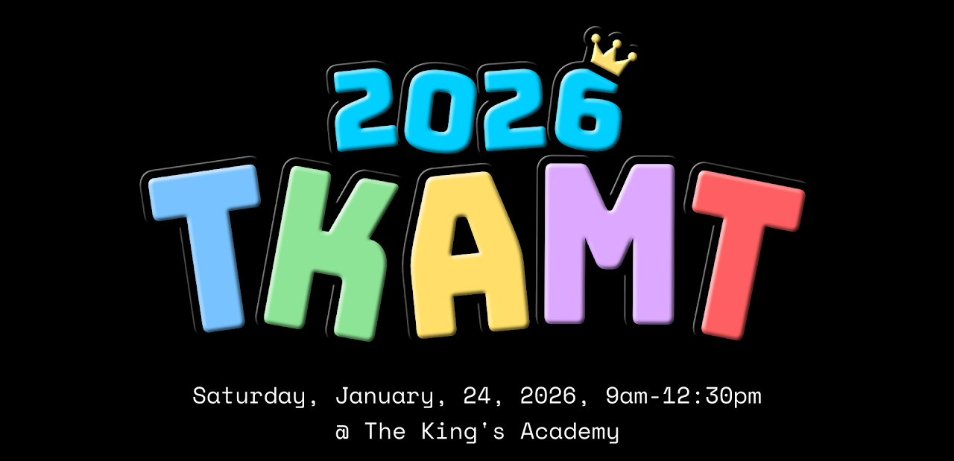
TKA Math Tournament
Complete Website Reference Document
Scraped from sites.google.com/view/tka-math-tournament | May 2026

This document contains the complete text, images, structure, and links from the TKA Math Tournament Google Sites website. It is intended to be given to Claude Code (or another AI) to recreate the website without needing internet access.

PAGE 1 — HOME
URL: /home

Announcement Banner (top of page)
2026 TKA Math Tournament Logistics are Live! [More Info] → links to /2026-tkamt/2026-logistics

Hero Image
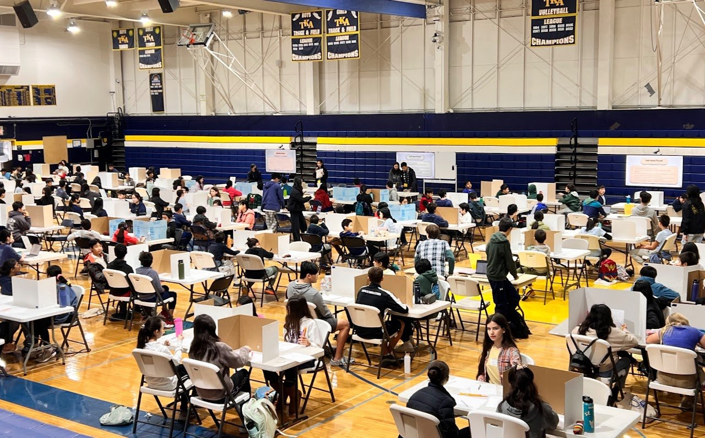
Hero banner — Individual Round in the TKA gymnasium

Main Description
The TKA Math Tournament (TKAMT) is a local, student-run math tournament for middle school students hosted by The King's Academy in Sunnyvale, CA. The 4th annual TKAMT will be held on Saturday, 1/24/2026 from 9am-12:30pm.

Call-to-Action Buttons
[Competition Format] → links to /format
[2026 Tournament] → links to /2026-tkamt

2025 TKAMT Photos
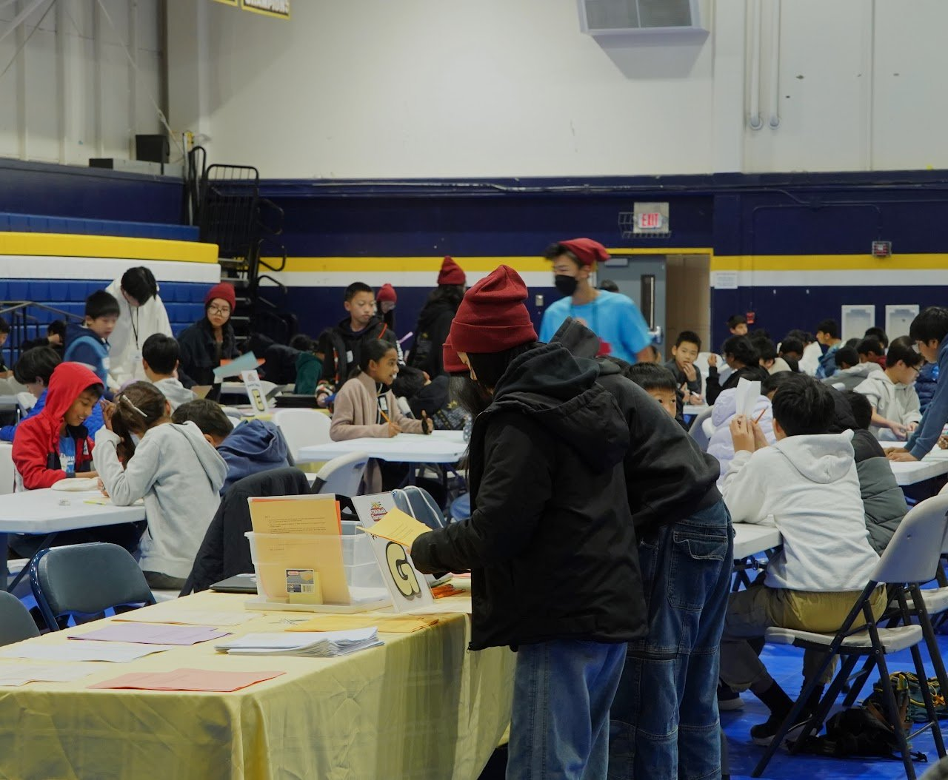
Guts Round
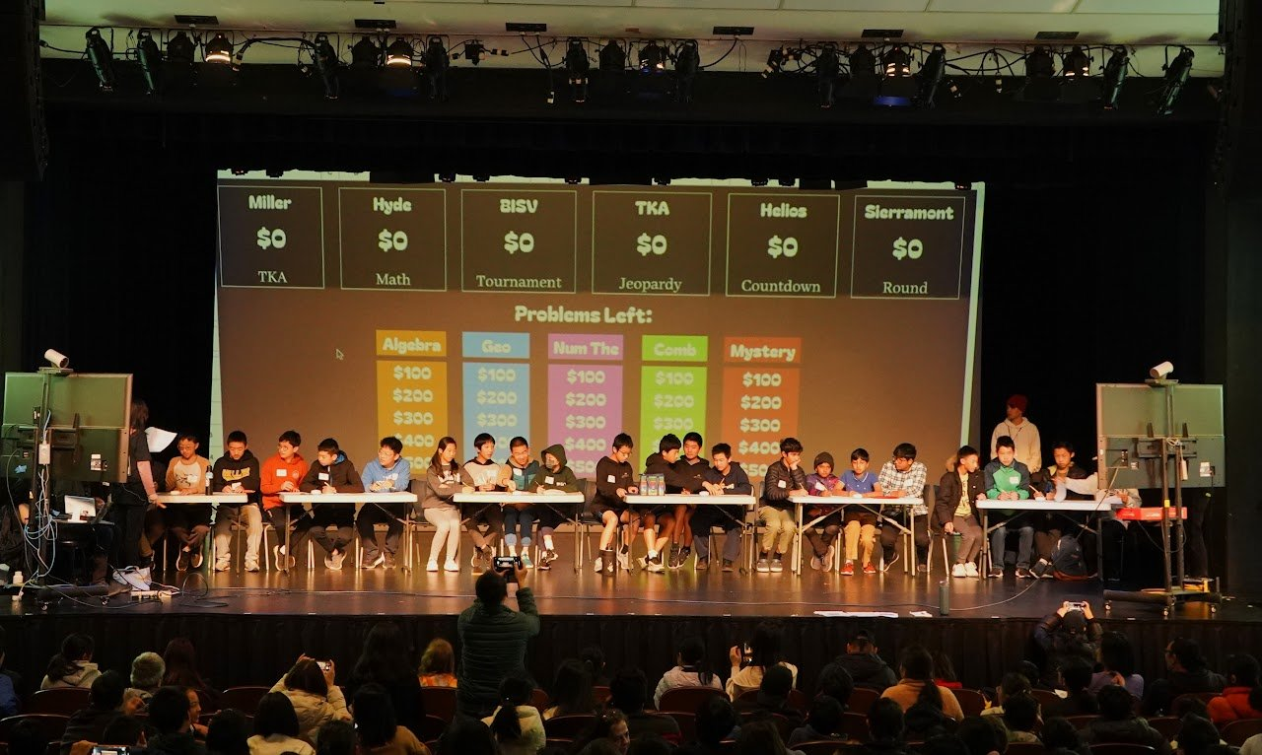
Jeopardy Countdown Round
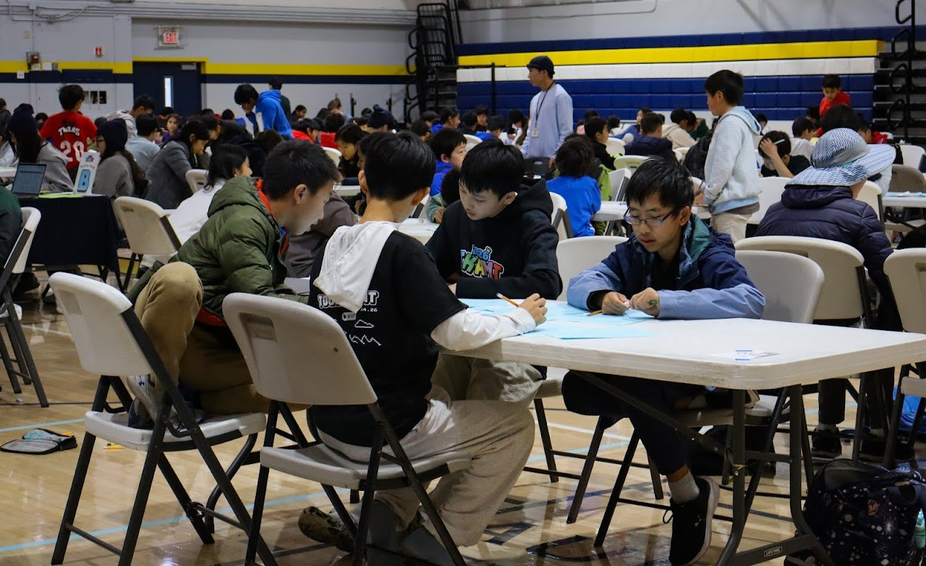
Some of the 2025 TKAMT staff

Footer / Contact
Questions? Contact us at math.team@tka.org
YouTube: https://www.youtube.com/@TKAMathTournament

PAGE 2 — 2026 TKAMT
URL: /2026-tkamt
Meta description: The 2026 TKA Math Tournament will be held on Saturday, January 24, 2026, from 9am to 12:30pm at The King's Academy in Sunnyvale, CA.

2026 TKA Math Tournament

Subheading
The 2026 TKA Math Tournament will be held on Saturday, January 24, 2026, from 9am to 12:30pm at The King's Academy in Sunnyvale, CA.
Last year, our tournament welcomed nearly 200 students from over a dozen schools/groups, and we hope you will join us this January!

Hero Image
2026 TKAMT banner — "Saturday, January 24, 2026, 9am-12:30pm @ The King's Academy"

2026 THEME: MOBILE GAMES
The theme of this year's tournament is mobile games! You'll be seeing these characters on our website, signage, and other printed material, and questions themed around mobile games will likely appear on the tests.
The tournament is intended for students in grades 6-8, but younger students are also welcome. Each school can send up to six teams, each team with 3 or 4 students. Students in the same team do not have to be from the same grade, but they must be from the same school. Registration fee is $40 per team.
Registration for the 2026 TKAMT is closed.
We'd like to encourage schools with newer or less established competition math communities to attend. Just like last year, all participants and teams must attend through their school. Non-school, for-profit organizations will not be allowed to participate.
Usually, we invite a few panelists to share their perspectives on a math-related topic with parents and teachers, while students are competing. See this page for info about this year's panel discussion: [2026 Panel Discussion] → /2026-tkamt/2026-panel-discussion

FAQs
Q: Can parents register for the tournament instead of teachers or coaches?
A: Yes, but we ask that one adult register all teams from the same school so we have a single point of contact for your teams.
Q: Must teams contain students only from one grade?
A: No, students in the same team may be from different grades.
Q: Are teams with fewer people at a scoring disadvantage?
A: No. We do not calculate overall team scores at all, so teams with fewer people will not be at a disadvantage in the team-based rounds (Guts and Jeopardy Countdown), other than the fact that they have fewer people to work on the problems.
Q: Can elementary school students participate?
A: Yes, but we have 6-8th graders in mind when writing the problems and compiling the tests.
Q: What awards will be given at the tournament?
A: The top three scorers on the Individual Round in each grade (8th, 7th, and 6th & under), top three teams on the Guts Round, and 1st place team on the Jeopardy Countdown Round.
Q: Where can I find more details about the day-of logistics?
A: We'll post more details about that on this webpage closer to the tournament date!

PAGE 3 — 2026 RESULTS
URL: /2026-tkamt/2026-results

Hero Image
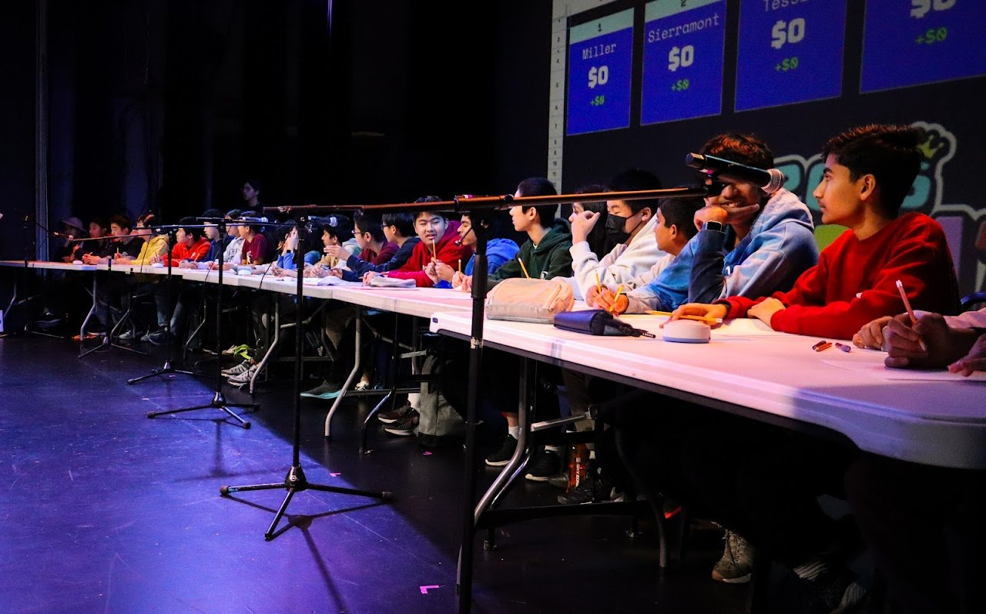
2026 TKAMT — Jeopardy Countdown Round, teams on stage

Intro Text
Thank you—to all 19 schools, 61 teams, 222 participants, and all parents, coaches, and volunteers—for making the 2026 TKAMT a success! It was great to see so many students (and their adult supporters!) come together at the tournament. We hope everyone enjoyed the problem-solving and teamwork, and found a sense of community.
We are currently working on processing/sending out scores and answer sheets to coaches/adult supervisors. Please be patient with us this week!
We'd appreciate it if you could take the time to give us some feedback in the survey linked below. If you have any very specific feedback, ideas, or suggestions you'd like us to address you can also send an email to math.team@tka.org.
[Fill out the survey here!] → https://forms.gle/9F3jzCeiiCHHqQ576

Results

Individual Round

6th grade & below
- Alvin Wang, Helios
- Marshall Huang, BISV
- Jayden Zhu, Challenger SP
- Jayden Kim, Dilworth
- Rohan Iyer, Helios
- Calvin Dinh, DCS

7th grade
- Minkee Cho, Peterson
- Weiwei Wang, Hyde
- James Liang-Cheng, DCS
- Bohan Li, Redwood
- Tiffany Han, BISV
- Henry Han, BISV

8th grade
- Justin Kim, Miller
- Minxing Yang, Sierramont
- Allen Li, Rancho
- Arthur Chang, Miller
- William Tao, Miller
- Pranav Krishnapuram, Tessellations

Guts Round
- Team 1, Miller (Daniel Hu, Justin Kim, Arthur Chang, William Tao)
- Sierramont E2MC, Sierramont (Eli Zhang, Minxing Yang, Caroline Guan, Ella Park)
- Tessie 2, Tessellations (Pranav Krishnapuram, Beatrice Hung, Vivaan Loiwal, Aarav Shah)
- Rancho Milpitas Falcons, Rancho (Carter Lo, Allen Li, Roger Huynh, Muhammad Sheriff)
- BISV Bobcat Team 1, BISV (Tiffany Han, Larry Liao, Tiancheng Zheng, Advik Garg)
- Hyde Lions, Hyde (Weiwei Wang, Reed Li, Nikit Sai Annapureddy, Aaditya Agrawal)
- furrier, TKA (Yifan Jiang, Alex Shen, Leo Yang, James Song)
- Cookies!, Discovery CS (James Liang-Cheng, Asher Kim, Royce Yu, Calvin Dinh)
- RMS TEAM A, Redwood (Sharon Luk, Bohan Li, Bonnie Qin, RAVPREET Ahuja)
- BISV Bobcat Team 2, BISV (Grayson Liu, Lashia Arulkumar, Mihika Gupta, Marshall Huang)

Jeopardy Countdown Round
Congrats to Team 1 from Miller (Daniel Hu, Justin Kim, Arthur Chang, William Tao) for winning the Jeopardy Countdown Round with a final balance of $3200.01!

Tournament Statistics
Individual Round: top score 19, average score 10.48, median score 11
Guts Round: top score 168, average score 45.15, median score 32
[Note: Score distribution chart images were hosted on Google CDN and blocked — not available in this document]

2026 TKAMT Photos
Individual Round — students in the TKA gymnasium
Guts Round — teams working on problems
Jeopardy Countdown Round — teams on stage (wide shot)
Jeopardy Countdown Round — teams at the buzzer table (side view)

PAGE 4 — 2026 PANEL DISCUSSION
URL: /2026-tkamt/2026-panel-discussion

Adapting Math Education to a Digitalized Generation
Parents and coaches are invited to attend this year's panel discussion, "Adapting Math Education to a Digitalized Generation". This event is free and open to the public.
The panelists–each bringing expertise in traditional, online, hybrid, or technology-enhanced learning–will be sharing their perspectives on how educators should address math education in an increasingly digitalized environment. We'll be addressing questions like "How do digital tools impact the role of educators?" and "Do you believe technology helps or exacerbates the problem of shrinking attention spans?", and there will be a time for audience Q & A as well.
Saturday, January 24, 2026 • 9:45am-10:45am • Cabot Theater
Moderated by Karissa Tang, TKA Class of 2026

Panelists

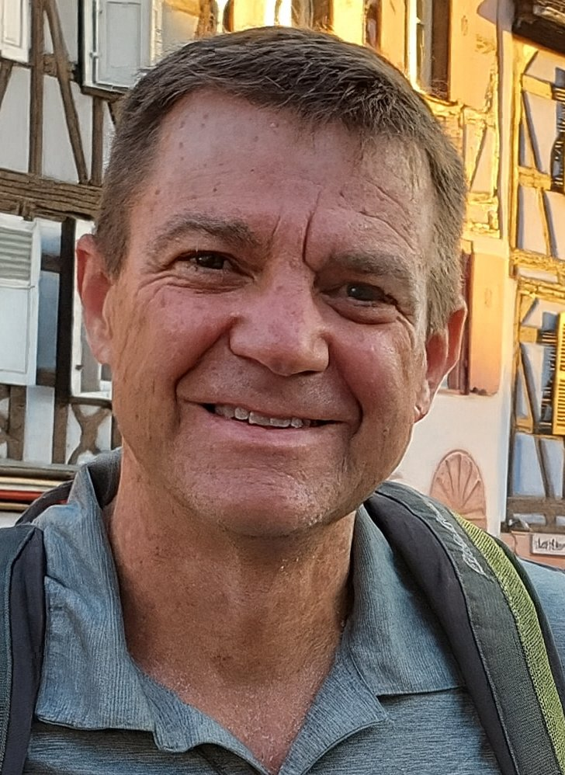 | Derek Sanders  Senior Manager, ExploreLearning  Derek Sanders is a senior manager at ExploreLearning, an EdTech firm focused on delivering engaging, research-driven STEM experiences. Derek leads a team responsible for the adaptive behavior of game-based math activities, including Frax, a fractions curriculum suite.  Derek received his master's degree in Operations Research from Stanford and has devoted his career to mathematical modeling, simulation, and algorithm development in a variety of contexts. In addition to EdTech, his areas of mathematical applications include optical networking, the automotive and health care marketplaces, cybersecurity, and (surprisingly) tacos.

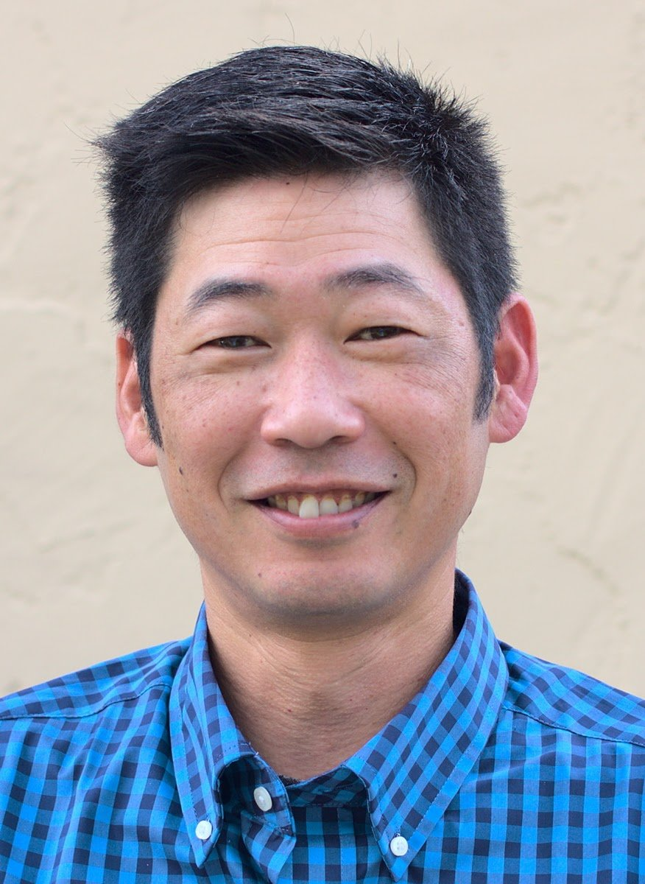 | Mat Miyashiro  Senior Professional Learning Advisor, Corwin  Mat Miyashiro is an experienced educator who has spent his entire career supporting and creating a positive learning environment in K12 education. A founding teacher at Gompers Preparatory Academy for 10 years and served as the Math Department Chair and varsity tennis and soccer coach.  Following his time teaching, he worked as a writer for math curriculum, math digital editor, and software quality assurance engineer at Pearson. He has helped develop various interactives and learning management systems at Pearson Realize and Learnzillion for Imagine Learning.  Currently, he works with Corwin as a Senior Professional Learning Advisor to partner with CA school districts to provide school improved solutions for K12 teachers and leaders.

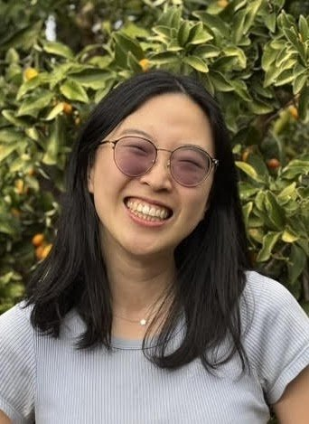 | Rebecca Hao  Learning Designer & Software Engineer  Rebecca Hao is a learning designer and software engineer excited about technologies that thoughtfully, enjoyably, and effectively support learning. She is a recent graduate of the Stanford Graduate School of Education Learning Design and Technology Master's program, where she researched and built generative AI tools for teachers and technologies to support self-directed learning for young adults.  Prior, she was a software engineer at Google and studied human-computer interaction and linguistics at Harvard. She uses human-centered design and aims to ground and evaluate educational technologies in the science of how we learn and to develop AI tools responsibly and ethically.

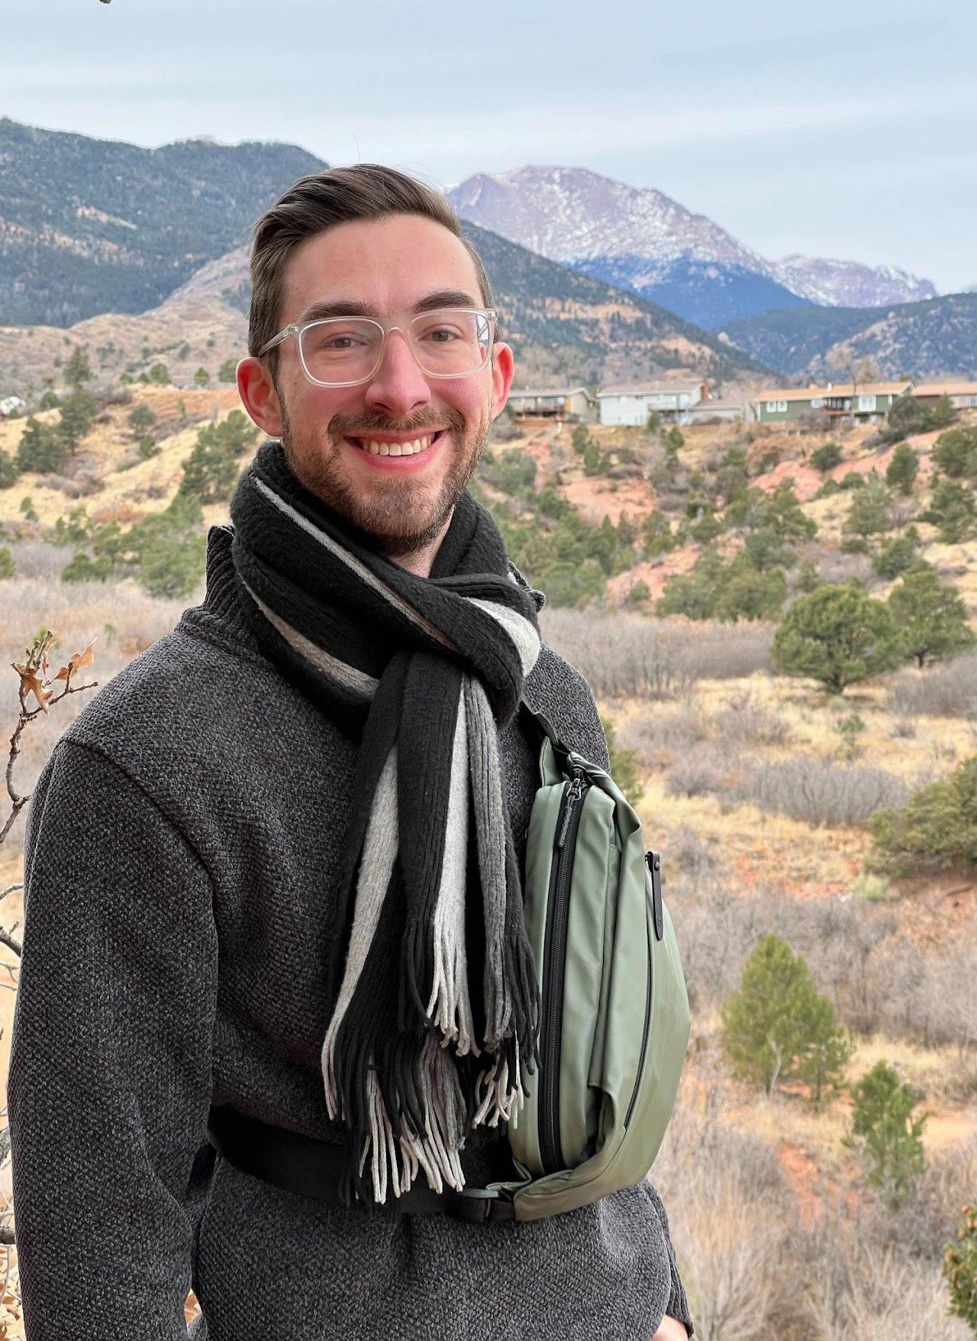 | David Wise  Math & Computer Science Teacher  David Wise is a gifted math and computer science teacher. He graduated with a double major in Mathematics and Computer Science from Carnegie Mellon University.  David has experience teaching and mentoring students across a variety of settings. He previously worked as a backend and full-stack software engineer at Facebook and spent a year abroad in Kyrgyzstan teaching software engineering to local students.  His achievements include qualifying twice for the USA Mathematical Olympiad, placing first in the Colorado Mathematical Olympiad, and ranking in the top 100 in North America in the Putnam Mathematical Competition.

PAGE 5 — FORMAT
URL: /format
Meta description: The TKA Math Tournament consists of 3 rounds: an Individual Round, a Guts Round, and a Jeopardy Countdown Round.

Format
The TKA Math Tournament consists of 3 rounds: an Individual Round, a Guts Round, and a Jeopardy Countdown Round. View past problems on our Archive page (/archive).

Individual Round
Individual Round — students seated in the gymnasium
50 minutes, 20 short-answer questions. Questions range across all standard topics (algebra, geometry, number theory, counting/probability).

Guts Round
Guts Round — teams collaborating at tables
1 hour, 8 sets of 3 problems. Students work in teams, and may go as quickly or as slowly as they want. However, they cannot work on the next set of problems until after their current set has been submitted.

Jeopardy Countdown Round
Jeopardy Countdown Round — teams on the main stage
In this Jeopardy-style round, teams buzz in to answer and receive points for correct answers and deductions for incorrect answers. Daily Doubles and a Final Jeopardy are also featured!
More details about rules, scoring, and procedures: https://docs.google.com/document/d/e/2PACX-1vQXY6BFkgTu6cqGggcZkLnzPv3SI-iTB27GW0DjIFdP0pqaKt9AcBilGPh9bTP-HtO85KRk3W7cg0Be/pub

PAGE 6 — ARCHIVE
URL: /archive

Problem Archive

2026 TKAMT
- 2026 Individual Round Problems: https://drive.google.com/file/d/1bPF4g4N359GoXrQaOXfdS4jQhSo9jaI0/view?usp=sharing
- 2026 Guts Round Problems: https://drive.google.com/file/d/11QOYZSnzcU9QYKW8n-4dJ85iGfy13Aql/view?usp=sharing
- 2026 Jeopardy Countdown Round Problems: https://drive.google.com/file/d/1ezgECebzKu7ZnDtlB8S4yoNvLhDs3ZMw/view?usp=sharing
- 2026 Solutions: https://drive.google.com/file/d/16yizmzkvCrmmPHqGZZ1a7C4KnFxl06-N/view?usp=sharing

2025 TKAMT
- 2025 Individual Round Problems: https://drive.google.com/file/d/1ZxfOuF9Z-c-6DaJlz78LYlIdcBNlO9Lr/view?usp=sharing
- 2025 Guts Round Problems: https://drive.google.com/file/d/11mzHvC_vOC6I2QYzjT2On54xlsA4R8nw/view?usp=sharing
- 2025 Jeopardy Countdown Round Problems: https://drive.google.com/file/d/1nayUNKVHUTXe26pvPj_shPQHgCy2to8g/view?usp=sharing
- 2025 Solutions: https://drive.google.com/file/d/12n7zwLM_ccN0Y1uGn3-t043u1Ju9TN3j/view?usp=sharing

2024 TKAMT
- 2024 Individual Round Problems: https://drive.google.com/file/d/14Tiz4KEU9Z-azW8vKtLBBI9wxULaNvoh/view
- 2024 Guts Round Problems: https://drive.google.com/file/d/1lsBsBU6X664EXXQ_3FHY3K6JMC52HisK/view
- 2024 Jeopardy Countdown Round Problems: https://drive.google.com/file/d/1-V0krxveQlKsTQ_gkslVbOcWmcCd522D/view
- 2024 Solutions: https://drive.google.com/file/d/1KbwUeGOMEJs87zMU5uTklsp-aPbxH9pl/view?usp=sharing

2023 TKAMT
- 2023 Individual Round Problems: https://drive.google.com/file/d/1-MX5OQU8fOiCqCgwuVxKmjilGK-Z1rJW/view
- 2023 Guts Round Problems: https://drive.google.com/file/d/1msc9K08EIEa3xwW7Gj5-KBkMvV0UgeSB/view
- 2023 Jeopardy Countdown Round Problems: https://drive.google.com/file/d/1faj2zXMwVEWx0eO5-pZkTIelsusa8k0o/view
(No 2023 Solutions link was listed on the site)

APPENDIX — DESIGN NOTES FOR RECREATION

Site Structure
Platform: Google Sites
Navigation: Fixed top nav bar — logo on left, links on right. Collapses to hamburger on mobile.
Pages: Home | 2026 TKAMT (with sub-pages: 2026 Results, 2026 Panel Discussion) | Format | Archive

Visual Design
- Background: White
- Font: Google Sans / Roboto (sans-serif)
- Primary color: Dark blue (#1A3A6B approx)
- Announcement bar: Full-width colored banner at top of Home page
- Images: Full content-width (~1280px max), centered
- Buttons: Two CTA buttons side-by-side on Home page
- Footer per page: Contact email + YouTube icon links

Special Layout Elements
- Home page: Announcement banner → Hero image → Description + 2 CTA buttons → Photo gallery → Contact footer
- 2026 TKAMT page: Hero → Theme section → FAQs accordion → Contact footer
- Results page: Hero image → Thank-you text → Results tables → Statistics charts → Photo gallery
- Panel Discussion page: Banner image → Event details → 4 panelist cards (photo + bio side by side)
- Format page: Intro → 3 round sections each with image + description
- Archive page: Problem links organized by year

External Links
- The King's Academy: https://www.tka.org/
- Rules/Scoring doc: https://docs.google.com/document/d/e/2PACX-1vQXY6BFkgTu6cqGggcZkLnzPv3SI-iTB27GW0DjIFdP0pqaKt9AcBilGPh9bTP-HtO85KRk3W7cg0Be/pub
- Feedback survey: https://forms.gle/9F3jzCeiiCHHqQ576
- YouTube: https://www.youtube.com/@TKAMathTournament
- Email: math.team@tka.org

