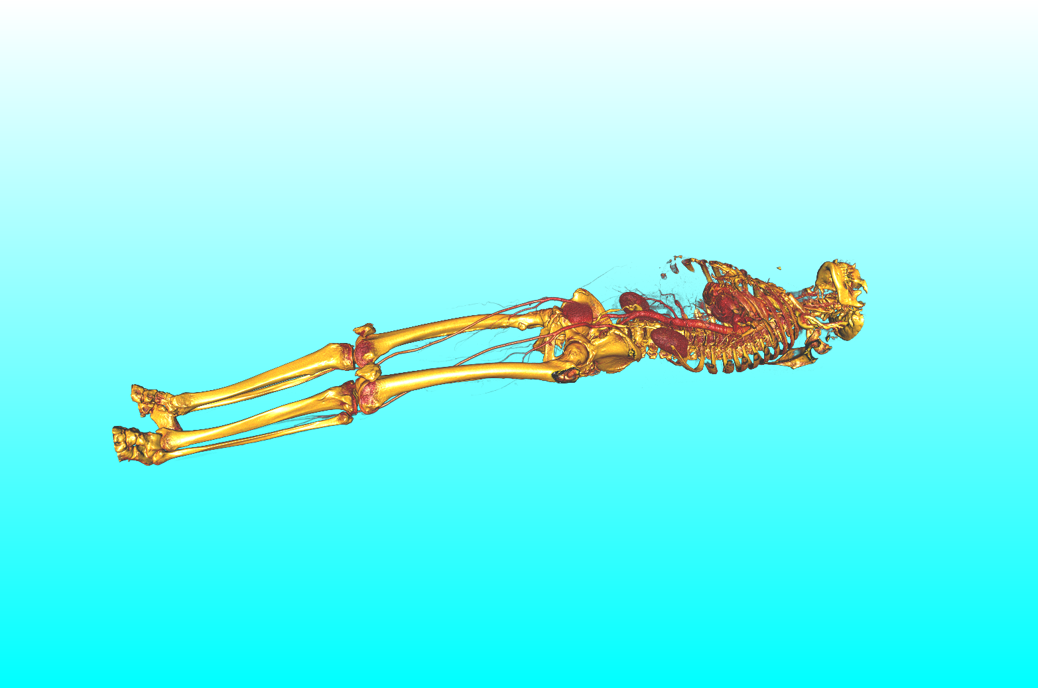SCI-logo-ppt.png

Users Manual

Jens Krüger & Tom Fogal

Scientific Computing and Imaging Institute, University of Utah  
72 S Central Campus Drive, 3750 WEB, Salt Lake City, UT 84112, USA

ImageVis3D Version 1.0

Table of Contents

2. Introduction 4

I. Getting ImageVis3D 4

a. Downloading 4

b. Installation and Unistallation 4

II. Screenshots and Operating Systems 6

III. The First Start of ImageVis3D 7

3. User Interface Basics 8

IV. The Welcome Screen 8

V. The Main Menu 9

VI. The Workspace 10

4. File Handling 10

VII. Loading Data 10

c. Loading Native UVF Data 10

d. Importing Data From a File 10

e. Importing Data From a Directory 11

VIII. Exporting Data 11

f. Exporting Volumetric Data 11

g. Exporting Mesh Data from an Iso-Surface 11

h. Merging Datasets 11

5. Interacting with the Data 12

IX. The Render Window 12

X. Changing Rendermodes 12

i. Working with a 1D Transfer Function 12

j. Working with a 2D Transfer Function 12

k. Working with Iso-Surface Rendering 12

l. Working with ClearView 12

XI. The Render Window Revisited 13

m. Single Window vs. Four by Four View 13

n. Maximum Intensity Projection (MIP) View 13

XII. Working with multiple Windows 13

o. Locking 13

XIII. Clip Planes 13

XIV. Stereo Rendering 13

6. Capturing Images and Sequences 14

7. Advanced Topics 15

XV. Changing Parameters 15

XVI. Reporting a Bug 15

XVII. The Debug Console 15

XVIII. Running a Script 15

XIX. Keyboard Shortcuts 16

XX. Command Line Parameters 16

XXI. Troubleshooting 16

XXII. Compiling ImageVis3D 16

XXIII. The MIT License 16

# Introduction

Welcome to the world of interactive volume visualization! In this manual we are going to introduce you to ImageVis3D, a lightweight, feature-rich volume rendering application. That was specifically designed for rendering data which is significantly larger than the available memory of the machine. While ImageVis3D can take advantage of many recent advances in graphics hardware, advanced scheduling and caching algorithms ensure interactive performance even on older systems. We sincerely hope that ImageVis3D will improve the workflow in your environment and that you will have as much fun using it as we had developing it. If you should have a question, bug-report, or feature request, feel free to contact us at [iv3d-users@sci.utah.edu](mailto:iv3d-users@sci.utah.edu). Or use the build in reporting feature in ImageVis3D (see Section XVI on about details on this feature).

## Getting ImageVis3D

If you already downloaded and installed the latest version of ImageVis3D on your system you can skip this Section if not just read on.

### Downloading

ImageVis3D is a free open source program release under the MIT license, which basically means you can download it, change it, and do whatever you want with it for completely for free. Just note that legally we do not give you any guarantees for anything (see Section XXII). Practically, this means you can browse to <http://www.ImageVis3D.com>, click the download button and pick the latest binary that is suitable for your operating system (OS). If you do not know what you operating system is and whether it is 32 or 64bit please ask you system administrator or consult your computer’s owner’s manual. If you fell more like playing around with the latest and greatest in “development version” of ImageVis3D you can also browse to <http://software.sci.utah.edu/devbuilds/imagevis3d/> and download the latest build. These latest versions often offer new exciting features but are still under development and my not run as stable and reliable as the release versions that you can get from the “Download” site.

### Installation and Uninstallation

As the installation of ImageVis3D is differs from OS to OS we will describe the process separately for the most common operating systems.

#### Windows XP and above

On windows you can either choose to run the installer directly from our website (recommended) or choose download. If you have downloaded the installer to your system instead of running it directly you should have either have an “ImageVis3D-1.0-64.bit” or “ImageVis3D-1.0-32.bit” binary in your browser’s download folder (see Figure 1).

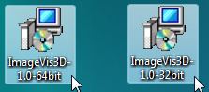

Figure 64bit and 32bit Windows Installer Packages

To start the installation process, double-click on that installer. On Windows Vista and Windows 7 you will be prompted by the “user account” control to allow the installer to run, please click “OK” to continue. Next, you will see the familiar windows installer dialogs, please simply follow the instructions in the wizard, as seen in Figure 2. We recommend that you leave all settings at their default values.

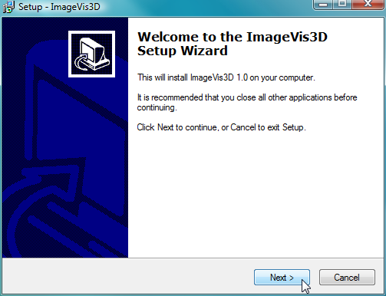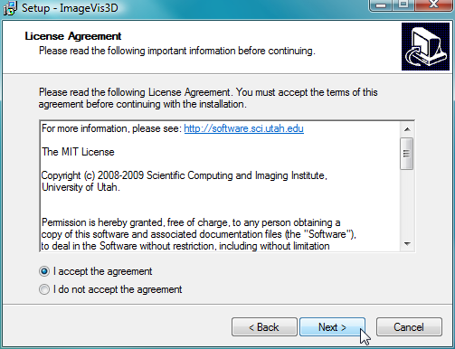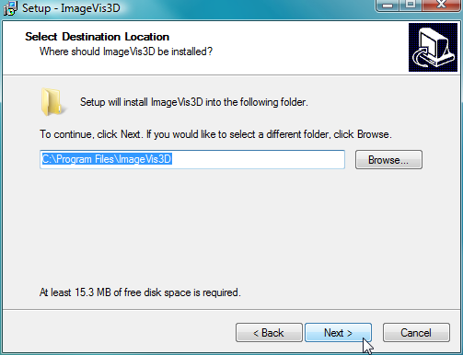  
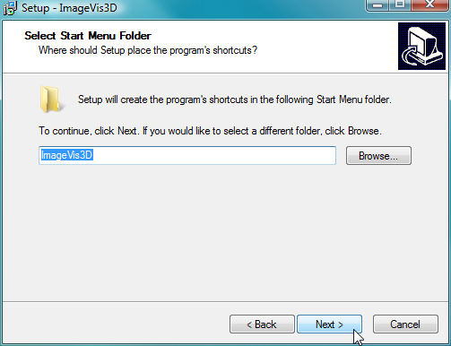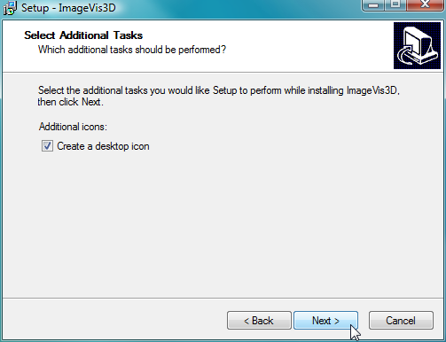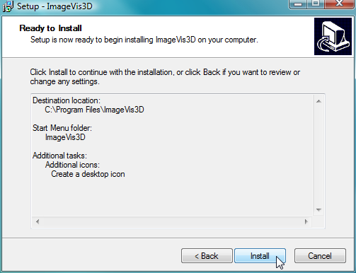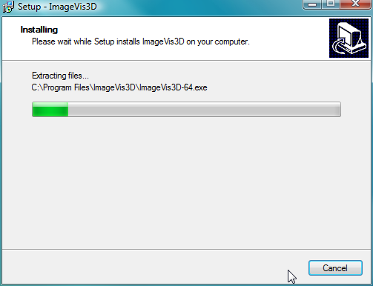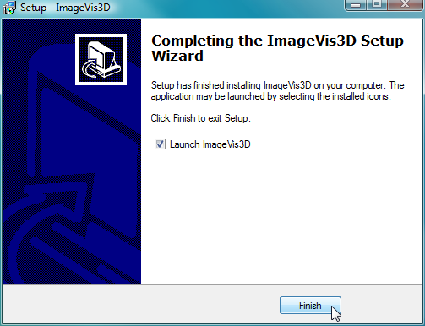

Figure The Install Wizard on Windows Systems

After the wizard has finished the installation it will automatically start ImageVis3D or – if you have deselected the option to do so – you have to start it manually by clicking on the new desktop item or by starting ImageVis3D from Windows’ Start menu (bottom left on most systems).

To uninstall ImageVis3D later all you have to do is to double-click ImageVis3D 1.0 from the software list (called Programs and Features on Vista and Windows 7) in the control panel.

#### OS X

On a Macintosh computer running OS X you simply download the DMG disk image regardless of what Macintosh computer you have. This one image contains ImageVis3D versions for multiple configurations and automatically picks the right one. If you perform the download with OS X default browser Safari, the entire installation process will happen completely automatically. After the DMG has been downloaded, mounted, extracted, dismounted, and finally deleted, you should see the ImageVis3D program in your download folder. If you want to you can now move it into the application folder, so it is stored alongside with all your other OS X applications.

If you ever want to uninstall ImageVis3D all you have to do is drag the ImageVis3D icon from the Download (or from the Application folder) into the Trash.

#### Linux

At the moment we are not offering any installation system for the various Unix like OSes. Please either download the binary tarball or download the source from the SVN serve at and compile it yourself (see Section XXII for details on to do this).

## Screenshots and Operating Systems

As mentioned before, ImageVis3D runs on all major operation systems, such as Windows, OS X, and Linux. While the overall look and feel of the program remains the same, it will look slightly different on operating systems, throughout this manual we will mainly use screenshots from a Windows Vista system thus a button a checkbox or a dialog may look slightly different. But as can be seen in Figure 3 this difference should not be a major problem, if you still find it impossible to understand a certain part of this manual feel free to send an email to [iv3d-users@sci.utah.edu](mailto:iv3d-users@sci.utah.edu) and we will gladly help you with your problem and will also make the necessary changes to improve this manual for everyone else.

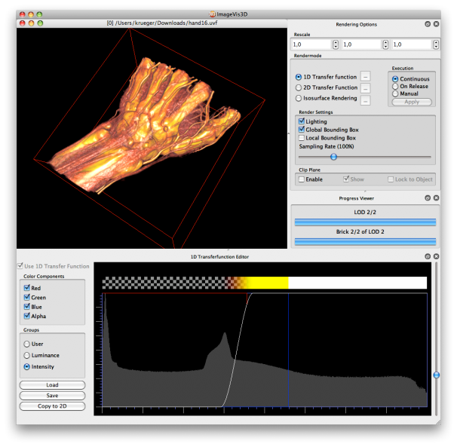 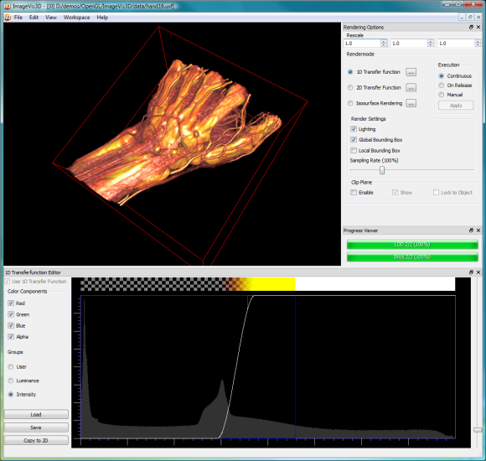

Figure ImageVis3D running on OS X and Windows Vista

## The First Start of ImageVis3D

When you start ImageVis3D for the very first time the “Initial Setup Dialog” (see Figure 4) will open up and ask you if you want to change the default settings ImageVis3D has picked. For an inexperienced user it is best to just click “No” and accept the defaults, you will later (in Section XV) learn how to change those settings if it becomes necessary.

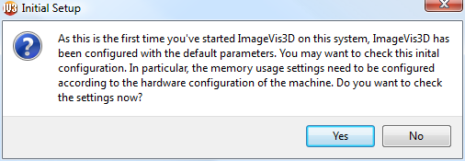

Figure The Initial Settings Dialog

If you accidently clicked “Yes” in “Initial Setup Dialog” do not worry just close the “ImageVis3D Settings Dialog” with either “OK” or “Cancel” or and no harm is done.

After you managed to pass the initial Setting/Setup phase ImageVis3D will start by presenting you the “Welcome Screen” (see Figure 5).

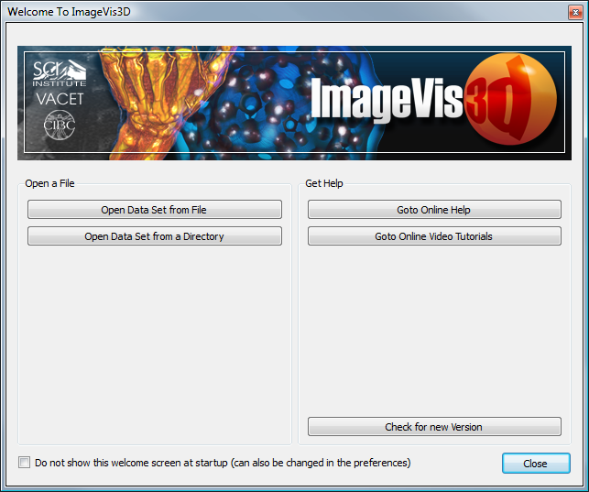

Figure The ImageVis3D Welcome Screen

# User Interface Basics

In this Section we will introduce the basic concepts of ImaveVis3D’s User Interface (UI). ImageVis3D was designed to be very intuitive if you already are already familiar with graphical user interfaces (GUI) in general. Figure 6 shows an annotated screenshot of ImageVis3D’s user interface during a visualization session.

**Main Menu**

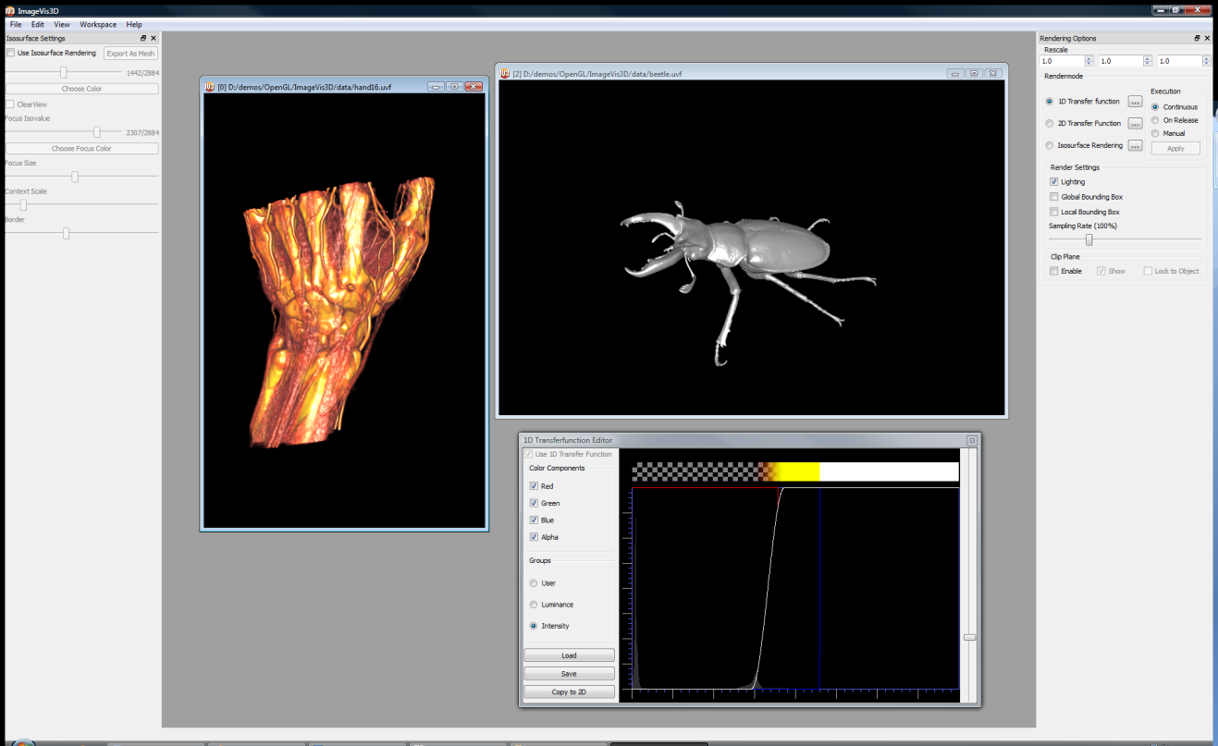

**Status Bar**

**Render Windows**

**Main Canvas**

**Free Floating   
Tool-Widget**

**Docked Tool-Widgets**

Figure ImageVis3D's Anatomy

## The Welcome Screen

If you start ImageVis3D the “Welcome Screen” (see Figure 5). opens up, unless you disabled it (see Section XV on how to re-enable it if you want to). In this window you can open data sets, open the online help, see the video tutorials, or check whether you have the most recent version of ImageVis3D. Particularly helpful is that ImageVis3D keeps track of you recently accessed data sets and lets you load these directly with having to find them on disk (see Figure 7).

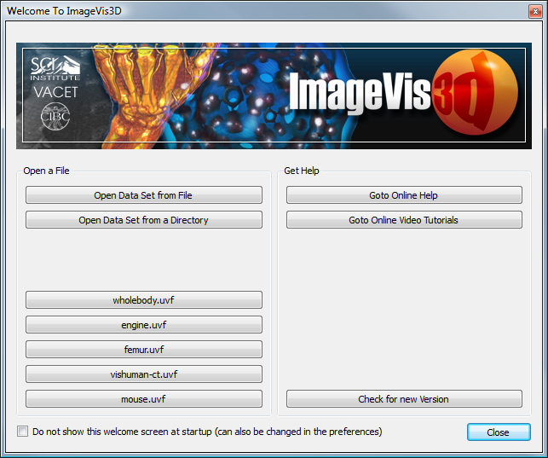

Figure The Welcome Screen showing the most recently used items.

## The Main Menu

Like most graphics programs ImageVis3D’s has a Main Menu from with the basic features are accessed (see Figure 8). Such as loading and saving from the “File”-menu or “Settings” from the “Edit”-menu (note that on OS X the Settings are located in the “ImageVis3D”-Menu on the top left as “Preferences”). The “View”-menu becomes important once we start to work with multiple data sets at once (for details see Section XII) while in the “Workspace”-Menu workspaces are loaded and saved and all of the tool-widgets (see Figure 6) are enabled and disabled, as ImageVis3D is primarily controlled through these tool widgets, this menu item is of special importance for the next Section. The “Help”-menu, finally, gives you access to the only help and the Update and Report features of ImageVis3D.

.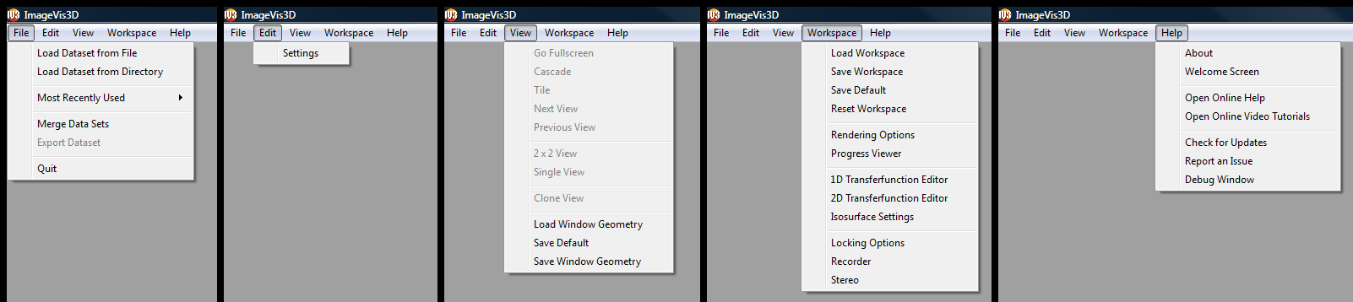

Figure ImageVis3D's Main Menu

## The Main Canvas

### Tool Widgets

Lorem ipsum dolor sit amet, consectetur adipiscing elit. Proin ullamcorper tempus nisi, et lobortis elit consequat a. Maecenas sem diam, adipiscing vitae semper nec, iaculis id nunc. Etiam laoreet ultricies dolor, eu iaculis libero fringilla sed. Morbi fermentum, tellus non bibendum placerat, tortor sapien interdum turpis, eget ultrices turpis risus vitae ante.

### Data Windows

Lorem ipsum dolor sit amet, consectetur adipiscing elit. Proin ullamcorper tempus nisi, et lobortis elit consequat a. Maecenas sem diam, adipiscing vitae semper nec, iaculis id nunc. Etiam laoreet ultricies dolor, eu iaculis libero fringilla sed. Morbi fermentum, tellus non bibendum placerat, tortor sapien interdum turpis, eget ultrices turpis risus vitae ante.

# File Handling

## Loading Data

Lorem ipsum dolor sit amet, consectetur adipiscing elit. Proin ullamcorper tempus nisi, et lobortis elit consequat a. Maecenas sem diam, adipiscing vitae semper nec, iaculis id nunc. Etiam laoreet ultricies dolor, eu iaculis libero fringilla sed. Morbi fermentum, tellus non bibendum placerat, tortor sapien interdum turpis, eget ultrices turpis risus vitae ante. Nullam euismod dolor quis nulla vestibulum fermentum. Etiam dignissim mollis pellentesque. Phasellus sed fringilla est. In lacinia sem eu augue laoreet eu pulvinar nibh feugiat. Ut consequat orci tortor. Vestibulum ante ipsum primis in faucibus orci luctus et ultrices posuere cubilia Curae; Lorem ipsum dolor sit amet, consectetur adipiscing elit. Pellentesque ac magna urna.

### Loading Native UVF Data

Lorem ipsum dolor sit amet, consectetur adipiscing elit. Proin ullamcorper tempus nisi, et lobortis elit consequat a. Maecenas sem diam, adipiscing vitae semper nec, iaculis id nunc. Etiam laoreet ultricies dolor, eu iaculis libero fringilla sed. Morbi fermentum, tellus non bibendum placerat, tortor sapien interdum turpis, eget ultrices turpis risus vitae ante. Nullam euismod dolor quis nulla vestibulum fermentum.

### Importing Data From a File

Lorem ipsum dolor sit amet, consectetur adipiscing elit. Proin ullamcorper tempus nisi, et lobortis elit consequat a. Maecenas sem diam, adipiscing vitae semper nec, iaculis id nunc. Etiam laoreet ultricies dolor, eu iaculis libero fringilla sed. Morbi fermentum, tellus non bibendum placerat, tortor sapien interdum turpis, eget ultrices turpis risus vitae ante. Nullam euismod dolor quis nulla vestibulum fermentum. Etiam dignissim mollis pellentesque. Phasellus sed fringilla est. In lacinia sem eu augue laoreet eu pulvinar nibh feugiat. Ut consequat orci tortor. Vestibulum ante ipsum primis in faucibus orci luctus et ultrices posuere cubilia Curae; Lorem ipsum dolor sit amet, consectetur adipiscing elit. Pellentesque ac magna urna.

### Importing Data From a Directory

Lorem ipsum dolor sit amet, consectetur adipiscing elit. Proin ullamcorper tempus nisi, et lobortis elit consequat a. Maecenas sem diam, adipiscing vitae semper nec, iaculis id nunc. Etiam laoreet ultricies dolor, eu iaculis libero fringilla sed. Morbi fermentum, tellus non bibendum placerat, tortor sapien interdum turpis, eget ultrices turpis risus vitae ante. Nullam euismod dolor quis nulla vestibulum fermentum. Etiam dignissim mollis pellentesque. Phasellus sed fringilla est. In lacinia sem eu augue laoreet eu pulvinar nibh feugiat. Ut consequat orci tortor. Vestibulum ante ipsum primis in faucibus orci luctus et ultrices posuere cubilia Curae; Lorem ipsum dolor sit amet, consectetur adipiscing elit. Pellentesque ac magna urna.

## Exporting Data

Lorem ipsum dolor sit amet, consectetur adipiscing elit. Proin ullamcorper tempus nisi, et lobortis elit consequat a. Maecenas sem diam, adipiscing vitae semper nec, iaculis id nunc. Etiam laoreet ultricies dolor, eu iaculis libero fringilla sed. Morbi fermentum, tellus non bibendum placerat, tortor sapien interdum turpis, eget ultrices turpis risus vitae ante. Nullam euismod dolor quis nulla vestibulum fermentum.

### Exporting Volumetric Data

Lorem ipsum dolor sit amet, consectetur adipiscing elit. Proin ullamcorper tempus nisi, et lobortis elit consequat a. Maecenas sem diam, adipiscing vitae semper nec, iaculis id nunc. Etiam laoreet ultricies dolor, eu iaculis libero fringilla sed. Morbi fermentum, tellus non bibendum placerat, tortor sapien interdum turpis, eget ultrices turpis risus vitae ante. Nullam euismod dolor quis nulla vestibulum fermentum.

### Exporting Mesh Data from an Iso-Surface

Lorem ipsum dolor sit amet, consectetur adipiscing elit. Proin ullamcorper tempus nisi, et lobortis elit consequat a. Maecenas sem diam, adipiscing vitae semper nec, iaculis id nunc. Etiam laoreet ultricies dolor, eu iaculis libero fringilla sed. Morbi fermentum, tellus non bibendum placerat, tortor sapien interdum turpis, eget ultrices turpis risus vitae ante. Nullam euismod dolor quis nulla vestibulum fermentum.

### Merging Datasets

Lorem ipsum dolor sit amet, consectetur adipiscing elit. Proin ullamcorper tempus nisi, et lobortis elit consequat a. Maecenas sem diam, adipiscing vitae semper nec, iaculis id nunc. Etiam laoreet ultricies dolor, eu iaculis libero fringilla sed. Morbi fermentum, tellus non bibendum placerat, tortor sapien interdum turpis, eget ultrices turpis risus vitae ante.

# Interacting with the Data

Lorem ipsum dolor sit amet, consectetur adipiscing elit. Proin ullamcorper tempus nisi, et lobortis elit consequat a. Maecenas sem diam, adipiscing vitae semper nec, iaculis id nunc. Etiam laoreet ultricies dolor, eu iaculis libero fringilla sed. Morbi fermentum, tellus non bibendum placerat, tortor sapien interdum turpis, eget ultrices turpis risus vitae ante.

## The Render Window

Lorem ipsum dolor sit amet, consectetur adipiscing elit. Proin ullamcorper tempus nisi, et lobortis elit consequat a. Maecenas sem diam, adipiscing vitae semper nec, iaculis id nunc. Etiam laoreet ultricies dolor, eu iaculis libero fringilla sed. Morbi fermentum, tellus non bibendum placerat, tortor sapien interdum turpis, eget ultrices turpis risus vitae ante.

## Changing Rendermodes

Lorem ipsum dolor sit amet, consectetur adipiscing elit. Proin ullamcorper tempus nisi, et lobortis elit consequat a. Maecenas sem diam, adipiscing vitae semper nec, iaculis id nunc. Etiam laoreet ultricies dolor, eu iaculis libero fringilla sed. Morbi fermentum, tellus non bibendum placerat, tortor sapien interdum turpis, eget ultrices turpis risus vitae ante.

### Working with a 1D Transfer Function

Lorem ipsum dolor sit amet, consectetur adipiscing elit. Proin ullamcorper tempus nisi, et lobortis elit consequat a. Maecenas sem diam, adipiscing vitae semper nec, iaculis id nunc. Etiam laoreet ultricies dolor, eu iaculis libero fringilla sed. Morbi fermentum, tellus non bibendum placerat, tortor sapien interdum turpis, eget ultrices turpis risus vitae ante.

### Working with a 2D Transfer Function

Lorem ipsum dolor sit amet, consectetur adipiscing elit. Proin ullamcorper tempus nisi, et lobortis elit consequat a. Maecenas sem diam, adipiscing vitae semper nec, iaculis id nunc. Etiam laoreet ultricies dolor, eu iaculis libero fringilla sed. Morbi fermentum, tellus non bibendum placerat, tortor sapien interdum turpis, eget ultrices turpis risus vitae ante.

### Working with Iso-Surface Rendering

Lorem ipsum dolor sit amet, consectetur adipiscing elit. Proin ullamcorper tempus nisi, et lobortis elit consequat a. Maecenas sem diam, adipiscing vitae semper nec, iaculis id nunc. Etiam laoreet ultricies dolor, eu iaculis libero fringilla sed. Morbi fermentum, tellus non bibendum placerat, tortor sapien interdum turpis, eget ultrices turpis risus vitae ante.

### Working with ClearView

Lorem ipsum dolor sit amet, consectetur adipiscing elit. Proin ullamcorper tempus nisi, et lobortis elit consequat a. Maecenas sem diam, adipiscing vitae semper nec, iaculis id nunc. Etiam laoreet ultricies dolor, eu iaculis libero fringilla sed. Morbi fermentum, tellus non bibendum placerat, tortor sapien interdum turpis, eget ultrices turpis risus vitae ante.

## The Render Window Revisited

Lorem ipsum dolor sit amet, consectetur adipiscing elit. Proin ullamcorper tempus nisi, et lobortis elit consequat a. Maecenas sem diam, adipiscing vitae semper nec, iaculis id nunc. Etiam laoreet ultricies dolor, eu iaculis libero fringilla sed. Morbi fermentum, tellus non bibendum placerat, tortor sapien interdum turpis, eget ultrices turpis risus vitae ante.

### Single Window vs. Four by Four View

Lorem ipsum dolor sit amet, consectetur adipiscing elit. Proin ullamcorper tempus nisi, et lobortis elit consequat a. Maecenas sem diam, adipiscing vitae semper nec, iaculis id nunc. Etiam laoreet ultricies dolor, eu iaculis libero fringilla sed. Morbi fermentum, tellus non bibendum placerat, tortor sapien interdum turpis, eget ultrices turpis risus vitae ante.

### Maximum Intensity Projection (MIP) View

Lorem ipsum dolor sit amet, consectetur adipiscing elit. Proin ullamcorper tempus nisi, et lobortis elit consequat a. Maecenas sem diam, adipiscing vitae semper nec, iaculis id nunc. Etiam laoreet ultricies dolor, eu iaculis libero fringilla sed. Morbi fermentum, tellus non bibendum placerat, tortor sapien interdum turpis, eget ultrices turpis risus vitae ante.

## Working with multiple Windows

Lorem ipsum dolor sit amet, consectetur adipiscing elit. Proin ullamcorper tempus nisi, et lobortis elit consequat a. Maecenas sem diam, adipiscing vitae semper nec, iaculis id nunc. Etiam laoreet ultricies dolor, eu iaculis libero fringilla sed. Morbi fermentum, tellus non bibendum placerat, tortor sapien interdum turpis, eget ultrices turpis risus vitae ante.

### Locking

Lorem ipsum dolor sit amet, consectetur adipiscing elit. Proin ullamcorper tempus nisi, et lobortis elit consequat a. Maecenas sem diam, adipiscing vitae semper nec, iaculis id nunc. Etiam laoreet ultricies dolor, eu iaculis libero fringilla sed. Morbi fermentum, tellus non bibendum placerat, tortor sapien interdum turpis, eget ultrices turpis risus vitae ante.

## Clip Planes

Lorem ipsum dolor sit amet, consectetur adipiscing elit. Proin ullamcorper tempus nisi, et lobortis elit consequat a. Maecenas sem diam, adipiscing vitae semper nec, iaculis id nunc. Etiam laoreet ultricies dolor, eu iaculis libero fringilla sed. Morbi fermentum, tellus non bibendum placerat, tortor sapien interdum turpis, eget ultrices turpis risus vitae ante.

## Stereo Rendering

Lorem ipsum dolor sit amet, consectetur adipiscing elit. Proin ullamcorper tempus nisi, et lobortis elit consequat a. Maecenas sem diam, adipiscing vitae semper nec, iaculis id nunc. Etiam laoreet ultricies dolor, eu iaculis libero fringilla sed. Morbi fermentum, tellus non bibendum placerat, tortor sapien interdum turpis, eget ultrices turpis risus vitae ante.

# Capturing Images and Sequences

Lorem ipsum dolor sit amet, consectetur adipiscing elit. Proin ullamcorper tempus nisi, et lobortis elit consequat a. Maecenas sem diam, adipiscing vitae semper nec, iaculis id nunc. Etiam laoreet ultricies dolor, eu iaculis libero fringilla sed. Morbi fermentum, tellus non bibendum placerat, tortor sapien interdum turpis, eget ultrices turpis risus vitae ante.

# Advanced Topics

## Changing Parameters

Lorem ipsum dolor sit amet, consectetur adipiscing elit. Proin ullamcorper tempus nisi, et lobortis elit consequat a. Maecenas sem diam, adipiscing vitae semper nec, iaculis id nunc. Etiam laoreet ultricies dolor, eu iaculis libero fringilla sed. Morbi fermentum, tellus non bibendum placerat, tortor sapien interdum turpis, eget ultrices turpis risus vitae ante.

## Reporting a Bug

Lorem ipsum dolor sit amet, consectetur adipiscing elit. Proin ullamcorper tempus nisi, et lobortis elit consequat a. Maecenas sem diam, adipiscing vitae semper nec, iaculis id nunc. Etiam laoreet ultricies dolor, eu iaculis libero fringilla sed. Morbi fermentum, tellus non bibendum placerat, tortor sapien interdum turpis, eget ultrices turpis risus vitae ante.

## The Debug Console

Lorem ipsum dolor sit amet, consectetur adipiscing elit. Proin ullamcorper tempus nisi, et lobortis elit consequat a. Maecenas sem diam, adipiscing vitae semper nec, iaculis id nunc. Etiam laoreet ultricies dolor, eu iaculis libero fringilla sed. Morbi fermentum, tellus non bibendum placerat, tortor sapien interdum turpis, eget ultrices turpis risus vitae ante.

## Running a Script

Lorem ipsum dolor sit amet, consectetur adipiscing elit. Proin ullamcorper tempus nisi, et lobortis elit consequat a. Maecenas sem diam, adipiscing vitae semper nec, iaculis id nunc. Etiam laoreet ultricies dolor, eu iaculis libero fringilla sed. Morbi fermentum, tellus non bibendum placerat, tortor sapien interdum turpis, eget ultrices turpis risus vitae ante.Appendix

Lorem ipsum dolor sit amet, consectetur adipiscing elit. Proin ullamcorper tempus nisi, et lobortis elit consequat a. Maecenas sem diam, adipiscing vitae semper nec, iaculis id nunc. Etiam laoreet ultricies dolor, eu iaculis libero fringilla sed. Morbi fermentum, tellus non bibendum placerat, tortor sapien interdum turpis, eget ultrices turpis risus vitae ante.

## Keyboard Shortcuts

Lorem ipsum dolor sit amet, consectetur adipiscing elit. Proin ullamcorper tempus nisi, et lobortis elit consequat a. Maecenas sem diam, adipiscing vitae semper nec, iaculis id nunc. Etiam laoreet ultricies dolor, eu iaculis libero fringilla sed. Morbi fermentum, tellus non bibendum placerat, tortor sapien interdum turpis, eget ultrices turpis risus vitae ante.

## Command Line Parameters

Lorem ipsum dolor sit amet, consectetur adipiscing elit. Proin ullamcorper tempus nisi, et lobortis elit consequat a. Maecenas sem diam, adipiscing vitae semper nec, iaculis id nunc. Etiam laoreet ultricies dolor, eu iaculis libero fringilla sed. Morbi fermentum, tellus non bibendum placerat, tortor sapien interdum turpis, eget ultrices turpis risus vitae ante.

## Troubleshooting

Lorem ipsum dolor sit amet, consectetur adipiscing elit. Proin ullamcorper tempus nisi, et lobortis elit consequat a. Maecenas sem diam, adipiscing vitae semper nec, iaculis id nunc. Etiam laoreet ultricies dolor, eu iaculis libero fringilla sed. Morbi fermentum, tellus non bibendum placerat, tortor sapien interdum turpis, eget ultrices turpis risus vitae ante.

## Compiling ImageVis3D

Lorem ipsum dolor sit amet, consectetur adipiscing elit. Proin ullamcorper tempus nisi, et lobortis elit consequat a. Maecenas sem diam, adipiscing vitae semper nec, iaculis id nunc. Etiam laoreet ultricies dolor, eu iaculis libero fringilla sed. Morbi fermentum, tellus non bibendum placerat, tortor sapien interdum turpis, eget ultrices turpis risus vitae ante.

## The MIT License

Permission is hereby granted, free of charge, to any person obtaining a copy of this software and associated documentation files (the "Software"), to deal in the Software without restriction, including without limitation the rights to use, copy, modify, merge, publish, distribute, sublicense, and/or sell copies of the Software, and to permit persons to whom the Software is furnished to do so, subject to the following conditions:

The above copyright notice and this permission notice shall be included in all copies or substantial portions of the Software.

THE SOFTWARE IS PROVIDED "AS IS", WITHOUT WARRANTY OF ANY KIND, EXPRESS OR IMPLIED, INCLUDING BUT NOT LIMITED TO THE WARRANTIES OF MERCHANTABILITY, FITNESS FOR A PARTICULAR PURPOSE AND NONINFRINGEMENT. IN NO EVENT SHALL THE AUTHORS OR COPYRIGHT HOLDERS BE LIABLE FOR ANY CLAIM, DAMAGES OR OTHER LIABILITY, WHETHER IN AN ACTION OF CONTRACT, TORT OR OTHERWISE, ARISING FROM, OUT OF OR IN CONNECTION WITH THE SOFTWARE OR THE USE OR OTHER DEALINGS IN THE SOFTWARE.

## List of Images

Figure 1 64bit and 32bit Windows Installer Packages 5

Figure 2 The Install Wizard on Windows Systems 5

Figure 3 ImageVis3D running on OS X and Windows Vista 6

Figure 4 The Initial Settings Dialog 7

Figure 5 The ImageVis3D Welcome Screen 7