**M3.1.1 – Arrays**

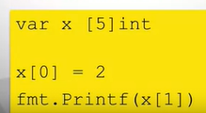

Array Literals:

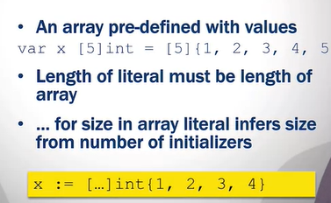

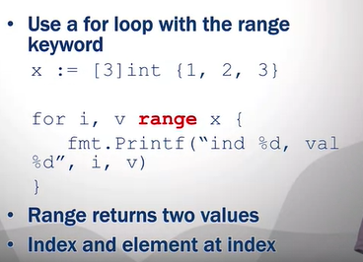With go, you can essentially use the enumerate function equivalent from python

#### M3.1.2 - Slices

Slices are like a window on a underlying array

Using … means undefined length

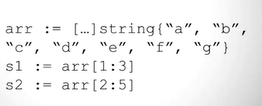

NOTE: end point of the slice is non-inclusive

#### M3.1.3 - Variable Slices

make() essentially lets you create the slice as a variable

size of slice can be increased by using append()

#### M3.2.1 - Hash Tables

* Key/value pairs
* Hash function is used to compute the slot for a key
* Faster lookup
  + Constant time (hash) vs linear time (list)
* Can have collisions

#### M3.2.2 - Maps

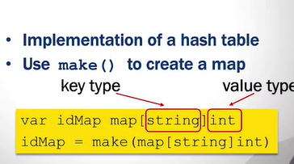

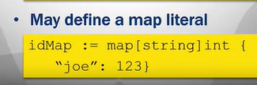

Acces values with [key]



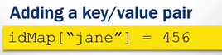

* This will also update the ‘jane’ value if it already exists

Delete a key with delete (idMap, ‘key’)

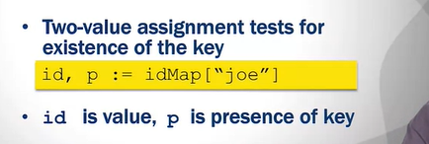

Iterating through a map:

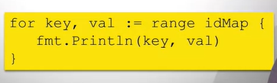

#### M3.3.1 - Structs

Example: Person Struct

Name, Address,Phone

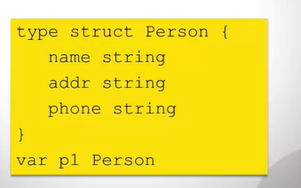

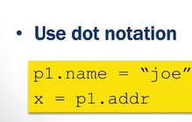

Initialization:

