**M4.1.1 - RFCs**

RFC 🡪 Requests for Comments

Definitions of Internet protocols and formats

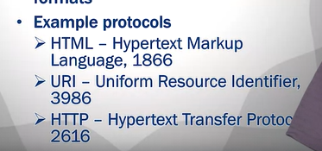

Golang provides packages for important RFCs

* Net/http
  + Web communication protocol
* “net”
  + TCP/IP and socket programming

JSON

* JavaScript Object Notation
* RFC 74159
* Attribute-value pairs

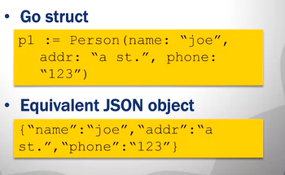

#### M4.1.2 - JSON

JSON Properties:

* All Unicode
* Readable
* Fairly compact representation
* Types can be combined recursively
  + Array of structs, struct in struct

JSON Marshalling

* Generating JSON representation from object

**Marshal**() returns JSON representation as []byte

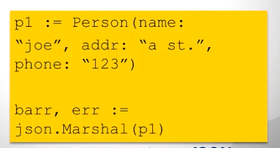

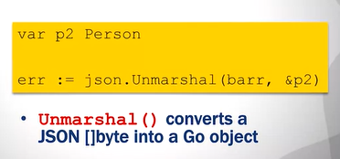

#### M4.2.1 - File Access, ioutil

Files:

* Linear access, not random access
  + Mechanical delay

Operations:

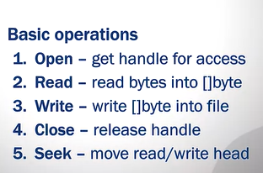

ioutil File Read

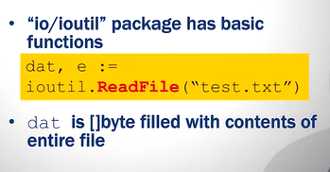

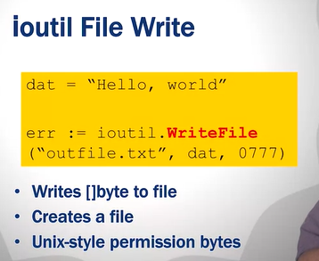

#### M4.2.2 - File Access, os

#### 

