Asynchronous vs. Synchronous
Asynchronous and synchronous flows, as the name implies is about processing the request in parallel or sequential. Asynchronous bpel lets a user invoke an instance of the bpel and allows user to use a callback activity to get the response at a later time. Synchronous bpel, however, will wait for the request to complete before continuing through the bpel. As long as the request complete before the default timeout parameter had reached. This parameter can be configured.
- Create a New BPEL Project
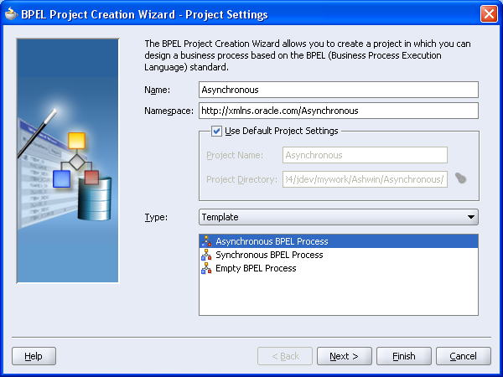
- Select Asynchronous Template' or ‘Synchronous’ Template and Click ‘Finish’
To invoke an asynchronous flow
- Create a invoke activity and associate to the partnerlink of the asynchronous flow
- Create a receive activity and associate to the partnerlink of the asynchronous flow
To receive from synchronous flow
- Create a receive activity and associate to the partnerlink of the synchronous flow

Invoke Asynchronous BPEL Receive Synchronous BPEL
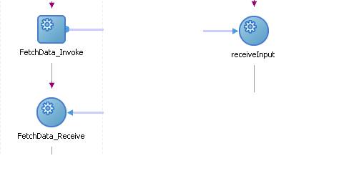
One might wonder, receive activity immediately following the invoke activity, how is it any different then invoking a synchronous bpel. This is why, it is better practice to create an ‘Asynchronous’ BPEL.
The only true use case for synchronous bpel is when you invoke the bpel from an external application. In this case, you do not have access correlation sets to invoke and receive from asynchronous bpel.

