Pabillon Dayne B, Paolo Bacolod, Leo Jake De Lo Cientos CSIT  
  
  
 **Player**: A player is an individual who participates in games. Each player has an ID, a name, and an email address.

**Machine**: A machine is used for playing games. Each machine has an ID, a name, and a description.

**Game**: A game is played by players on a machine. Each game has a unique ID, involves one or more players, is played on a machine, and takes place at a specific date and time. A game may also result in a player winning a prize.

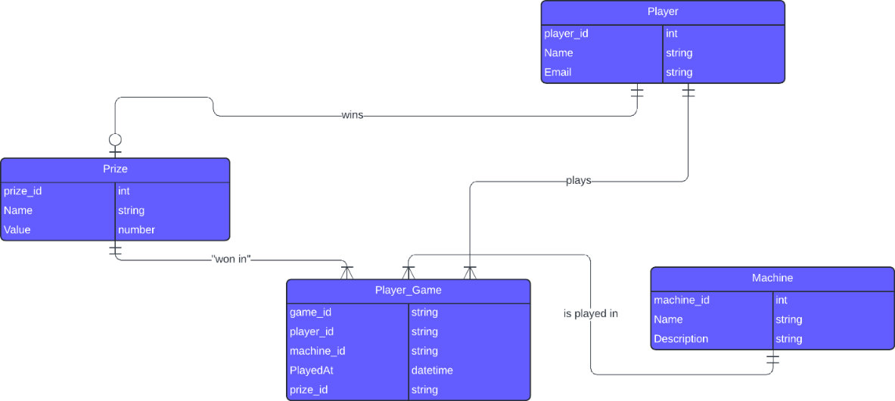 **Prize**: A prize is an item that can be won by a player in a game. Each prize has an ID, a name, and a value.  
 **Player_Game**: This table represents the relationship between players, games, machines, and prizes. It tracks which player played which game, on which machine, at what time, and if a prize was won.

