Software Design For A Robot To Assist Laparoscopic Surgery
Dayanne Fernandes da Cunha
Robotics and Automation Laboratory (LARA), University of Brasilia, Brazil
dayannefernandesc@gmail.com
Abstract. This paper presents a software design developed for a robot to assist laparoscopic surgery to be applied at Brazilian's public health system (SUS). It’s a modular system expandable and able to be applied in multiple environments since powerful open source and cross-platforms frameworks/libraries as QT, Julius and OpenCV was used. The application of a Portuguese acoustic model for voice recognition to control the robot is also a remarkable achievement.
Keywords: Software Design, Robotics, Laparoscopic Surgery, Voice Recognition

- Introduction
In the beginning of 1980s, laparoscopic surgery was migrated from diagnostic to a surgical procedure. Semm K. and Muehe E. are the medics that introduced this technique for a wide field of indications, e.g., appendectomy, cholecystectomy, reflux surgery, gastric surgery, urology [1].
Nowadays the use of robotic surgery system are becoming more common, its benefits are being studied all around the world. Robotic technology allows the surgeon to increase dexterity and the degree of maneuverability to perform complex tasks in a minimally invasive fashion way [2].
Laparoscopic surgery demands an operating surgeon to make the medical procedure and a camera driver to show the surgeon the location of the operative field. This structure come with lots of problems, e.g. conflicts about the optimum visualization, fatigue of the assistant who holds the camera [3], inaccurate movements, image tremors.
There are many projects to solve the problems about the fatigue during laparoscopic surgery, e.g., EndoAssist [4], Vicky [5]. These solutions are very expansive to apply into Brazilian's public health system (SUS). In this context, CLARA is a low-cost project created at LARA (Robotics and Automation Laboratory, University of Brasilia) to help the operating surgeon to procedure the surgery.
CLARA's project was designed to help the operating surgeon to perform the procedure with full control of the tools through effective interfaces, voice recognition and a joystick linked with the laparoscopic grasper.
To be possible the application of the software into SUS, compatibility, modularity, fault-tolerance, security, usability, performance and maintainability were topics considered during the software modeling process. This paper shows a software designed to assist laparoscopic robot surgery with all the aspects cited above.
- Methods
- Results
  - Overview

An overview of CLARA software is illustrated at Fig. Qt5 [7] is used as the main framework of the system. QT is an open source (LGPL [8]), cross-platform framework with a thread library that helps control the asynchronous modules and a GUI component to produce its visualization.

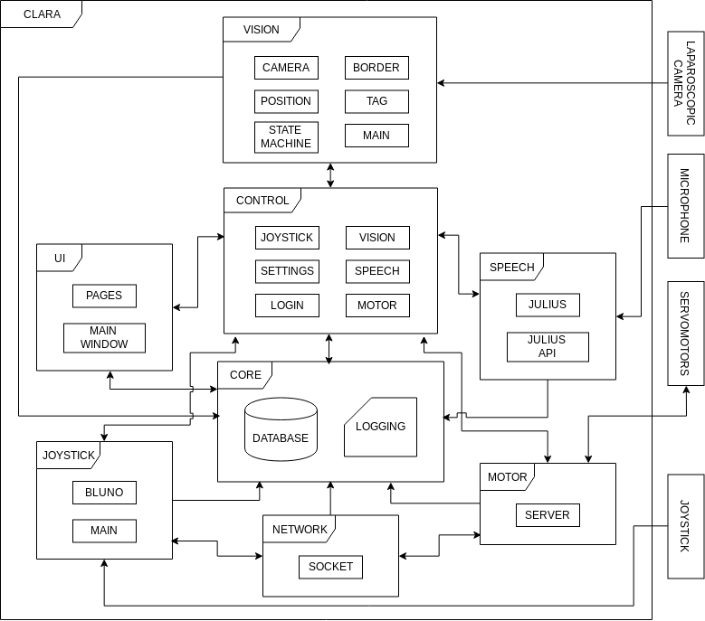
Fig. 1: CLARA software design overview.

  - Modules

VISION. This module is responsible to estimate the 2D pose of a single instrument tip [11] using OpenCV and Boost's libraries.

CONTROL.

JOYSTICK.

CORE.

NETWORK.

MOTOR.

SPEECH. The voice control was compared with foot pedal interface, and they concluded that voice control was more accurate and had the advantage of not requiring the surgeon to look away from the operative field [6]. Julius [9] is a open-source (GPL [10]) speech recognition.

UI. The usability and user experience was put as a priority to produce CLARA's software.

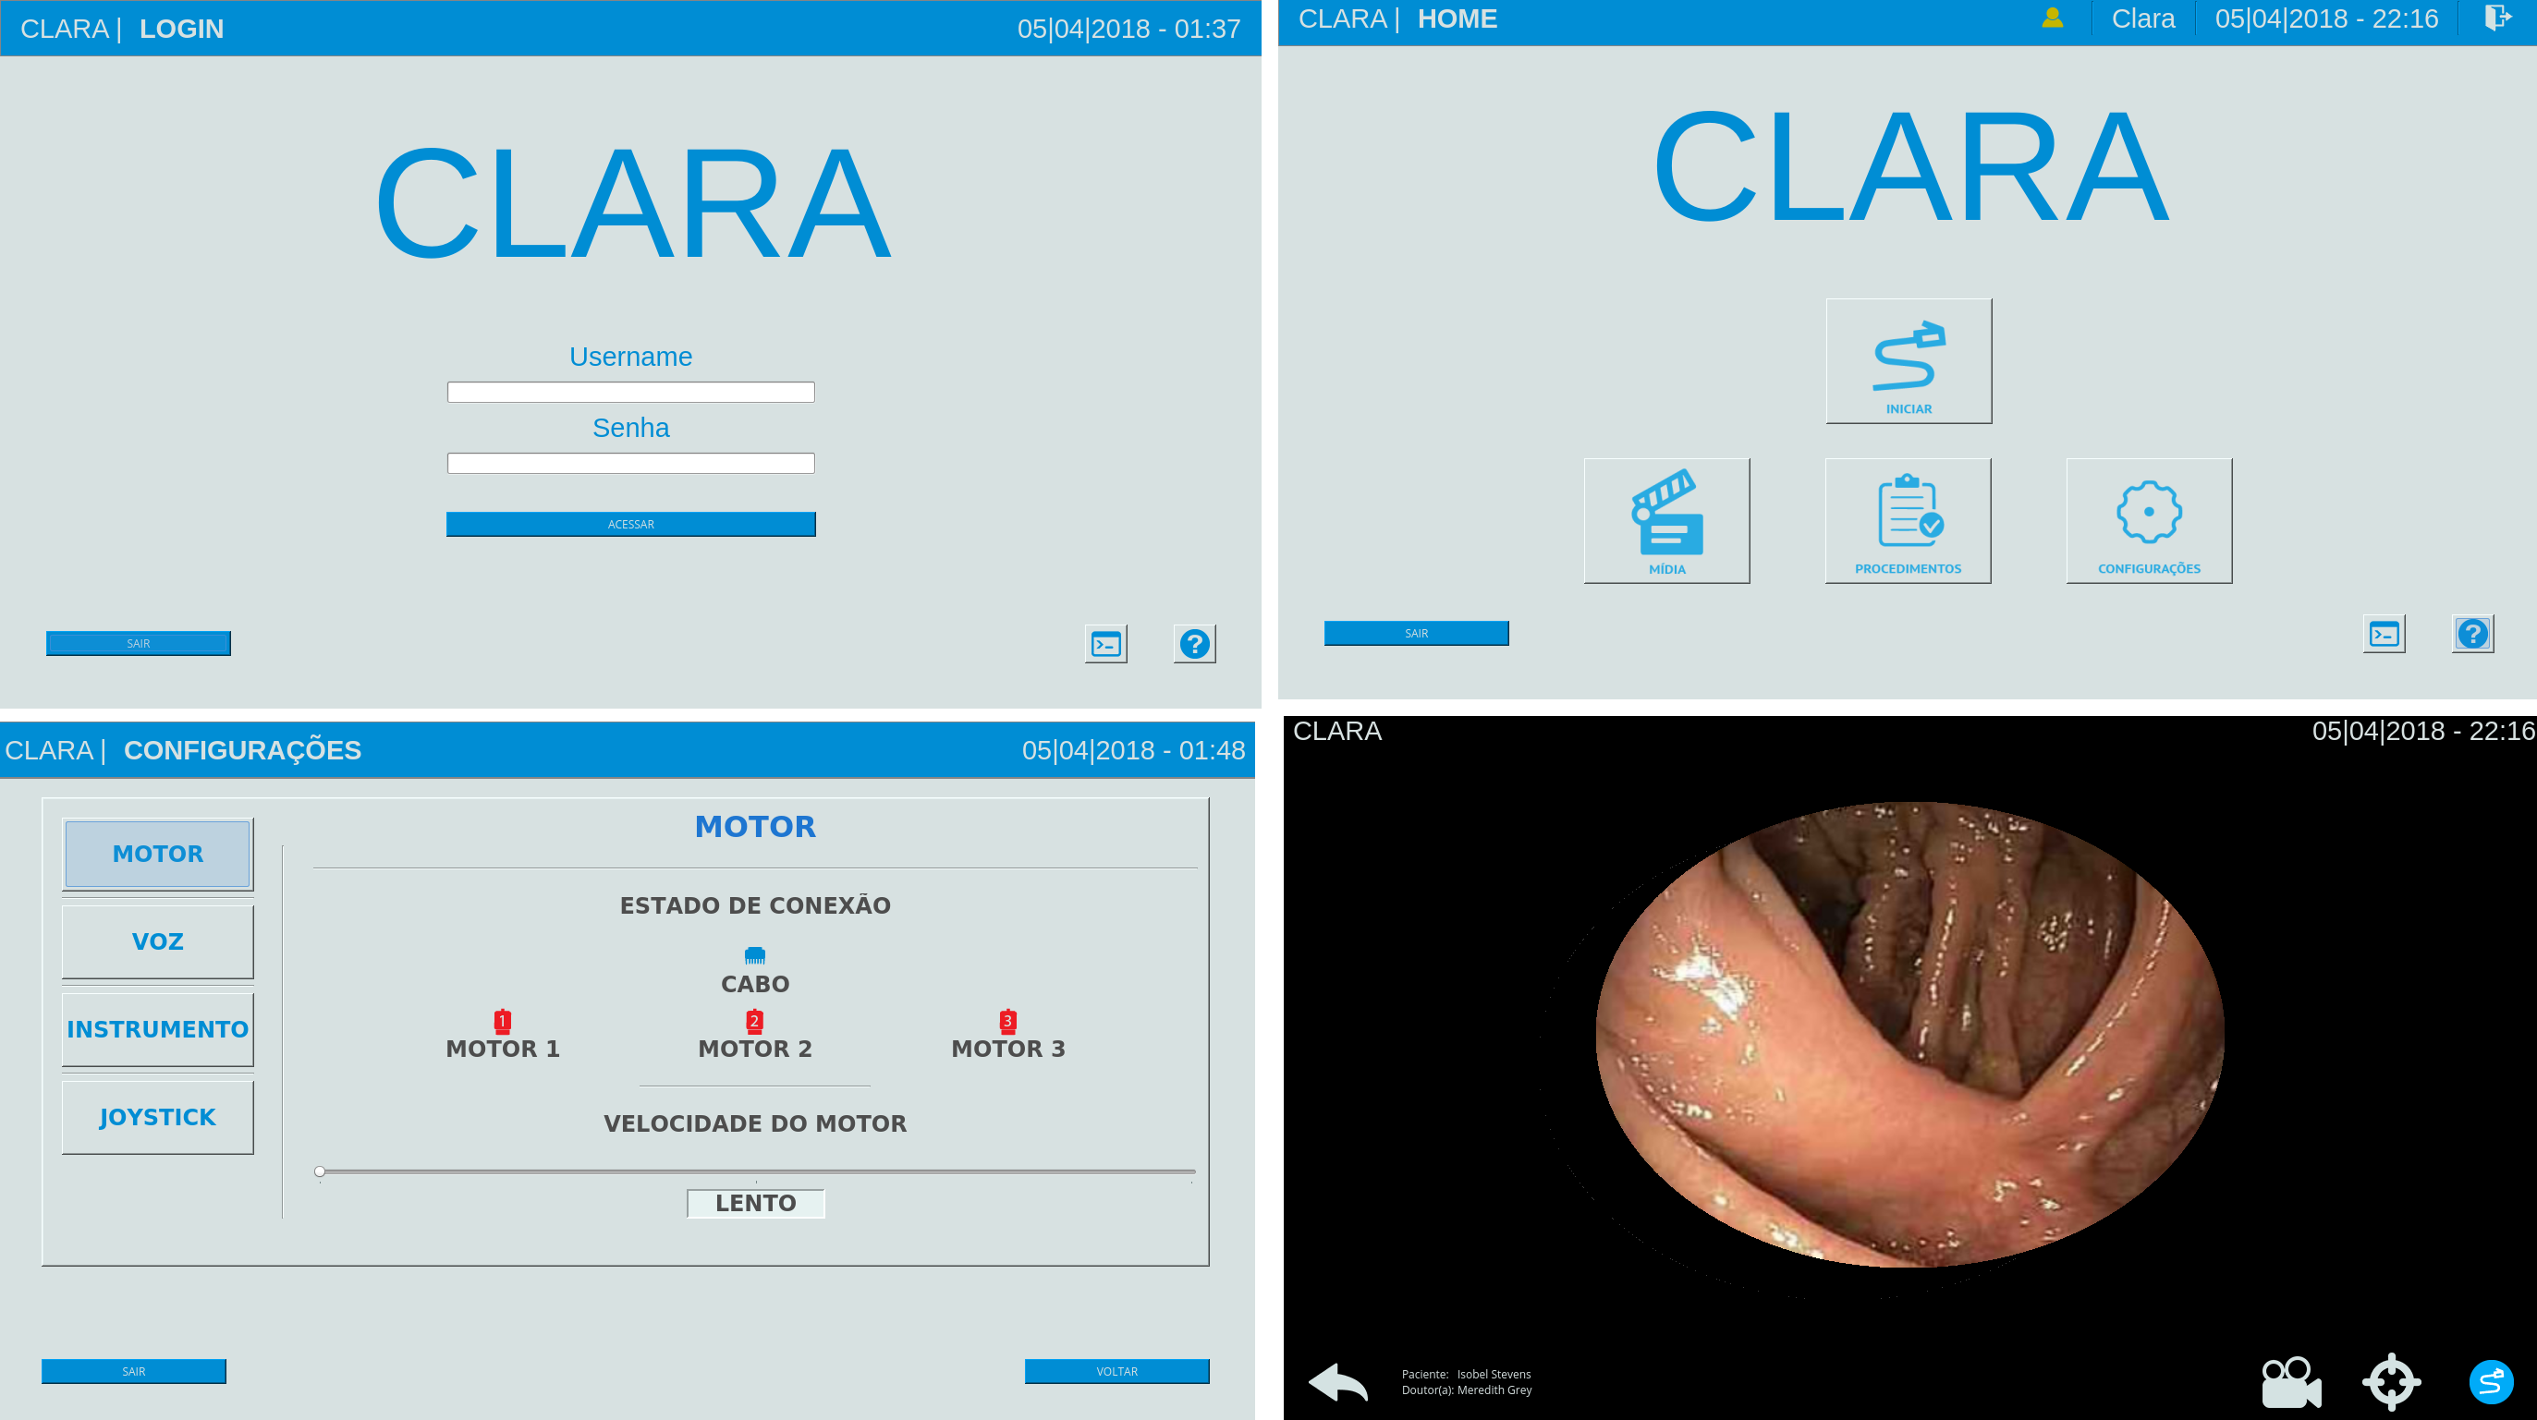

- Future work

- Conclusion

Develop a software to be applied in a public hospital in Brazil demands a few worries, e.g. use cross-platforms frameworks since we don't know the operating system used on hospital machines or its computer architecture, choose open source frameworks and libraries to help achieve the low-cost aim.
CLARA software covered all the attributes above using Julius and QT frameworks.

- Acknowledgements

CLARA project is funded by the Brazilian Ministry of Health (Term of Cooperation no 121/2013, Process 25000.169843/2013-83).

References
- Buia, A., Stockhausen, F., Hanisch, E.: Laparoscopic surgery: A qualified systematic review. World J Methodol, 5(4):238–254 (2015).
- Singh, I.: Robotics in urological surgery: Review of current status and maneuverability, and comparison of robot-assisted and traditional laparoscopy. Computer Aided Surgery, 16(1):38–45 (2011). PMID: 21198426.
- Liu, S., Hemming, D., Luo, R. B., Reynolds, J., Delong, J. C., Sandler, B. J., Jacobsen, G. R., Horgan, S.: Solving the surgeon ergonomic crisis with surgical exosuit. Surg Endosc, 32(1):236–244 (2018).
- Kommu, S. S., Rimington, P., Anderson, C., Rane, A.: Initial experience with the EndoAssist camera-holding robot in laparoscopic urological surgery. J Robot Surg, 1(2):133–137 (2007).
- Long, J. A., Cinquin, P., Troccaz, J., Voros, S., Berkelman, P., Descotes, J. L., Letoublon, C., Rambeaud, J. J.: Development of miniaturized light endoscope-holder robot for laparoscopic surgery. J. Endourol., 21(8):911–914 (2007).
- Wagner, A. A., Varkarakis, I. M., Link, R. E., Sullivan, W., Su, L. M.: Comparison of surgical performance during laparoscopic radical prostatectomy of two robotic camera holders, EndoAssist and AESOP: a pilot study. Urology, 68(1):70–74 (2006).
- Nokia Corp. Qt : cross-platform application and ui framework (2012).
- Gnu lesser general public license, version 3, http://www.gnu.org/licenses/lgpl.html, last accessed 2018/04/05.
- Akinobu, L., Tatsuya, K.: Recent development of open-source speech recognition engine julius. In Proceedings: APSIPA ASC: Asia-Pacific Signal and Information Processing Association, Annual Summit and Conference, International Organizing Committee, 131–137 (2009).
- Gnu general public license, version 3, http://www.gnu.org/licenses/gpl.html, last accessed 2018/04/05.
- Vergara, R. F., Miranda, G. M., Perruci, P. H. S., Bernardes, M. C.: Edges based surgical instrument tracking in laparoscopic images. XXV Brazilian Congress on Biomedical Engineering, 1223–1226 (2016). ISSN: 2359-3164.

