MIT 8103 Advanced Database Systems
Individual Practical Database Portfolio: documentation (2026/2027, first semester)
Student: Temidayo Michael Ige Matric number: 2026/A/MIT/0316
GitHub repository (public): https://github.com/Dayoscape/advanced-database-portfolio
The repository is public because I could not obtain the assessor’s GitHub username to invite them to a private repository, so that the assessor can open it without an invitation.

1. Selected case study: ShopCave
Scenario. ShopCave is a simulated multi-seller online marketplace for Nigeria. Sellers list products, customers place orders and pay by card, bank transfer or pay on delivery, and orders are delivered by state. All data is synthetic.
Users: customers, sellers, delivery agents, administrators and analysts. Major data: customers and addresses, sellers, categories, products with varying attributes, stock, orders and order items, payments, deliveries and reviews. Key operations: browse and search products, place an order (reserve stock and take payment), track delivery, seller sales reports and a customer’s order history.
Environment. PostgreSQL 16 and MongoDB 7 in Docker on Windows; a free Neon (PostgreSQL 18) project for the cloud exercise. The same case study is used in all five portfolios.

2. The five portfolio activities

Portfolio 1: database design and modelling
I started from one unnormalised order spreadsheet and normalised it step by step to third normal form, giving 10 tables: customers, addresses, sellers, categories, products, orders, order_items, payments, deliveries and reviews, with primary and foreign keys and CHECK constraints (for example stock_qty >= 0). order_items keeps its own unit_price as the price at the time of sale, so later price changes do not rewrite old orders, and the order total is calculated, not stored, to avoid inconsistent copies. I loaded the schema into a real PostgreSQL database and saved screenshots and an ER diagram (Appendix A).

Portfolio 2: query processing and optimisation
I generated about 500,000 orders and 1.25 million order items and wrote five queries (customer history, top products in a month, stale pending orders, seller delivery failures, best-rated products). With EXPLAIN (ANALYZE, BUFFERS) I recorded plans before and after adding indexes. A composite index on orders(customer_id, placed_at) cut Q1 from 25.5 ms to 3.4 ms, and a partial index on pending orders cut Q3 from 30.3 ms to 0.28 ms. Q2, Q4 and Q5 did not improve, because they read most of a large table, and a covering index for Q5 was never used even after VACUUM. Repeated runs of Q2 varied from 197 to 840 ms with the same plan, so I treat small differences as noise.

Portfolio 3: transactions and concurrency
I demonstrated commit and rollback (a failed payment restores the stock and removes the order). Without locking, two buyers both read stock = 1 and both placed an order: two orders for one unit, a lost update. SELECT ... FOR UPDATE made the second buyer wait, then see stock = 0 and be rejected. Under READ COMMITTED a transaction read a price of 1000 and then 1500 after another session committed; under REPEATABLE READ it read 1000 both times. Two sessions locking two products in opposite order caused PostgreSQL to report a deadlock and abort one; locking in a consistent order removed it.

Portfolio 4: NoSQL and advanced data models
I modelled the catalogue in MongoDB, where phones, laptops, shirts and shoes each carry different attributes, with the latest reviews embedded, and orders as documents with embedded items, address and payment. This avoids a table of NULLs or an entity-attribute-value design. Stock and payments stay in PostgreSQL because they need strict consistency. With 100,000 products and orders, indexes cut the documents examined from 100,000 to 2 for a customer’s order history and to 1,207 for black size-M shirts. A tag filter matching 27% of products barely improved. Timings varied between two runs, so I rely on documents examined.

Portfolio 5: distributed and cloud databases
I built a streaming replica of the PostgreSQL primary. It held all 500,000 orders, rejected writes with a read-only error, and caught up with a 200,000-row burst in about a second. When I stopped the primary and promoted the replica it accepted writes, but the old primary then lacked the new row (the servers had diverged, as in split brain). Range partitioning orders by quarter let the planner skip 8 of 10 partitions, and dropping an old partition took 2.9 ms against 81 ms for the same DELETE; hash partitioning by customer gave four evenly sized shards. On Neon’s free plan the same schema loaded unchanged, with a 6-hour restore window and manual snapshots; scheduled snapshots and the read-replica option I did not test. I discuss which ShopCave data needs consistency (stock, payments) and which can be eventually consistent (catalogue, reviews).
Portfolio | Key evidence (from my runs) | Main finding
1 Design | 10 tables, 3NF, loaded into PostgreSQL 16 without errors | Price at time of sale is kept in order_items on purpose; no stored order total
2 Queries | 500k orders, 1.25M items. Q1 25.5 ms to 3.4 ms; Q3 30.3 ms to 0.28 ms | Indexes helped selective queries; Q2, Q4, Q5 did not improve
3 Transactions | Oversell: 2 orders for 1 unit; deadlock detected | FOR UPDATE and a fixed lock order fixed both problems
4 NoSQL | MongoDB, 100k products and orders; order history 93 / 997 ms to 1 ms | Documents suit varying attributes; fewer documents examined is the reliable measure
5 Distributed | Replica streaming; failover; 8 of 10 partitions pruned; Neon cloud | Async replication can diverge on failover; cloud free plan limits backups

3. Individual technical reflection
Design choices. I chose a marketplace because it supports every portfolio: relationships to normalise, volume to index, stock contention for transactions, varying product attributes for NoSQL, and a natural split between data that needs consistency and data that does not. I kept the price at the time of sale and avoided a stored total so that each fact is held once.
Challenges. Docker would not start until I enabled the Windows Virtual Machine Platform feature and restarted Windows. In Portfolio 2 I expected indexes to help every query, but three of five did not, and my guess that VACUUM would fix the covering index was wrong. My first partition test compared a partitioned copy without an index against an indexed table, so it was not a fair comparison and I reported it as such. A replication demo also failed once because the replica needed about 20 seconds to finish recovery.
Lessons. An index helps when a query picks a small part of a table, and I must check with EXPLAIN that it is used. One timing is unreliable, so I repeat measurements and prefer counts such as rows or documents examined. Locking and ordering decide whether concurrent updates are safe. Replication and partitioning each trade speed or availability against consistency. I also learned to commit and collect evidence as I go.
Hardest part and what I would change. The hardest part was getting the tools working, not the database theory: Docker needed a Windows feature, PowerShell blocked my scripts until I allowed them for one session, and the cloud connection string had to be quoted because it contains an ampersand. Next time I would check the environment first and keep a short setup note. I would also repeat every benchmark several times from the start, because my first single timings were misleading.

4. AI use declaration
Tool: Claude (Anthropic), used through Claude Code.
Used for: suggesting and scaffolding the case study and repository; drafting the schema, and helping install and troubleshoot Docker.
How I reviewed and verified it: I ran the schema, demos and benchmarks on my own machine and saved the outputs and screenshots in the repository. I ran the oversell, deadlock, replication and MongoDB index demos and took the screenshots myself, and I created the Neon project and loaded the schema myself. Where results differed from what the AI had written (for example MongoDB timings) the documents were corrected to match my runs. I chose the case study and its name (ShopCave), retook a screenshot that showed a database password and reset that password, and rejected unsuitable early output (for example failed replication screenshots taken before the replica was ready). I understand that I remain responsible for the accuracy of everything I submit.

5. References
- PostgreSQL Global Development Group (2024) PostgreSQL 16 Documentation: Table Partitioning; Explicit Locking; Transaction Isolation; High Availability, Load Balancing and Replication. https://www.postgresql.org/docs/16/
- MongoDB Inc. MongoDB Manual: Data Modeling; Indexes; explain results. https://www.mongodb.com/docs/manual/
- Neon. Neon Documentation: Backup & Restore; Compute and autoscaling. https://neon.com/docs
- Docker Inc. Docker Desktop and Docker Compose documentation. https://docs.docker.com/
- Codd, E. F. (1970) A relational model of data for large shared data banks. Communications of the ACM, 13(6), 377–387.
- Gilbert, S. and Lynch, N. (2002) Brewer’s conjecture and the feasibility of consistent, available, partition-tolerant web services. ACM SIGACT News, 33(2), 51–59.
- School of Postgraduate Studies (2026/2027) MIT 8103 Advanced Database Systems: First Semester Continuous Assessment brief (Individual Practical Database Portfolio).

Appendix: supporting evidence (full-size files are in the GitHub repository)
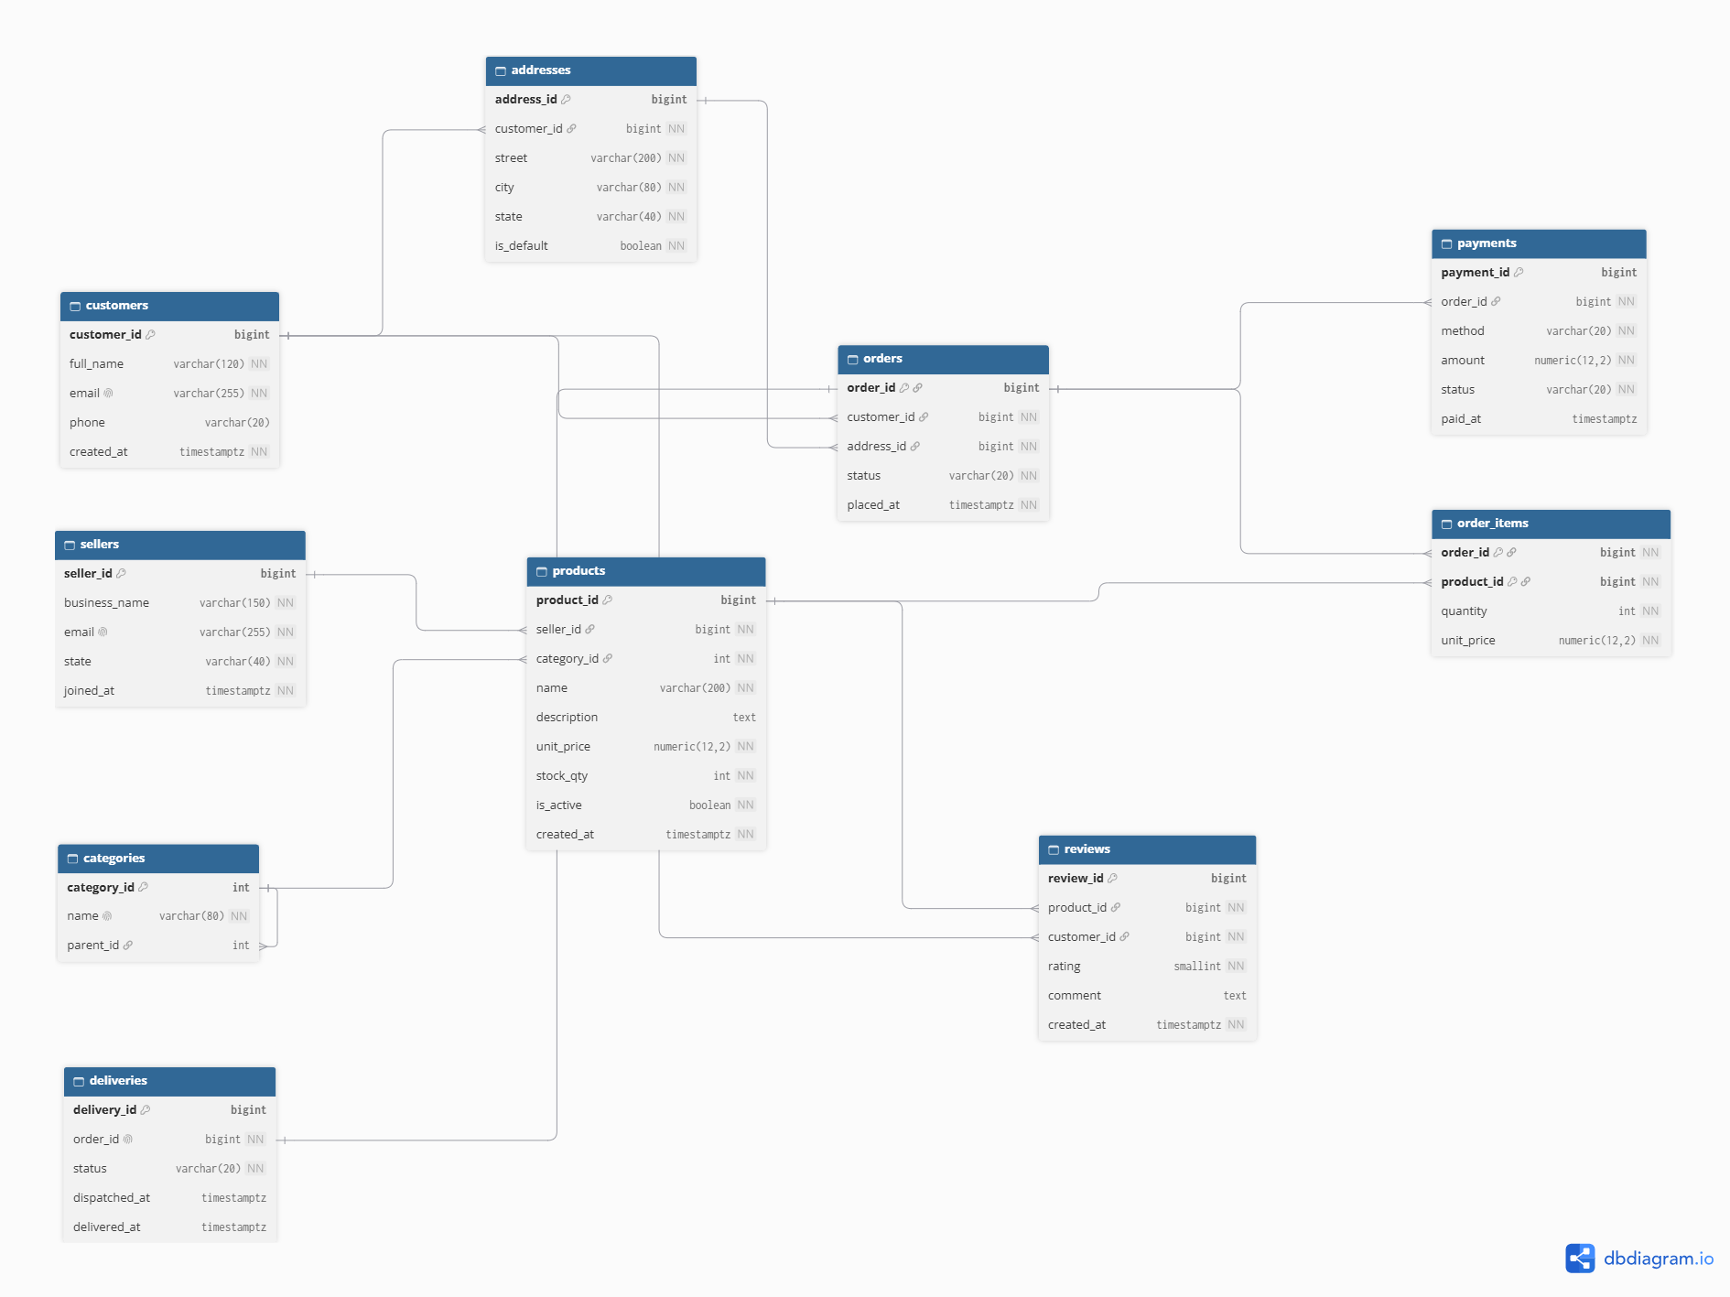  A1. ER diagram of the ShopCave schema (Portfolio 1) | 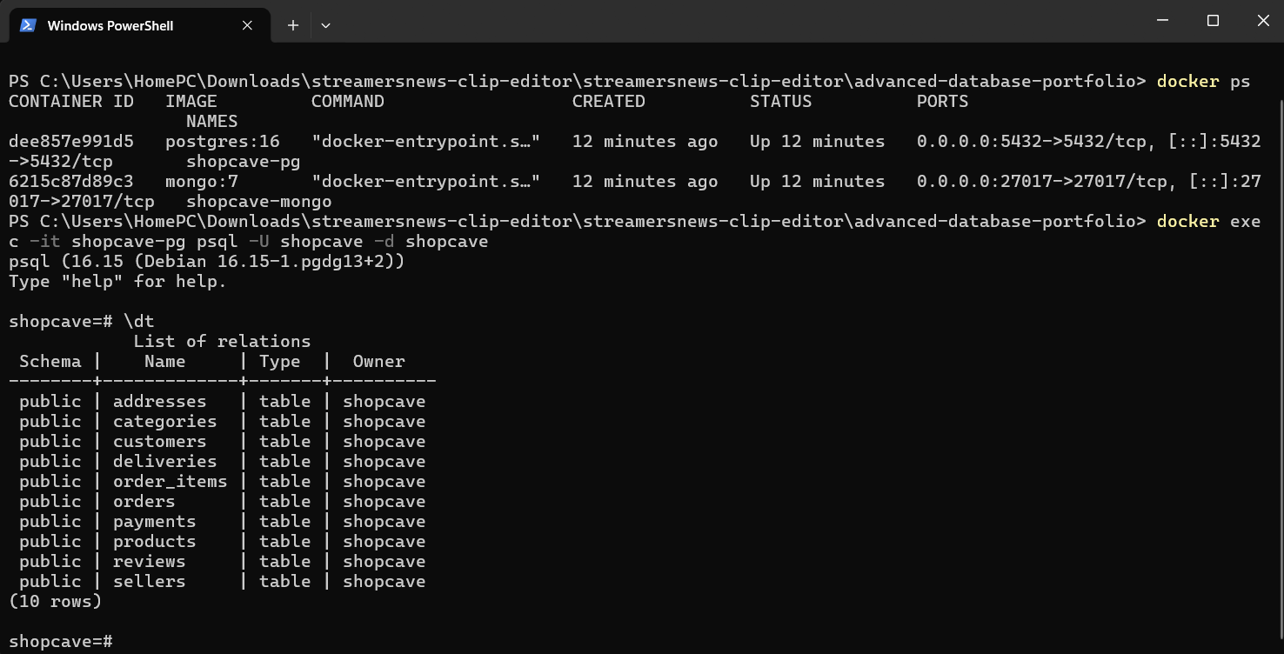  A2. docker ps and \dt: 10 tables created in PostgreSQL 16 (Portfolio 1)
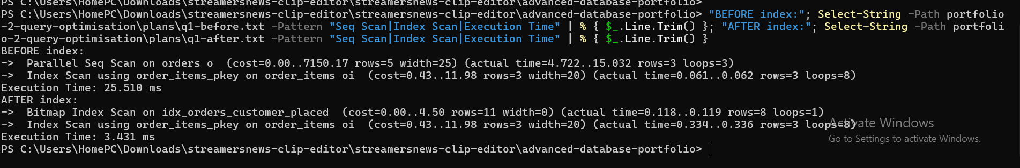
A3. Q1 plan before (Parallel Seq Scan, 25.5 ms) and after the index (Bitmap Index Scan, 3.4 ms) (Portfolio 2)
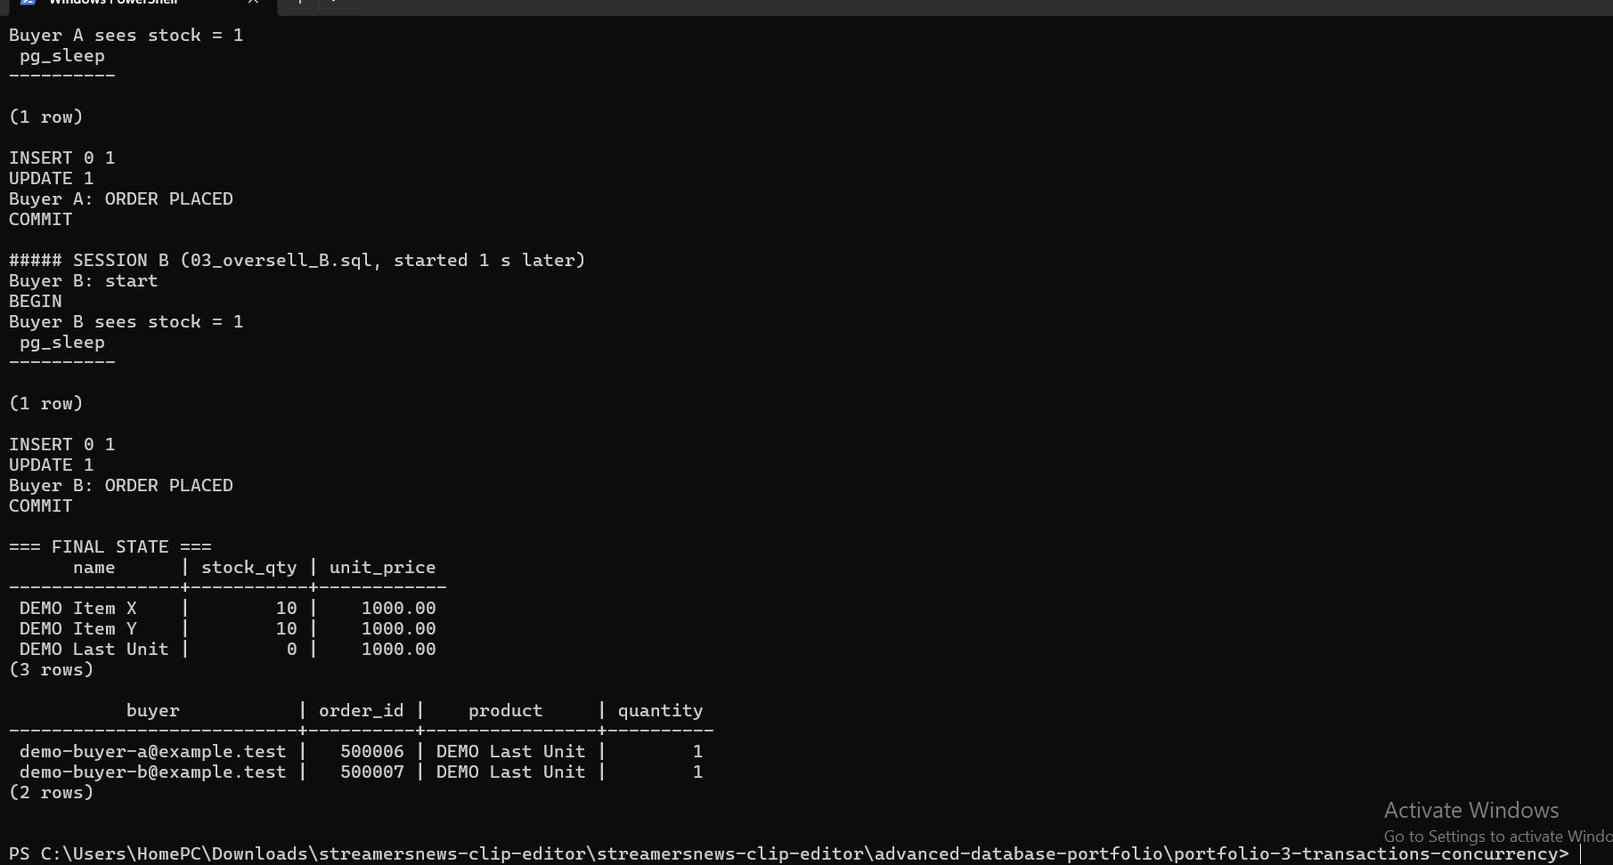  A4. Two buyers both get the last unit: 2 orders, stock 0 (Portfolio 3) | 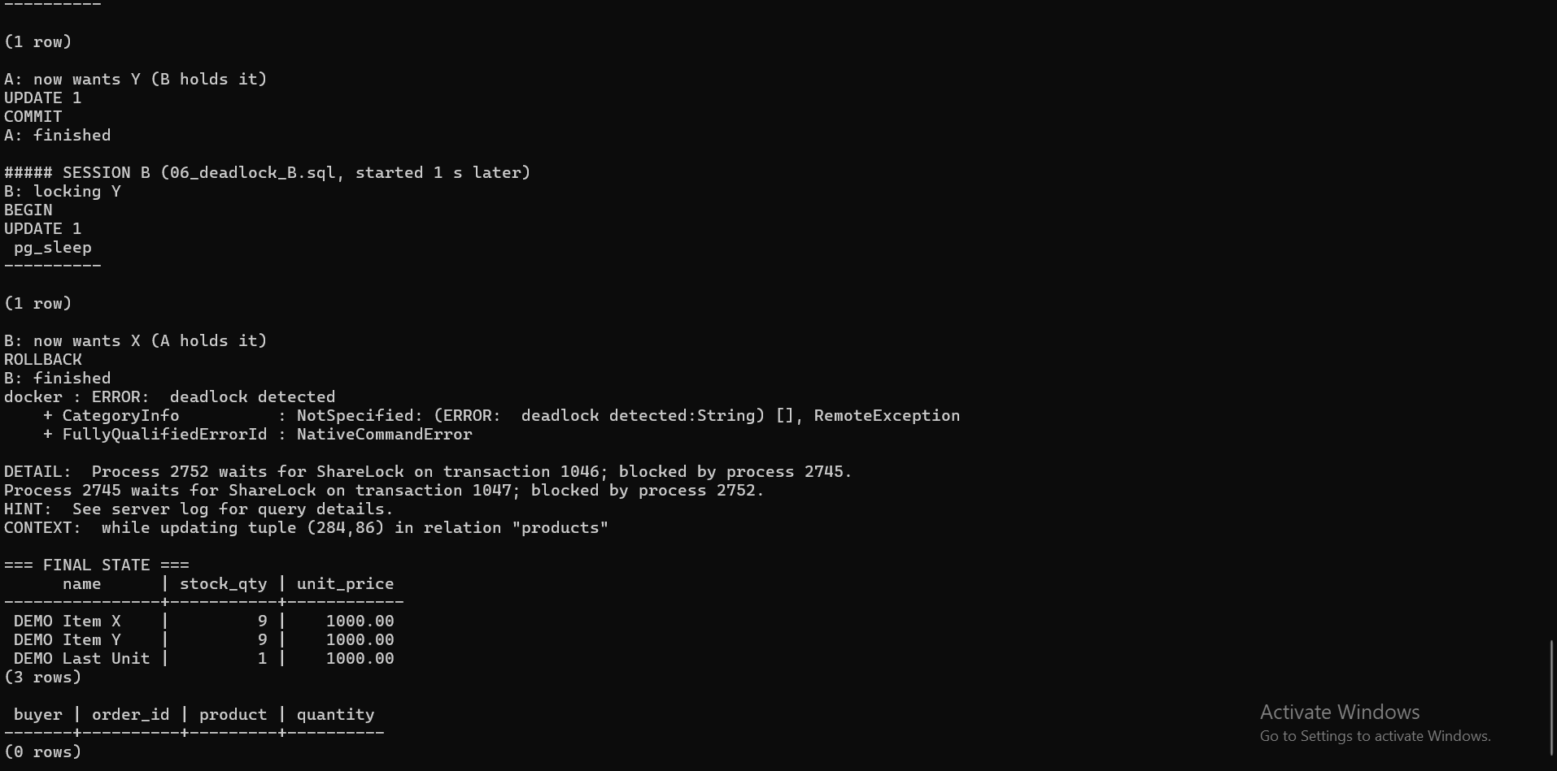  A5. PostgreSQL reports "deadlock detected" and aborts one session (Portfolio 3)
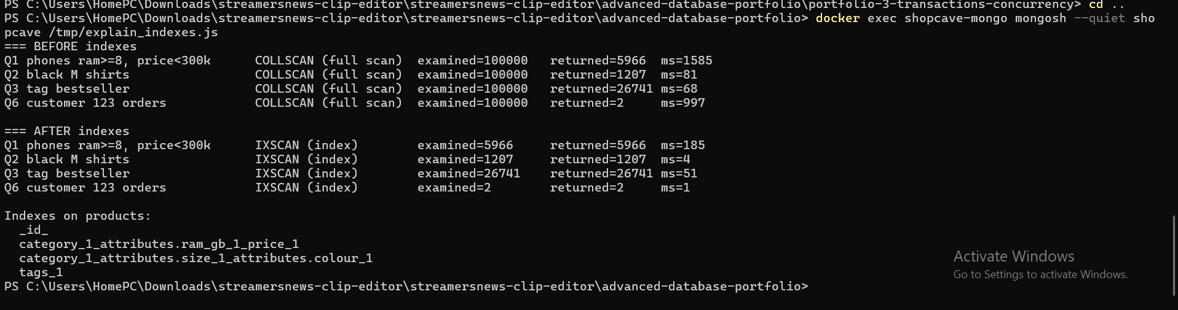
A6. MongoDB explain: COLLSCAN before, IXSCAN after indexes (Portfolio 4)
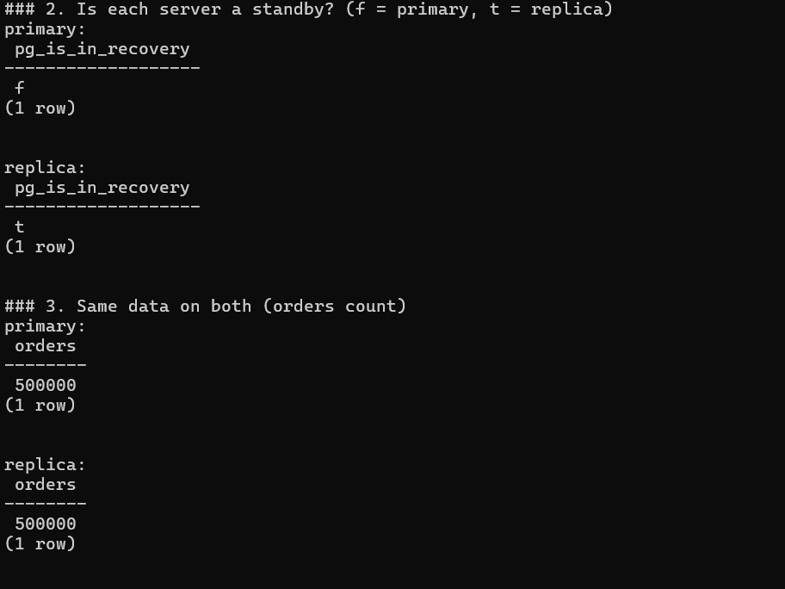  A7. Primary (f) and replica (t) both hold 500000 orders (Portfolio 5) | 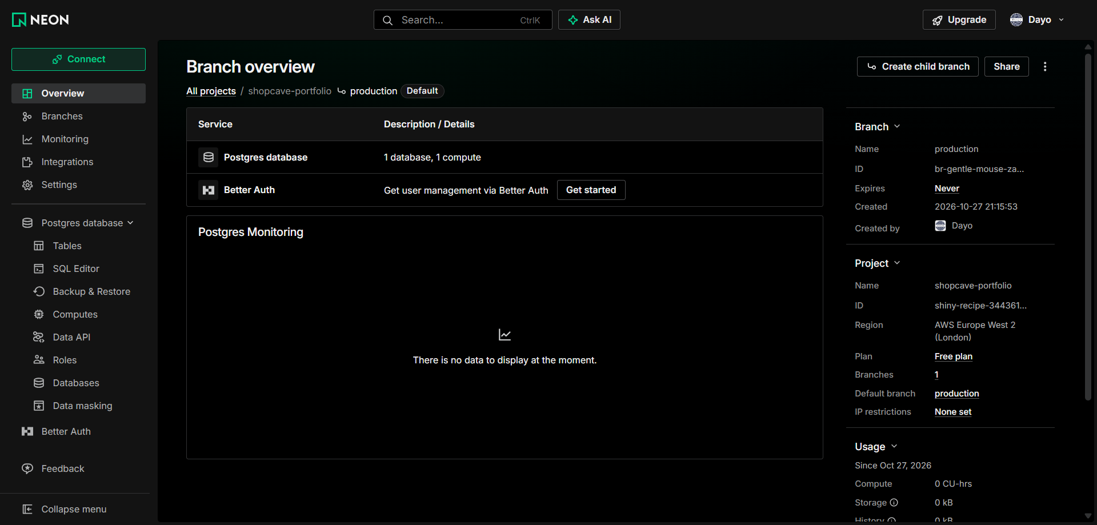  A8. Neon project on the Free plan, AWS London (Portfolio 5)
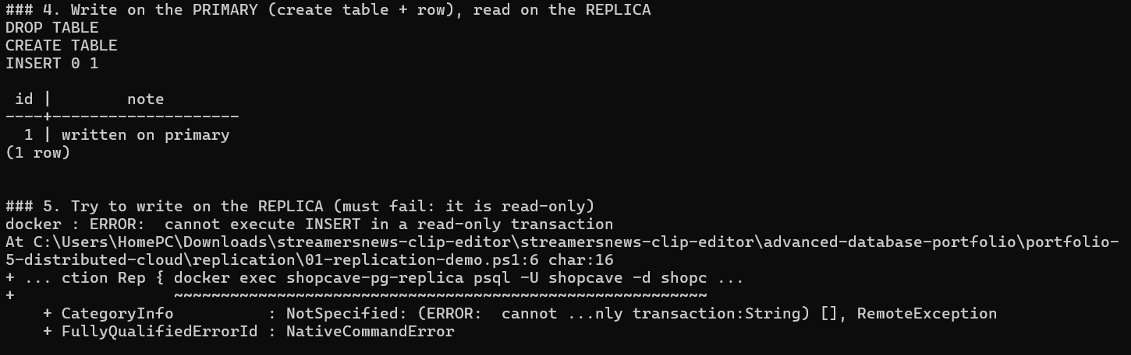
A9. A row written on the primary appears on the replica; a write to the replica is rejected (Portfolio 5)

