

**Introduction to Database System (Lab)**

**Spring 2023**

# **Final Term Lab**

# **VERSION I**

**Time Allowed: 90 min**

|  |  |
| --- | --- |
| Name: |  |
| Registration No |  |
| Serial Number (of attendance sheet) |  |

|  |  |  |  |
| --- | --- | --- | --- |
|  | DDL | DML | Total |
| Total Marks | 20 | 30 | 50 |
| Ob. Marks |  |  |  |

**Instructions:**

1. **This is a closed book, closed notes paper.**
2. **Understanding questions is part of the paper**. Therefore, no queries will be entertained during examination.
3. **chess.sql** file is uploaded on teams/portal. Use those files to attempt the DML section of paper.
4. Use proper indentation/formatting while writing queries. Not properly indenting will deduct 5% marks.
5. **You need to make an MS Word with your name and registration should be mentioned on each page.**
6. **You need to write only queries with output in MS Word file, you need to write query (text form) + its output table (picture) if any.**
7. **You will solve the DDL + DML section only in word docx.**

# **Part 1 DDL** **[20 Marks]**

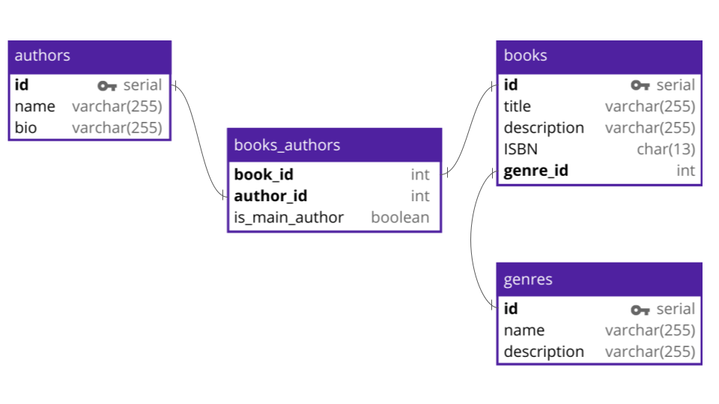

**Q#1:** Implement all the table with its attributes. Make primary keys in all tables (Without foreign keys).

**Q#2:** Alter **books** and **books_authors** tables and add foreign keys by altering these tables.

**Q#3:** Add a column ABC (data type must be char(255)) in the **genres’s** table.

**Q#4:** Change the data type of ISBN from char to varchar (255).

**Part 2 DML**  **[30 Marks]**

**Import chess.sql schema.**

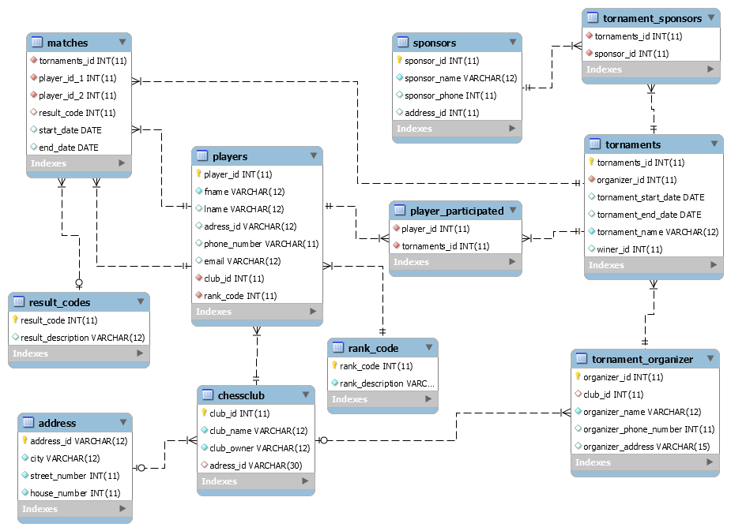

**Solve the following questions from the above schema:**

**Q#1:**

Write a query to display the count of tournaments sponsored by Mr. Azhar.

**Note: [use Join]**

**Q#2:**

**Write a query to display the ID, first name, and last name of players who play for the club "Ned Chess" and have the club organizer named "Hafiz Asif"**

Note: **[use correlated query]**

**Q#3:**

Create a view that displays the names of players who have played the maximum number of matches.

**Q#4:**

Write a query to display the details of players who have participated in more than one tournament, including the tournament name, tournament sponsor name, and the name of the organizer.

**Q#5:**

Write a query to print the count of players who participated in the tournament named 'Grand Master'

**Note: [use nested query]**

**Q#6**

Create a stored procedure that displays the names of players as participants along with their rank description for all players who participated in a tournament with an end date in the year 2002. Also, call the procedure.