

**Introduction to Database System (Lab)**

**Spring 2023**

# Final Term Lab

# VERSION II

**Time Allowed: 90 min**

|  |  |
| --- | --- |
| Name: |  |
| Registration No |  |
| Serial Number (of attendance sheet) |  |

|  |  |  |  |
| --- | --- | --- | --- |
|  | Q1 | Q2 | Total |
| Total Marks | 25 | 25 | 50 |
| Ob. Marks |  |  |  |

**Instructions:**

1. **This is a closed book, closed notes paper.**
2. **Understanding questions is part of the paper. Therefore, no queries will be entertained during examination.**
3. **NorthWind.sql file is uploaded on teams/portal. Use those files to attempt the DML section of paper.**
4. **Use proper indentation/formatting while writing queries. Not properly indenting will deduct 5% marks. 5) You need to make an MS Word with your name and registration should be mentioned on each page.**
5. **You need to write only queries with output in MS Word file, you need to write query (text form) + its output table (picture) if any.**

# Question 1: DDL Marks (25)

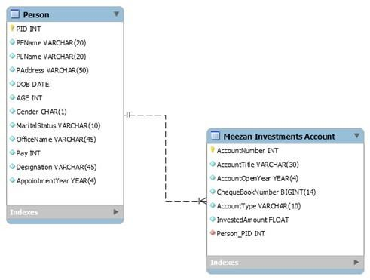

**Q1)** Implement the above schema. Create the tables and the relationship between them.

**Q2)** Alter the table **Person** and change the data type of **Pay** from **INT** to **BIGINT. Q3)** Remove the attribute **Marital Status** from the **Person** table.

**Q4)** Add a column **Branch Number** to the table **Meezan Investments Account** (Data type must be varchar(30))**.**

**Q5)** Drop all the data from the table **Person** from the schema.

# Question 2: DML Marks (25)

# Note: Import northwind schema and solve the below questions

**Question 1**

**Write a stored procedure that retrieves the names of customers whose orders have a shipped date in a specific year. The stored procedure should accept the year as a parameter.**

**Hint: [Use EXISTS operator]**

**Question 2**

Create a view named “ProductOrderStats” that displays the name of every product along with the minimum, maximum, average, and total quantity ordered in all orders.

**Note: [Use Join]**

**Question 3**

Write a co-related query that display name of those customers whose at least one order has status id equals to zero.

**Hint: [Use EXISTS operator]**

**Question 4**

Display Name of all products with total amount of all its purchased till now.

**[Use Joins. No cross product / Co-related sub query / nested subquery is allowed.]**

**Hint: You will use products and purchase_order_details table to solve this query.**

**Question 5**

Display name of all products categories with minimum, maximum, average and sum of list_price of product belongs to it.

**Note: [You need to make one query that display all above values, not separate/individual query]**