**University of Central Punjab**

Assignment # 3

**Time & Date Deadline**: 2nd June, 2022 11:59 PM

**Course**: Programming Fundamentals (PF)

# Submission Instructions:

1. You have to submit 1 zip file containing:
   * MS word document containing C++ programs with screen shot of console
   * .cpp file of the program and input files where required
2. You have to upload your assignments on CMS.
3. Plagiarism is not acceptable. If someone’s assignment is plagiarized, that student will be given F straight away, so beware.
4. The deadline for this assignment is **June 2nd, 2022, 11:59 pm**. No late submission will be accepted.

**Learning Objectives:** Demonstrate knowledge of pointers and dynamic memory allocation/deallocation in programming(C++).

**Task 1:**

Write a program in C++ that reads integers from a file into an array (dynamically created) and shifts all even numbers in ascending order to the left and odd numbers in descending order to the right side.

**Sample Output:**

Updated Data:2 8 10 14 82 21 15 9 3 1

14 2 3 15 1 82 8 9 10 21 55 12 14 16 18

**data.txt**

**Note:** Use only one array and make necessary and required changes to it only.

**Screenshot of console:**

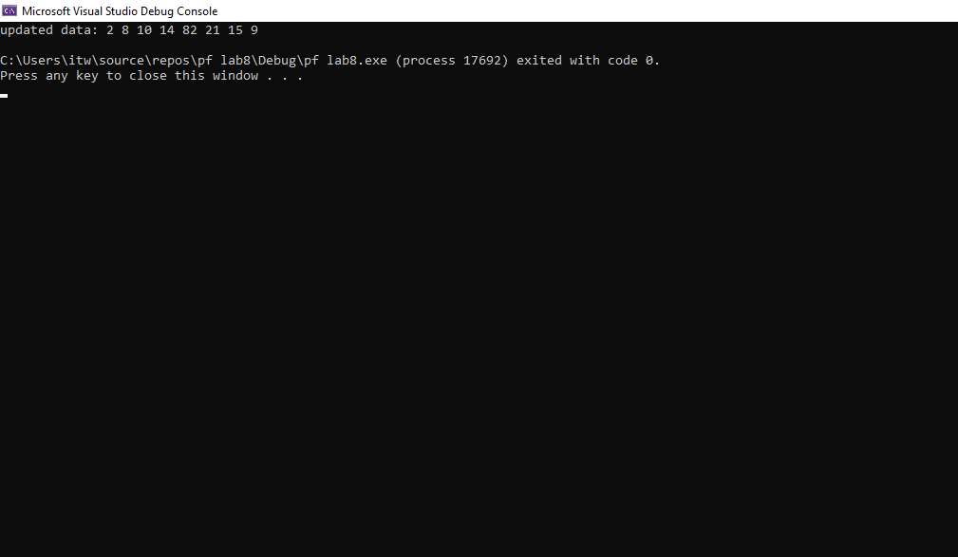

**Task 2:**

Write a program in C++ that reads data from user into a dynamically growing array until user enters 0. Separate 1-digit and 2-digit numbers from the given data and store them in separately growing dynamic arrays.

**Sample Output:**

Input Data: 2 3 15 1 82 8 9 10 21 55 12 14 16 18 0

One-digit: 2 3 1 8 9

Two-digit: 15 82 10 21 55 12 14 16 18

**Screenshot of console:**

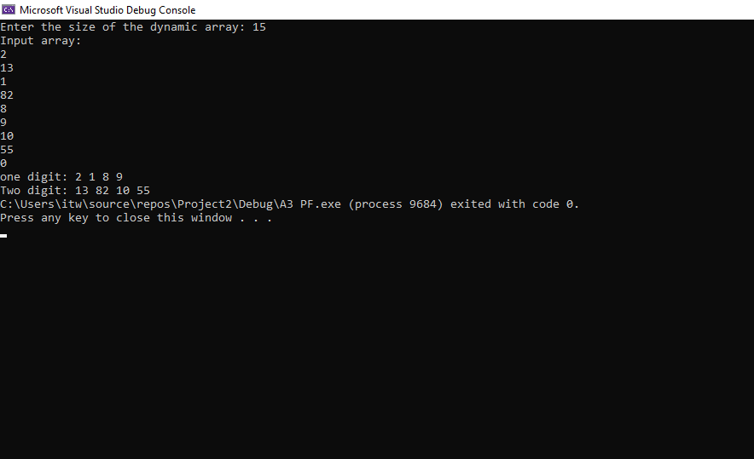

🡨--------------------------------------------------------------------------------------------------🡪

***“When you are not practicing, remember somewhere someone is practicing, and when you meet him, he will win.”***