|  |
| --- |
| <> Executive Summary |
| Group Member Richa Pahuja (s5353290), Dayyan Ahmed (s5280098), Zekun Liu (s5291882)2810ICT Software TechnologiesDate |

# Abstract

The study revealed a daunting challenge within the extensive Sydney Airbnb database, characterized by clutter, time inefficiency, and a lack of organization, hindering the client's navigation. The current system fails to captivate interest due to its non-interactive design, ambiguous review timeframes, and overall disorganization, leading users to prematurely abandon exploration. In response, a proposed website seeks to revolutionize this experience by presenting a meticulously designed interface. The platform integrates user-friendly features such as search and filtering options, empowering clients to effortlessly discover ideal Airbnb listings based on budget, location, rating, and reviews. This transformative system prioritizes efficiency, time-saving, and tailored organization, ensuring a seamless and engaging experience that aligns precisely with the clients' preferences and requirements.

# Introduction

The purpose of this report, spanning from December 2018, is to provide a comprehensive understanding of Airbnb activity in Sydney. The analysis encompasses several key tasks. Firstly, an examination of the overall booking ratio reveals a dominance of entire homes at 60%, followed by private rooms at 38%, and shared rooms at 2%. The report further delves into geographical preferences, highlighting Sydney's suburbs as the most booked location at 26%, trailed by Waverly at 14%, and Randwick at 9%, among others. Additionally, the report explores the duration of bookings, revealing that 1-day stays account for 29%, 2-day stays for 25%, and 3-day stays for 15%. Lastly, a focus on pricing details indicates an average cost of $200 for entire homes, $83 for private rooms, and $50 for shared rooms. This multifaceted analysis aims to inform stakeholders about trends and patterns within the Airbnb market during the specified timeframe.

# **Analysis 1: Sydney's Airbnb Preferences of Suburbs**

This analysis delves into the intricate landscape of Airbnb bookings in Sydney, exposing a fascinating distribution in accommodation choices. Titled "Dwelling Dynamics," the study unveils a distinct booking ratio, where 60% of users opt for entire homes, 38% prefer private rooms, and a unique 2% opt for shared rooms. This insight not only reflects the diverse preferences of Airbnb patrons but also provides valuable information for property owners and market strategists seeking to align their offerings with the prevailing trends in Sydney's dynamic lodging landscape.

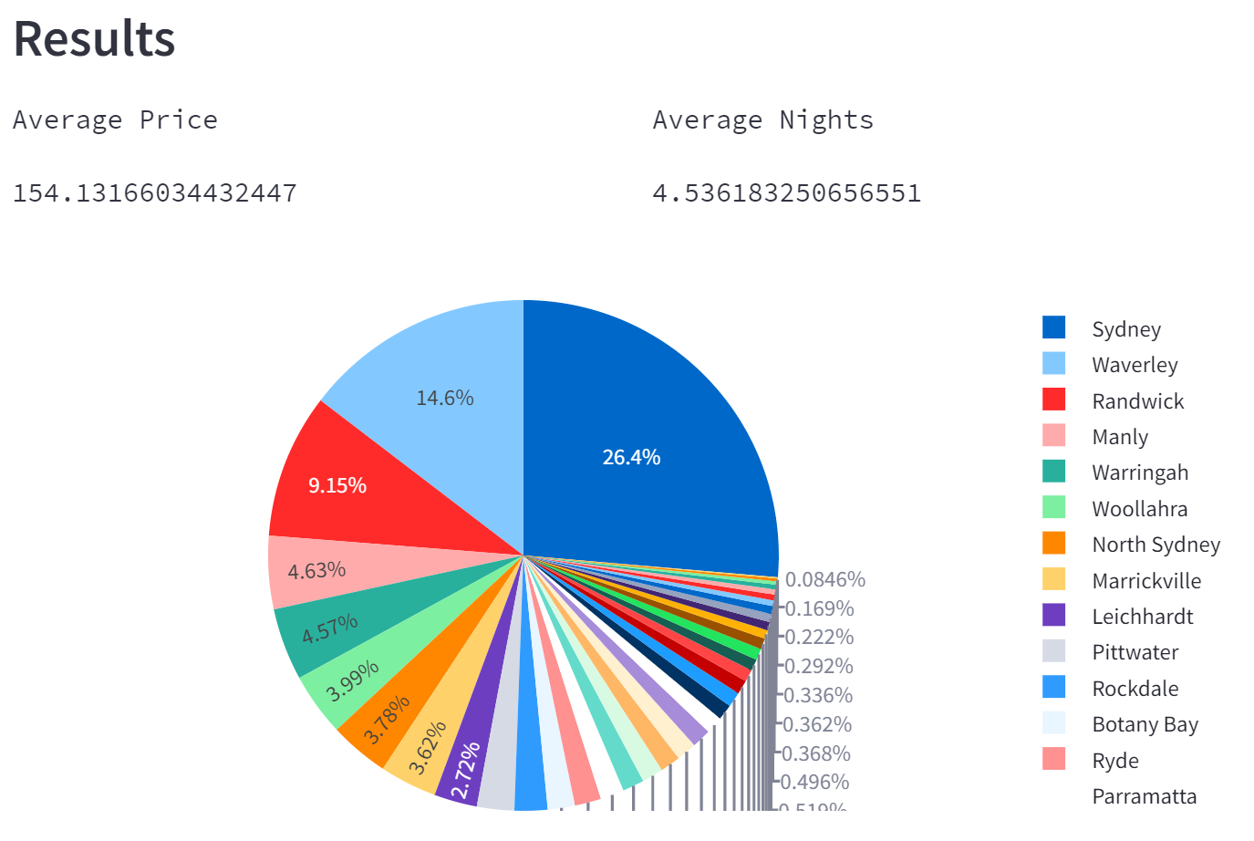

# **Analysis 2: People Stay’s Preferences**

We figured out that when it comes to Airbnb, 60% of folks like having the whole place to themselves, 38% prefer a private room, and a quirky 2% enjoy sharing a room. It's like peeking into the different ways people choose to stay in Sydney. Whether you're a host or a traveler, these insights can help you understand what's popular in the city's lodging scene.

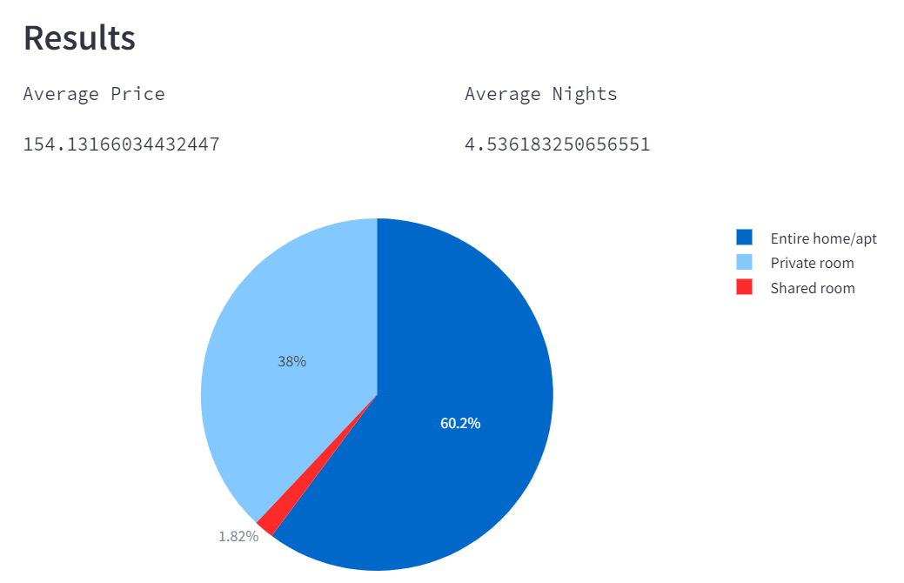

# **Analysis 3: How People Stay in Sydney**

We found out that a big chunk, 29%, go for just a one-day stay, and another 25% enjoy a cozy two-day escape. Some, about 15%, prefer a relaxed three-day trip, and the rest have their own unique plans. This report gives you a peek into the different ways people choose to stay briefly in Sydney, whether you're someone hosting guests or planning a short visit yourself.

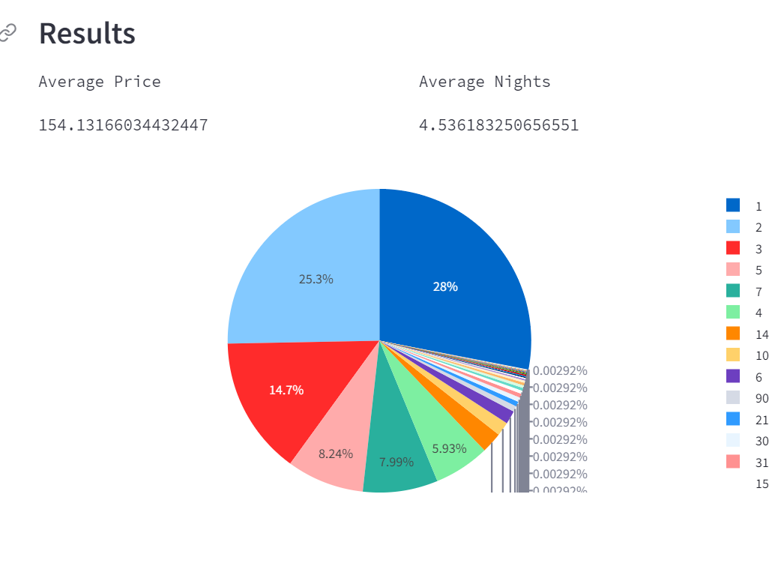

# **Analysis 4” Sydney Stays on a Budget**

we've figured out the average prices for different types of places. If you want a whole home, it's around $200. For a private room, it's about $83, and if you're up for sharing a room, it's a budget-friendly $50. Get the lowdown on these average prices to help plan your stay or host your space in Sydney without breaking the bank.

