Reading Feedback 2

Name: Dazhi Li

**One sentence conclusion:**

It is inspiring to know the inherent difficulties of the software design and how to overcome these with some principles. However, I am confused with the incremental and evolutionary design strategy as shown below. I was also given a clear view of what architecture is from comparing architecture in building and computer hardware. And I learnt some most influential models of software architecture, analyzing the difference between them. Finally, I am extremely insighted by the visual notation of software architecture. The process of turning a system design to a visual notation diagram that a developer could easily understand is really important for improving our design skills.

# Software Design Methodology

## Chapter 3 page 63

Muddy

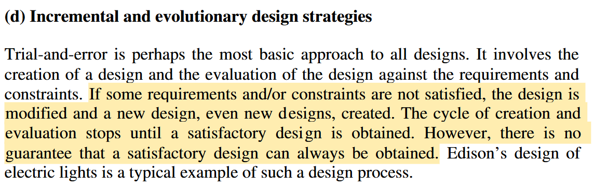

My question:

This strategy seems like no future vision of a plan. How does it overcome the inherent difficulty of design like changeability and invisibility? As it said there is no guaranteed that a satisfactory design can always be obtained.

## Chapter 4 page 82

Clear

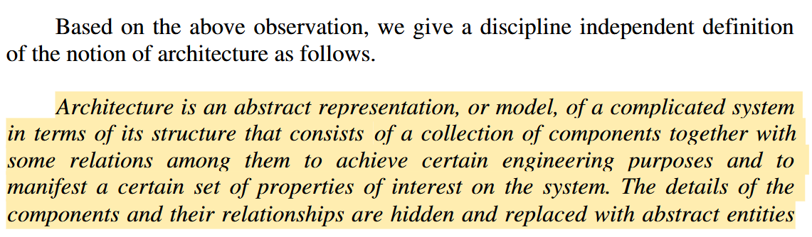

It gives a really clear definition on what is architecture. Most importantly, it observes this concept from our well-known building styles and how computer hardware architecture evolves from von Neumann to SIMD and MIMD.

## Chapter 5 page 129

Insightful

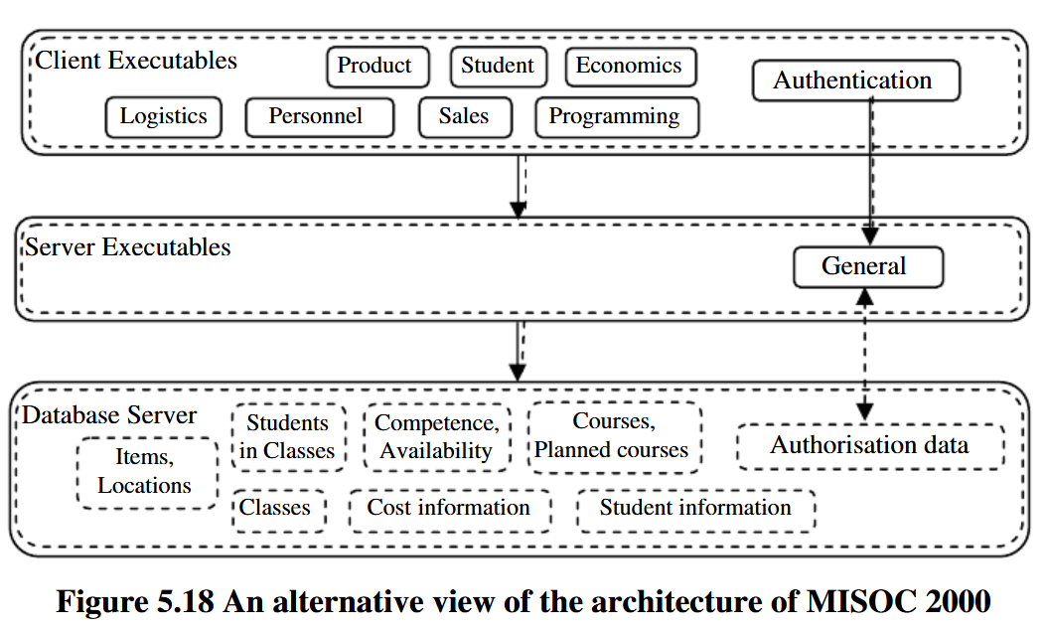

This is very insightful for me to understand how the author turns a system diagram to a visual notation diagram. Moreover, with realization of internal sub elements in MISOC2000 performs different roles, the author decomposed the large component, MISOC2000, into small sub elements and figured out the inter relationships between each sub elements. Finally, the author came out with a visual notation diagram that any developer can understand instantly.