Reading Feedback 4

Name: Dazhi Li

**One sentence conclusion:**

What is really inspiring is the ways of finding ASRs (architecturally significant requirements). Not only from documentations but also business goals and the experience of an architect. And this book gives a really vivid view of how to process ADD and many details in it. Moreover, it is very clear on how ATAM is going to help the whole stakeholders to evaluate the architectures in a comprehensive and structured way. Finally, the last part shows a variety of views on architecture documentation and how to document on different contexts. What I am confusing is when to use a combining view or simply documented two views without combining. Why don’t we just delivery and document two different views?

# Software Architecture in Practice

## Chapter 19

Inspiring

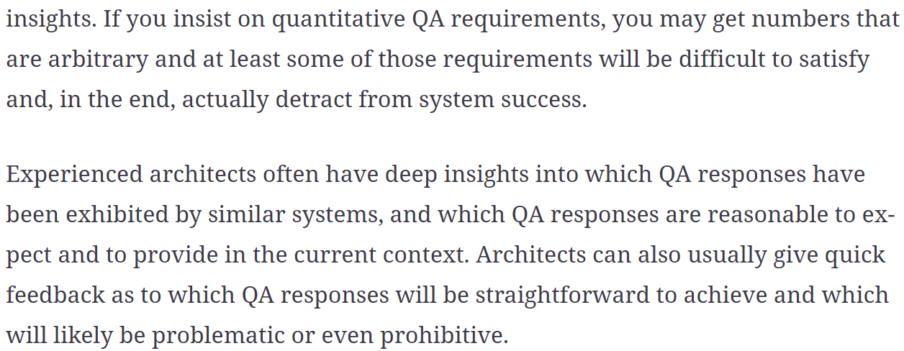

At the first glance of the upper paragraph, I felt confused. Because most of our supervisors often requires to quantify something. For example, quantify our target, our workload etc. So, the intuitive thoughts on how to evaluate a QA contains quantify the quality. However, later paragraph just gives an insight on what an experienced architect will do. And it is what really happens in reality that differs architect from junior engineer. So quantifying is not everything that software architects does, they are also input of the QA based on the experience.

## Chapter 21

Clear

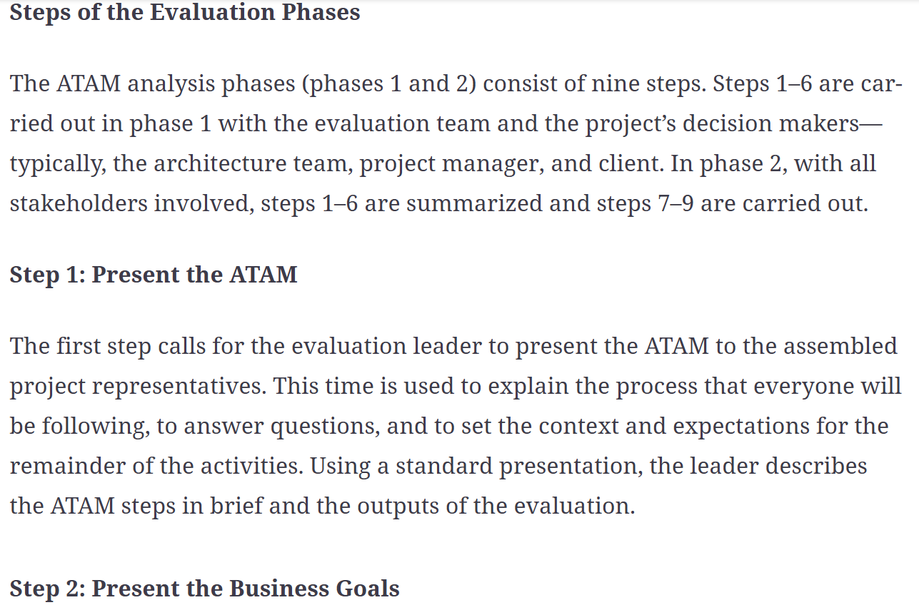

It is very clear to see what is the goal of every step that ATAM includes with a specified range of participation and how to are going to influence the result of ATAM.

## Chapter 22

Muddy

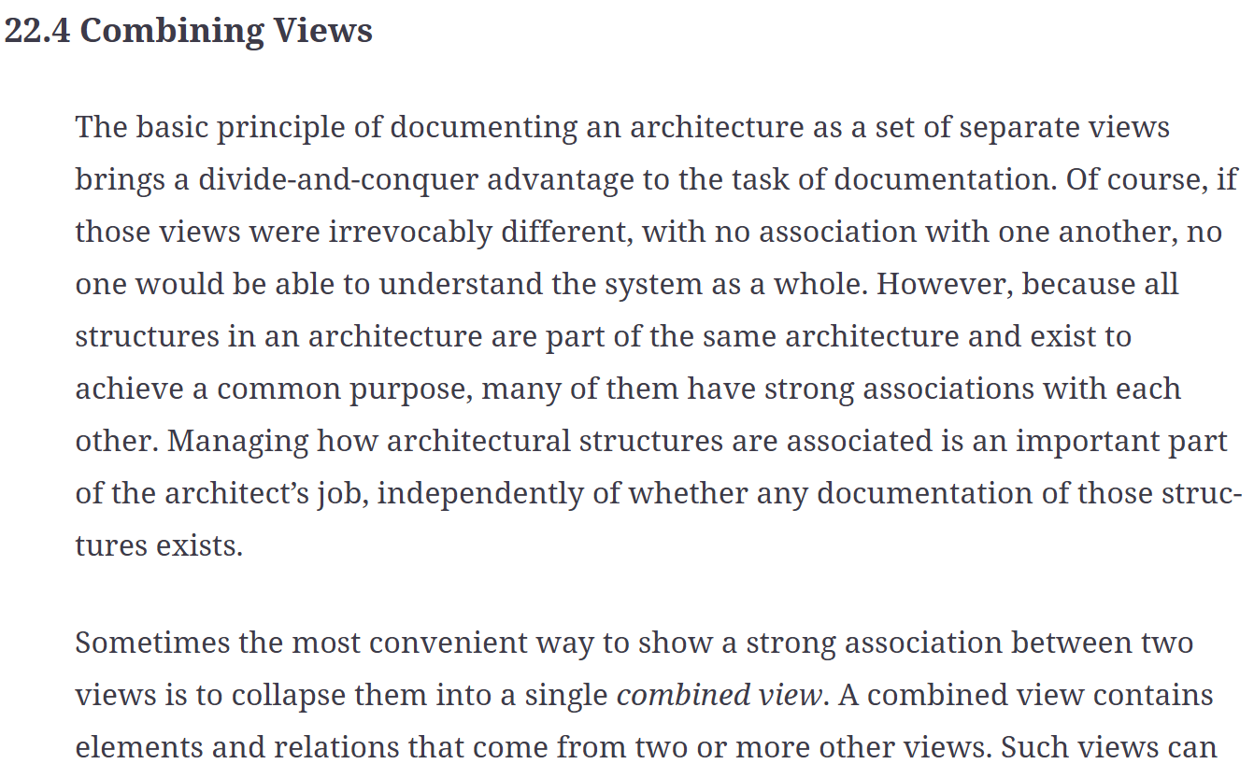

What are the benefits of using a combining view rather than using two different kinds of views? Although I see the strong associations between two different kinds views like module in module view and component in C&C view, I am still wondering when is the best timing for an architect to combine those two together.