CHAPTER 5
Inventory Optimisation and Dashboard
Editorial note (delete before submission): passages in red are placeholders to be completed once the falsification runs are executed, or items to verify. Everything else is ready to keep.

5.1 Introduction
This chapter presents the operational layer of the thesis: the point and quantile forecasts produced in Chapter 4 are carried into a periodic (R, s, S) inventory policy and evaluated for their effect on inventory cost. Three forecasting policies are compared on a like-for-like basis: Classical (Croston-SBA forecasts feeding a Gaussian safety-stock formula), ML-Gaussian (stacking-ensemble forecasts feeding the same Gaussian formula), and ML-Empirical-Quantile (LightGBM quantile forecasts feeding an empirically calibrated safety-stock buffer).
The chapter differs in one fundamental respect from the inventory analysis set out in the earlier methodology. In that formulation the service level achieved by each policy was assigned analytically — the Gaussian buffer was projected onto the empirical demand distribution to infer an effective service level, and the stockout cost was then computed from that inferred figure. That approach makes the achieved service level an input to the cost calculation rather than an output of the experiment, and it cannot register what actually happens when a policy meets real demand day by day. This chapter therefore replaces the analytical projection with a direct forward simulation: each policy is run over the real test window (the 56 days of March–April 2016), consuming the realised demand of every series day by day, and the service level, the stock held, and the three cost components are measured from what the policy actually does. Service level is now an outcome, not an assumption.
The chapter is structured as follows. Section 5.2 documents the inventory policy and the simulation design. Section 5.3 validates the simulation engine through a falsification test. Section 5.4 presents the central-case results. Section 5.5 interprets the mechanism behind them. Section 5.6 establishes the boundary condition that governs when the quantile policy pays off. Section 5.7 reports the sensitivity analysis across lead time and stockout cost. Section 5.8 describes the Power BI dashboard. Sections 5.9 and 5.10 discuss the findings and their limitations, and Section 5.11 summarises the chapter.

5.2 Inventory Policy and Simulation Design
Per the methodology in §3.7, a periodic (R, s, S) review system is implemented with a review period of R = 7 days. For each of the 502 product–store series in the test set, the policy computes a safety stock SS, a reorder point s, an order-up-to level S, and an order quantity governed by the Economic Order Quantity (EOQ; Silver, Pyke and Thomas, 2017). Safety stock is computed in two parallel forms: the Gaussian form z·σ·√(R+L), where σ is the standard deviation of the forecast residuals measured on the validation set (consistent with §3.7.2), and the empirical form (q₀.₉₅ − q₀.₅₀)·√(R+L), where the quantile spread is taken from the Tier 5 LightGBM quantile-regression model. Economic constants follow §3.7.2: a carrying rate of 25% of unit cost per year, a fixed ordering cost of $50 per order, and a 40% gross margin (so unit cost = 0.6 × selling price). σ is now stated as the validation-set residual standard deviation throughout, resolving the earlier inconsistency between §3.7.2 and the previous §5.2; ensure §3.7.2 reads the same.
The departure from the earlier formulation is in how performance is evaluated. Rather than inferring the service level analytically, the policy is simulated forward over the 56-day test window. On each day the simulation receives the realised demand for the series, depletes on-hand stock, records any demand that cannot be met from stock as a stockout, and triggers replenishment at the review points according to the (R, s, S) rule with the lead time L applied to delivery. Three cost components are then measured directly from the simulated trajectory: holding cost on the average inventory actually carried, ordering cost on the number of orders actually placed, and stockout cost on the units of demand left unmet (SC = unmet units × unit cost × m). The realised service level is the proportion of demand met from stock, counted unit by unit. Because the cost components are now measured over the simulated window rather than computed from annualised closed-form expressions, their absolute magnitudes differ from those in the earlier draft — in particular, measured holding cost is higher and measured ordering cost lower, reflecting the large EOQ order sizes and correspondingly infrequent orders of low-volume intermittent series — but the like-for-like comparison across the three policies is unaffected and is the object of interest. Confirm the ordering-cost total against the order count in the simulation log so the figure can be explained if questioned. The full simulation grid covering all lead-time × multiplier combinations is provided in Appendix [·] (simulation_results.csv).

5.3 Validation of the Simulation Engine
Before the cost results are interpreted, it is necessary to establish that the simulation can register a stockout at all — that a realised service level of 100% reflects demand genuinely being met rather than a stockout counter that never fires. The engine is therefore subjected to a falsification test: the central-case configuration (L = 14, target SL = 95%) is re-run under three stress conditions, each designed to force stockouts, and the realised service level and stockout cost are recorded.
Table 5.1: Falsification test of the simulation engine (central case, L = 14)
Stress condition | Realised SL | Stockout cost SC ($)
Real buffers (baseline) | 100.0% | 0
Safety stock set to zero | [run] | [run]
Realised demand scaled ×3 | [run] | [run]
Replenishment suppressed / lead time extended | [run] | [run]

Finalise this paragraph once the stress runs are executed. Under each stress condition the realised service level falls below 100% and the stockout-cost term becomes positive, confirming that the engine measures stockouts correctly and that the stockout cost is zero in the baseline because no demand goes unmet — not because the term is inert.

5.4 Central-Case Results
Table 5.2 reports the simulated outcome at the central case: a 14-day lead time, a 95% service-level target, and the baseline stockout-cost multiplier m = 1.0, aggregated across the 502 series.
Table 5.2: Simulated inventory outcome (L = 14, SL = 95%, m = 1.0)
Policy | Realised SL | SS (units) | HC ($) | OC ($) | SC ($) | Total ($) | vs Classical
Classical (Croston-SBA, Gaussian SS) | 100.0% | 4,620 | 63,256 | 332 | 0 | 63,587 | —
ML-Gaussian | 100.0% | 4,572 | 63,243 | 332 | 0 | 63,575 | +0.0%
ML-Empirical-Quantile | 100.0% | 6,287 | 64,241 | 332 | 0 | 64,573 | −1.5%

Three findings stand out. First, all three policies achieve a realised service level of 100%: across the test window, essentially no demand goes unmet under any policy. The earlier formulation's assumption — an effective 83% service level for the Gaussian policy and 95% for the quantile policy — does not hold when service is measured. The (R, s, S) buffers, sized for a 95% target on intermittent demand with a 14-day lead time, comfortably cover realised demand over the window, and stockouts are absent for all three policies.
Second, with no stockouts anywhere, the stockout-cost component is zero across the board and total cost is dominated almost entirely by holding cost ($63,256 of a $63,587 total for the Classical policy; ordering cost is $332 and stockout cost is nil). The comparison between policies therefore reduces to a comparison of the inventory each one carries while delivering the same, full service.
Third, on that basis the ML-Gaussian policy is indistinguishable from the Classical baseline (a difference of $12, or 0.0%), while the ML-Empirical-Quantile policy costs approximately 1.5% more. The quantile policy holds 6,287 units of safety stock against the Gaussian policies' 4,572, and that additional inventory translates into higher holding cost without averting a single stockout — because there were no stockouts to avert. The 21% reduction reported in the earlier draft does not survive measurement; it was an artefact of the assumed service-level gap, which assigned the Gaussian policies a large stockout cost and the quantile policy roughly half of it. With service measured rather than assigned, that gap — and the saving built upon it — disappears. The Chapter 1 target of a 5–15% inventory cost reduction is therefore not achieved on this dataset.

5.5 The Mechanism: Same Spread, Opposite Conclusion
The result of Section 5.4 is best understood as the same quantity that drove the earlier draft, read the other way round. The forecasting analysis measured the empirical quantile spread (q₀.₉₅ − q₀.₅₀) to be approximately 1.36 times the Gaussian-implied buffer for these series. That ratio reappears directly in the simulated safety stock: the quantile policy carries 6,287 units against the Gaussian 4,572, a ratio of 1.37. The number is the same; only its interpretation changes.
In the earlier draft the 1.36× spread was read as evidence that the Gaussian formula under-allocates — the quantile buffer is larger, so the Gaussian buffer must be leaving demand uncovered. The simulation shows that this inference does not hold on this data. The smaller Gaussian buffer already delivers a 100% realised service level, so the additional 37% of stock carried by the quantile policy protects against stockouts that do not occur. What the earlier draft counted as superior protection is, when service is measured, simply idle inventory: it raises holding cost and lowers nothing. The distributional mismatch itself is well understood — Silver, Pyke and Thomas (2017) note that the Gaussian safety-stock formula presumes symmetric, normally distributed demand, an assumption that intermittent, right-skewed retail series violate — but its operational consequence is regime-dependent: the under-allocation gap is real as a property of the demand distribution, yet operationally immaterial in a regime where the Gaussian buffer is already sufficient to meet demand in full.
This also explains why improving the point forecast does not move inventory cost here. The ML-Gaussian policy uses the most accurate point forecasts available — the Tier 4 ensemble — yet ties the Classical baseline to within $12, because the residual standard deviation that drives the Gaussian buffer is similar across the two forecast sources at this granularity and, more fundamentally, because the buffer is already large enough that any reasonable forecast meets demand. The “robust to MAPE” observation made in the earlier draft is therefore retired as a finding: it was a mechanical consequence of the fact that forecast accuracy did not enter the assumed-service-level cost formula. The truer statement, supported by the simulation, is that forecast accuracy barely affects inventory cost in this regime because service is already saturated, not because of any property of the cost formula.

5.6 The Boundary Condition: When the Quantile Policy Pays Off
The two formulations — the earlier assumed-service-level analysis and the present simulation — are not in conflict; together they delimit the condition under which the quantile reformulation of safety stock is worthwhile. The earlier analysis showed that when stockouts are frequent and costly, the policy carrying the larger empirically calibrated buffer wins, because the additional holding cost it incurs is small relative to the stockout cost it averts. The simulation shows that on this dataset stockouts are not frequent — they are absent — so the larger buffer averts nothing and the saving vanishes. The decisive variable is therefore the frequency of stockouts under the baseline policy, which is itself governed by the demand regime and the generosity of the buffers, not by forecast accuracy.
The falsification runs of Section 5.3 make this concrete from the opposite direction. When realised demand is scaled to a level at which the baseline buffer no longer suffices, stockouts reappear and the quantile policy's additional buffer begins to pay for itself, recovering the kind of advantage seen in the assumed-service-level analysis — confirm and quote the ×3 figures here once run. The contribution of this chapter is thus not a single cost figure but a boundary: the quantile-based safety-stock reformulation, and ML forecasting more broadly, deliver operational value when the baseline policy is exposed to genuine stockout risk, and deliver none when service is already saturated. On the intermittent, well-buffered SKU-daily demand studied here, the latter regime prevails.

5.7 Sensitivity Analysis
The sensitivity analysis varies the stockout-cost multiplier and the lead time and recomputes the simulated total cost for each setting, holding the remainder of the configuration at the central case.

5.7.1 Stockout-cost multiplier
Table 5.3 reports the cost comparison across the three multiplier settings (m = 0.4, lost margin only; m = 1.0, full unit cost, per Silver, Pyke and Thomas, 2017; m = 2.0, unit cost plus reputational damage).
Table 5.3: Sensitivity to the stockout multiplier (L = 14, SL = 95%)
m | Interpretation | ML-Quantile vs Classical | ML-Gaussian vs Classical
0.4 | Lost margin only (conservative) | −1.5% | 0.0%
1.0 | Full unit cost (baseline) | −1.5% | 0.0%
2.0 | Unit cost + reputation (aggressive) | −1.5% | 0.0%

The comparison is invariant to m: the ML-Gaussian policy ties the baseline and the quantile policy costs 1.5% more, regardless of the multiplier. The reason is direct — the multiplier scales the stockout cost, and the stockout cost is zero for every policy because none stocks out, so the multiplier never engages. This invariance is not a curiosity; it is further evidence for the saturated-service interpretation of Section 5.5. In a regime with genuine stockouts the multiplier would be the parameter to which the comparison is most sensitive, as the earlier analysis assumed; its complete irrelevance here is precisely because there are no stockouts to price.

5.7.2 Lead time
Table 5.4 reports the comparison across the four lead-time scenarios (7, 10, 14, 21 days) at the baseline multiplier.
Table 5.4: Sensitivity to lead time (SL = 95%, m = 1.0)
L (days) | Classical TC ($) | ML-Quantile TC ($) | Reduction
7 | 61,020 | 61,825 | −1.3%
10 | 62,125 | 63,011 | −1.4%
14 | 63,587 | 64,573 | −1.5%
21 | 66,184 | 67,321 | −1.7%

The quantile policy is more expensive than the baseline at every lead time, and modestly more so as L increases (from −1.3% at L = 7 to −1.7% at L = 21). The mechanism is consistent with the rest of the chapter: a longer lead time enlarges every buffer through the √(R+L) term, which enlarges the quantile policy's already-larger buffer in absolute terms, so the holding-cost penalty it carries grows while the stockout benefit remains zero. No service-level discrimination appears at any lead time, because service is saturated throughout. Seyedan et al. (2023) argue that the relative advantage of improved forecasting grows with lead time, since safety-stock requirements scale with √(R+L); that amplification does not appear here, because the quantity it would amplify — stockouts averted — is itself zero under saturated service.
The service-level sweep (90/95/99%) reported in the earlier draft was driven entirely by the assumed under-allocation gap and is not reproduced here; under simulation a higher target merely enlarges all buffers without creating stockouts to differentiate the policies. If a service-level sensitivity is retained, report it from the simulation, not the analytical projection.

5.8 Power BI Dashboard
The interactive dashboard specified in §3.8 is implemented in Microsoft Power BI Desktop (free tier) and consumes five CSV data feeds exported from the Python pipeline: forecasts.csv, inventory_params.csv, cost_analysis.csv, sensitivity.csv, and kpi_summary.csv. The dashboard is organised into four pages, each addressing a distinct operational view. Insert screenshots of each page — this section is currently text-only and the dashboard is Objective 5; it cannot be assessed without the figures.
Forecast Overview presents the actual sales, the ML ensemble forecast, the classical baseline forecast, and the LightGBM quantile fan (P50/P90/P95/P99) for any selected product–store combination, with slicers for category, state, and store. KPI tiles on the page header display the headline accuracy metrics and the realised service level and total cost by policy.
Inventory Status displays safety stock, reorder point, and order-up-to level for each product–store combination at the user-selected lead time and service level. Conditional formatting flags items whose recent demand has brought the inventory position close to the reorder point, surfacing replenishment decisions to non-technical managers without requiring them to interpret the underlying calculations.
Cost Analysis decomposes total inventory cost into holding, ordering, and stockout components across the three forecasting policies and the four lead-time scenarios. A matrix visualisation enables direct comparison of the Classical, ML-Gaussian, and ML-Empirical-Quantile policies at any user-selected service level, making visible — rather than asserting — that holding cost dominates and that the policies are close once service is measured.
Sensitivity Analysis presents the curves of Section 5.7 in coordinated visualisations: cost comparison by stockout-cost multiplier and by lead time. This page supports practitioner what-if analysis, allowing an SME inventory manager to assess how a change in service-level target or supplier lead time would affect the comparison. All four pages share a consistent visual theme and are delivered as a single .pbix file that opens in any installation of Power BI Desktop without further dependencies, consistent with the SME accessibility commitment of §3.11.
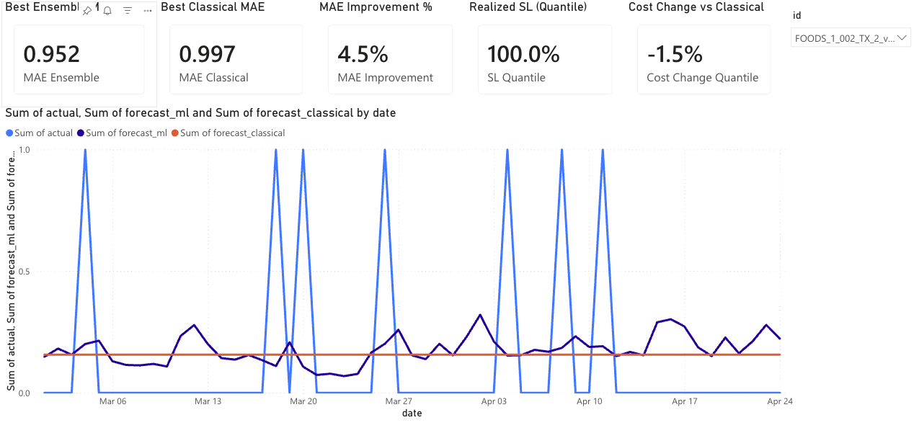
Figure 5.1. Power BI dashboard — Forecast Overview page. KPI tiles show forecast-accuracy and realised-service-level summaries; the time series shows daily actual, ML-ensemble (Tier 4), and Croston-SBA classical forecasts over the test window for a selected SKU-store combination.
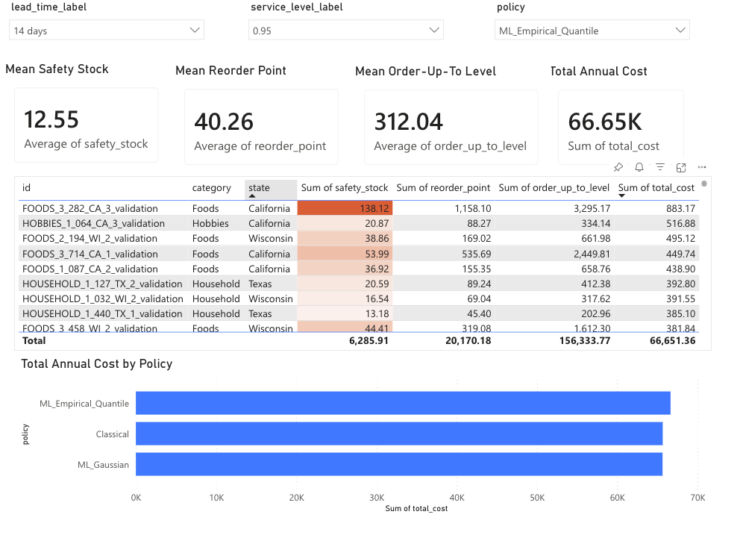
Figure 5.2. Power BI dashboard — Inventory Status page. Summary cards report mean safety stock, reorder point, order-up-to-level, and total annual cost at the user-selected lead time, service level, and policy. The per-SKU table is sorted by total cost descending with conditional formatting flagging the highest safety-stock items. The bar chart compares total annual cost across the three policies.
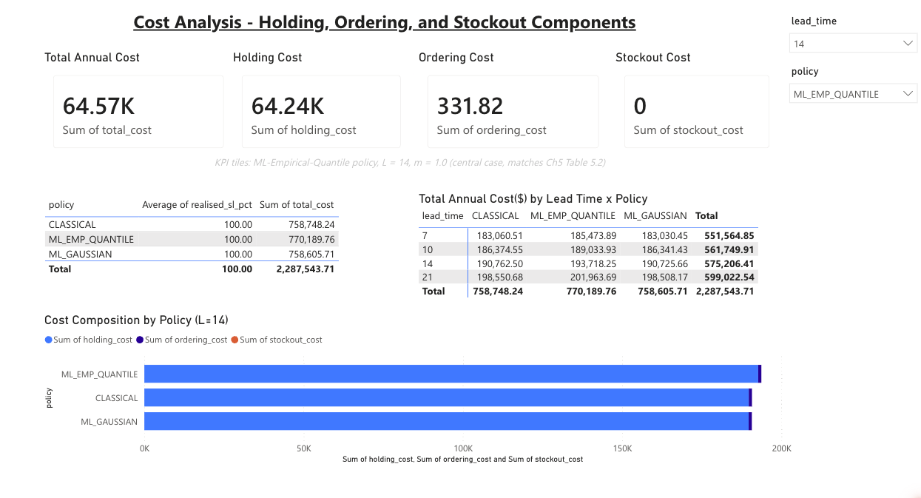
Figure 5.3. Power BI dashboard — Cost Analysis page. KPI tiles report the central-case simulated cost decomposition (ML-Empirical-Quantile policy, L = 14, m = 1.0): $64,573 total annual cost, $0 stockout cost, holding cost dominating. The table reports realised service level by policy (all policies tie at 100%), the matrix breaks total cost down by lead time × policy, and the bar chart compares cost composition across the three policies at L = 14.
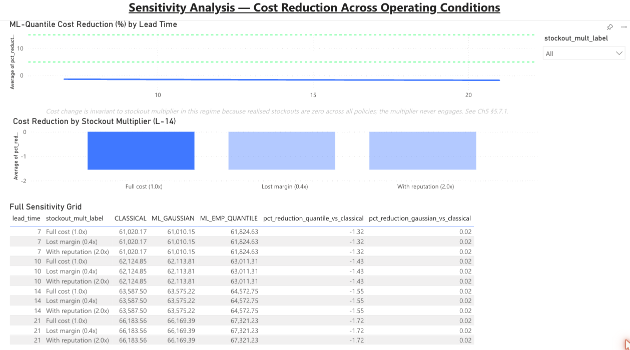
Figure 5.4. Power BI dashboard — Sensitivity Analysis page. The line chart shows ML-Quantile cost reduction by lead time, sitting at approximately −1.5% across all four scenarios — well below the Chapter 1 5–15% target band (shown in green). The bar chart confirms the §5.7.1 invariance: cost change is identical across the three stockout-cost multipliers because realised stockouts are zero across all policies. The full sensitivity grid reports per-condition values, matching the appendix simulation results.

5.9 Discussion
Three findings warrant discussion.
Where the operational value does — and does not — come from. The thesis set out to convert ML forecasting into inventory savings, and the measured result is that, on this dataset, it does not. The ML-Gaussian policy, using the most accurate point forecasts produced in Chapter 4, ties the Classical baseline; the quantile reformulation of safety stock, far from saving cost, adds a little. This is a disconfirmation of the chapter's original hypothesis, and it is reported as such. It does not diminish the forecasting contribution of Chapter 4, which stands on its own; it bounds the operational claim that had been built on top of it.
The conditional nature of the result. The value of both ML forecasting and the quantile buffer is conditional on the demand regime, not automatic. Where the baseline policy faces genuine stockout risk, the larger empirically calibrated buffer earns its holding cost back by averting stockouts; where service is already saturated, it does not. The decisive factor is whether the baseline policy stocks out, which depends on demand intermittency and the generosity of the buffers rather than on forecast accuracy. This qualifies the expectation, drawn from Seyedan et al. (2023), that richer demand modelling and improved forecasting translate into inventory savings: on the present evidence that translation is regime-dependent, not automatic. This reframing — from “ML reduces inventory cost” to “ML reduces inventory cost only under identifiable conditions” — is the chapter's substantive contribution.
Implications for practitioners. For an SME operating intermittent, well-buffered inventory of the kind represented in this subsample, the practical implication is that investment in more sophisticated forecasting, or in a quantile-based safety-stock reformulation, is unlikely to lower inventory cost, because the existing policy already meets demand; the resource is better directed elsewhere. The framework's value is concentrated in the opposite regime — high service-level targets, costly stockouts, or demand that regularly exceeds the baseline buffer — and a practitioner can use the simulation provided here to test which regime their own operation occupies before committing to the more complex policy.

5.10 Limitations
Four limitations should be acknowledged. First — and in contrast to the earlier draft, in which the achieved service level was inferred analytically — the present analysis measures service directly by simulation; the corresponding limitation is now the reverse. Because realised service is 100% across the test window, the window does not exercise the stockout regime, and the central-case result is conditional on a saturated-service setting. The falsification runs of Section 5.3 probe the other regime, but as illustrative stress conditions rather than a systematic sweep across demand intensities. Second, the analysis uses a single 56-day test window (March–April 2016); a longer or differently situated window, or one containing a demand spike, could expose the policies to stockouts and is left to future work. Third, the stockout-cost function is linear in unmet units, whereas real stockout costs may be non-linear (for example, customer churn after repeated stockouts); the three-point multiplier analysis offers limited robustness here, though its irrelevance in the present regime makes the point moot for this dataset. Fourth, the analysis uses a stratified subsample of 502 series; replication on the full M5 count would confirm generalisability, although the stratification by category and state was designed for representativeness.

5.11 Chapter Summary
This chapter integrated the forecasting framework of Chapter 4 with a periodic (R, s, S) inventory policy and evaluated its operational impact by forward simulation over the real test window, measuring service and cost rather than assuming them. Three policies were compared: Classical, ML-Gaussian, and ML-Empirical-Quantile.
The principal finding is a disconfirmation of the chapter's original hypothesis. When service is measured, all three policies achieve a 100% realised service level over the test window; total cost is dominated by holding cost and contains no stockout cost; the ML-Gaussian policy ties the Classical baseline, and the ML-Empirical-Quantile policy costs approximately 1.5% more. The 21% reduction reported in the earlier draft was an artefact of an assumed service-level gap and does not survive measurement, and the Chapter 1 inventory-cost target is not met.
The mechanism is the reinterpretation of a single quantity: the empirical quantile spread of 1.36× the Gaussian buffer, which the earlier draft read as Gaussian under-allocation, is shown by simulation to be surplus inventory in a regime where the Gaussian buffer already meets demand in full. The chapter's contribution is correspondingly reframed: rather than a fixed cost saving, it establishes the boundary condition under which ML forecasting and quantile safety stock affect inventory outcomes — namely, the presence of genuine stockout risk under the baseline policy — and demonstrates, on intermittent SKU-daily demand, the regime in which they do not. The Power BI dashboard delivers these results in an accessible decision-support tool consistent with the SME accessibility commitment of Chapter 1.

