🧠 TASK AUTOMATION - File Organizer Tool
Welcome to the Task Automation project — a smart and simple tool built using Python and Streamlit to automatically organize files in a selected directory into categorized folders like Images, Documents, Videos, Audio, etc.
This project was developed as part of my Python Programming Internship at CodeTechIT Solutions.

📌 Project Objective
To build a lightweight, interactive tool that helps users:
- Automatically categorize files based on type/extension.
- Clean up messy directories by sorting files into organized subfolders.
- Delete empty folders after reorganization to reduce clutter.
- Provide a web interface for non-tech users to use the tool effortlessly.

🚀 How It Works
This project has two core components:
- Backend Logic (logic.py)
  - Categorizes files into groups like Images, Documents, Videos, etc.
  - Moves them into appropriate folders.
  - Deletes empty directories after sorting.
- Frontend UI (app.py)
  - Built using Streamlit, a Python framework for web apps.
  - Lets users upload files, enter target directory, and trigger the organizer.
  - Shows logs of operations performed (moved, deleted, skipped).

🧰 Technologies & Libraries Used
Tool / Library | Purpose
Python | Core programming language
os, shutil | File handling, path operations, and moving files
Streamlit | Frontend web interface for ease of use

⚙️ Setting Up the Environment
Follow these simple steps to get the project running on your machine:
1️⃣ Install Python
Make sure Python 3.x is installed. Download from: https://www.python.org/downloads/
2️⃣ Install Required Library
pip install streamlit
4️⃣ Run the App
~ bash
streamlit run app.py

✨ Features
- 📁 Directory Path Input – Type the absolute path where files will be saved and organized.
- 📤 Multiple File Uploads – Upload many files at once to the selected directory.
- 🚀 Single-Click Organize – Automatically sort files into categorized folders.
- 🧾 Log Viewer – See all the actions performed (moved, deleted, errors).
- 🧹 Deletes Empty Folders – Cleans up the directory after organizing.
- 🎨 Styled UI – Clean, dark-mode interface with buttons and feedback messages.

📂 File Categories Used
Category | Extensions Included
Images | .jpg, .png, .gif, etc.
Documents | .pdf, .docx, .txt, etc.
Videos | .mp4, .mkv, .avi, etc.
Audio | .mp3, .wav, .aac, etc.
Archives | .zip, .rar, .7z, etc.
Executables | .exe, .msi
Scripts | .py, .js, .html, .css
Others | Anything uncategorized
🎨 Screenshots
- Unorganised Folder
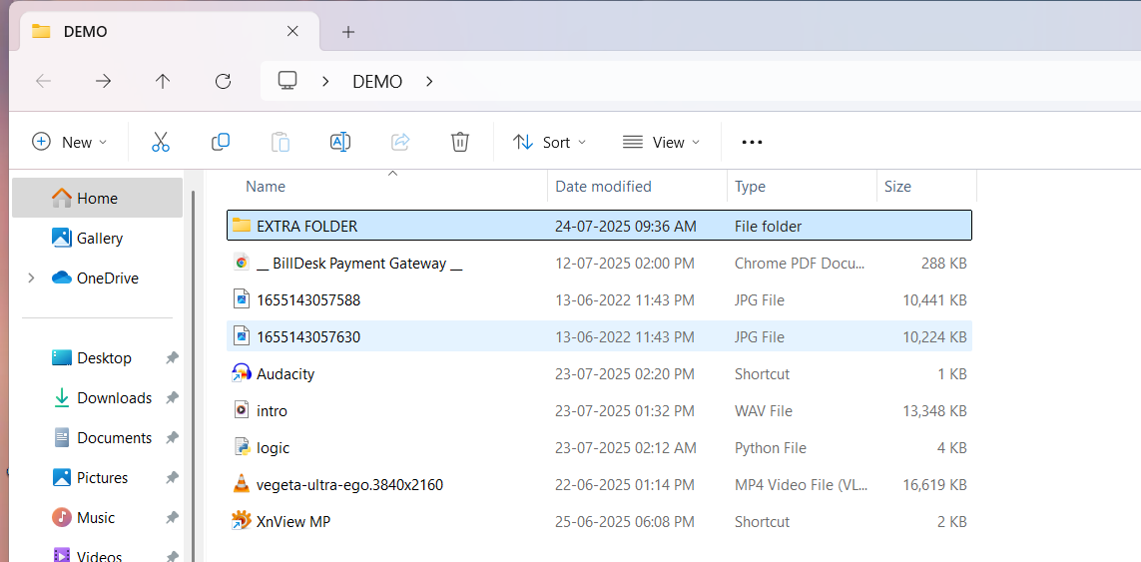

- Terminal command
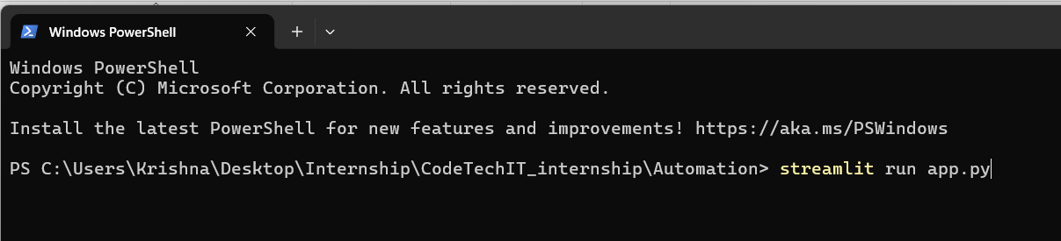

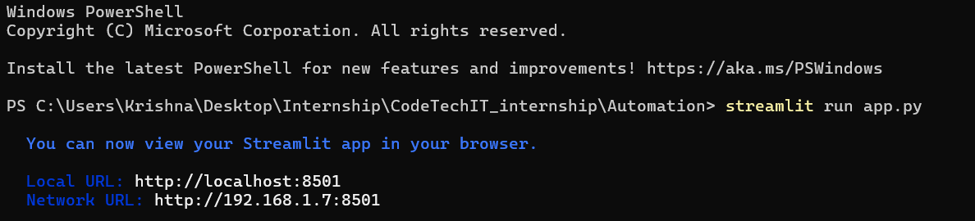

- Streamlit Browser
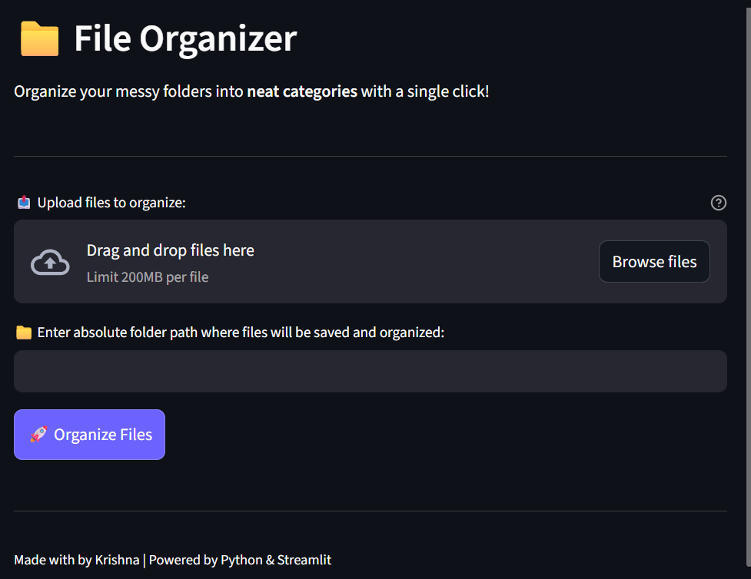
- Upload Files
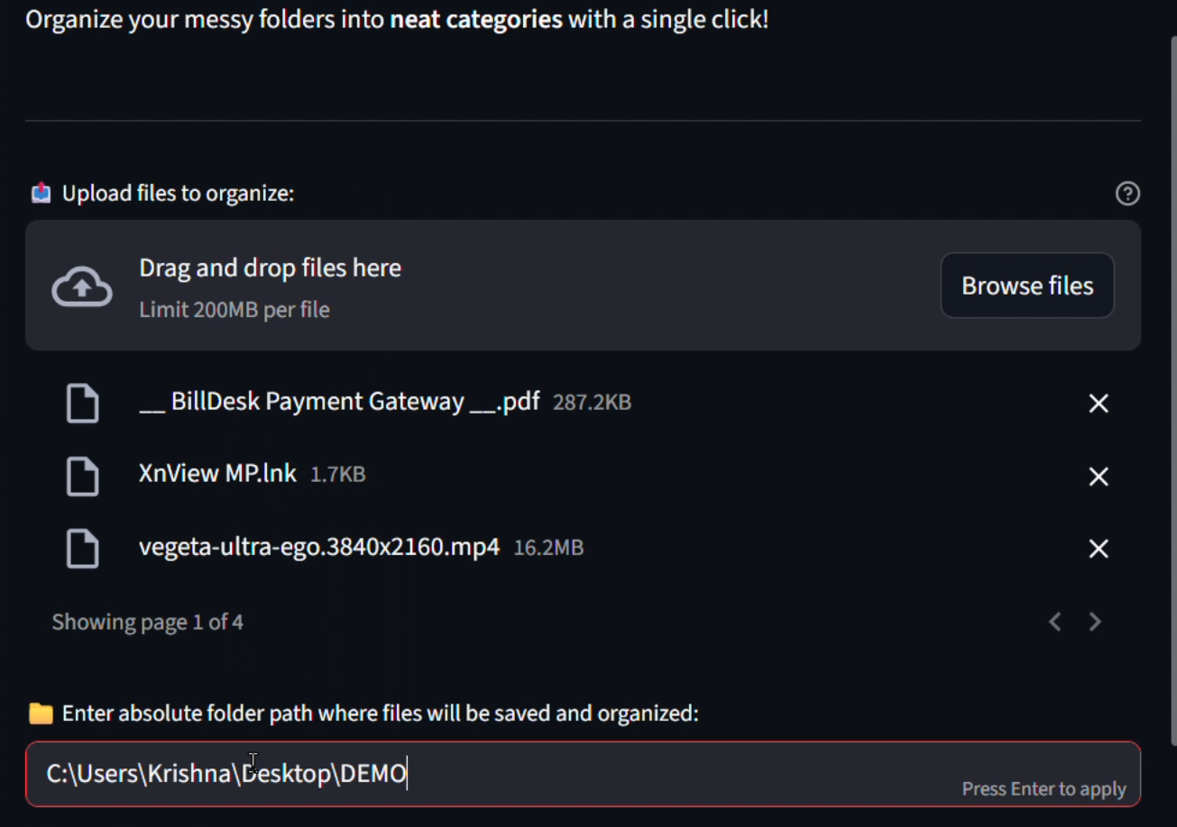
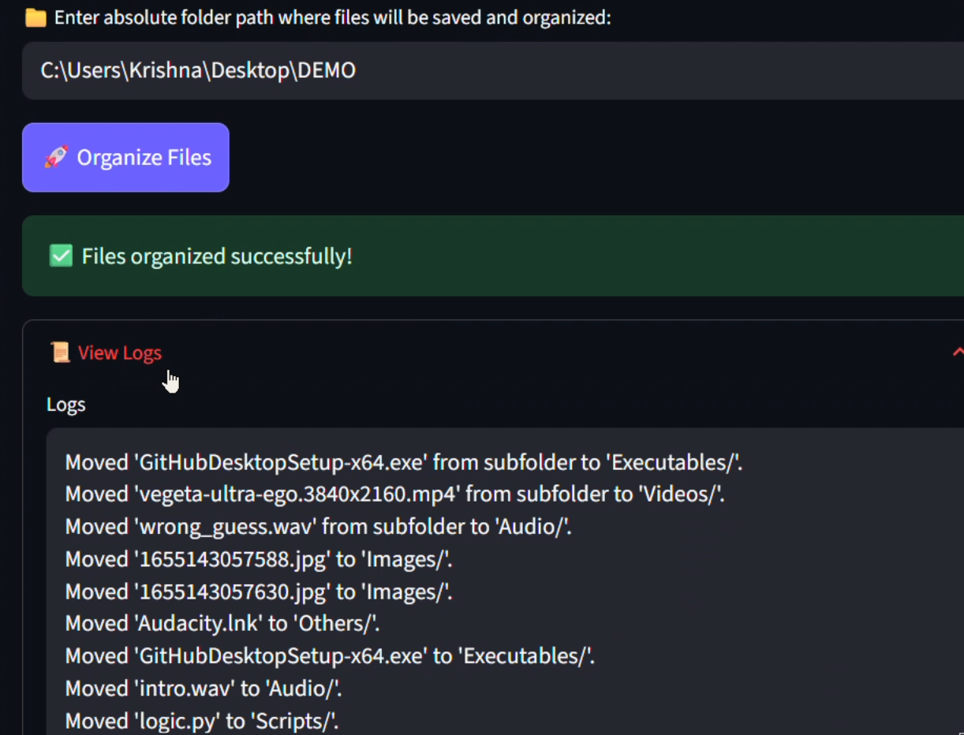
- Organised Folder
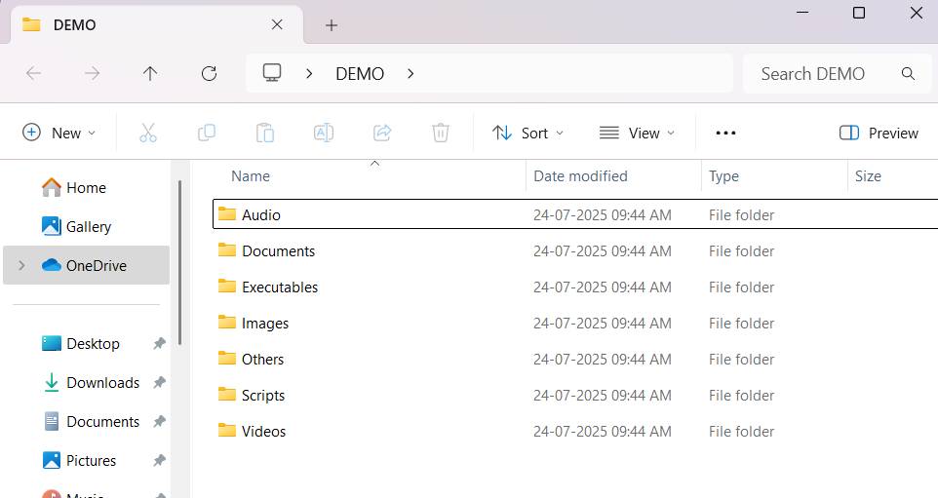

Deleted empty folder
traverse every folder then moved
Organised files as per categories and extension.

🧑‍💻 Author
Krishna
Project created during internship at CodeTechIT Solutions.

