🎮 Hangman Game — Python Mini Project
🎮 Welcome to the Hangman Game Project — a fun and interactive word-guessing game built using Python and Tkinter, designed as part of my internship at CodeTechIT Solutions.
This project was developed as part of my Python Programming Internship at CodeTechIT Solutions.

🧠 Objective
The goal of this project was to build a classic Hangman game using Python — incorporating both backend logic and a GUI frontend. This project helped sharpen my Python skills while applying concepts like OOP, event-driven programming, GUI design, API interaction, and audio feedback.

🛠 Technologies & Libraries Used
Component | Description
Python | Core programming language used for backend logic & GUI frontend.
Tkinter | Built-in Python library for creating GUI applications.
Pygame | Used for integrating sound effects and background music.
Requests | Used to fetch random words from an external API.

📂 Project Structure
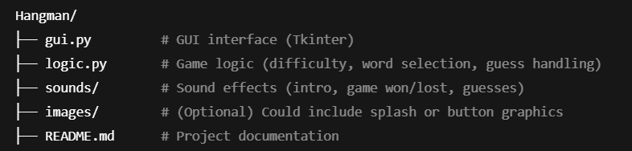

⚙️ Features
- 🎚 Difficulty Levels — Easy, Medium, and Hard with dynamic lives & word length.
- 🔊 Audio Feedback — Correct/incorrect guess, win/loss sounds, and background music.
- 🧠 Word Logic — Words are fetched from a live API or fall back to built-in list.
- 💻 Responsive GUI — Clean interface with labels, entry fields, and buttons.
- 🧵 Multithreading — Prevents audio blocking UI by using separate threads.
- ❌ Error Handling — Handles API failure and invalid inputs gracefully.

🔧 Setup Instructions
1. Install Python
Make sure Python is installed. You can download it from python.org.
2. Install Required Libraries
~bash
pip install pygame requests
Note: tkinter comes built-in with most Python installations.
4. Run the Game
~ bash
python gui.py

🎨 Screenshots
- Terminal command
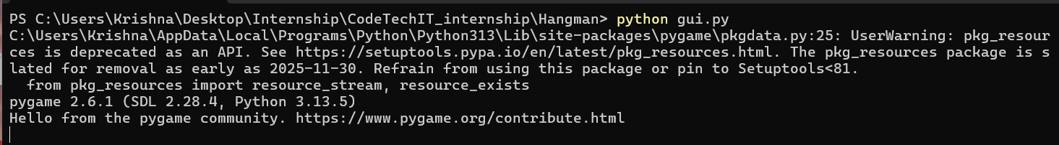
- Intro screen
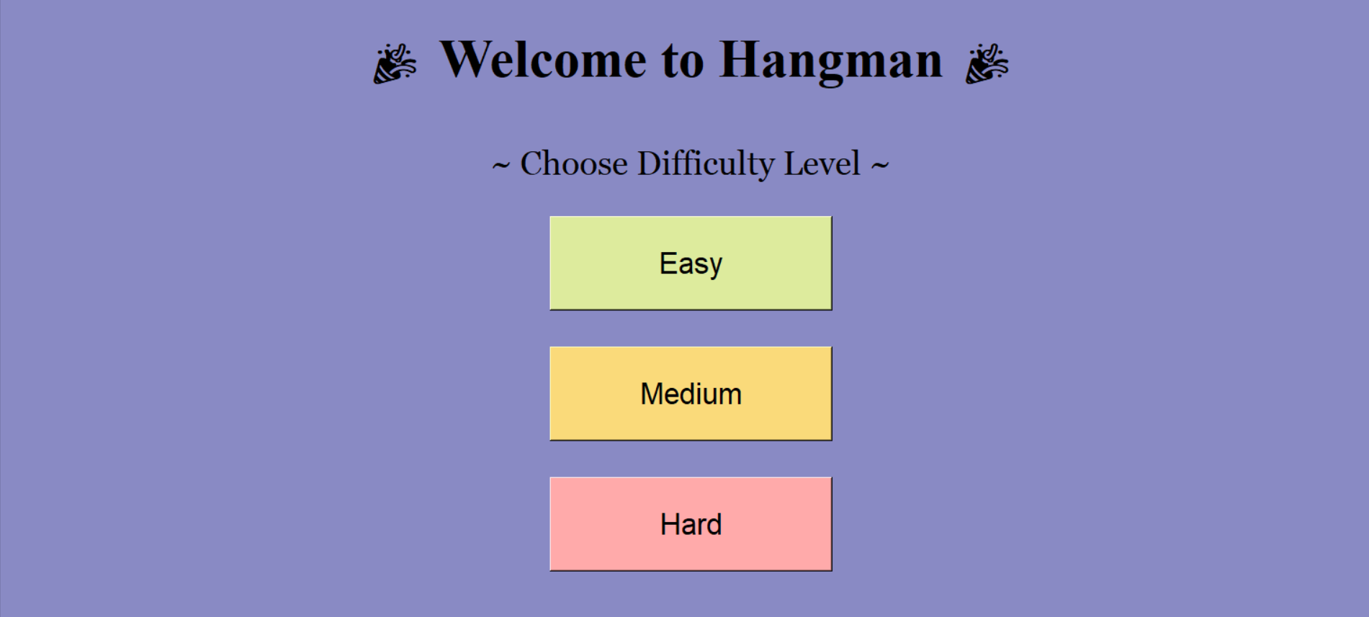

- Right & Wrong Guess

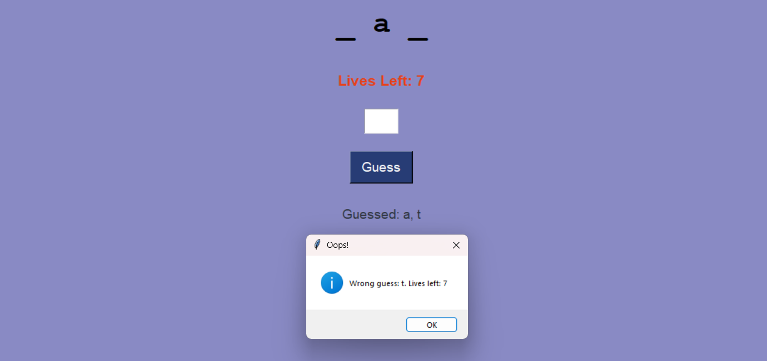
- Won & Lost
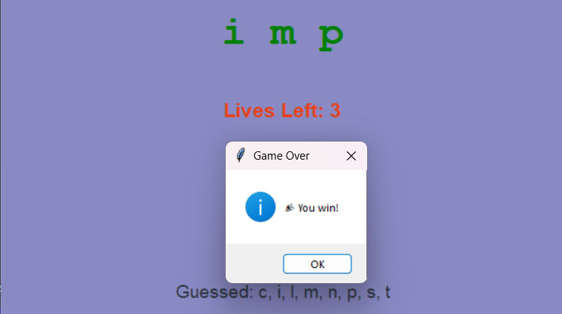
- Invalid input (special characters or numbers or 1 < letters)

- Splash screen
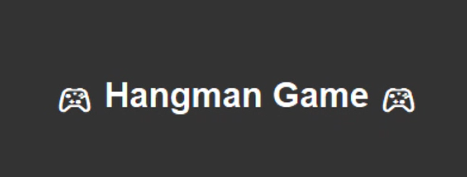

💡 Learnings
- Implemented OOP concepts in Python
- Designed UI with Tkinter
- Used real-time API data
- Managed GUI responsiveness with after() and threading
- Integrated sound for immersive gameplay

📌 Future Improvements
- Add a leaderboard or score counter
- Improve UI design with better layouts or images
- Package the game into a .exe using PyInstaller

🧑‍💻 Author
Krishna
Project created during internship at CodeTechIT Solutions.

