**🤖 Chatbot Creation Using IBM Watson Assistant**

**📌 Project Summary**

This project involved creating a fully functional chatbot using **IBM Watson Assistant** on IBM Cloud. The chatbot was designed to simulate a course inquiry and enrollment assistant, capable of responding to user greetings, answering questions about available courses, collecting user details, and integrating with external messaging platforms.

**🎯 Objective**

To build a low-code chatbot that can:

* Handle basic user conversation flows
* Provide dynamic course information
* Collect user qualifications and contact details
* Integrate with **Twilio for WhatsApp deployment**

**🔧 Tools & Technologies Used**

* **IBM Watson Assistant (Lite Plan)**
* **IBM Cloud**
* **Twilio** (for WhatsApp channel integration)

**🗂️ Workflow Summary**

1. Created a chatbot assistant with a customized name and interface settings
2. Set up conversation steps using **Action** blocks, including:
   * Greeting the user
   * Asking for the user's name (stored in a variable)
   * Presenting a list of courses as response options
   * Handling conditional flows based on course selection
   * Verifying user qualifications and collecting contact details
3. Built a structured dialog including:
   * Yes/No conditions
   * Free-text input fields
   * Assistant responses with dynamic logic
4. **Tested and previewed** the chatbot functionality
5. **Published** the chatbot after version creation
6. Integrated the chatbot with **Twilio for WhatsApp** to enable real-time chat via messaging

**✅ Outcome**

* Successfully created and deployed a working chatbot using IBM Watson Assistant
* Learned end-to-end chatbot flow setup, including:
  + Intent recognition
  + Variable management
  + Conditional logic
  + Channel integration
* Gained experience integrating AI assistants with third-party platforms like Twilio

**📸 Screenshots**

* **Setting up the ChatBot**

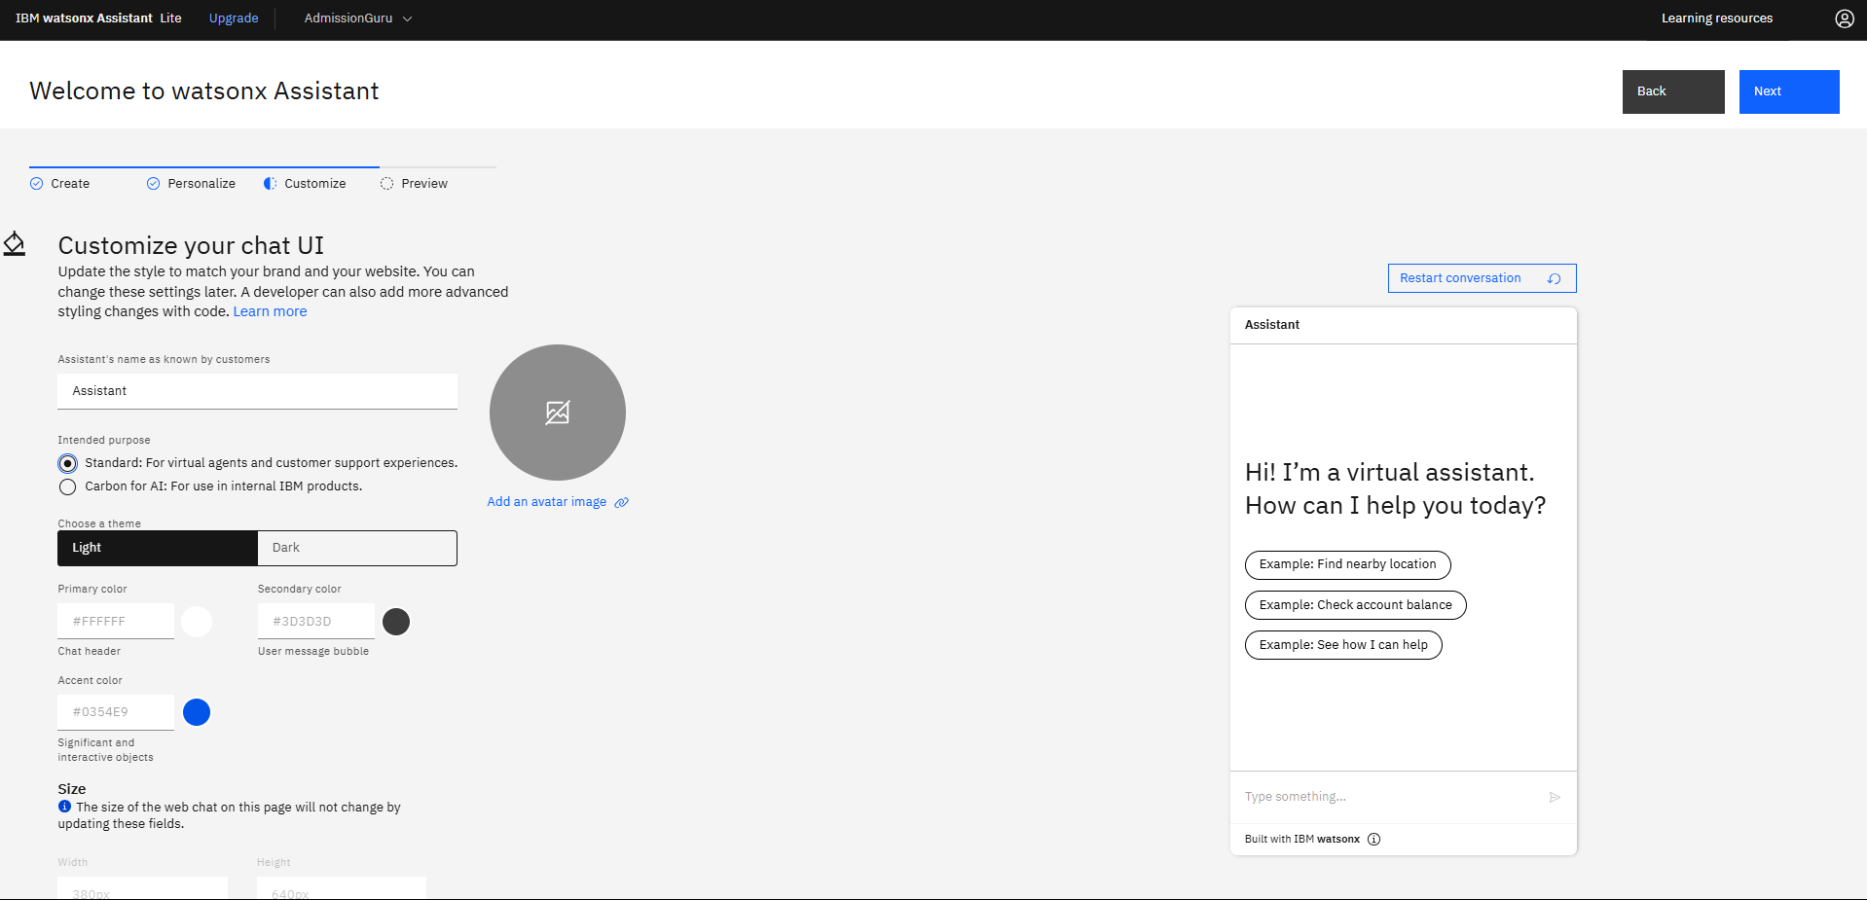

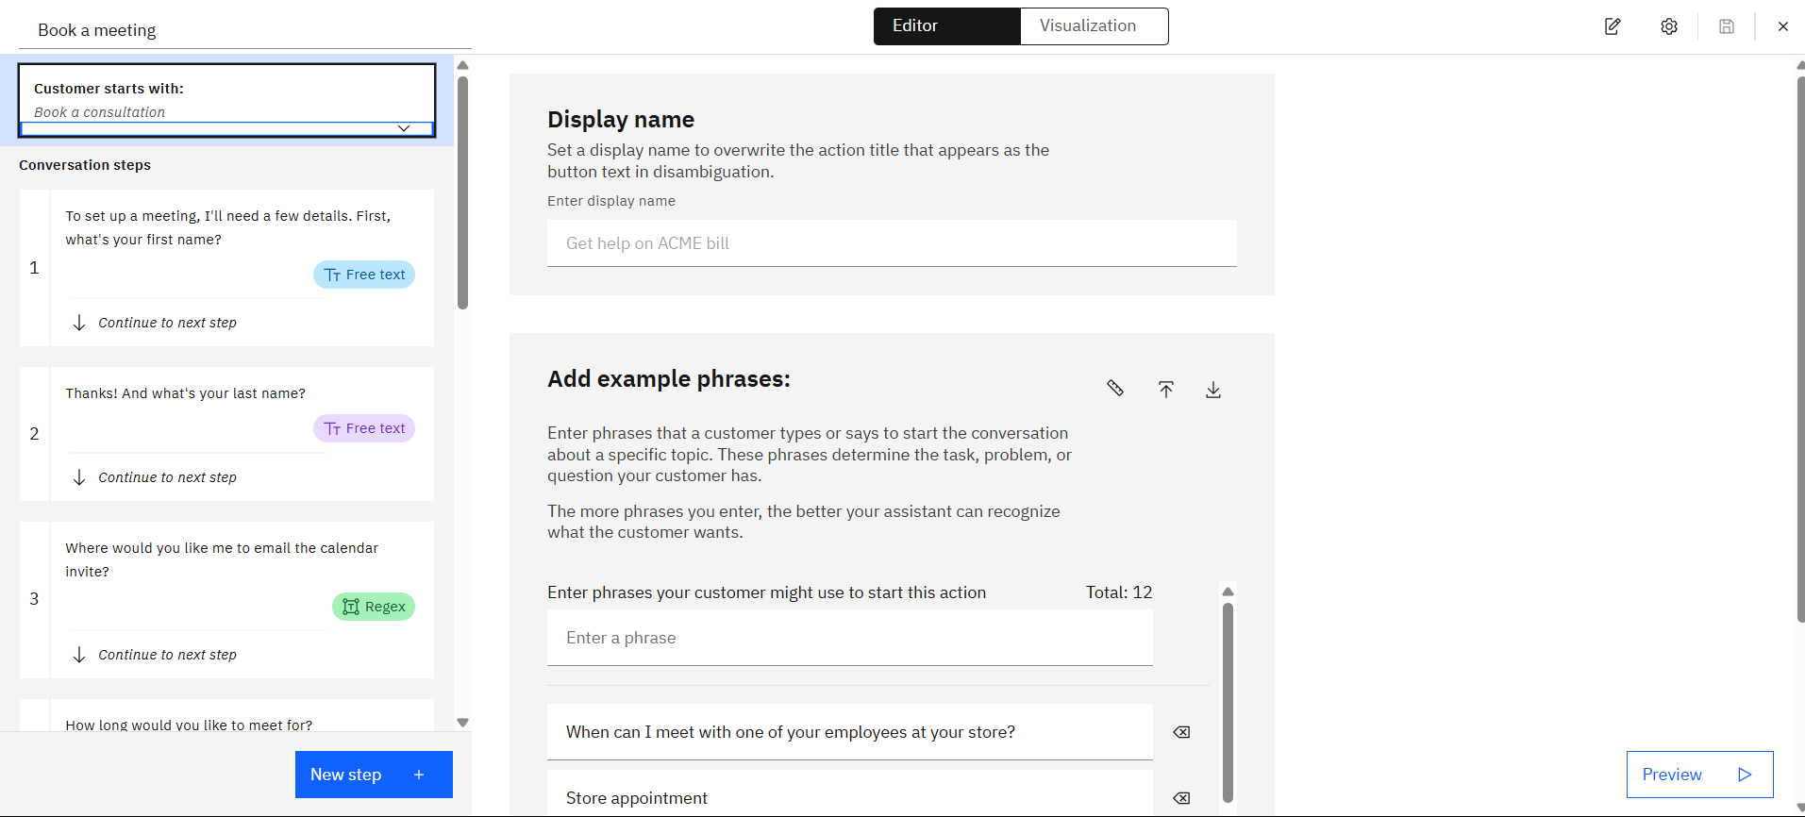

* Workflow of Chatbot

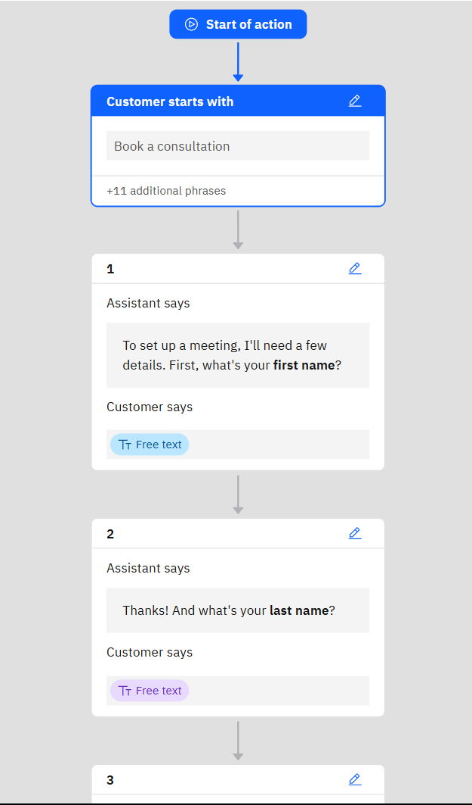 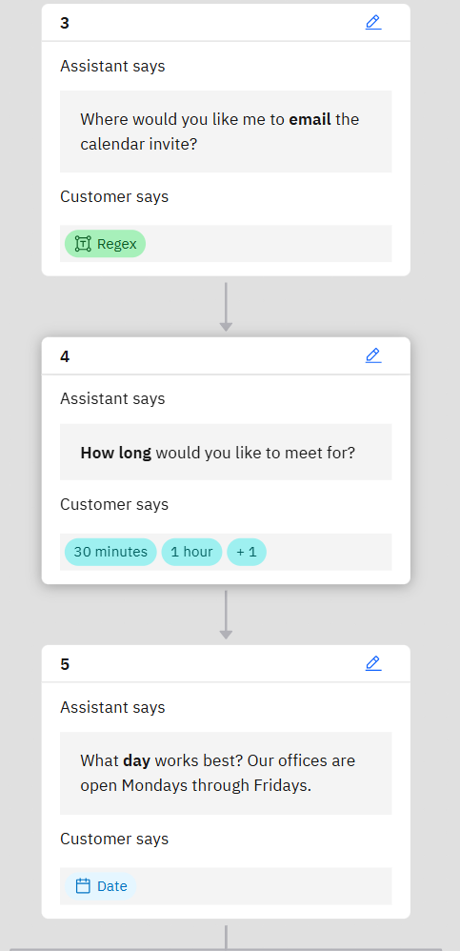

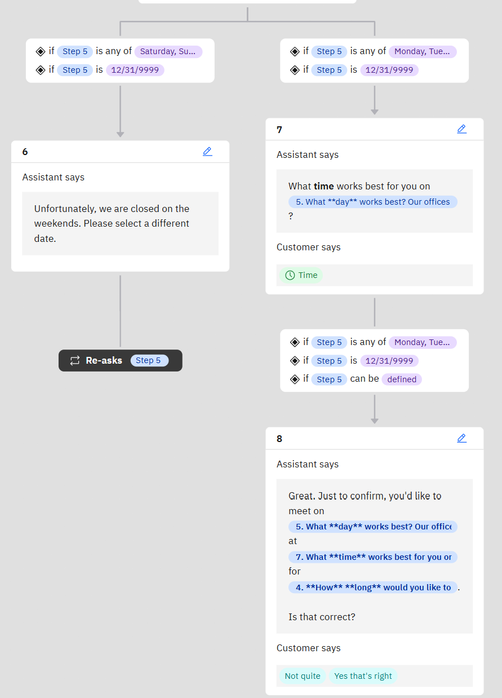 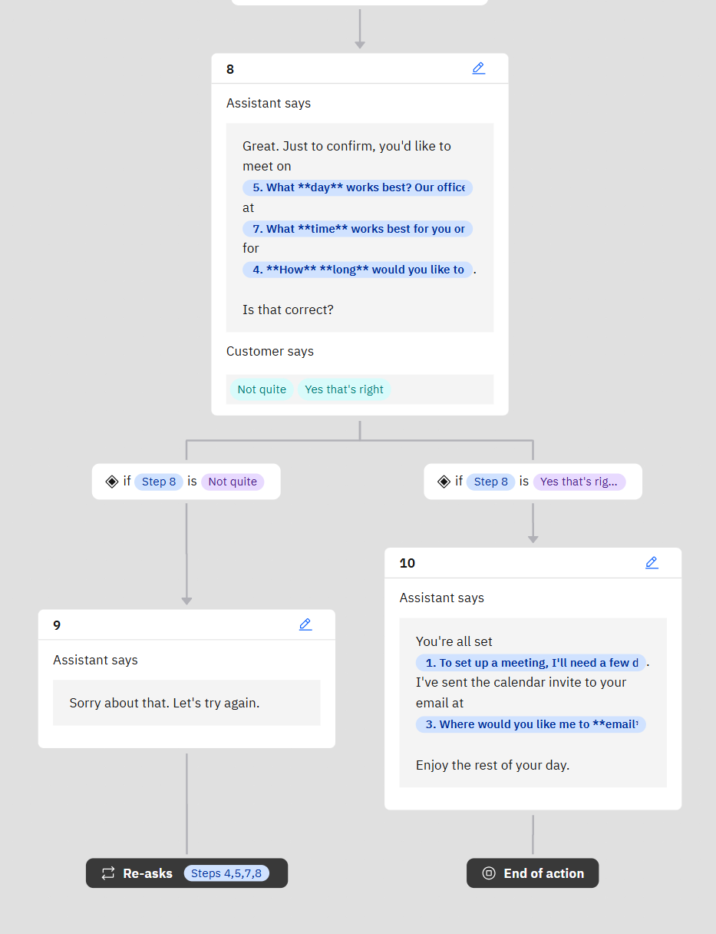

* Preview

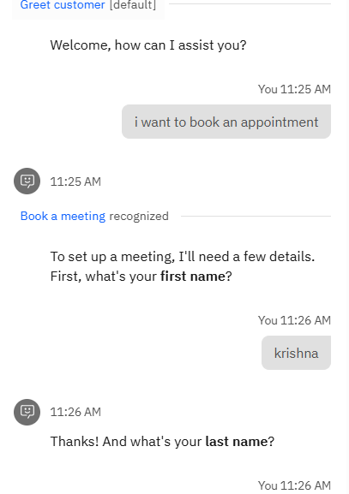 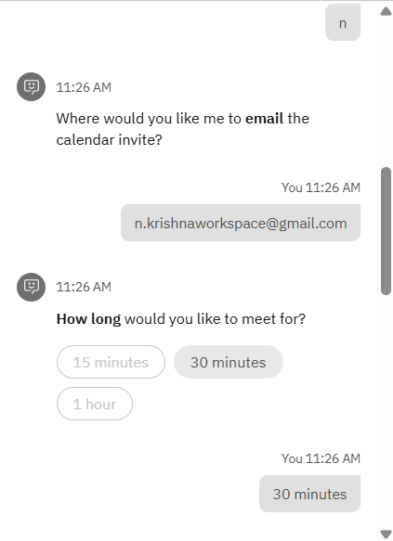

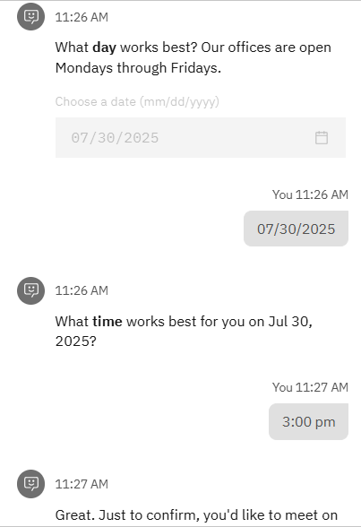 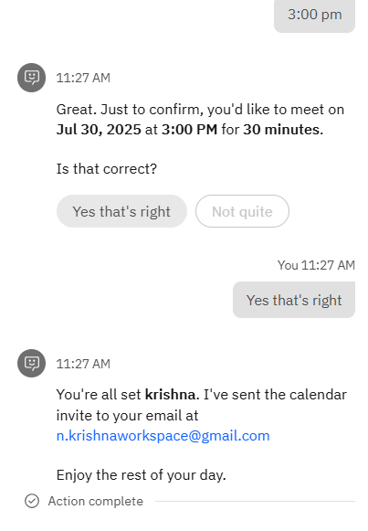

* WhatsApp Integration through Twilio

