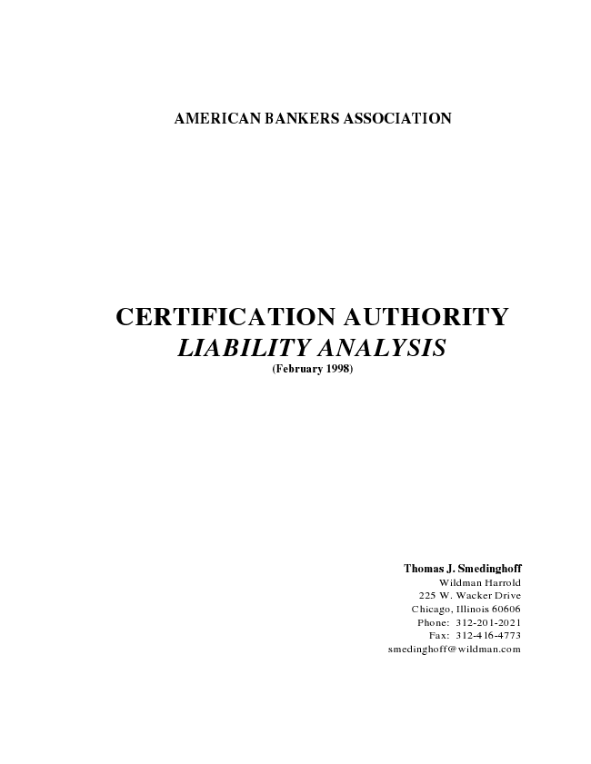
AMERICAN BANKERS ASSOCIATION
CERTIFICATION AUTHORITY LIABILITY ANALYSIS (February 1998)
Thomas J. Smedinghoff Wildman Harrold 225 W. Wacker Drive Chicago, Illinois 60606 Phone: 312-201-2021 Fax: 312-416-4773 smedinghoff@wildman.com

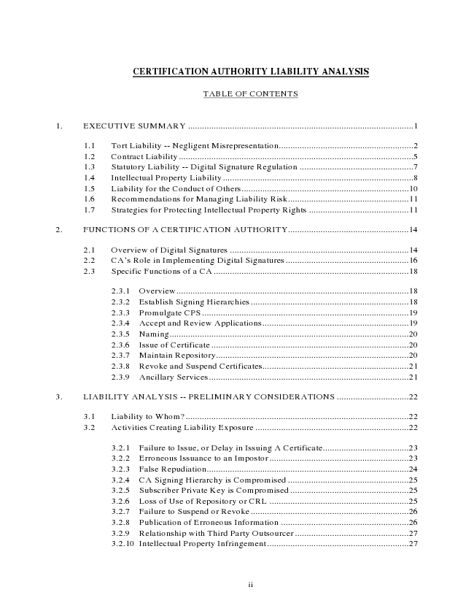
CERTIFICATION AUTHORITY LIABILITY ANALYSIS
TABLE OF CONTENTS
1. EXECUTIVE SUMMARY .................................................................................................1
1.1 Tort Liability -- Negligent Misrepresentation..........................................................2 1.2 Contract Liability .....................................................................................................5 1.3 Statutory Liability -- Digital Signature Regulation .................................................7 1.4 Intellectual Property Liability ..................................................................................8 1.5 Liability for the Conduct of Others........................................................................10 1.6 Recommendations for Managing Liability Risk....................................................11 1.7 Strategies for Protecting Intellectual Property Rights ...........................................11
2. FUNCTIONS OF A CERTIFICATION AUTHORITY....................................................14
2.1 Overview of Digital Signatures .............................................................................14 2.2 CA’s Role in Implementing Digital Signatures.....................................................16 2.3 Specific Functions of a CA....................................................................................18
2.3.1 Overview....................................................................................................18 2.3.2 Establish Signing Hierarchies....................................................................18 2.3.3 Promulgate CPS .........................................................................................19 2.3.4 Accept and Review Applications...............................................................19 2.3.5 Naming.......................................................................................................20 2.3.6 Issue of Certificate .....................................................................................20 2.3.7 Maintain Repository...................................................................................20 2.3.8 Revoke and Suspend Certificates...............................................................21 2.3.9 Ancillary Services......................................................................................21
3. LIABILITY ANALYSIS -- PRELIMINARY CONSIDERATIONS ...............................22
3.1 Liability to Whom? ................................................................................................22 3.2 Activities Creating Liability Exposure ..................................................................22
3.2.1 Failure to Issue, or Delay in Issuing A Certificate.....................................23 3.2.2 Erroneous Issuance to an Impostor ............................................................23 3.2.3 False Repudiation.......................................................................................24 3.2.4 CA Signing Hierarchy is Compromised ....................................................25 3.2.5 Subscriber Private Key is Compromised ...................................................25 3.2.6 Loss of Use of Repository or CRL ............................................................25 3.2.7 Failure to Suspend or Revoke....................................................................26 3.2.8 Publication of Erroneous Information .......................................................26 3.2.9 Relationship with Third Party Outsourcer .................................................27 3.2.10 Intellectual Property Infringement.............................................................27
ii

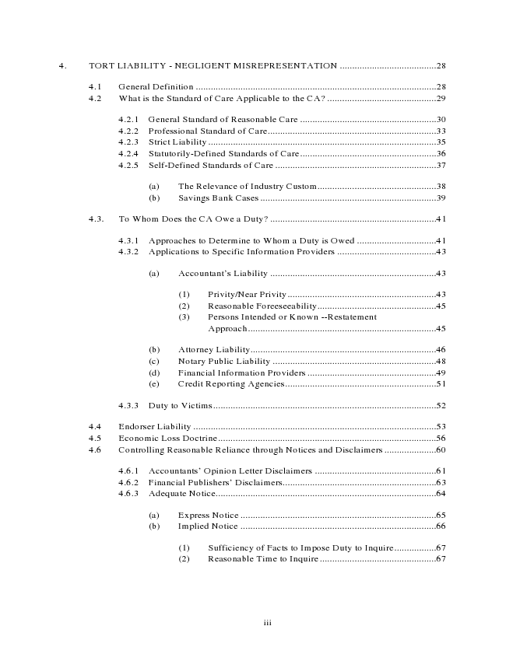
4. TORT LIABILITY - NEGLIGENT MISREPRESENTATION .......................................28
4.1 General Definition .................................................................................................28 4.2 What is the Standard of Care Applicable to the CA? ............................................29
4.2.1 General Standard of Reasonable Care .......................................................30 4.2.2 Professional Standard of Care....................................................................33 4.2.3 Strict Liability ............................................................................................35 4.2.4 Statutorily-Defined Standards of Care.......................................................36 4.2.5 Self-Defined Standards of Care .................................................................37
(a) The Relevance of Industry Custom................................................38 (b) Savings Bank Cases .......................................................................39
4.3. To Whom Does the CA Owe a Duty? ...................................................................41
4.3.1 Approaches to Determine to Whom a Duty is Owed ................................41 4.3.2 Applications to Specific Information Providers ........................................43
(a) Accountant’s Liability ...................................................................43
(1) Privity/Near Privity............................................................43 (2) Reasonable Foreeseeability................................................45 (3) Persons Intended or Known --Restatement
Approach............................................................................45
(b) Attorney Liability...........................................................................46 (c) Notary Public Liability ..................................................................48 (d) Financial Information Providers ....................................................49 (e) Credit Reporting Agencies.............................................................51
4.3.3 Duty to Victims..........................................................................................52
4.4 Endorser Liability ..................................................................................................53 4.5 Economic Loss Doctrine........................................................................................56 4.6 Controlling Reasonable Reliance through Notices and Disclaimers .....................60
4.6.1 Accountants’ Opinion Letter Disclaimers .................................................61 4.6.2 Financial Publishers’ Disclaimers..............................................................63 4.6.3 Adequate Notice.........................................................................................64
(a) Express Notice ...............................................................................65 (b) Implied Notice ...............................................................................66
(1) Sufficiency of Facts to Impose Duty to Inquire.................67 (2) Reasonable Time to Inquire...............................................67
iii

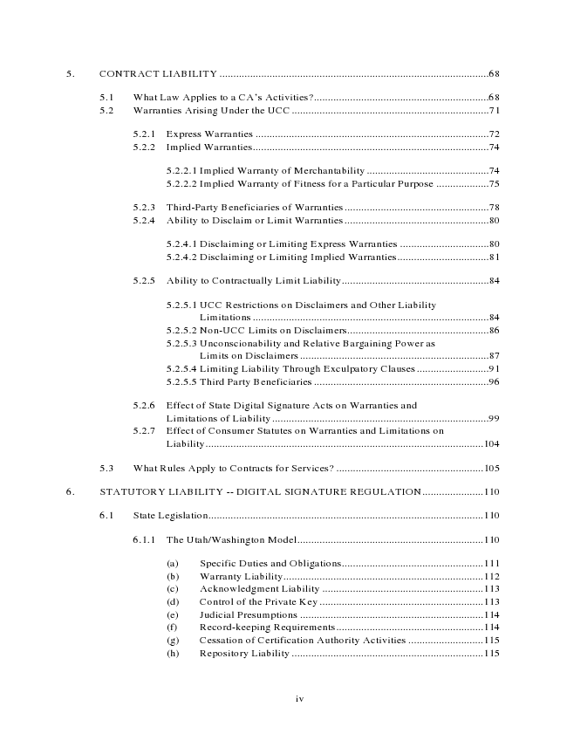
5. CONTRACT LIABILITY .................................................................................................68
5.1 What Law Applies to a CA’s Activities?...............................................................68 5.2 Warranties Arising Under the UCC.......................................................................71
5.2.1 Express Warranties ....................................................................................72 5.2.2 Implied Warranties.....................................................................................74
5.2.2.1 Implied Warranty of Merchantability ............................................74 5.2.2.2 Implied Warranty of Fitness for a Particular Purpose ...................75
5.2.3 Third-Party Beneficiaries of Warranties....................................................78 5.2.4 Ability to Disclaim or Limit Warranties....................................................80
5.2.4.1 Disclaiming or Limiting Express Warranties ................................80 5.2.4.2 Disclaiming or Limiting Implied Warranties.................................81
5.2.5 Ability to Contractually Limit Liability.....................................................84
5.2.5.1 UCC Restrictions on Disclaimers and Other Liability
Limitations .....................................................................................84 5.2.5.2 Non-UCC Limits on Disclaimers...................................................86 5.2.5.3 Unconscionability and Relative Bargaining Power as
Limits on Disclaimers ....................................................................87 5.2.5.4 Limiting Liability Through Exculpatory Clauses..........................91 5.2.5.5 Third Party Beneficiaries ...............................................................96
5.2.6 Effect of State Digital Signature Acts on Warranties and
Limitations of Liability..............................................................................99 5.2.7 Effect of Consumer Statutes on Warranties and Limitations on
Liability....................................................................................................104
5.3 What Rules Apply to Contracts for Services? .....................................................105
6. STATUTORY LIABILITY -- DIGITAL SIGNATURE REGULATION......................110
6.1 State Legislation...................................................................................................110
6.1.1 The Utah/Washington Model...................................................................110
(a) Specific Duties and Obligations...................................................111 (b) Warranty Liability........................................................................112 (c) Acknowledgment Liability ..........................................................113 (d) Control of the Private Key ...........................................................113 (e) Judicial Presumptions ..................................................................114 (f) Record-keeping Requirements.....................................................114 (g) Cessation of Certification Authority Activities ...........................115 (h) Repository Liability .....................................................................115
iv

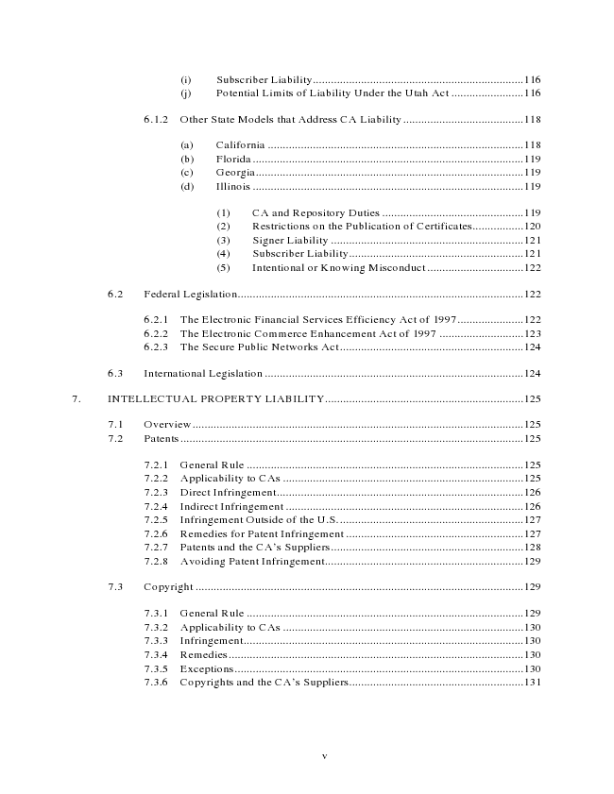
(i) Subscriber Liability......................................................................116 (j) Potential Limits of Liability Under the Utah Act ........................116
6.1.2 Other State Models that Address CA Liability........................................118
(a) California .....................................................................................118 (b) Florida..........................................................................................119 (c) Georgia.........................................................................................119 (d) Illinois ..........................................................................................119
(1) CA and Repository Duties ...............................................119 (2) Restrictions on the Publication of Certificates.................120 (3) Signer Liability ................................................................121 (4) Subscriber Liability..........................................................121 (5) Intentional or Knowing Misconduct ................................122
6.2 Federal Legislation...............................................................................................122
6.2.1 The Electronic Financial Services Efficiency Act of 1997......................122 6.2.2 The Electronic Commerce Enhancement Act of 1997 ............................123 6.2.3 The Secure Public Networks Act.............................................................124
6.3 International Legislation ......................................................................................124
7. INTELLECTUAL PROPERTY LIABILITY..................................................................125
7.1 Overview..............................................................................................................125 7.2 Patents..................................................................................................................125
7.2.1 General Rule ............................................................................................125 7.2.2 Applicability to CAs ................................................................................125 7.2.3 Direct Infringement..................................................................................126 7.2.4 Indirect Infringement ...............................................................................126 7.2.5 Infringement Outside of the U.S..............................................................127 7.2.6 Remedies for Patent Infringement ...........................................................127 7.2.7 Patents and the CA’s Suppliers................................................................128 7.2.8 Avoiding Patent Infringement..................................................................129
7.3 Copyright .............................................................................................................129
7.3.1 General Rule ............................................................................................129 7.3.2 Applicability to CAs ................................................................................130 7.3.3 Infringement.............................................................................................130 7.3.4 Remedies..................................................................................................130 7.3.5 Exceptions................................................................................................130 7.3.6 Copyrights and the CA’s Suppliers..........................................................131
v

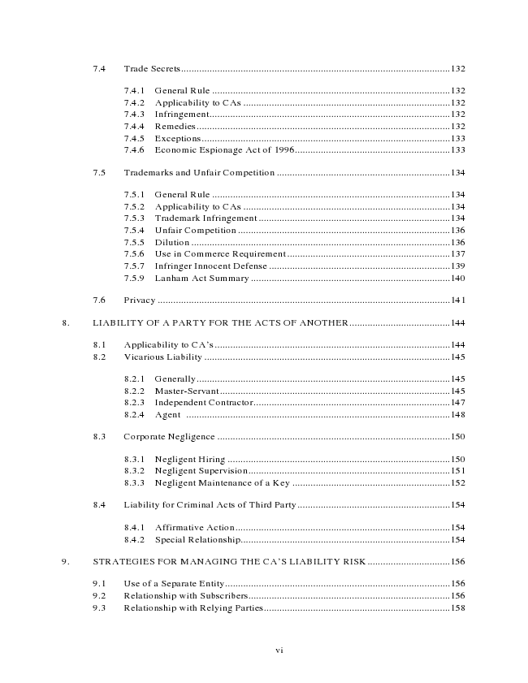
7.4 Trade Secrets........................................................................................................132
7.4.1 General Rule ............................................................................................132 7.4.2 Applicability to CAs ................................................................................132 7.4.3 Infringement.............................................................................................132 7.4.4 Remedies..................................................................................................132 7.4.5 Exceptions................................................................................................133 7.4.6 Economic Espionage Act of 1996............................................................133
7.5 Trademarks and Unfair Competition ...................................................................134
7.5.1 General Rule ............................................................................................134 7.5.2 Applicability to CAs ................................................................................134 7.5.3 Trademark Infringement ..........................................................................134 7.5.4 Unfair Competition ..................................................................................136 7.5.5 Dilution ....................................................................................................136 7.5.6 Use in Commerce Requirement ...............................................................137 7.5.7 Infringer Innocent Defense ......................................................................139 7.5.9 Lanham Act Summary .............................................................................140
7.6 Privacy .................................................................................................................141
8. LIABILITY OF A PARTY FOR THE ACTS OF ANOTHER.......................................144
8.1 Applicability to CA’s...........................................................................................144 8.2 Vicarious Liability ...............................................................................................145
8.2.1 Generally..................................................................................................145 8.2.2 Master-Servant.........................................................................................145 8.2.3 Independent Contractor............................................................................147 8.2.4 Agent ......................................................................................................148
8.3 Corporate Negligence ..........................................................................................150
8.3.1 Negligent Hiring ......................................................................................150 8.3.2 Negligent Supervision..............................................................................151 8.3.3 Negligent Maintenance of a Key .............................................................152
8.4 Liability for Criminal Acts of Third Party...........................................................154
8.4.1 Affirmative Action...................................................................................154 8.4.2 Special Relationship.................................................................................154
9. STRATEGIES FOR MANAGING THE CA’S LIABILITY RISK................................156
9.1 Use of a Separate Entity.......................................................................................156 9.2 Relationship with Subscribers..............................................................................156 9.3 Relationship with Relying Parties........................................................................158
vi

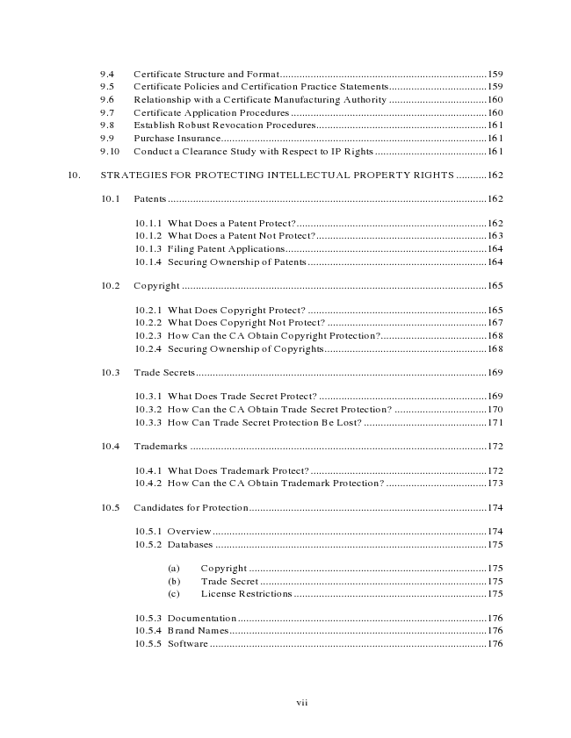
9.4 Certificate Structure and Format..........................................................................159 9.5 Certificate Policies and Certification Practice Statements...................................159 9.6 Relationship with a Certificate Manufacturing Authority ...................................160 9.7 Certificate Application Procedures ......................................................................160 9.8 Establish Robust Revocation Procedures.............................................................161 9.9 Purchase Insurance...............................................................................................161 9.10 Conduct a Clearance Study with Respect to IP Rights........................................161
10. STRATEGIES FOR PROTECTING INTELLECTUAL PROPERTY RIGHTS ...........162
10.1 Patents..................................................................................................................162
10.1.1 What Does a Patent Protect?....................................................................162 10.1.2 What Does a Patent Not Protect?.............................................................163 10.1.3 Filing Patent Applications........................................................................164 10.1.4 Securing Ownership of Patents................................................................164
10.2 Copyright .............................................................................................................165
10.2.1 What Does Copyright Protect? ................................................................165 10.2.2 What Does Copyright Not Protect? .........................................................167 10.2.3 How Can the CA Obtain Copyright Protection?......................................168 10.2.4 Securing Ownership of Copyrights..........................................................168
10.3 Trade Secrets........................................................................................................169
10.3.1 What Does Trade Secret Protect? ............................................................169 10.3.2 How Can the CA Obtain Trade Secret Protection? .................................170 10.3.3 How Can Trade Secret Protection Be Lost? ............................................171
10.4 Trademarks ..........................................................................................................172
10.4.1 What Does Trademark Protect?...............................................................172 10.4.2 How Can the CA Obtain Trademark Protection? ....................................173
10.5 Candidates for Protection.....................................................................................174
10.5.1 Overview..................................................................................................174 10.5.2 Databases.................................................................................................175
(a) Copyright .....................................................................................175 (b) Trade Secret .................................................................................175 (c) License Restrictions .....................................................................175
10.5.3 Documentation.........................................................................................176 10.5.4 Brand Names............................................................................................176 10.5.5 Software...................................................................................................176
vii

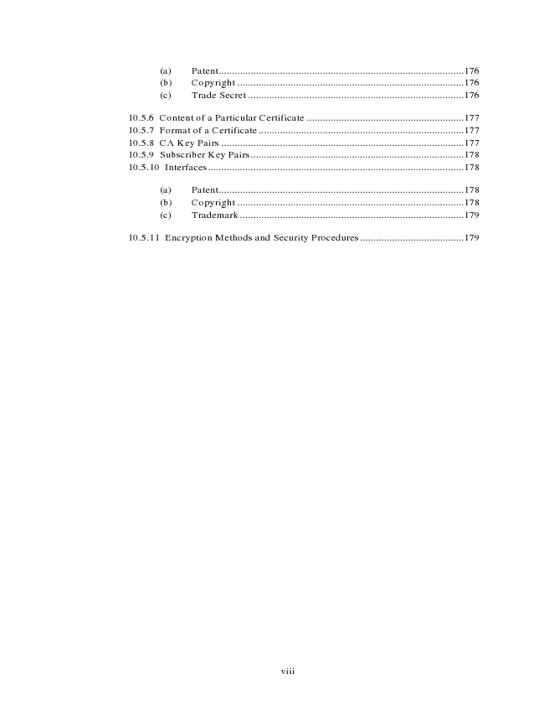
(a) Patent............................................................................................176 (b) Copyright .....................................................................................176 (c) Trade Secret .................................................................................176
10.5.6 Content of a Particular Certificate ...........................................................177 10.5.7 Format of a Certificate.............................................................................177 10.5.8 CA Key Pairs ...........................................................................................177 10.5.9 Subscriber Key Pairs................................................................................178 10.5.10 Interfaces................................................................................................178
(a) Patent............................................................................................178 (b) Copyright .....................................................................................178 (c) Trademark....................................................................................179
10.5.11 Encryption Methods and Security Procedures.......................................179
viii

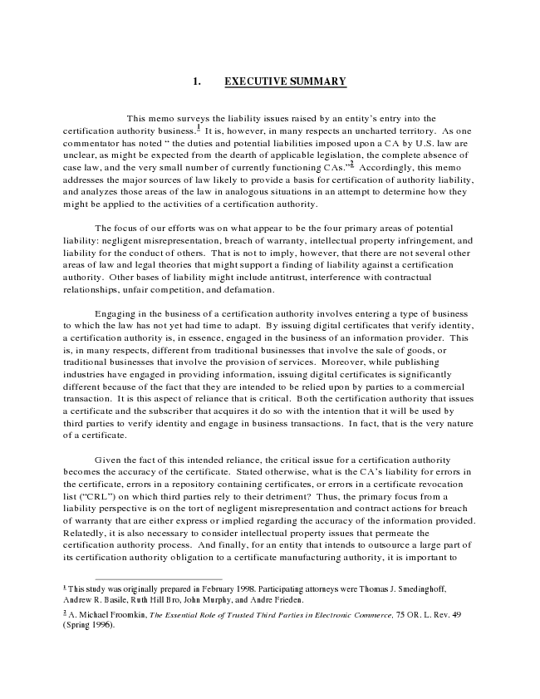
1. EXECUTIVE SUMMARY
This memo surveys the liability issues raised by an entity’s entry into the certification authority business.
1
It is, however, in many respects an uncharted territory. As one commentator has noted “ the duties and potential liabilities imposed upon a CA by U.S. law are unclear, as might be expected from the dearth of applicable legislation, the complete absence of case law, and the very small number of currently functioning CAs.”2 Accordingly, this memo addresses the major sources of law likely to provide a basis for certification of authority liability, and analyzes those areas of the law in analogous situations in an attempt to determine how they might be applied to the activities of a certification authority.
The focus of our efforts was on what appear to be the four primary areas of potential liability: negligent misrepresentation, breach of warranty, intellectual property infringement, and liability for the conduct of others. That is not to imply, however, that there are not several other areas of law and legal theories that might support a finding of liability against a certification authority. Other bases of liability might include antitrust, interference with contractual relationships, unfair competition, and defamation.
Engaging in the business of a certification authority involves entering a type of business to which the law has not yet had time to adapt. By issuing digital certificates that verify identity, a certification authority is, in essence, engaged in the business of an information provider. This is, in many respects, different from traditional businesses that involve the sale of goods, or traditional businesses that involve the provision of services. Moreover, while publishing industries have engaged in providing information, issuing digital certificates is significantly different because of the fact that they are intended to be relied upon by parties to a commercial transaction. It is this aspect of reliance that is critical. Both the certification authority that issues a certificate and the subscriber that acquires it do so with the intention that it will be used by third parties to verify identity and engage in business transactions. In fact, that is the very nature of a certificate.
Given the fact of this intended reliance, the critical issue for a certification authority becomes the accuracy of the certificate. Stated otherwise, what is the CA’s liability for errors in the certificate, errors in a repository containing certificates, or errors in a certificate revocation list (“CRL”) on which third parties rely to their detriment? Thus, the primary focus from a liability perspective is on the tort of negligent misrepresentation and contract actions for breach of warranty that are either express or implied regarding the accuracy of the information provided. Relatedly, it is also necessary to consider intellectual property issues that permeate the certification authority process. And finally, for an entity that intends to outsource a large part of its certification authority obligation to a certificate manufacturing authority, it is important to
1 This study was originally prepared in February 1998. Participating attorneys were Thomas J. Smedinghoff, Andrew R. Basile, Ruth Hill Bro, John Murphy, and Andre Frieden.
2 A. Michael Froomkin, The Essential Role of Trusted Third Parties in Electronic Commerce, 75 OR. L. Rev. 49 (Spring 1996).

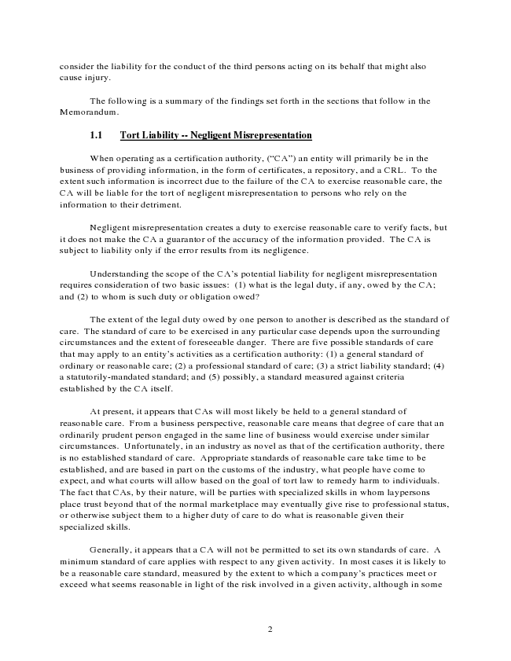
consider the liability for the conduct of the third persons acting on its behalf that might also cause injury.
The following is a summary of the findings set forth in the sections that follow in the Memorandum.
1.1 Tort Liability -- Negligent Misrepresentation
When operating as a certification authority, (“CA”) an entity will primarily be in the business of providing information, in the form of certificates, a repository, and a CRL. To the extent such information is incorrect due to the failure of the CA to exercise reasonable care, the CA will be liable for the tort of negligent misrepresentation to persons who rely on the information to their detriment.
Negligent misrepresentation creates a duty to exercise reasonable care to verify facts, but it does not make the CA a guarantor of the accuracy of the information provided. The CA is subject to liability only if the error results from its negligence.
Understanding the scope of the CA’s potential liability for negligent misrepresentation requires consideration of two basic issues: (1) what is the legal duty, if any, owed by the CA; and (2) to whom is such duty or obligation owed?
The extent of the legal duty owed by one person to another is described as the standard of care. The standard of care to be exercised in any particular case depends upon the surrounding circumstances and the extent of foreseeable danger. There are five possible standards of care that may apply to an entity’s activities as a certification authority: (1) a general standard of ordinary or reasonable care; (2) a professional standard of care; (3) a strict liability standard; (4) a statutorily-mandated standard; and (5) possibly, a standard measured against criteria established by the CA itself.
At present, it appears that CAs will most likely be held to a general standard of reasonable care. From a business perspective, reasonable care means that degree of care that an ordinarily prudent person engaged in the same line of business would exercise under similar circumstances. Unfortunately, in an industry as novel as that of the certification authority, there is no established standard of care. Appropriate standards of reasonable care take time to be established, and are based in part on the customs of the industry, what people have come to expect, and what courts will allow based on the goal of tort law to remedy harm to individuals. The fact that CAs, by their nature, will be parties with specialized skills in whom laypersons place trust beyond that of the normal marketplace may eventually give rise to professional status, or otherwise subject them to a higher duty of care to do what is reasonable given their specialized skills.
Generally, it appears that a CA will not be permitted to set its own standards of care. A minimum standard of care applies with respect to any given activity. In most cases it is likely to be a reasonable care standard, measured by the extent to which a company’s practices meet or exceed what seems reasonable in light of the risk involved in a given activity, although in some
2

