JavaEE Deployment Runbook
macOS → AWS EC2 → Tomcat/PostgreSQL → GitHub Actions self-hosted runner
Purpose: a concise reminder of the deployment sequence used for the Pahana Edu Bookshop JavaEE WAR application. The EC2 instance used in this exercise has since been terminated, so values such as public IPs and temporary keys must be recreated for a future deployment.

Deployment flow
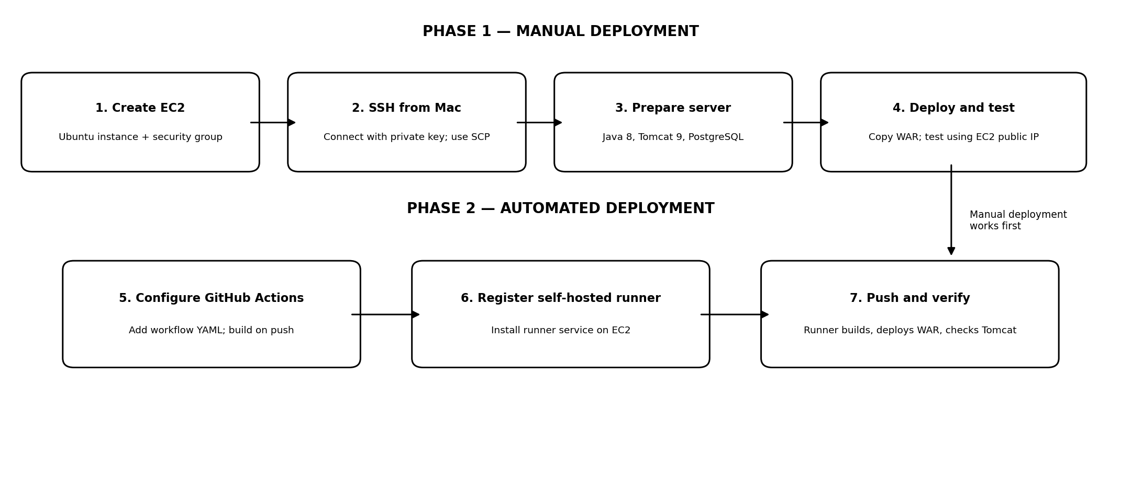

Phase 1 — Manual deployment

1. Create the EC2 instance
In AWS EC2, launch an Ubuntu Server x86_64 instance (we used a t3.micro for this learning exercise). Create/download a key pair and configure a security group. Allow SSH only from your current public IP; allow the application port only as needed for testing. Do not expose PostgreSQL port 5432 publicly.

2. Connect from macOS using SSH
On the Mac, place the private key in ~/.ssh and restrict its permissions:
chmod 400 ~/.ssh/javaee-lab-key.pem
ssh -i ~/.ssh/javaee-lab-key.pem ubuntu@<EC2_PUBLIC_IP>
Use the Mac terminal for local commands; once connected, the prompt changes to ubuntu@<EC2_PRIVATE_HOST>.

3. Install and configure server dependencies
On EC2, install the runtime and database components required by the application: Amazon Corretto/OpenJDK 8, Apache Tomcat 9 (compatible with the app's javax.servlet dependencies), and PostgreSQL. Configure Tomcat as a systemd service, create the application database, and run the project's database initialization SQL script.
Keep database credentials out of source control where possible. Configure the deployed application to connect to PostgreSQL on localhost; do not create a public inbound rule for port 5432.

4. Build, transfer, deploy, and test the WAR
From the project directory on the Mac, build the WAR with the Maven wrapper:
./mvnw -B clean package
Copy the generated WAR to EC2 (replace the path/name if the project version changes):
scp -i ~/.ssh/javaee-lab-key.pem \
target/Pahana-Edu-Bookshop-JavaEE-1.0-SNAPSHOT.war \
ubuntu@<EC2_PUBLIC_IP>:/tmp/
On EC2, stop Tomcat, move the WAR into /opt/tomcat/webapps/, set ownership to tomcat:tomcat, set appropriate file permissions, and start Tomcat. Then open http://<EC2_PUBLIC_IP>:8080/Pahana-Edu-Bookshop-JavaEE-1.0-SNAPSHOT/ and test the login and key application features.

Phase 2 — GitHub Actions automation

5. Add the workflow to the GitHub repository
Add .github/workflows/deploy.yml to the repository. The workflow checks out the source, configures Java 8, runs ./mvnw -B clean package, and deploys the generated WAR. Commit and push the workflow to the main branch.

6. Register and start a self-hosted runner on EC2
In the repository's Settings → Actions → Runners, add a new self-hosted runner for Linux x64. On EC2, download the runner package and extract it in a dedicated directory such as ~/actions-runner. Run the GitHub-provided ./config.sh command using the short-lived registration token, choose the default runner group, and give the runner a clear name such as javaee-ec2-runner.
Install and start the runner service with the provided service script (for example, sudo ./svc.sh install ubuntu followed by sudo ./svc.sh start). Confirm the runner appears as Idle/Online in GitHub before testing the workflow.

7. Push a change and verify automated deployment
Configure the workflow job to use the self-hosted runner labels (for example, runs-on: [self-hosted, Linux, X64]). Because the runner executes on the EC2 instance, the deployment step can run local commands there to stop/start Tomcat and replace the WAR. Use least privilege for any permissions needed; an IAM role grants AWS API permissions only and does not replace GitHub runner registration or OS-level permissions. For a local deployment, SSH keys are not needed for the runner to SSH back into the same EC2 instance.
Commit and push a small application change. In GitHub → Actions, confirm the workflow builds the WAR, deploys it, and verifies Tomcat. Open the application through the EC2 public IP while the instance is running to confirm the change is live.

Security and cleanup checklist
- Keep the EC2 private key and GitHub tokens out of the repository and out of logs.
- Restrict inbound SSH to your current public IP; avoid opening SSH to 0.0.0.0/0.
- Do not expose PostgreSQL port 5432 to the internet.
- A self-hosted runner can execute repository workflow code with the permissions of its OS account; use it only with repositories and workflow changes you trust.
- After the learning exercise, terminate EC2 and confirm there are no leftover EBS volumes, snapshots, Elastic IPs, load balancers, or other billable resources.
- The instance was terminated after the exercise; the GitHub repository and workflow can be retained as a reference. A future run needs a new EC2 instance, key pair/host details, and runner registration.

End of runbook

