Machine Learning Assignment 2
Employee Attrition Classification using multiple ML models with Streamlit deployment

GitHub Repository Link: https://github.com/DbShan25/ML_Assignment2

Live Streamlit Application Link: https://mlassignment2-s4cbxhspge4mschhhugfwh.streamlit.app/

Dataset chosen: Employee Attrition Analysis

Problem Statement:
Employee attrition is a critical challenge for organizations as it leads to increased hiring costs and loss of skilled talent. The objective of this project is to build and evaluate multiple machine learning classification models to predict employee attrition.

Dataset Description:
The Employee Attrition dataset is sourced from Kaggle and contains employee demographic, job-related, and performance-related attributes.
• Number of instances: > 1000
• Number of features: > 30
• Target variable: Attrition (Yes / No)

Data Preparation, Model Training, and Evaluation:
- The Employee Attrition dataset was loaded and preprocessed using a Jupyter Notebook (Employee_Attrition.ipynb).
- Categorical variables were encoded and numerical features were standardized using a saved scaler.
- The dataset was split into training and test sets to ensure unbiased evaluation.
- Six classification models were trained on the same training data for fair comparison.
- Trained models were serialized and stored as .pkl files using joblib.
- During deployment, the saved scaler and trained models are dynamically loaded in streamlit_app.py.
- Users upload a test CSV file containing the target variable (Attrition) through the Streamlit interface.
- Uploaded data is scaled using the saved scaler before prediction.
- Model predictions and probability scores are generated for evaluation.
- Performance is evaluated using Accuracy, AUC, Precision, Recall, F1-score, and MCC.
- Results are displayed through evaluation metrics, confusion matrix, and classification report.
- The complete workflow was executed and validated on the BITS Virtual Lab.

Correlation heatmap obtained from EDA:
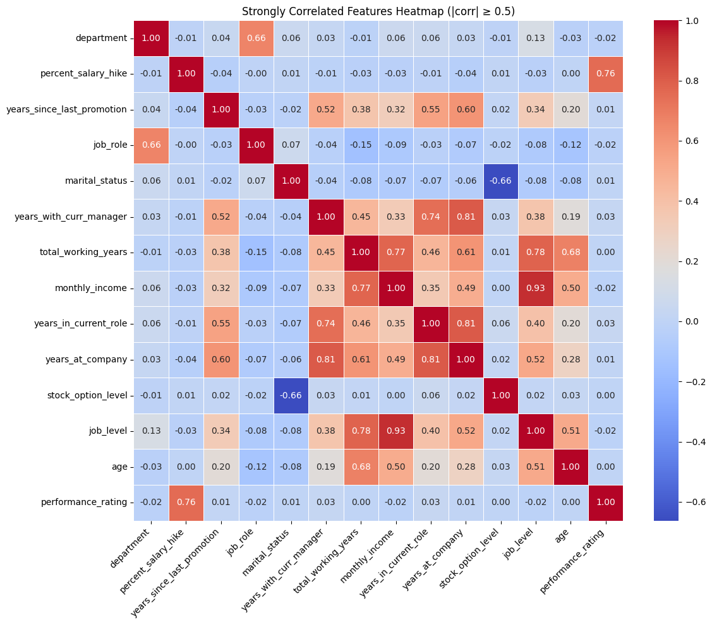
Feature Importance from EDA:
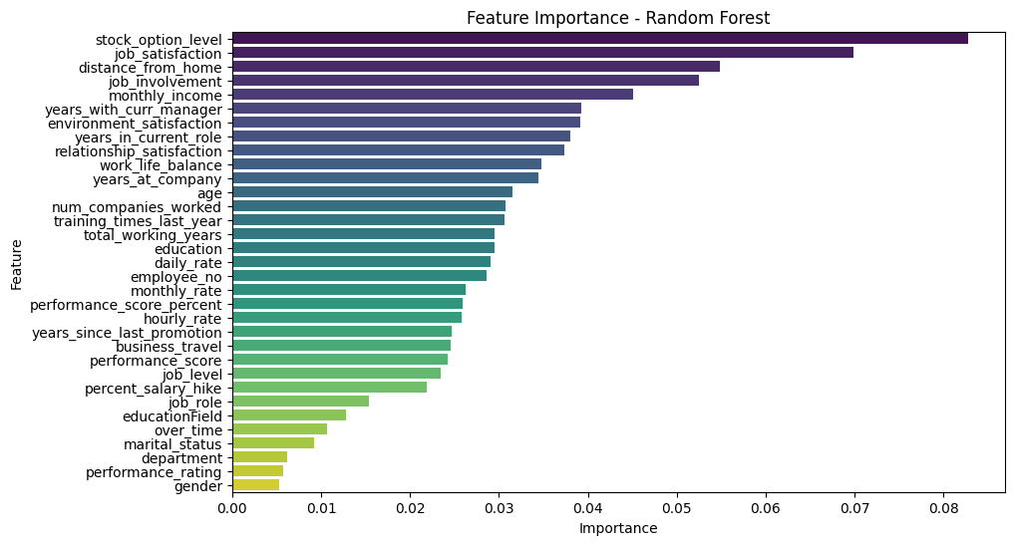
Feature selection:
By combining both figure given above:
- Feature Importance ensured that only variables with strong predictive contribution were selected.
- Correlation Heatmap ensured that selected variables were not redundant with each other.

Final selected features:
- Over_Time
- Stock_Option_Level
- Marital_Status
- Job_Satisfaction
- Monthly_Income
- Distance_From_Home
- Job_Involvement
- Years_in_Current_Role

These features collectively represent:
- Workload (Over_Time)
- Compensation (Monthly_Income, Stock_Option_Level)
- Engagement & Satisfaction (Job_Satisfaction, Job_Involvement)
- Lifestyle & Demographics (Distance_From_Home, Marital_Status)
- Role Stability (Years_in_Current_Role)

Models Used and Evaluation Metrics:

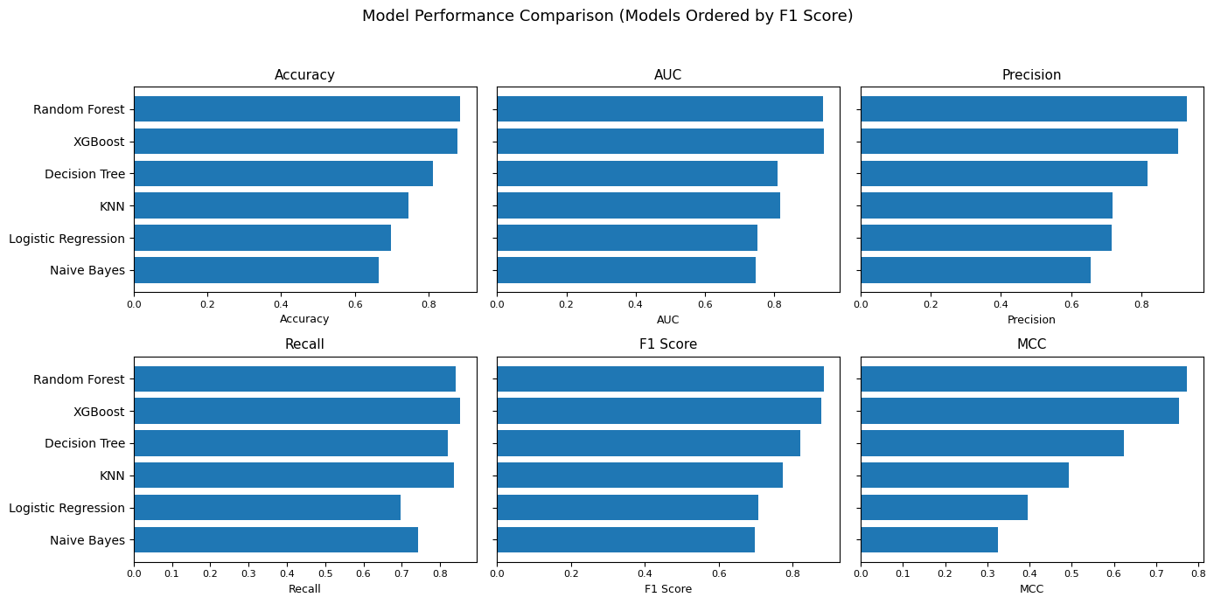

Model | Accuracy | AUC | Precision | Recall | F1 | MCC
Logistic Regression | 0.698 | 0.753 | 0.716 | 0.696 | 0.706 | 0.397
Decision Tree | 0.812 | 0.811 | 0.818 | 0.821 | 0.819 | 0.623
KNN | 0.745 | 0.818 | 0.719 | 0.837 | 0.773 | 0.493
Naive Bayes | 0.664 | 0.749 | 0.656 | 0.743 | 0.697 | 0.326
Random Forest | 0.885 | 0.941 | 0.931 | 0.84 | 0.883 | 0.774
XGBoost | 0.877 | 0.944 | 0.905 | 0.852 | 0.878 | 0.755

Model Performance Observations:

Model | Observation
Logistic Regression | Shows moderate performance, suggesting that linear decision boundaries are insufficient to capture the complex relationships influencing employee attrition.
Decision Tree | Effectively captures non-linear relationships but shows slightly lower generalization performance compared to ensemble models, indicating mild overfitting.
KNN | Achieves relatively high recall but lower precision, reflecting sensitivity to local data distributions and class overlap.
Naive Bayes | Demonstrates lower overall performance due to strong feature independence assumptions, which do not fully hold in the dataset.
Random Forest | Achieves the best overall performance with the highest Accuracy, AUC, F1-score, and MCC, indicating strong generalization and robustness.
XGBoost | Shows performance comparable to Random Forest with well-balanced metrics, benefiting from boosting and effective handling of complex feature interactions.

BITS Virtual Lab Execution:

The assignment was executed on the BITS Virtual Lab. The screenshot given below is from Jupyter notebook file execution.
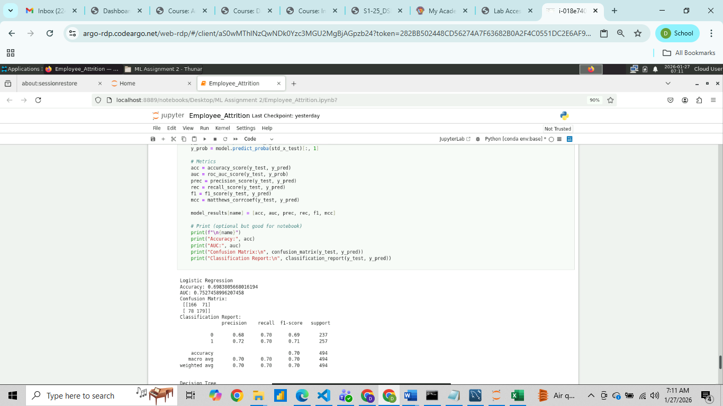

The screenshot below is from VS Code file:
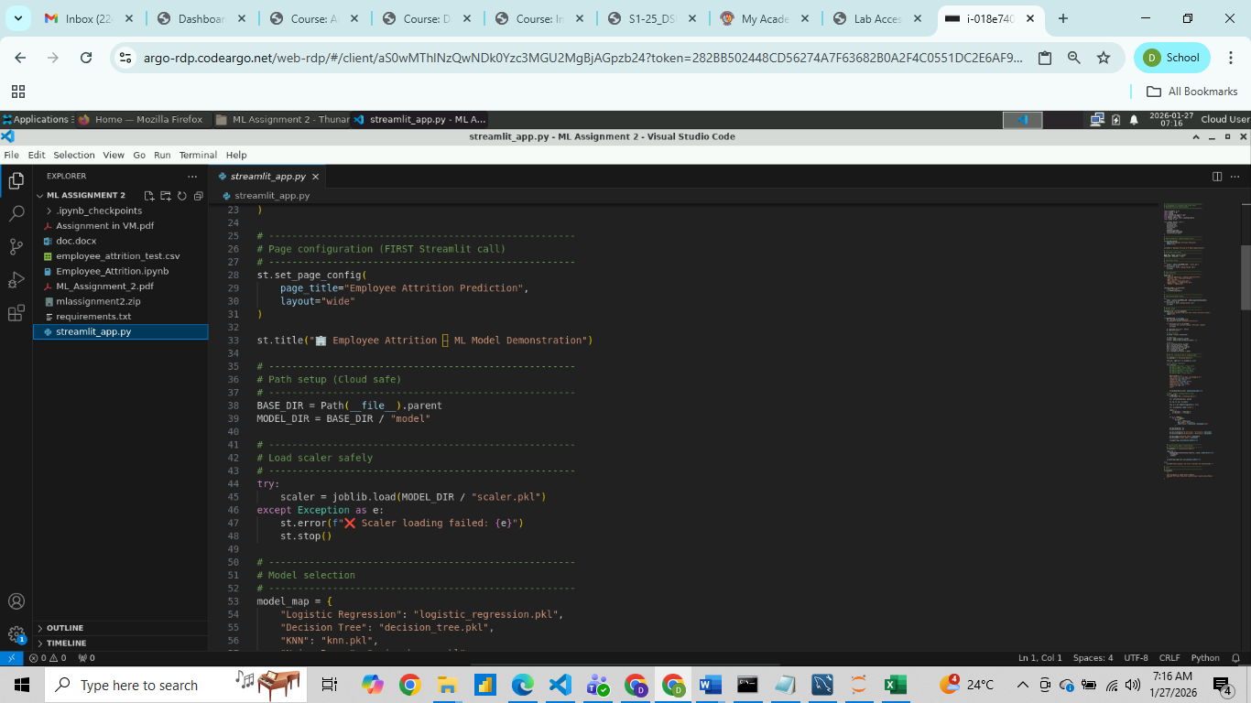

The screenshot below shows successful execution of the Streamlit application.

