Charles Wilson & The Soul Town Sinners
Stage Plot & Technical Information
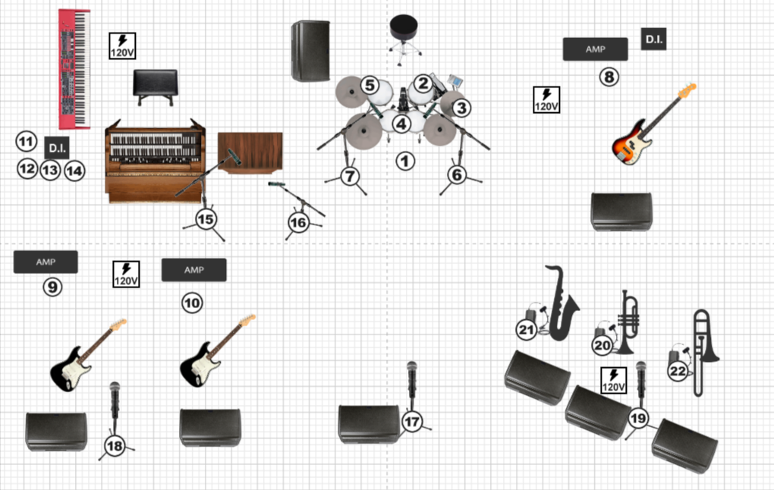
Production Contact:
Name: Charles Wilson
Phone: (662) 889-7317
Email: crownprinceofsoul17@gmail.com

Quick Tech Summary:
Band Size: 7-8 performers
Configurations: 2 guitars + 2 horns; 1 guitar + 3 horns
Typical Inputs: 18-20 channels
Monitor Preference: In-ear monitors preferred (wedges acceptable)
Power required: Guitar positions, bass amp, keyboards, horn section.

Technical Rider
This technical rider outlines the stage, backline, and audio requirements for Charles Wilson & the Soul Town Sinners, a retro soul and Motown band performing concerts, festivals, and corporate events.

Comparable professional equipment substitutions are acceptable with prior approval.

Band Configurations
The band performs in one of the following configurations depending upon the event:
Configuration 1 - Two Guitars | Configuration 2 - One Guitar
- Lead Vocals  - Guitar 1 (Background vocals)  - Guitar 2  - Keyboards  - Bass  - Drums  - Trumpet (Background vocals)  - Saxophone | - Lead Vocals  - Guitar (Background vocals)  - Keyboards  - Bass  - Drums  - Trumpet (Background vocals)  - Saxophone  - Trombone

Guitar Amplifiers
Preferred guitar amplifiers (in order of preference):
- Fender ‘65 Twin Reverb
- Fender ‘59 Bassman
- Fender ‘65 Deluxe Reverb

Comparable vintage-style tube amplifiers are acceptable.

Two amplifiers are required when performing in Configuration 1.

Bass Amplifier
Preferred bass amplifiers (in order of preference):
- Ampeg B-15
- Fender Bassman 500 Combo

Comparable professional bass amplifiers may be substituted.

Keyboard Setup
Keyboard setups must allow for organ sounds and additional keyboard voices.

Preferred keyboard configurations:
- Hammond B3 with Leslie
  - If a B3 is provided, a second electronic keyboard must also be provided for non-organ sounds.
- Hammond XK-3C with Leslie
- Nord Electro 6 or Nord Electro 7

Comparable professional keyboards are acceptable.

Keyboard setup must include:
- Adjustable keyboard stand
- Bench or stool
- Sustain pedal
- Stereo DI (2 channels) for each keyboard provided

Drum Kit
Preferred drum kit brand: Gretsch

Minimum kit configuration:
- Bass drum
- Rack tom
- Floor tom
- Snare drum
- Hi-hat stand
- Snare stand
- Two boom cymbal stands
- Kick pedal
- Drum throne

The drummer will typically provide cymbals and sticks unless otherwise arranged.

Horn Section
The horn section may consist of:
- Trumpet
- Saxophone
- Trombone (Configuration 2)

The trumpet and saxophone players typically perform using musician-provided wireless clip-on microphones.

If microphones are provided by the venue, clip-on microphones are strongly preferred.
Preferred models include:
- Shure Beta 98H/C
- Audio-Technica ATM350
- DPA 4099

If clip-on microphones are not available, dynamic microphones on boom stands such as Shure SM57 are acceptable.

Vocal Microphones
Required microphones:
- Lead Vocal - 1
- Background Vocal - 2

Preferred models:
- Shure SM58
- Shure Beta 58A
- Audio-Technica ATM510
- Audio-Technica ATM610a

All vocal microphones should be provided with boom stands.

Input List
Final input list may vary depending on keyboard configuration and horn section instrumentation.
Channel | Source | Mic/DI
1 | Kick Drum | Beta 52/D112
2 | Snare | SM57
3 | Hi-Hat | SM81
4 | Rack Tom | e604/e904
5 | Floor Tom | e604/e904
6 | Drum OH L | Condenser
7 | Drum OH R | Condenser
8 | Bass | DI (+mic if available)
9 | Guitar 1 | SM57/e906
10 | Guitar 2 (Config 1 Only) | SM57/e906
11 | Keys 1 L | DI
12 | Keys 1 R | DI
13 | Keys 2 L (If second Keyboard) | DI
14 | Keys 2 R (If second Keyboard) | DI
15 | Leslie Top (If Leslie provided) | SM57/Condenser
16 | Leslie Bottom (If Leslie provided) | Dynamic mic
17 | Lead Vocal | SM58/Beta 58
18 | Guitar BGV | SM58/Beta 58
19 | Trumpet BGV | SM58/Beta 58
20 | Trumpet | Clip-on/SM57
21 | Sax | Clip-on/SM57
22 | Trombone (Config 2 Only) | Clip-on/SM57
Typical channel count: 18-20 channels depending on configuration and keyboard setup. Unused input channels may be omitted depending on instrumentation for the event.

If a Hammond organ and Leslie speaker are provided, the Leslie cabinet should be miked using two microphones (top rotor and bottom rotor). When a Hammond organ with Leslie is provided, the organ will be amplified through the Leslie cabinet and the organ DI channels may not be required.

Horn Microphones
Trumpet and saxophone typically perform using band-provided wireless clip-on microphones.

If microphones are provided by the venue, clip-on instrument microphones are strongly preferred for all horns.

If clip-on microphones are not available, Shure SM57 (or similar) on boom stands are acceptable.

Stage Layout
Minimum recommended stage size: 20 ft wide x 16 ft deep
Preferred stage size for festivals and large events: 24 ft wide x 20 ft deep or larger

The stage must accommodate 7-8 performers, drum kit, guitar and bass amplifiers, keyboard setup, and horn section.
Upstage Center - Drums (preferably on riser)
Stage Left - Keyboards
Stage Right - Bass amplifier
Downstage left - Guitar position(s)
Downstage center - Lead Vocal
Downstage Right - Horn Section

Monitor wedges positioned as needed.

Monitor Requirements
In-ear monitor systems are preferred for all musicians.

If the venue is able to provide in-ear monitor capacity, individual mixes for each performer are preferred.

If in-ear monitoring is not available, floor wedges are acceptable, with one dedicated monitor per performer.

Minimum monitor requirements:
- Lead Vocal - 1 monitor mix
- Guitar 1 - 1 monitor mix
- Guitar 2 - 1 monitor mix (Configuration 1 only)
- Keyboards - 1 monitor mix
- Bass - 1 monitor mix
- Drums - 1 monitor mix
- Horn Section - minimum 1 shared monitor mix, 3 individual mixes preferred

When wedges are used, monitors should be placed at each performer’s position along the stage, with an additional monitor for the drum position if needed.

Monitor mixes may be shared when necessary depending on venue capabilities.

Power Requirements
Standard 120V AC power should be available at the following stage positions:
- Guitar position(s)
- Bass amplifier
- Keyboard position
- Horn section

Power strips or power distribution are preferred at positions with multiple devices (keyboards, pedalboards, wireless receivers).

A power drop should be available near the horn line for wireless microphone receivers and related equipment.

All power should be grounded and stage-safe.

Production Notes
- The band requires approximately 45-60 minutes for soundcheck when possible
- When using the band’s wireless systems, RF coordination with the venue may be required
- Comparable professional equipment substitutions are acceptable with prior approval
- Venue should provide a professional front-of-house sound system appropriate for the room size, capable of full-range reproduction suitable for live soul and Motown music.

This technical rider is considered part of the performance agreement.

Charles Wilson & The Soul Town Sinners - Technical Rider - 3/13/2026

