Oracle Exadata to Azure Migrations

*Updated: 03/16/2023*

*Author: Kellyn Gorman*

***Disclaimer: Strictly for internal consumption. Do not share with anyone outside of Microsoft.***

Table of Contents

Exadata Release Versions 3

Decoupling Exadata to Azure 5

Understanding Exadata 5

Understanding Real Application Clusters, (RAC) 6

Exadata Features vs. Azure Solutions 7

Sizing Assessment 12

Exadata Workloads 13

Decoupling from Exadata 14

Wait Events and Inefficiencies 14

Exadata Server Configuration 15

Temp Tablespace Reads and Writes 15

Top Database by IO Throughput 15

Licensing and End-of-Life 16

ORACLE EXADATA END-OF-LIFE: BY APPLIANCE GENERATION 17

Running a POC or Pilot 18

The Migration 19

Post Migration Monitoring 20

Top Checkpoints 20

Summary 20

Exadata is Oracle’s top-of-the-line engineered system for Oracle database performance. Oracle released the first Exadata in 2008 in conjunction with HP and subsequent cloud solutions of Exadata Cloud Service (ExaSC) in 2015, followed by the Exadata Cloud@Customer (ExaCC) in 2017.

Exadata is an engineered system, which means it is both hardware and software, combined with providing a unified platform specifically for Oracle workloads. Although Oracle will promote it for all Oracle databases, it primarily offers the most enhanced performance for OLAP (analytics) databases with limited benefits around RAC scalability and logging for OLTP. The increase in performance around the engineered features, (which are outside of the hardware allocated to the version of Exadata) is highly dependent on the Oracle workload and the database design. This is likely the most surprising aspect for database specialists once they become familiar with Oracle workload assessments- performance benefits vary greatly. This also impacts the database’s actual requirement to run on Exadata or “lock-in” when deciding on a cloud vendor.

This white paper will discuss advanced Oracle engineered system features and database concepts, hoping to identify when an Oracle database can lift and shift, or decouple from an Exadata to the Azure cloud.

In the overall Oracle universe, Exadata has been a highly over-sold solution. Oracle has leveraged it as a “private cloud in a box”, a way to extend software past its capabilities with a highly tuned hardware solution and for some, a way to further their technical career.

As expensive as Oracle licensing is, Exadata will be a large percentage of the customer’s infrastructure investment, and to justify that investment, most of the Oracle data estate will be targeted to run on the engineered system once deployed.

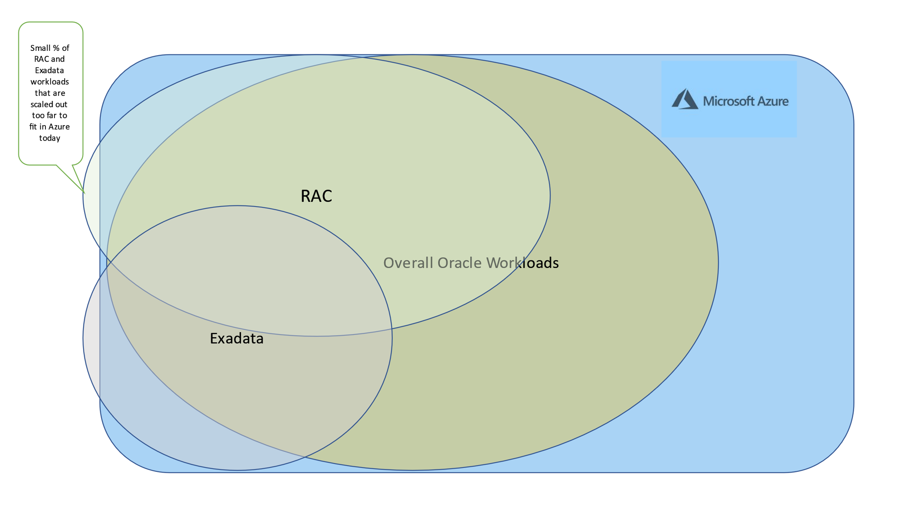

How much Oracle on Exadata can migrate to Azure?

# Exadata Release Versions

Customers are regularly migrating off end-of-life Exadata systems and want to understand the impact, especially if they can migrate to a public cloud. Knowing about the different features included in Exadata models can help understand how much potential decoupling may be required to migrate the workload. The table below is when features were introduced and increases in each Exadata model release.

|  |  |  |
| --- | --- | --- |
| Exadata Release and Model | Software Features | Hardware Features |
| **X5** | Smart Flash Cache | InfiniBand |
|  | Bloom filters | All-flash storage server option |
|  | IO Resource Manager | InfiniBand |
| **X6** | Exafusion direct-to-wire OLTP protocol | 2x increase in flash capacity |
|  | Smart Fusion Block Transfer | 10% increase in compute cores |
|  | Smart Flash Log | 2x increase in memory capacity |
| **X7** | DRAM cache in storage | 2x increase in flash capacity |
|  | Large-scale storage software updates | 25% increase in disk capacity |
|  | In-memory database in flash storage | 25 Gbit/s data center Ethernet support |
|  | Storage Server Extended (XT) |  |
| **X8** | ML-based monitoring and auto-indexing |  |
|  | Real-time updates of optimizer statistics | 40% increase in disk capacity |
|  | AIDE: Advanced Intrusion Detection Environment | 60% increase in storage processor cores |
|  | Persistent Memory (PMEM) in storage |  |
| **X8M** | Persistent Memory Data Accelerator |  |
|  | Persistent Memory Commit Accelerator | 100 Gbit/s internal fabric (2.5x increase) |
|  | KVM virtual machine support |  |
|  | RoCE: RDMA over Converged Ethernet |  |
|  | PCIe 4.0 dual-port active-active 100Gb RoCE network |  |
| **X9M** | Smart Flash Log write-back |  |
|  | Storage Index and Columnar Cache persistence | 33% increase in compute cores |
|  | Faster decryption and decompression Algorithms | 33% increase in memory capacity |
|  | Smart Scan performance optimizations | 28% increase in disk capacity |
|  | Secure RDMA fabric isolation | 1.8x greater internal fabric bandwidth (PCIe 4.0) |
|  |  | 1.8x greater flash bandwidth (PCIe 4.0) |

# Decoupling Exadata to Azure

Migrating Oracle databases from an Exadata engineered system is a unique opportunity and challenge for the database professional. From the tables above, each newer release offers more features to create Oracle’s flagship solution that can be deployed on-premises, as a dedicated resource or a service in the Oracle Cloud. Where database migrations from standard infrastructure are vulnerable to failure when simply replicating with cloud infrastructure, Exadata databases are more so since 70% of the components and features have no way to be shifted. The only successful path is to understand the workload deeply to:

1. Understand the real workload demand.
2. Know what features and infrastructure and produce similar results to Exadata features.

With this knowledge, we can decouple even some of the largest Exadata database workloads. It may be the only way to successfully migrate to the Oracle database if the customer wishes to stay on Oracle but migrate to Azure.

## Understanding Exadata

Oracle’s Promotional Slide for Exadata

What is important to discern from the list above is that many of the features that are touted by Exadata are features available to any Oracle database and can simply be licensed separately:

* Multitenant
* In-Memory DB
* Active DataGuard
* Partitioning
* Advanced Compression
* Advanced Security/DB Vault
* Real Application Testing
* Advanced Analytics
* Management Packs for Oracle Database
* IO Resource Manager

## Understanding Real Application Clusters, (RAC)

Oracle Real Application Cluster, (RAC) is software with hardware clustering solutions that has been very successful for Oracle enterprise database solutions. For onprem databases, it contains several great features that the DBA has become dependent on and may misinterpret as FULL high availability when it only satisfies a small subset of the requirements. These features include:

1. Instance resiliency
2. Rollover patching

Where Real Application Cluster, (RAC) doesn’t meet high availability is evident when reading through [Oracle’s Maximum Availability Architecture,](https://www.oracle.com/database/technologies/high-availability/oracle-database-maa-best-practices.html) (MAA) which is the standard grade of high availability for an Oracle database environment. RAC is simply a suggestion and not a requirement to meet MAA in many instances and as Azure is not an applies-to-apples comparison to any standard data center, closest MAA architecture requires us to review bronze level and above to identify high availability that makes sense for our customers. The reasons for this are:

* + RAC nodes, by default all reside in a single datacenter, leaving them vulnerable to disaster.
  + A RAC environment corresponds to a single database, which doesn’t protect from database corruption.
  + Often, a failover will cause failure due to resource demands once nodes evict from the environment, as RAC is better suited to scalability.
  + Oracle Dataguard IS a requirement for any MAA bronze or above configuration to meet HA and DR requirements, which is very similar to our own Always-on Availability Groups in Azure.

RAC offers the DBA a multi-node, (host) scalability and with load balancing, can divert workload evenly or directly to separate nodes. The scan listener receives requests and directs them to the RAC node to be processed by the single database. RAC consists of a single database though, so if there is database corruption, a standby database served by Oracle Dataguard is still required for fail over till the RAC environment is recovered. The key to RAC is the shared storage, but in any version, RAC one-node or multi-node, Oracle doesn’t support the product in any third-party cloud, (including AWS and GCP, not just Azure.)

[*Understanding RAC latency*](https://www.oracle.com/technetwork/database/options/clustering/overview/s298716-oow2008-perf-130776.pdf)

# Exadata Features vs. Azure Solutions

Once the relational database workload(s) are [correctly sized for Azure,](https://techcommunity.microsoft.com/t5/data-architecture-blog/estimate-tool-for-sizing-oracle-workloads-to-azure-iaas-vms/ba-p/1427183) the next step is to identify the software layer of the Exadata features used by each database and how to address them when losing these once in the Azure cloud.

1. Mixed increase/decrease of IO from [cell node offloading](https://www.oracle.com/technical-resources/articles/enterprise-manager/exadata-commands.html) 
   * Introduce high IO storage solutions, (Silk, ANF, ElasticSAN, etc.) to bypass limits for attached storage per VM for IOPs/MBPs
   * Ensure sizing is done properly and escalate to an Oracle SME to verify that the calculations are correct, as sizing out Exadata IO isn’t straightforward.
   * Use storage snapshots for backups to remove IO demands for RMAN.
   * Use correct series of VM, (E and M series)
2. [Storage Indexes-](https://docs.oracle.com/en/engineered-systems/exadata-database-machine/sagug/exadata-storage-server-software-introduction.html#GUID-11230200-2220-4FA3-9EFF-1792F992FBA5) “Indexes in Memory”
   * Indexes can be queried.
   * Identify the loss from the amount of storage indexes.
   * Review and build DDL for indexes that are needed in the new, cloud database.
   * Physically create the indexes in the new database, (estimate another 10% to house these physical indexes)
   * In Oracle 19c+ the Index Advisor feature can help to build physical indexes that are missing.

\**Storage indexes aren’t simply indexes. This is a feature in Exadata that we can’t fully reproduce.*

1. [Flash Cache](https://docs.oracle.com/en/engineered-systems/exadata-database-machine/sagug/exadata-storage-server-software-introduction.html#GUID-9F582D5C-5E14-47A2-A778-DD738266248C) 
   * Identify through queries what objects are most often in flash cache and pin these in memory on VM. Flash cache is just a secondary buffer cache on disk.
   * Use attached temp storage on VM to allocate to Flash cache.
   * Add ultra-disk managed disk, add specific tablespace to write object to this tablespace, isolated to the ultra-disk.
2. [Flash Logging](https://docs.oracle.com/en/engineered-systems/exadata-database-machine/sagug/exadata-storage-server-software-introduction.html#GUID-E10F7A58-2B07-472D-BF31-28D6D0201D53) 
   * Allocate a small allotment of ultra disks for the redo logs for Oracle, offering faster performance.
   * If latency is around parallel log write, consider separating the redo log members from each redo log group to separate [ultra-disk](https://docs.microsoft.com/en-us/azure/virtual-machines/disks-enable-ultra-ssd?tabs=azure-portal) and separating these parallel writes on disk to ease latency
   * Add more ARCH processes for increased performance.
3. Hybrid Columnar Compression
   * [Hybrid Columnar Compression,](https://docs.oracle.com/en/engineered-systems/exadata-database-machine/sagug/exadata-storage-server-monitoring.html#GUID-30D46E56-0455-447E-8C9F-611C442C0F6C) (HCC) is the highest level of compression known in Oracle.
   * Identify HCC usage and amount of additional storage needed to recompress at a lower compression level in Azure using the second query in the “dbspace.sql” script (downloadable [HERE](https://github.com/Azure/Oracle-Workloads-for-Azure/blob/main/az-oracle-sizing/dbspace.sql)).
   * Use a high IO storage solution like Silk or ANF AVGs that include compression ratio that is close to HCC to ease “IO Explosion” when leaving Exadata.
   * Supplement with Compression high in [advanced compression in Oracle.](https://www.oracle.com/database/technologies/advanced-compression.html)
   * Add supplement [partitioning](https://www.oracle.com/database/technologies/partitioning.html#:~:text=%20Oracle%20supports%20a%20wide%20array%20of%20partitioning,automatically%20defining%20new%20partitions%20for%20any...%20More%20) to assist with some loss in compression and less blocks required for queries impacted whenever possible.

Where Azure on IaaS Increases Performance from Exadata

1. Single-cell Block Reads
   * This is [non-optimal use of cell node offloading.](https://blogs.oracle.com/exadata/persistent-memory-in-exadata-x8m#:~:text=Single%20block%20reads%20are%20the%20highest%20IOPS%20event,Repository%29%20report%20screen%20shot%20shows%20this%20in%20action%3A) Actually lessens the IO totals once off the Exadata. This results in a full object or objects offloaded to a cell node, only to return a single block. Without offloading, a standard Oracle database would optimize the processing to lessen a hash join or use an index, decreasing the IO for statements that experience this on an Exadata.
2. Removal of [Real Application Cluster, (RAC)](https://www.oracle.com/technetwork/database/options/clustering/overview/s298716-oow2008-perf-130776.pdf) and enhance use of Oracle Dataguard. Oracle RAC is the 3rd most functional HA solution by Oracle yet one of the most expensive. Oracle DataGuard and Oracle GoldenGate each protect against many more failure scenarios than RAC is capable of.
   * No longer shipping of read and writes between RAC nodes. Only writes down to Dataguard standbys. This removes significant overhead, (global cache latency)
   * Use [-start failover/switchover,](https://docs.oracle.com/en/database/oracle/oracle-database/18/dgbkr/using-data-guard-broker-to-manage-switchovers-failovers.html) Broker for session failover and automate everything to offer automatic failover in case of failure.
   * [Oracle Dataguard 19c](https://www.oracle.com/technetwork/database/availability/dg-adg-technical-overview-wp-5347548.pdf) has rollover patching with grid control broker, can make it transparent for the user for any software that is mature, and session break aware to failover.
   * [RAC isn’t supported in any third-party cloud,](https://www.oracle.com/technetwork/database/options/clustering/overview/rac-cloud-support-2843861.pdf) but it’s also not a requirement to reach high availability in the cloud. Azure architecture already includes HA options that would then introduce redundancy if we placed RAC as part of the cloud solution. We are now architecting FOR the cloud vs. lift and shift of what was on-premises.
3. Offloading IO
   * A percentage of [IO is caused by the act of offloading](https://www.oracle.com/technical-resources/articles/enterprise-manager/exadata-commands.html) to the cell nodes and returning the data from the cell nodes to the database nodes. This amount of IO will disappear once the database is migrated to a VM with a high IO storage solution like ANF or Silk.

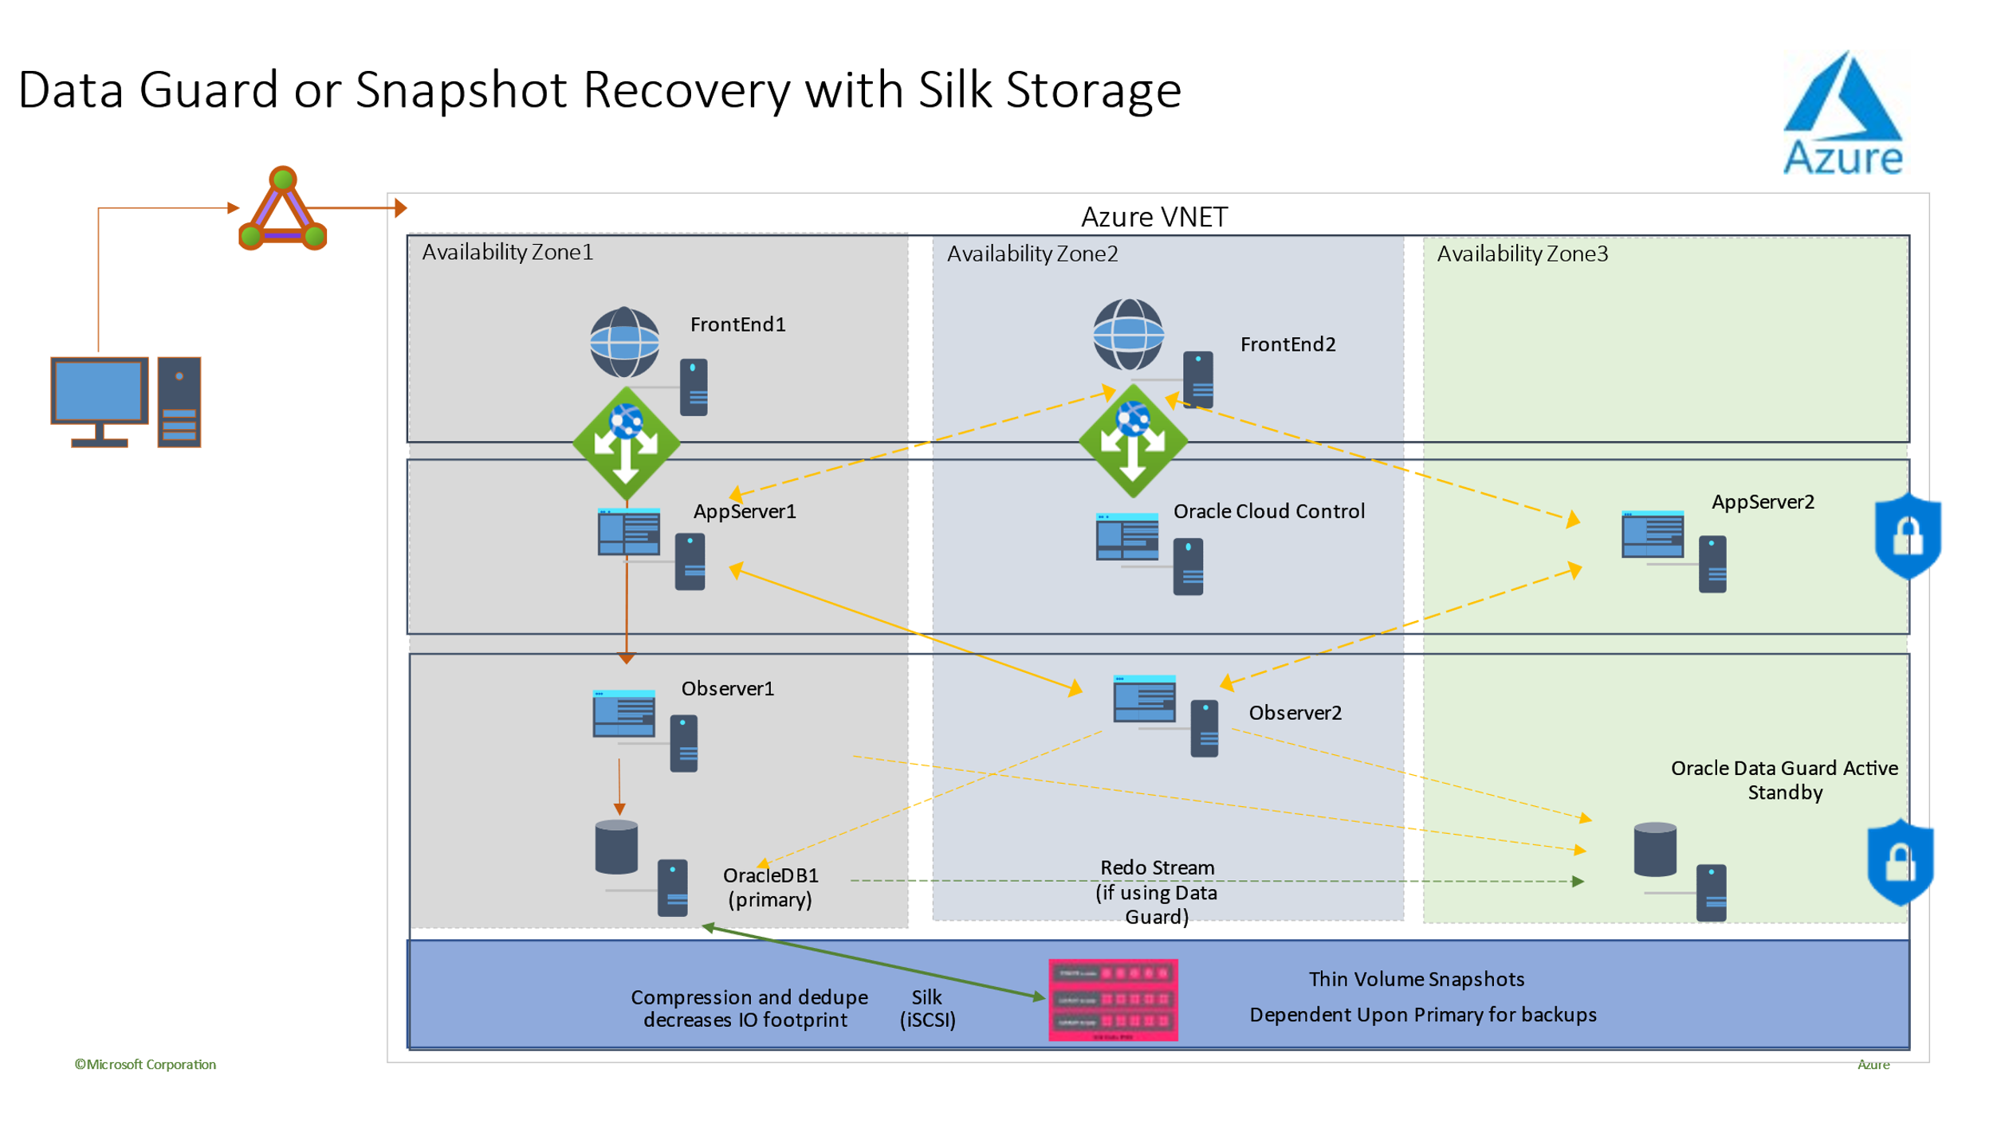

Common Multi-Availablity Zon Deployment for Oracle in Azure

1. Increase of SGA and less IO needed.
   * The first step to increasing offloading is to decrease the memory allocated to the [System Global Area, (SGA).](https://docs.oracle.com/database/121/TGDBA/tune_sga.htm) By having less memory, less fits in memory and *forces* offloading. By increasing the SGA, the workload fits inside the buffer cache more often and requires less IO to perform tasks.
   * Expect the database to inch up requests for more SGA over the first month or so of running the workload on it. This is quite normal for databases migrated off an Exadata.
2. [Write-back Flash cache](https://support.oracle.com/knowledge/Sun%20Microsystems/1500257_1.html) 
   * Feature promoted for write-intensive database to offer performance in Exadata but isn’t as successful. Isolate these objects and build onto a managed disk solution on Ultra disk or on ANF.
3. IO Resource Management, (IORM)
   * Not only is [IORM](https://docs.oracle.com/database/121/DGBKR/concepts.htm) available to be implemented on the new database in Azure, there are [Resource managers for IO, etc. that are automatic per VM.](https://docs.microsoft.com/en-us/azure/virtual-machines/windows/disk-scalability-targets) This will be available without any issue.

# Sizing Assessment

In an AWR sizing estimate, you can only size for what is in the repository. If data is missing for peak workloads, then sizing accuracy will be impacted. Always work with the database specialist from the customer to identify the best possible window for sizing and carefully balance a size between what will scale for the Oracle workload needs and cost efficiency. With this knowledge, there are changes that occur in the Oracle SME’s sizing assessment vs. an Oracle database not on Exadata. AWR Reports:

1. Always should be in HTML format so that Exadata features are included for 12.1 and above reports.
2. Should always be a Global AWR Report ($ORACLE_HOME/rdbms/admin/awrgrpt.sql)
3. Commonly there are 1-2 large database workloads residing on the Exadata and then others that have consolidated to it. Find out from the customer which ones are the larger databases and if there are days when the workload is heavier than others.
4. Ask for a smaller window AWR for these databases, 3-4 days has shown to offer the best sizing for Exadata workloads using the Right-sizing assessment.
   1. For an AWR with a 1-hour interval on snapshots, this would equate to 72-96 snapshot variance between the beginning and ending snapshot.
5. The customer will still need to provide the size of the database and the [dbspace.sql](https://github.com/Azure/Oracle-Workloads-for-Azure/commit/0a8b8fdd22a94ec80cb17419e959e3fc2af4d483) is the best way to collect this data in a script that is very low impact to the database.
6. If the customer would like to identify the peak workload times in the AWR, the [busiest_AWR.sql](https://github.com/Azure/Oracle-Workloads-for-Azure/commit/ec5c36fbf9015f256b8c4e3738675c33feba7e6d) can identify the top five AWR windows.

Once this data has been collected, the AWR reports should be sized using the [sizing instructions](https://github.com/Azure/Oracle-Workloads-for-Azure/commit/4e81609d2d50228699ab2b249e08e30613455ebf) and [sizing worksheet](https://github.com/Azure/Oracle-Workloads-for-Azure/commit/6f463169934fb4cbe1799fcb1b7bc2b05dbc589b). There are some basic differences that can be used to begin the sizing from Exadata to Azure by adjusting the fudge/consideration factors below the “AWR detail collected by database instance” section in the AWR worksheet:

Consideration/Fudge Factors from a Sizing Estimate

By default, the IO metrics will be set to 2.00, (in the calculations, once moved to MBPs, multiply by 2.) In Exadata, as you lose Hybrid Columnar Compression, (HCC) offloading and storage indexes, there is an additional 2X that is expected by default to be added to the IO. This is now the starting point for workload sizing estimates. There are added features to offload IO from the database nodes to cell nodes, known as smart scans, IO savings using storage indexes and additional flash cache which can multiply additional IO calculated on top of the throughput displayed by another 2 times to total 6.00 in the IO metrics. Due to this IO explosion that can result for an Oracle workload when taking full advantage of Exadata engineered features, (primarily experienced in OLAP workloads) it is important to perform advanced database assessments for any Oracle database migrating from Exadata to determine which type of workload you may be faced with.

# Exadata Workloads

When choosing to run Oracle on Exadata, there are some common reasons for the investment in an engineered system:

* One or two high IO workloads which take advantage of Exadata engineered system features effectively. There may be considerable, smaller Oracle workloads consolidated onto the system afterwards.
* Complicated or difficult OLTP workloads that require RAC to scale and are difficult to architect with proprietary hardware and/or deep knowledge of Oracle optimization and removal of technical debt.
* Surprisingly under-utilized Exadata with various workloads, either due to previous migrations, end-of-life on Exadata or due to a desire to work/test an Exadata in-house.

It is essential for any migration off Exadata for the technologist to have a clear understanding of the workloads residing and how simple or complex the migration may be.

More Exadata Features Used=More Complex Migration

Less Exadata Features Used = Simpler Migration Opportunity

There are several tools that can be used to assess these workload opportunities-

* The Automatic Workload Repository (AWR)
  + All Exadata databases are licensed to use AWR reports and connected performance and diagnostic features.
  + It is always on and collects data that can be used to view historical workload information and assess usage.
  + Peak values can assess the high usage of the system.
  + Larger window reports can assess the overall workload, providing valuable insight into feature usage and how to migrate the workload to non-Exadata effectively.
* The Global (RAC-Aware) AWR report for Exadata also includes an Exadata specific section which drills down into specific Exadata feature usage and provides valuable insight info flash cache, flash logging, IO and other feature usage by database and cell node.

# Decoupling from Exadata

Questions to answered when identifying Oracle Exadata workloads to migrate to the cloud:

1. Is the workload consuming significant Exadata features, outside of hardware benefits? Can these features be used in Azure or does Azure have a solution that can replicate the benefit?
   1. Smart Scans
      1. Identity the type of offloading occurring.
   2. Storage Indexes
      1. Oracle automatic indexing or replacing missing indexes are the closest to this feature outside of Exadata.
   3. Flash Cache
      1. Flash cache is just a secondary buffer cache on fast disk. This can be replicated on the local ephemeral disk on a VM.
   4. Flash Logging
      1. Inspect log file latency and consider ultra disk for small, fast IO for redo logs and for parallel write latency, consider separating the redo members by separated ultra disks.
   5. Hybrid Columnar Compression
      1. Use Network attached storage that includes storage compression that can compete with HCC. Consider advanced partitioning strategies that can decrease IO demands.

## Wait Events and Inefficiencies

Oracle provides significant evidence as part of an AWR report around wait events and usage of Exadata features. These wait events will provide not only the database time allocated to performing the action, but by understanding the wait event, understanding if it’s the most efficient way to use the Exadata features.

Is the workload using Exadata offloading (smart scans) efficiently? In the **Top Time Foreground Events**, what is the ratio of workload using:

* 1. Cell Smart Table Scan (Optimal)
  2. Cell Multiblock Physical Read (Less Optimal)
  3. Cell Single Block Physical Read (Suboptimal)

1. Hybrid Columnar Compression (HCC/EHCC), What is the compressed vs. uncompressed ratios:
   1. Is the database spending significant cycles compressing and decompressing data?
   2. Inspect the performance gains for predicates using the compression in queries- is the value gained worth it vs. the amount saved with compression?
2. Cell Physical IO- Inspect the savings provided from:
   1. Inspect the amount directed to the DB node to balance CPU.
   2. Identify the number of bytes returned by smart scan, as these values can be subtracted in IO for the percentage of cell single block physical reads once it migrates off Exadata.
3. Note the number of logical reads from cache, determine of flash cache will be required in a cloud IaaS solution for the workload.
4. Compare the physical read and write total bytes to the amount performed total in cache. Can memory be raised to eliminate physical read requirements, (it is common for some to shrink down SGA to force offloading for Exadata.)
5. In **System Statistics,** identify what objects are impacted by what statistics and if tuning SQL, additional indexing, partitioning or other physical tuning may optimize the workload dramatically.
6. Inspect **Initialization Parameters** for underscore (_) or deprecated parameters which should be justified due to database level impact they may be causing on performance.

## Exadata Server Configuration

In 12.2 Oracle version and above, an Exadata specific addition will be included in the AWR global report. This report has sections which provide exceptional value to a migration from Exadata.

* Exadata Version and System Details
* Cell Node Alerts Detail
  + Note any alerts on performance or impacted infrastructure.
* Exadata Non-Online Disks
  + End-of-life Exadata are costly to continue to support. Hardware support is only provided by Oracle and
* Outlier Data for any Exadata OS Statistics
  + Yellow/Pink- Of concern. Exadata is not running optimally.
  + Red- Exadata performance is impacted significantly.

## Temp Tablespace Reads and Writes

Exadata can’t assist with heavy temp usage and will most likely have similar issues with heavy IO caused by it. Although faster storage can assist with these types of high IO, Exadata isn’t able to enhance temp usage and may be exasperated by the optimization practice of shrinking PGA for Exadata workloads. This practice may force more workload to “swap” to temp.

* + Consider moving temp tablespace to a local VM ephemeral disk.
  + Consider advanced partitioning to ease IO demand and have temp usage decreased.

## Top Database by IO Throughput

Although we perform a sizing assessment, there are some questions about the averages and the simulated peaks that are built into these values for large workloads. This section, to be found at the end of an AWR report, is exceptionally valuable, as it shows both the average flash and disk usage of the top ten databases on Exadata. Although many may assume they want to size for peak in the cloud, most will clearly understand this doesn’t make sense when most of the work, (over 95% is in the average range and with a simulated peak calculated in, can be upwards of 98% or more.) With this knowledge in hand, it is important to pay for what is needed, even for the highest of Oracle’s demand workloads and inspecting the **Top Databases by IO Throughput** can be enlightening for the resource needs for the database regularly.

|  |  |  |  |  |  |  |
| --- | --- | --- | --- | --- | --- | --- |
|  |  | **IO Throughput (MB)** | | | | |
| **DB Name** | **DBID** | **%Captured** | **Total MB** | **per Sec** | **Flash** | **Disk** | **Total Requests** |
| DW2 | 2331836840 | **80.44** | 21,596,728.35 | **20,297.68** | 18,206,009.51 | 3,390,718.84 | 333,026,771 |
| DB2 | 4598359864 | 6.25 | 1,678,218.75 | 1,577.27 | 1,040,217.38 | 638,001.37 | 21,749,389 |
| DB3 | 5401335437 | 5.68 | 1,523,786.41 | 1,432.13 | 721,742.39 | 802,044.02 | 25,468,330 |
| DW1 | 2098436247 | 2.70 | 726,132.98 | 682.46 | 419,143.54 | 306,989.44 | 6,768,151 |
| SCM1 | 7037465385 | 1.09 | 293,016.47 | 275.39 | 149,897.48 | 143,118.99 | 3,040,722 |
| OTHER | 0 | 1.03 | 276,503.75 | 259.87 | 161,764.83 | 114,738.92 | 25,587,670 |
| DB7 | 9825635685 | 0.07 | 18,233.54 | 17.14 | 16,609.95 | 1,623.59 | 417,124 |
| SCM2 | 8364532449 | 0.04 | 12,052.94 | 11.33 | 7,755.15 | 4,297.79 | 408,906 |
| ASM | 1 | 0.04 | 10,306.00 | 9.69 | 1,158.00 | 9,148.00 | 325,132 |
| OPS1 | 2863543564 | 0.02 | 5,614.00 | 5.28 | 2,919.69 | 2,694.31 | 75,464 |

Output from an AWR Top Database by IO Throughput in Exadata

Notice with the table above from an example AWR Exadata IO by Database throughput, that it’s obvious that the DB2 is the database that consumes the largest percentage of Exadata resources. Upon closer inspection, it will be found that most of the offloading, flash cache flash logging and storage index usage is consumed by the DB2 database, too. Inspecting the average throughput requirements, the rest of the databases will be much simpler to migrate, but the DB2 will take an expert’s assessment and investment, demonstrating how different a workload can be running on an Exadata.

# Licensing and End-of-Life

Oracle Exadata many times doesn’t just include bundled licensing for the database, but also for partitioning, management packs and even the operating system that runs on the database and cell nodes. The licensing negotiation to purchase the licensing required to run the migrated Oracle databases in Azure is often stated to be the most difficult part of the project.

Tips for Success:

1. Have a dedicated, [knowledgeable individual over the licensing](https://docs.oracle.com/en/database/oracle/oracle-database/19/dblic/index.html) negotiation with Oracle.
2. Licensing is much cheaper when [purchased through Oracle](https://www.oracle.com/corporate/pricing/) vs. a licensing vendor, but it will be a negotiation.
3. Already identify what you currently have licensed as part of the Exadata, including:
   1. Operating System Licenses
   2. Database Licenses, both standard and enterprise edition
   3. Know what database come with their own limited EE licenses for repository databases, such as Oracle Enterprise Manager, RMAN, etc.
   4. Know what management packs you are using, (tuning, diagnostic, cloud, and lifecycle management) and what you may not need.
   5. Trade in expensive licensing for RAC towards ones that are useful, such as Oracle Active Dataguard, lifecycle management pack and partition or advanced compression.
4. If Oracle states that they don’t support a product in a third-party cloud, such as E-business suite, consider asking for a one-off support license. This has been accomplished by other customers.

# ORACLE EXADATA END-OF-LIFE: BY APPLIANCE GENERATION

|  |  |  |
| --- | --- | --- |
| **Exadata appliance generation** | **Last Ship Date (LSD)** | **Effective end-of-support (EOS) date** |
| Exadata Database Machine X5-2 | July, 2016 | July, 2021 |
| Exadata Database Machine X5-8 | March, 2016 | March, 2021 |
| Exadata Database Machine X6-2 | November, 2017 | November, 2022 |
| Exadata Database Machine X6-8 | November, 2017 | November, 2022 |
| Exadata Database Machine X7-2 | June, 2019 | June, 2024 |
| Exadata Database Machine X7-8 | June, 2019 | June, 2024 |

End of life schedule for Oracle Exadata Appliance

# Running a POC or Pilot

It is common for customers to assume they are locked in with an Exadata for Oracle and are unable to run the database workload anywhere else, so a POC or pilot will often be required. Running a successful POC requires the following essentials:

1. Identify what defined list of tests or components must be tested to successfully satisfy the POC.
2. Have a clear set of dates and deadline for the POC completion.
3. Identify what components other than the database tier must be run as part of the POC.
   1. Application
   2. ETL/ELT
   3. Middleware
   4. Web tier
   5. Load balancers
   6. Misc. Blob storage to hold backup files, etc.
4. Have a clear list of accountable and dedicated resources for the POC- This can be employees or a partner, but the resources must be dedicated to the POC timeline.
5. Document and verify the current Azure investment-
   1. Is there already a robust Azure environment, with Azure Active Directory, mature networking, and cloud administration group to ease the POC execution?
   2. Is this their first time in Azure and some set-up and onboarding will be required?
6. Ensure the architecture diagrams are clear and the sizing is accurate.
7. Verify that the compute VM SKUs chosen, settings for storage, networking and other requirements for optimal performance are followed.
8. Have solid baselines of current performance on the Exadata, including Automatic Workload Repository (AWR) Reports especially around:
   1. #of executions and elapsed time per execution in Top SQL by Elapsed Time
   2. Active Session History (ASH) Reports that can be pulled for any time reports for test cases to compare wait events and differences between Exadata and non-Exadata runs.
   3. Capture SQL_IDs for the Most impactful SQL executions, (SQL executed in Oracle has a unique identifier called a SQL_ID that will be the same in the new environment as the old if there are no changes made to the SQL. Changes include capitalization, spaces, hints, etc.) SQL_IDs can be used to track down differences in execution plans if any optimization opportunities need to be identified as part of the POC.
9. Ensure expectations that some SQL may require optimization afterwards, but overall performance will be targeted for the same in the Azure IaaS environment.
10. Track both performance and lessons learned, including any steps that must be taken as part of the migration when it is performed fully.
11. Performance graphs and metrics are helpful to visualize the success or opportunities for improvement of any POC and can even be created from Excel.
12. Have a regular cadence meeting to ensure the POC is on track, documentation is updated, and all testing is completed fully.

Once the POC has met all the requirements set forth by the customer, the lead, partner, or project manager should ensure there is a full sign-off by the customer and a follow up meeting should be scheduled to proceed with next steps.

# The Migration

A migration should be planned out carefully and if followed by a POC for Oracle workload, ensure it identifies all tiers and connectors to the database system:

* Web Servers
* Applications
* ETL/ELT system
* Batch/script server(s)
* Middleware
* Operations/jump servers
* Monitoring systems/job servers
* Any database which closely exchanges data.
* Load balancers

All content and steps in the migration should be tracked in a master migration project plan to ease managing the process. Have one individual responsible for the project and someone identified as a backup. Ensure that there are dedicated technical resources assigned and accountable to making the migration a success.

In addition to the above list, architectural decisions should already be made for:

* High Availability (HA) with Data Guard, cloning, clustering, or another secondary solution that meets SLAs for uptime for Recovery Time Objective (RTO).
* A Disaster Recovery solution, such as offsite backups, a DR database copy, volume snapshots that meet Recovery Point Objective (RPO).
* Network bandwidth requirements for workload, including Express Route and network security groups to ensure policy division between tiers.
* Application High Availability and Disaster Recovery that includes solutions such as Azure Site Recovery and/or Scale Sets.

Full scale testing at each phase should be part of the migration strategy to simplify identification of issues in deployment and perform as much as possible using automation and scripting tools to ensure that everything is repeatable.

As part of testing, consider taking advantage of the following:

* Volume snapshot backup and clones, which can ease the time waiting for test data to be provided to testers to test and technical resources to provide solutions.
* Consider having multiple cloned VM environments to run in parallel to speed up testing.
* Use Azure Site Recovery to make backups between changes to application tiers.
* Use Azure DevOps, Templates and Bicep to speed up automation in Azure.

Full architecture diagrams and migration plans should be built out and responsibility assignments with deadlines created.

Consider having a regular scrum meeting to discuss high level tasks for the day and discuss any lessons learned or challenges faced. After each milestone is accomplished, ensure that there is a clear path to the next milestone to be undertaken and the project does not stagnate.

# Post Migration Monitoring

Azure provides significant monitoring tools to assist once the Oracle workload has switched to production in the cloud. It is quite normal to recommend using [Oracle Cloud Control,](https://www.oracle.com/enterprise-manager/) (i.e. Enterprise Manager) to provide a uniform, known and full infrastructure tool Oracle DBAs are comfortable with. The logs from Cloud Control can be ingested with the [Log Analytics Agent into Azure Monitor](https://learn.microsoft.com/en-us/azure/azure-monitor/agents/data-sources-custom-logs) for a single-pane experience, too.

Using baseline AWRs from the previous Exadata environment, comparisons can be done with new AWR reports collected on the new Azure Oracle environment. This allows the Oracle technologist to review how the new ecosystem is performing in Azure and how best to ensure its caring and feeding.

## Top Checkpoints

Verify the customer has implemented the recommended [practices for Oracle on Azure for IaaS.](https://github.com/Azure/Oracle-Workloads-for-Azure/blob/main/Oracle%20on%20Azure%20IaaS%20Recommended%20Practices%20for%20Success.pdf)

Top Elapsed SQL by Elapsed Time

1. Verify that the same SQL and SQL_IDs are present, and the execution time are within acceptable range for per execution and number of executions.
2. If not, is it just for one or two SQL or is it across all the SQL in the list, which would point to a database level issue with a resource, such as vCPU, memory, IO or networking?
3. If it’s at one resource level, check the Top SQL for that section: CPU, IO, gets (memory) or check changes in SQL*Net latency times that would help identify a networking issue.

Check the %CPU Busy, as well as CPU idle on the host in comparison to previously. Ensure the system busy CPU and wait for CPU is well within acceptable parameters.

Check for redo latency and parallel write latency if the system is still using redo log mirroring.

If the customer is experiencing latency between the database and application or other connected VMs/services in Azure, consider using a Proximity Placement Group to let Azure know they are part of a data ecosystem.

# Summary

Approximately 90%+ Exadata workloads can migrate from engineered systems to Azure, but those using significant Exadata engineered features will require some decoupling from those systems and aren’t a simple lift and shift to the cloud.

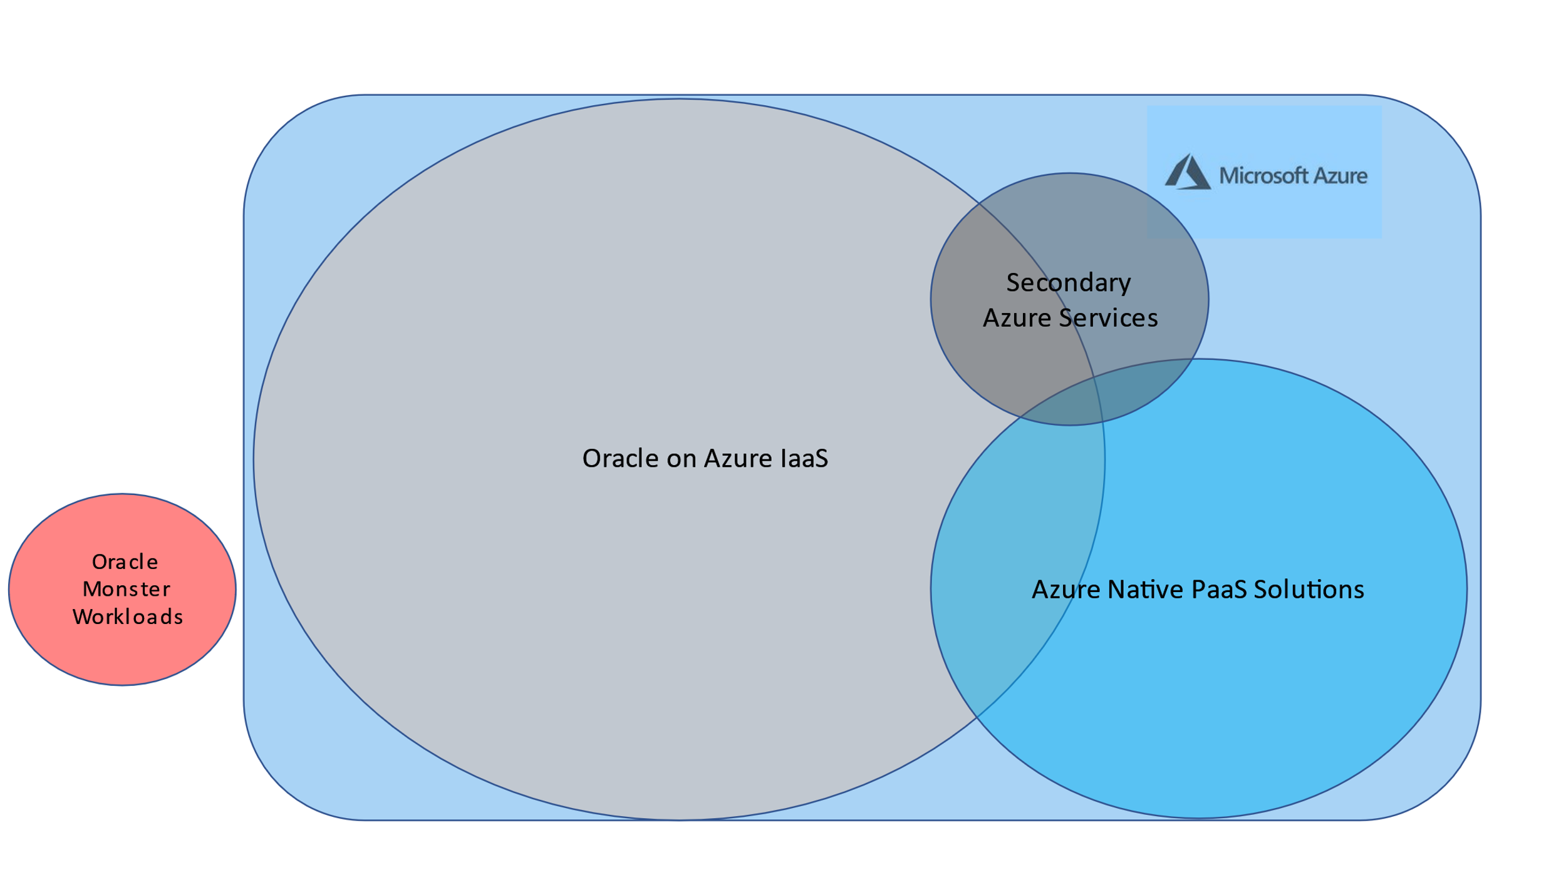

Oracle on and off Azure after migration

Having advanced Oracle skills will be required for these few larger workloads. Understanding Exadata at a deeper level, on both the hardware and software side is required, along with the tools at the Oracle Exadata technologists’ side to understand these workloads. Once this is understood, the migration to the cloud is as simple as building it to fit the demands and the customer will come.