**DEPARTMENT OF INFORMATION TECHNOLOGY**

**ORIENTAL INSTITUTE OF SCIENCE & TECHNOLOGY, BHOPAL**



**Biometric Recognition Based Attendance System**

Synopsys for Major Project

*Submitted in partial fulfillment of the requirement for the award of*

*Degree of*

**BACHELOR OF ENGINEERING**

In

**INFORMATION TECHNOLOGY**

Submitted to



**RAJIV GANDHI PROUDYOGIKI VISHWAVIDHYALAYA,**

**BHOPAL (M.P.)**

Submitted by

**Nidhi Jain** 0105IT091069

**Prateek Mehta** 0105IT091079

**Pankaj Kumar Pandey** 0105IT091073

**Biometrics Recognition Based Attendance System**

**ABSTRACT**

There have never been more accurate technologies as helpful to people in search of a way to keep track of group activity as biometric time and attendance technology. In business and Educational environment attendance is a big issue now a days. How this system can help in tracking attendance of employees, student more efficiently and accurately let us understand what Biometric analysis is:

Biometrics takes unique physical characteristics and uses them for identification of your identity and verification that you are doing something you've been authorized to do.  Your vascular patterns, hand print, finger print, iris patterns, and even your voice can be used to ensure that you are who you say you are, and to let people know that you've been given permission to do whatever it is you're attempting to do.

Biometric scanning also improves security factor when used for applications where a person’s identity need not to be disclosed. A biometric scanning device takes a user's biometric data, such as an iris pattern or fingerprint scan, and converts it into digital information a computer can interpret and verify. Since it is more difficult for a malicious hacker to gain access to a person's biometric data, and it is unlikely that a user will misplace or misuse his or her biometric data, this form of technology a greater level of assurance than other methods of identification.

Our project is a biometrics based comprehensive attendance management system for schools and colleges. It provides robust, secure and automatic attendance management system for both, Students and Staff. It has an inbuilt facility of sending automatic SMS and Email alerts to the Parents/Guardians of the students.

**INTRODUCTION TO BIOMETRIC RECOGNITION SYSTEM**

In Figure below shows a simple block diagram of a biometric system. The first block (Sensor, if any) is the interface between the real world and our system; it has to acquire all the necessary data. The second block performs all necessary pre-processing. In the third block, features needed are extracted and a template is generated. A template is a synthesis of all the characteristics extracted from the source, in the optimal size to allow for adequate identifiably. After creating a template, we have either an enrollment process or a recognition process. If enrollment is being performed, the template is simply stored somewhere within a database. If recognition is being performed, the obtained template is passed to a matcher that compares it with other exiting templates.



Figure 2: A Complete Biometric System

Due to the statistical nature of biometric samples, there is no exact match possible. For this reason, the decision process will confirm recognition only if the comparison score exceeds an adjustable value. The matching phase is usually done using software. The matching program will analyzes the template with the input. This will then output for any specified purpose.

**PROBLEM DEFINITION**

1. Enrollment is typically used for positive recognition, where the aim is to prevent multiple people from using the same identity.
2. Fingerprint verification is to verify the authenticity of one person by his fingerprint. There is one-to-one comparison in this case.
3. In the identification mode, the system recognizes an individual by searching the templates of all the users in the database for a match. Therefore, the system conducts a one to-many comparison to establish an individual’s identity.

**FINGER PRINT RECOGNIOTION BASED SYSTEM : A SOLUTION**

The fingerprint recognition problem can be grouped into three sub-domains: fingerprint enrollment, verification and fingerprint identification.

We propose a simple and effective approach for Biometric fingerprint image enhancement and minutiae extraction based on the frequency and orientation of the local ridges and thereby extracting correct minutiae points. Automatic and reliable extraction of minutiae from fingerprint images is a critical step in fingerprint matching.

The quality of input fingerprint images plays an important role in the performance of automatic identification and verification algorithms. In this project we presents a fast fingerprint enhancement and minutiae extraction algorithm which improves the clarity of the ridge and valley structures of the input fingerprint images based on the frequency and orientation of the local ridges and thereby extracting correct minutiae. Fingerprint based identification has been one of the most successful biometric techniques used for personal identification. Each individual has unique fingerprints. A fingerprint is the pattern of ridges and valleys on the finger tip. A fingerprint is thus defined by the uniqueness of the local ridge characteristics and their relationships. Minutiae points are these local ridge characteristics that occur either at a ridge ending or a ridge bifurcation. A ridge ending is defined as the point where the ridge ends abruptly and the ridge bifurcation is the point where the ridge splits into two or more branches.

**Automatic minutiae detection becomes a difficult task in low quality fingerprint images where noise and contrast deficiency result in pixel configurations similar to that of minutiae. This is an important aspect that has been taken into consideration in this presentation for extraction of the minutiae with a minimum error in a particular location.**

A complete minutiae extraction scheme for automatic fingerprint recognition systems is presented. The proposed method uses improving alternatives for the image enhancement process, leading consequently to an increase of the reliability in the minutiae extraction task.

**CURRENT MARKET SCENERIO**

Now a days it is highly adoptable technique in Business and Education sectors. Infect it is becoming a Business product which can be employed in various organizations where it need to be used.

Here are some of companies which are globally dealing in Biometrics based attendance systems.

* COGENT
* LG
* GREEN BIT
* MORPHOTECH
* I-Data

**PURPOSE BEHIND OUR PROJECT-**

We are going to make this project which can help Educational Organizations to track the attendance of the students. Which leads to reduce the time of attendance taken by faculties that can be utilized is other educational activities, also since it will maintain all the records of students on server, an Educational organization can use the same record of each individual student in various activities like examination, to judge the performance and sincerity of students. These systems not only saves the time consumed in attendance on paper, infect it saves paper and leads to give better shape for the future of students.

With this project being implemented all the above needs of any sincere Educational Organization can be achieved regarding attendance of students & staff. Some of the major goals behind this project are mentioned below :-

|  |
| --- |
|  |
| spacer red_aro | More Efficient Student Attendance – It automates the student and staff attendance hence; reducing irregularities in the attendance process arising due to human error. |
| spacer red_aro | Saving Time – Important administrative and educational resources could be freed up by utilizing this technique. |
| spacer red_aro | Environment Friendly – Reduces paper and other resource requirements.   |  |  | | --- | --- | | red_aro | Daily Absentee Report. | | red_aro | Daily attendance Register, Monthly attendance Register, Yearly attendance Report. | |  |  | |  |  | |

**EXISTING PROJECTS**

There are the list of projects which are already been developed:

* Finger Prints recognition based attendance system.
* Hand recognition based attendance system.
* Iris recognition based attendance system.
* Skull recognition based attendance system.
* Face recognition based attendance system.
* Ear recognition based attendance system.(Under construction)

**FUTURE ASPECTS**

Since our objective regarding this project is to make a system to reduce additional efforts of attendance and use the data gathered by the system of multiple functionalities of an organization. Existing systems as they are efficient , they are costly too. Here we want to make this project in a way to provide it in minimum cost and efforts, which not only can be employed in Higher organizations but also in City level Educational organizations such as Schools and Colleges as well.

Making it in generalized manner leads it to further enhancement and accuracy of authentication.

**GOALS OF OUR PROJECT-**

* To provide this system in minimal cost.
* Reduction of time consumption in taking attendance.
* To save paper or we can say to save Trees.
* To shape the academic performance of the students.

**HARDWARE REQUIREMENTS**

* High Resolution Digital Camera.
* 3D Sensors ( Optional & needed to identify a face from a range of viewing angles i.e. when the Subject or a person to be recognized is in continuous motion ) **.**
* CPU or an electronic device which can compare the images by running algorithms defined for the purpose.
* USB Connecting cable.

**SOFTWARE REQUIREMENTS**

* Windows OS.
* Language **–** Java or C++.
* Language Editors – Netbeans, Eclipse, Turbo C, Visual C++ IDE.
* Database – SQL.

**PART-I**

**Fingerprint  
Recognition  
Process**

**ABSTRACT**

Human fingerprints are rich in details called minutiae, which can be used as identification marks for fingerprint verification. The goal of this project is to develop a complete system for fingerprint verification through extracting and matching minutiae. To achieve good minutiae extraction in fingerprints with varying quality, preprocessing in form of image enhancement and binarization is first applied on fingerprints before they are evaluated. Many methods have been combined to build a minutia extractor and a minutia matcher. Minutia marking with special consideration of the triple branch counting and false minutiae removal methods is used in the work. An alignment-based elastic matching algorithm has been developed for minutia matching. This algorithm is capable of finding the correspondences between input minutia pattern and the stored template minutia pattern without resorting to exhaustive search. Performance of the developed system is then evaluated on a database with fingerprints from different people.

1. **INTRODUCTION**

***1.1 What is fingerprint?***

Skin on human fingertips contains ridges and valleys which together forms distinctive patterns. These patterns are fully developed under pregnancy and are permanent throughout whole lifetime. Prints of those patterns are called fingerprints. Injuries like cuts, burns and bruises can temporarily damage quality of fingerprints but when fully healed, patterns will be restored.

Through various studies it has been observed that no two persons have the same fingerprints, hence they are unique for every individual.

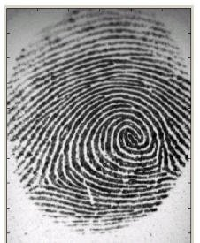

Figure 1. A fingerprint image obtained by optical sensor

Due to the above mentioned properties, fingerprints are very popular as biometrics measurements. Especially in law enforcement where they have been used over a hundred years to help solve crime. Unfortunately fingerprint matching is a complex pattern recognition problem. Manual fingerprint matching is not only time consuming but education and training of experts takes a long time. Therefore since 1960s there have been done a lot of effort on development of automatic fingerprint recognition systems.

Automatization of the fingerprint recognition process turned out to be success in forensic applications. Achievements made in forensic area expanded the usage of the automatic fingerprint recognition into the civilian applications. Fingerprints have remarkable permanency and individuality over the time. The observations showed that the fingerprints offer more secure and reliable person identification than keys, passwords or id-cards can provide. Examples such as mobile phones and computers equipped with fingerprint sensing devices for fingerprint based password protection are being produced to replace ordinary password protection methods. Those are only a fraction of civilian applications where fingerprints can be used.

***1.2 Fingerprint recognition***

The method that is selected for fingerprint matching was first discovered by Sir Francis Galton. In 1888 he observed that fingerprints are rich in details also called minutiae in form of discontinuities in ridges. He also noticed that position of those minutiae doesn’t change over the time. Therefore minutiae matching are a good way to establish if two fingerprints are from the same person or not.

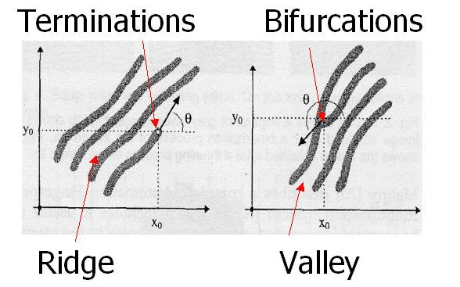

Figure 2 Minutia. (Valley is also referred as Furrow, Termination is also called Ending,

and Bifurcation is also called Branch)

The two most important minutiae are termination and bifurcation, termination, which is the immediate ending of a ridge; the other is called bifurcation, which is the point on the ridge from which two branches derive.

The fingerprint recognition problem can be grouped into two sub-domains: one is fingerprint verification and the other is fingerprint identification.

**2. System Design**  
 ***2.1 System Level Design***

A fingerprint recognition system constitutes of fingerprint acquiring device, minutia extractor and minutia matcher [Figure 2.1.1].

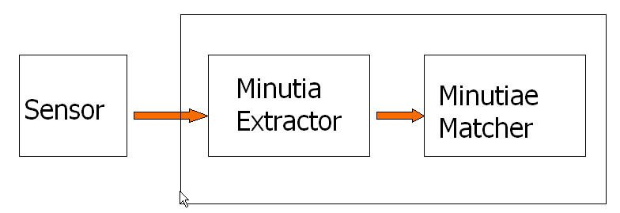

Figure 2.1.1 Simplified Fingerprint Recognition System

For fingerprint acquisition, optical or semi-conduct sensors are widely used. They have high efficiency and acceptable accuracy except for some cases that the user’s finger is too dirty or dry.

The minutia extractor and minutia matcher modules have been explained in detail in the next part for algorithm design and other subsequent sections.

For the post processing stage, a more rigorous algorithm is developed to remove false minutia. Also a novel representation for bifurcations is proposed to unify terminations and bifurcations.

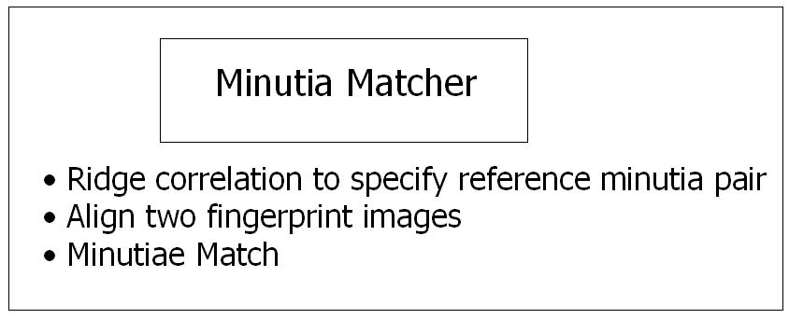

Figure2.2.2 Minutia Matcher

The minutia matcher chooses any two minutia as a reference minutia pair and then matches their associated ridges first. If the ridges match well , the two fingerprint images are aligned and matching is conducted for all remaining minutia .

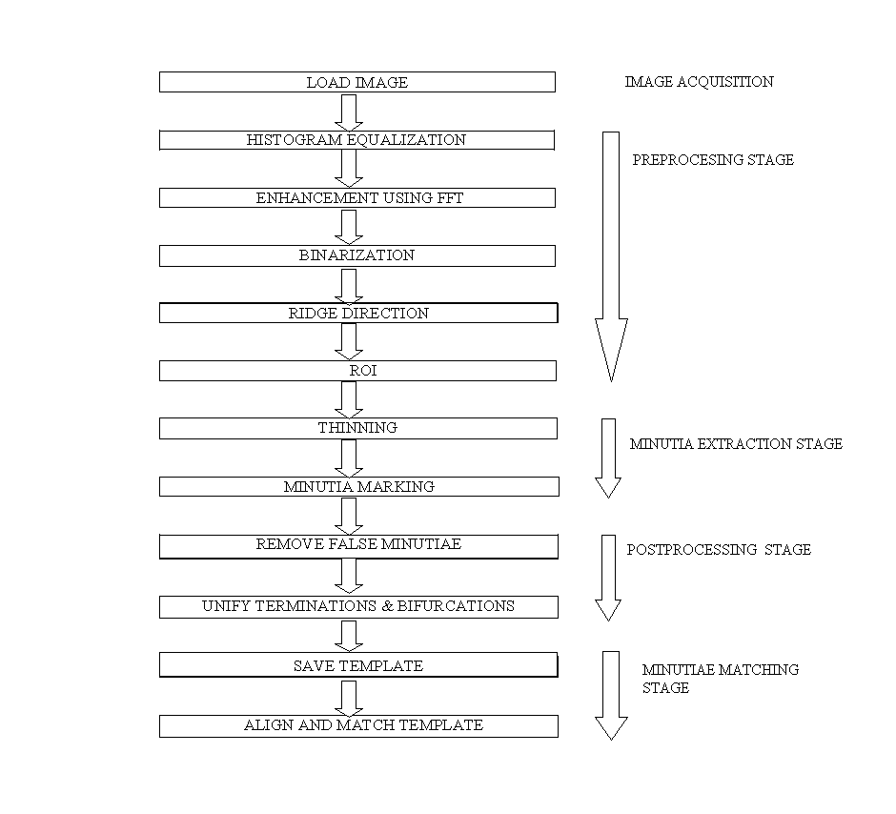

Figure 2.2.3 Steps involved in fingerprint recognition algorithm

**3. Fingerprint Image Enhancement**

Fingerprint Image enhancement is to make the image clearer for easy further operations. Since the fingerprint images acquired from sensors or other Medias are not assured with perfect quality, those enhancement methods, for increasing the contrast between ridges and furrows and for connecting the false broken points of ridges due to insufficient amount of ink, are very useful for keep a higher accuracy to fingerprint recognition. One of the Methods adopted for image enhancement stage one is Histogram Equalization.

**3.1.1 Histogram Equalization:**

Histogram equalization is to expand the pixel value distribution of an image so as to increase the perceptional information. The original histogram of a fingerprint image has the bimodal type [Figure 3.1.1.1], the histogram after the histogram equalization occupies all the range from 0 to 255 and the visualization effect is enhanced [Figure 3.1.1.2].

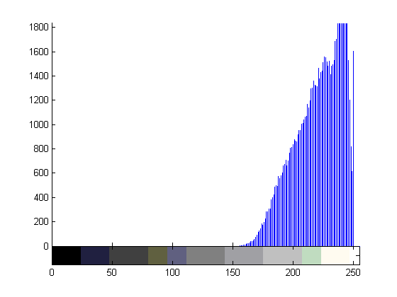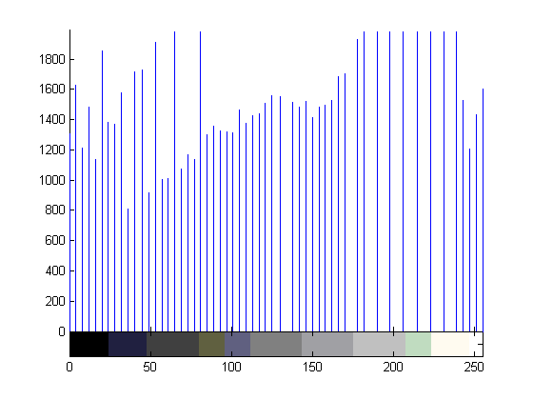

Figure 3.1.1.1 The Original Histogram of a Figure 3.1.1.2 Histogram after fingerprint image histogram equalization

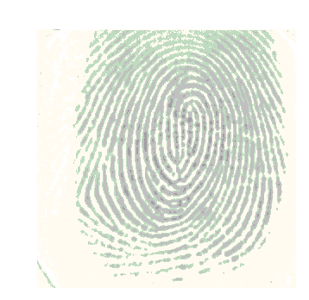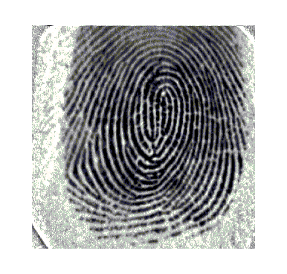

Figure 3.1.1.3 Original Image Figure 3.1.1.4 Enhanced Image after

Histogram Equalization

**4. Minutia Extraction**

***4.1 Fingerprint Ridge Thinning***

Ridge Thinning is to eliminate the redundant pixels of ridges till the ridges are just one pixel wide. An iterative, parallel thinning algorithm is used. In each scan of the full fingerprint image, the algorithm marks down redundant pixels in each small image window (3x3). And finally removes all those marked pixels after several scans. The thinned ridge map is then filtered by other three Morphological operations to remove some H breaks, isolated points and spikes.

***4.2 Minutia Marking***

After the fingerprint ridge thinning, marking minutia points is relatively easy. The concept of Crossing Number (CN) is widely used for extracting the minutiae. In general, for each 3x3 window, if the central pixel is 1 and has exactly 3 one-value neighbors, then the central pixel is a ridge branch [Figure 4.2.1]. If the central pixel is 1 and has only 1 one-value neighbor, then the central pixel is a ridge ending [Figure4.2.2] ,i.e., if Cn(P) = = 1 it’s a ridge end and if Cn(P) = = 3 it’s a ridge bifurcation point, for a pixel P.

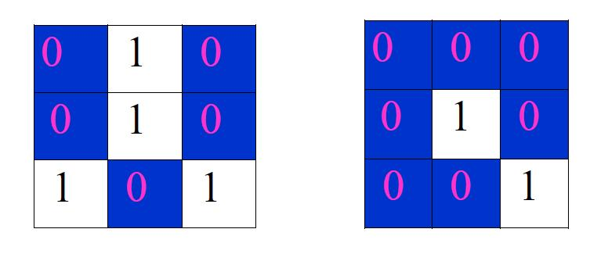 Figure 4.2.1. Bifurcation Figure 4.2.2. Termination

|  |  |  |
| --- | --- | --- |
| 0 | 1 | 0 |
| 0 | 1 | 1 |
| 1 | 0 | 0 |

Figure 4.2.3 Triple counting branch

Figure 4.2.3 illustrates a special case that a genuine branch is triple counted. Suppose both the uppermost pixel with value 1 and the rightmost pixel with value 1 have another neighbor outside the 3x3 window, so the two pixels will be marked as branches too. But actually only one branch is located in the small region. So a check routine requiring that none of the neighbors of a branch are branches is added.

Also the average inter-ridge width D is estimated at this stage. The average inter- ridge width refers to the average distance between two neighboring ridges. The way to approximate the D value is to scan a row of the thinned ridge image and sum up all pixels in the row whose value is one. Then divide the row length with the above summation to get an inter- ridge width. For more accuracy, such kind of row scan is performed upon several other rows and column scans are also conducted, finally all the inter-ridge widths are averaged to get the D. Together with the minutia marking, all thinned ridges in the fingerprint image are labeled with a unique ID for further operation. The labeling operation is realized by using the Morphological operation: BWLABEL.

**5. Minutia Processing  
  
*5.1 False Minutia Removal***

The preprocessing stage does not totally heal the fingerprint image. For example, false ridge breaks due to insufficient amount of ink and ridge cross-connections due to over inking are not totally eliminated. Actually all the earlier stages themselves occasionally introduce some artifacts which later lead to spurious minutia. These false minutia will significantly affect the accuracy of matching if they are simply regarded as genuine minutia. So some mechanisms of removing false minutia are essential to keep the fingerprint verification system effective.

Seven types of false minutia are specified in following diagrams:

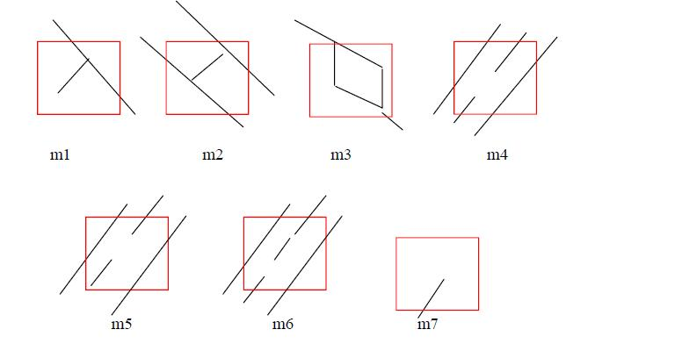

Figure 5.1.1. False Minutia Structures.

m1 is a spike piercing into a valley. In the m2 case a spike falsely connects two ridges. m3 has two near bifurcations located in the same ridge. The two ridge broken points in the m4 case have nearly the same orientation and a short distance. m5 is alike the m4 case with the exception that one part of the broken ridge is so short that another termination is generated. m6 extends the m4 case but with the extra property that a third ridge is found in the middle of the two parts of the broken ridge. m7 has only one short ridge found in the threshold window.

The procedure for the removal of false minutia are:

1. If the distance between one bifurcation and one termination is less than D and the two minutia are in the same ridge(m1 case), both of them are removed. Where D is the average inter-ridge width representing the average distance between two parallel neighboring ridges.

2. If the distance between two bifurcations is less than D and they are in the same ridge, the two bifurcations are removed. (m2, m3 cases).

3. If two terminations are within a distance D and their directions are coincident with a small angle variation. And they suffice the condition that no other termination is located between the two terminations. Then the two terminations are regarded as false minutia derived from a broken ridge and are removed. (case m4,m5, m6).

4. If two terminations are located in a short ridge with length less than D, remove the two terminations (m7).

***5.2 Unify terminations and bifurcations***

Since various data acquisition conditions such as impression pressure can easily change one type of minutia into the other, most researchers adopt the unification representation for both termination and bifurcation. So each minutia is completely characterized by the following parameters at last: 1) x-coordinate, 2) y-coordinate, and 3) orientation.

The orientation calculation for a bifurcation needs to be specially considered. All three ridges deriving from the bifurcation point have their own direction. The bifurcation is broken into three terminations. The three new terminations are the three neighbor pixels of the bifurcation and each of the three ridges connected to the bifurcation before is now associated with a termination respectively [Figure 5.2.1].

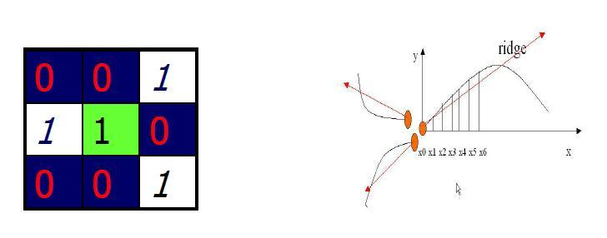

Figure 5.2.1 A bifurcation to three terminations  
Three neighbors become terminations (Left)  
Each termination has their own orientation (Right)

And the orientation of each termination (tx,ty) is estimated by following method :

A ridge segment is tracked whose starting point is the termination and length is D. All x- coordinates of points in the ridge segment are summed up. The above summation is then divided with D to get sx and sy can be obtained using the same way.

The direction is obtained from:

atan((sy-ty)/(sx-tx)).

**6. Minutia Match**

***6.1 Alignment Stage***

The ridge associated with each minutia is represented as a series of x-coordinates (x1, x2…xn) of the points on the ridge. A point is sampled per ridge length L starting from the minutia point, where the L is the average inter-ridge length. And n is set to 10 unless the total ridge length is less than 10\*L.

So the similarity of correlating the two ridges is derived from:

**C:\Documents and Settings\HP_Owner\Desktop\dgjh.JPG**

where (xi~xn) and (Xi~XN ) are the set of minutia for each fingerprint image respectively. And m is minimal one of the n and N value. If the similarity score is larger than 0.8, then the next step is executed else the next pair of rideges are continued to match.

. For each fingerprint, all other minutia are translated and rotated with respect to the reference minutia according to the following formula:

**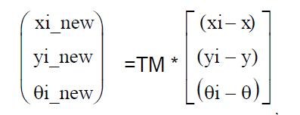**

where (x,y,) is the parameters of the reference minutia, and TM is

**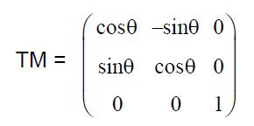**

The following diagram illustrate the effect of translation and rotation:

**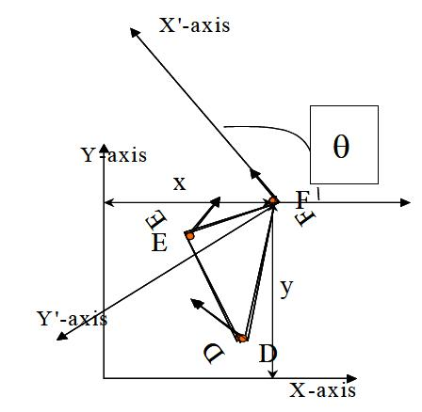**

The new coordinate system is originated at minutia F and the new x-axis is coincident with the direction of minutia F. No scaling effect is taken into account by assuming two fingerprints from the same finger have nearly the same size.

***6.2 Match Stage***

The matching algorithm for the aligned minutia patterns needs to be elastic since the strict match requiring that all parameters (x, y, ) are the same for two identical minutia is impossible due to the slight deformations and inexact quantizations of minutia.

The elastic matching of minutia is achieved by placing a bounding box around each template minutia. If the minutia to be matched is within the rectangle box and the direction discrepancy between them is very small, then the two minutia are regarded as a matched minutia pair. Each minutia in the template image either has no matched minutia or has only one corresponding minutia.

The final match ratio for two fingerprints is the number of total matched pair over the number of minutia of the template fingerprint. The score is 100\*ratio and ranges from 0 to 100. If the score is larger than a pre-specified threshold, the two fingerprints are from the same finger. However, the elastic match algorithm has large computation complexity and is vulnerable to spurious minutia.

**PART-II**

**Functions  
of the  
Project**

1. **FEATURES**

**User Interface:**

* Student registration form, filled by student itself under control of tutor guardian.
* Faculty registration filled by Head of the respective department.
* Through college level management all employees of college i.e. management staff and heads of the departments get registered.
* There is a single admin who can control all the activities related to attendance.
* Some lesser manipulation authority will be given to management.

**Functionality :**

* **Administrator-**
* Admin needs to login using specific id and password to perform activities.
* Can view the attendance of all management staff.
* Can view the attendance of all the HODs and Faculties of distinct departments.
* Can view the overall attendance of students of each department with distinction based on semester.
* Also analyze individual attendance of any person.
* **Employee-**
* To mark his/her daily attendance will select its College then Department then Name and will submit it.
* If Employee is management staff then he or she can select their details in college level filtering system .
* After submission of details system will ask to put impression of thumb.
* Just after successful match of thumb, a photo of respective faculty will be captured and stored.
* System will be designed in a way that apart from a permanent photo, database will maintain the collection last 7 recent photos of each faculty so that in case of false attendance security enhancement can be achieved.
* If 3 consecutive false attendance is marked then, system will block that faculty and management can only unblock that faculty.
* **Students-**
* Student simply will select their details by selecting college then department then semester then enrollment number and submit the details.
* System will ask to put thumb impression on the device.
* Student will mark their attendance by putting thumb impression and its successful match.

1. **INPUTS**

Inputs are divided in two categories-

1. Pre Inputs
2. Post Inputs

Pre Inputs are all the details that are used at the time of registration of the person and person can be an employee or any student. Post Inputs are used at the time of thumb impression recognition for match and attendance marking.

Basic Pre Inputs are :

1. Name
2. Address
3. Designation
4. College
5. Branch
6. Semester
7. Id
8. Permanent thumb impression binary image file
9. Permanent photograph
10. Temporary Image

Basic Post Inputs are :

1. Thumb Impression
2. Captured temporary photograph
3. **OUTPUTS**

According to pre Inputs we have set data of all the persons which will further used for match and attendance.

According to post inputs we have following 3 outputs-

1. Marked Attendance.
2. Unmarked Attendance.
3. Blocked status of the person if multiple false attempt are made.
4. **SYSTEM DESIGN**

PROPOSED MODEL

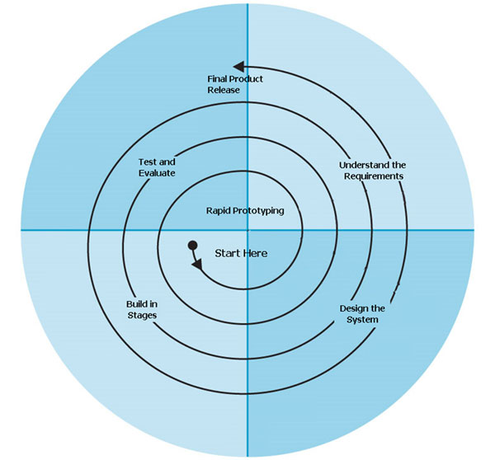

**The Spiral Model**

The Spiral Life Cycle Model is a type of iterative software development model which is generally implemented in high risk projects. It was first proposed by Boehm. In this system development method, we combine the features of both, waterfall model and prototype model. In Spiral model we can arrange all the activities in the form of a spiral.   
  
Each loop in a spiral represents a development phase (and we can have any number of loops according to the project). Each loop has four sections or quadrants:   
1. *To determine the objectives, alternatives and constraints.* We try to understand the product objectives, alternatives in design and constraints imposed because of cost, technology, schedule, etc.

2. *Risk analysis and evaluation of alternatives.* Here we try to find which other approaches can be implemented in order to fulfill the identified constraints. Operational and technical issues are addressed here. Risk mitigation is in focus in this phase. And evaluation of all these factors determines future action.

3. *Execution of that phase of development.* In this phase we develop the planned product. Testing is also done. In order to do development, waterfall or incremental approach can be implemented.

4. *Planning the next phase.* Here we review the progress and judge it considering all parameters. Issues which need to be resolved are identified in this phase and necessary steps are taken.

Subsequent loops of spiral model involve similar phases. Analysis and engineering efforts are applied in this model. Large, expensive or complicated projects use this type of life cycle. If at any point of time one feels the risk involved in the project is a lot more than anticipated, one can abort it. Reviews at different phases can be done by an in-house person or by an external client.

In our project the review works have been done by calculating the positive and negative aspects of existing systems and evaluating our software on the basis of the same.

**DATABASE**

Main Database is categorized in three basic groups in order to reduce redundancy-

1. **Administrator containing table-**

|  |
| --- |
| **Admin** |
| Admin Id  Name  Password  Admin permanent Image  Admin permanent thumb Image  Admin temporary Image[7]  Last login date time |

1. **Person containing table-**

|  |
| --- |
| **Management Staff** |
| Id(key)  Name  Designation  Address  Employee permanent Image  Employee permanent thumb Image  Employee temporary Image[7]  Last match date time  Status(Blocked/Unblocked) |

|  |
| --- |
| **Faculty** |
| Id(key)  Name  Designation  Address  Employee permanent Image  Employee permanent thumb Image  Employee temporary Image[7]  Last match date time  Status(Blocked/Unblocked) |

|  |
| --- |
| **Students** |
| Id(key)  Name  Branch  Address  Semester  Student permanent Image  Student permanent thumb Image  Last match date time |

1. **Attendance Containing table-**

|  |
| --- |
| **At-Faculty** |
| Id(Foreign key)  Last match status  Date  Mark(Boolean) |

|  |
| --- |
| **At-Management** |
| Id(Foreign key)  Last match status  Date  Mark(Boolean)  Match Attempt |

|  |
| --- |
| **At-Students** |
| Id(Foreign key)  Last match status  Date  Mark(Boolean) |

**USE-CASE DIAGRAM**

**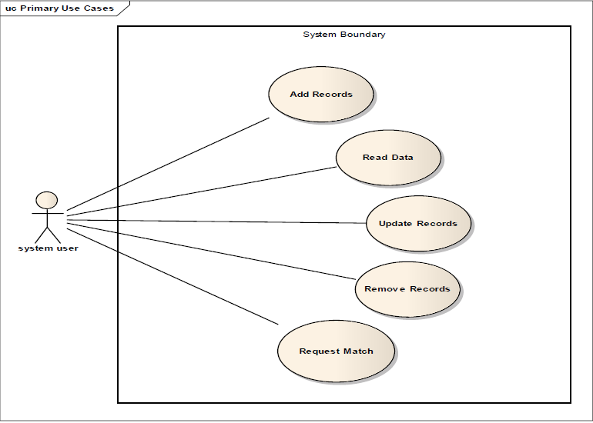**

**ACTIVITY DIAGRAM**

**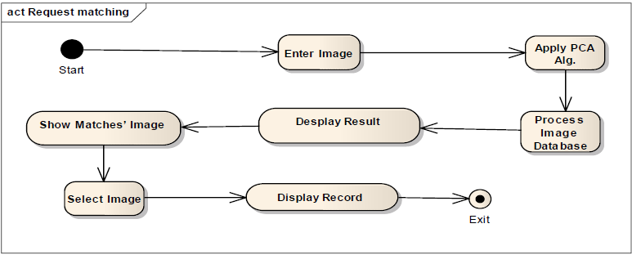**

**E-R DIAGRAMS**

Student

Management Staff

Faculty

**CONCLUSION**

The reliability of any automatic fingerprint system strongly relies on the precision obtained in the minutia extraction process. A number of factors are detrimental to the correct location of minutia. Among them, poor image quality is the most serious one. In this project, we have combined many methods to build a minutia extractor and a minutia matcher. The following concepts have been used- segmentation using Morphological operations, minutia marking by specially considering the triple branch counting, minutia unification by decomposing a branch into three terminations and matching in the unified x-y coordinate system after a 2-step transformation in order to increase the precision of the minutia localization process and elimination of spurious minutia with higher accuracy. The proposed alignment-based elastic matching algorithm is capable of finding the correspondences between minutiae without resorting to exhaustive research.

There is a scope of further improvement in terms of efficiency and accuracy which can be achieved by improving the hardware to capture the image or by improving the image enhancement techniques. So that the input image to the thinning stage could be made better which could improve the future stages and the final outcome.

Also, by using the proposed software we would be able to avoid prevent multiple people from using the same identity, a more convenient and accurate method to ensure one's identity. At the same time, we would be able to maintain, access or fetch the records more easily.