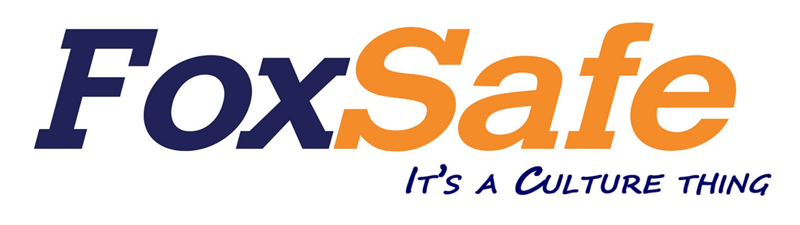

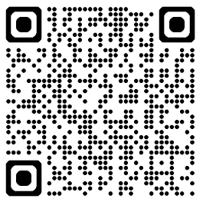

Woods Waste Induction
through the QR code above.

