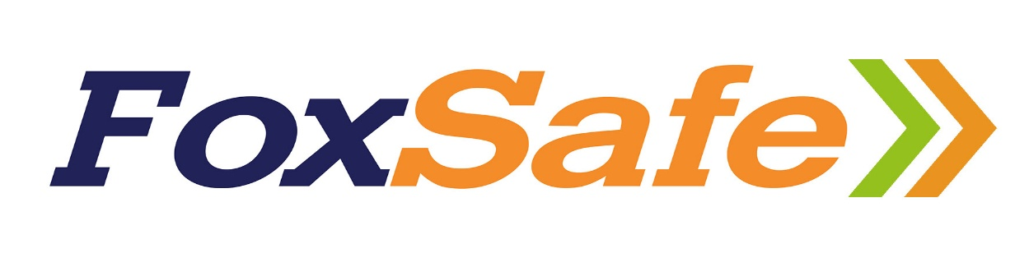

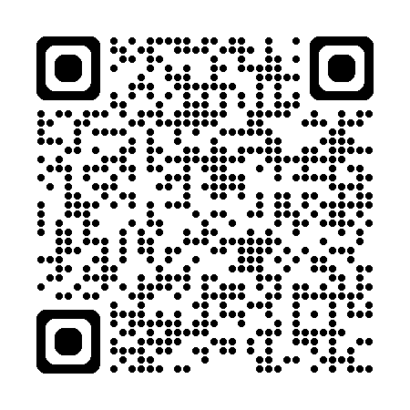
Bradley's Sandpit Quarry Induction
through the QR code above.

