

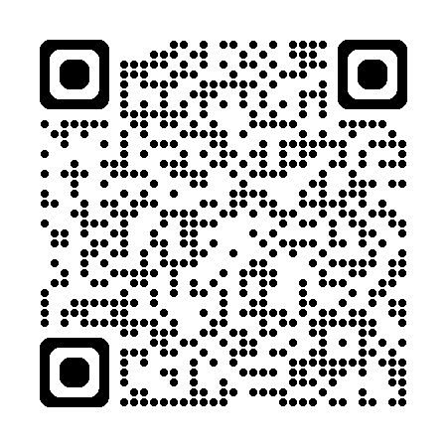
Ellel Crag Quarry Induction
through the QR code above.

