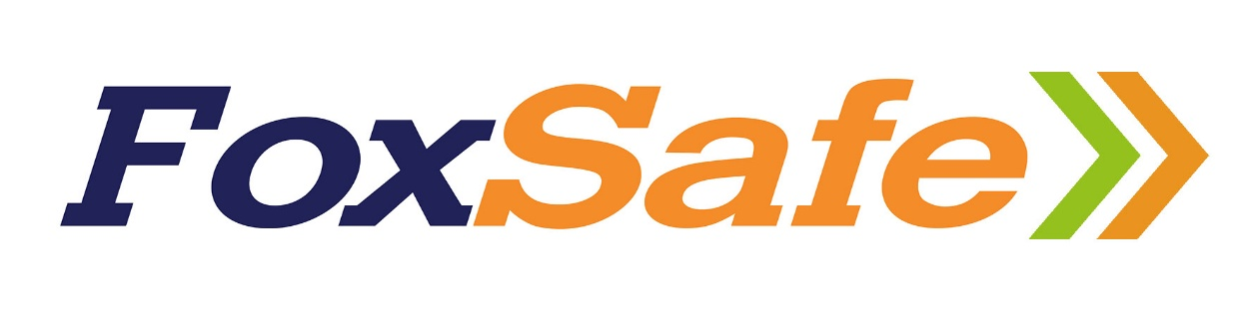

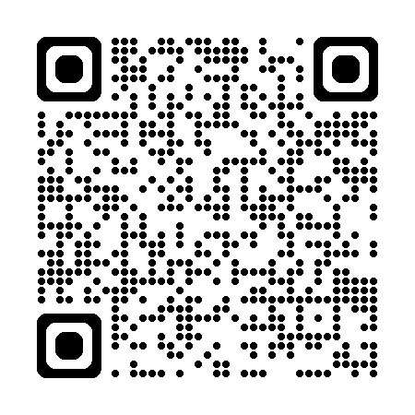
Lydiate Lane Quarry Induction
through the QR code above.

