

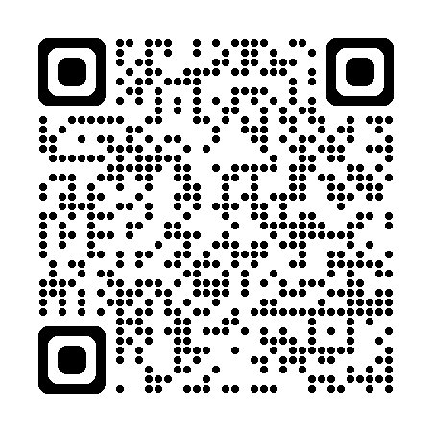

Tong Quarry Induction
through the QR code above.

