**EDUSENSE**

A Learning Academy

**A Project Report**

Submitted to Goa University

In partial fulfilment of the Requirement

For the degree of

Bachelor of Computer Applications

By

**Baviya H Prasad**

**Binson Dsouza**

**Dally Serrao**

**Rolika Tavares**

**Seya Souza**

Guided By

**Ms.Rama Borkar**

VVM’s Shree Damodar College of Commerce & Economics

Margo-Goa

2021-2022

VVM’s

Shree Damodar College of Commerce & Economics

Affiliated to Goa University

**CERTIFICATE**

This is to certify that the project on

“Edusense- A Learning Academy “has been

successfully completed and submitted by

**Baviya H Prasad**

**Binson Dsouza**

**Dally Serrao**

**Rolika Tavares**

**Seya Souza**

**Ms.Rama Borkar Dr.(Mrs.)Prita D.Mallya**

Internal Guide Principal

**Ms**. External Examiner

Project Coordinator

VVM’s

Shree Damodar College of Commerce & Economics

**DECLARATION BY CANDIDATES**

We declare that this project has been prepared by us and to the best of our knowledge, It has not been previously formed the basis for the award of any diploma or degree by this or any other university.

|  |  |  |
| --- | --- | --- |
| **ROLL NO** | **NAME** | **SIGNATURE** |
| 19807 | Baviya H Prasad |  |
| 19808 | Binson Dsouza |  |
| 19809 | Dally Serrao |  |
| 19827 | Rolika Tavares |  |
| 19833 | Seya Souza |  |

VVM’s

Shree Damodar College of Commerce & Economics

**CERTIFICATE BY GUIDE**

This is to certify that the project report is the record of the work done by the candidates themselves under my guidance during the period of study and to the best of my knowledge it has not previously formed the basis for the award of any degree by this or any other university.

Name of the college: VVM’s Shree Damodar College of Commerce & Economics

Program: Bachelor of Computer Applications (BCA)

Academic Year: 2021-2022

**Ms.Rama Borkar**

**ACKNOWLEDGEMENT**

It is our immense pleasure to present the project of “Edusense: A Learning Academy”. We wish to express our deepest gratitude to the people who deserve a special mention.

We express our sincere thanks to our guide MS. Rama Borkar for her guidance, motivation and inspiration in making our project a success. We would also like to thank all the teachers of the Computer Science Department who have taught us the concepts which are applied at different phases of this project.

We would also wish to express our sincere thanks to Mr. Sumit Kumar for his collaboration and support throughout the project.

We also like to thank the Coordinator of Computer Science Dept, Principal and all the staff members for their co-operation and support. We would like to thank various proprietors for giving us their precious time and providing us valuable insights in our project.

**-The Project Team**

**Table of Contents**

|  |  |
| --- | --- |
| **Title** | **Page Number** |
| **Chapter 1: Introduction** | |
| * 1. Introduction |  |
| 1.2 Problem Statement |  |
| 1.3 Existing System |  |
| 1.4 Objectives |  |
| 1.5Defination, Acronyms and Abbreviation |  |
| **Chapter 2: The Overall Description** | |
| 2.1 User Functions |  |
| 2.2 Non-functional |  |
| 2.3 Gantt Chart |  |
| 2.4 Back-end Software Tools |  |
| 2.5 Front-end Software Tools |  |
| 2.6 Specific Requirement |  |
| **Chapter 3: Database Design** | |
| 3.1 ERD Diagram |  |
| 3.2 Use Case Diagram |  |
| 3.3 Activity Diagram |  |

Chapter 1:

INTRODUCTION

* 1. **Introduction**

Since the COVID-19 outbreak, online learning has become more centric in people's lives. As the idea of online education is getting more popular day by day and is growing dramatically, the opportunities for such kinds of software have increased and will continue to increase in the future. This project is made for an educational system to conduct online education for students. The present working scenario of the organisation is manually managing teams and employees. This system is only sufficient for dealing with regular students and potential students. This system is secure enough and efficient. The software which is put forward is the Online Education System (OES). The system is used to upload

Assignments /tasks, conduct online quizzes, and register students.

**Chapter 2:**

**SYSTEM ANALYSIS**

**2.1. Problem Statement**

We have analysed the issue faced by the students due to offline learning. The students were facing problems travelling to training locations, typically a lecture hall or classroom. The students face lack of individual attention, it is quite tough to give attention to each and every student at the same time. Teachers will not be able to solve problems of all students.

Through our project we have endeavored to discover solutions to these issues. In our online learning system, students will get personal attention as it is one to one teaching/session. The students who hesitate to ask queries in offline mode can ask queries online without any hesitation and assists students who need to work on their own schedule and at their own speed.

Our system helps the guest to check our website and based on their interest they can view the demo.

**2.2. Existing System**

➔ All the work in the system is done manually in a personalized way.

**2.3. Objectives**

The goal of the Edusense system is to provide online learning which can be utilized by many students. Our system is to build different facilities in a single system including

● Notes

● Assignments

● e-certificates

● Feedback

● Quizzes

● Keeps the user modernize

**2.4. Scope**

The Online Education System will store all data in a single centralized database. The database will contain the following information:

**1.** Student details

**2**. Faculty members details

**3**. Students query and their solutions

**4**. Courses Information

* **User Functions**

❖**Faculty**

➔ Assign assignments

➔ Assign quiz

➔ Schedule lecture

❖ **Admin**

➔ Manages user (add, update and delete)

➔ can set up new subject

➔ Assigns faculty to student

➔ Upload notes

➔ Upload demo video

❖ **Students**

➔ Registers for subject

➔ Views study material

➔ Submits Assignment

➔ Gives feedback

➔ Answers quiz

➔ Change password

**2.5. Proposed System**

The aim of proposed system is to develop a system of improved facilities. The proposed system can overcome all the limitations of the existing system. The system provides proper security and reduces the manual work.

**2.6. Features of Proposed System**

The site will provide course study material to the students in electronic form.

All the information including course details and notices for students will also be displayed on the site.

The site will be used by three different types of users: Students, Faculties, and the Administrators.

Each user will be provided with a username and password to access his/her account on the site.

The students can take the mock test of their course and evaluate themselves.

**2.7. Non-Functional Requirements**

* Fully customized and secured administration area
* Minimizes time needed for the various processing
* User friendly and interactive
* Easy to access.
* 24*7 online services.
* Supported by the majority of the browser.

**Chapter 3:**

**DESIGN**

**3.1. Use – Case Diagram**

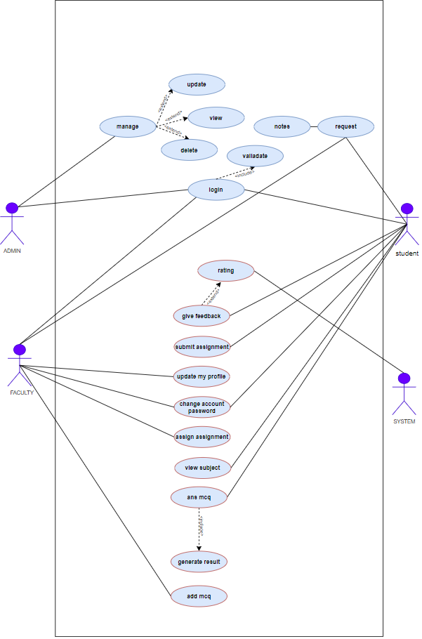

**3.2. Activity Diagram**

1. **Student**

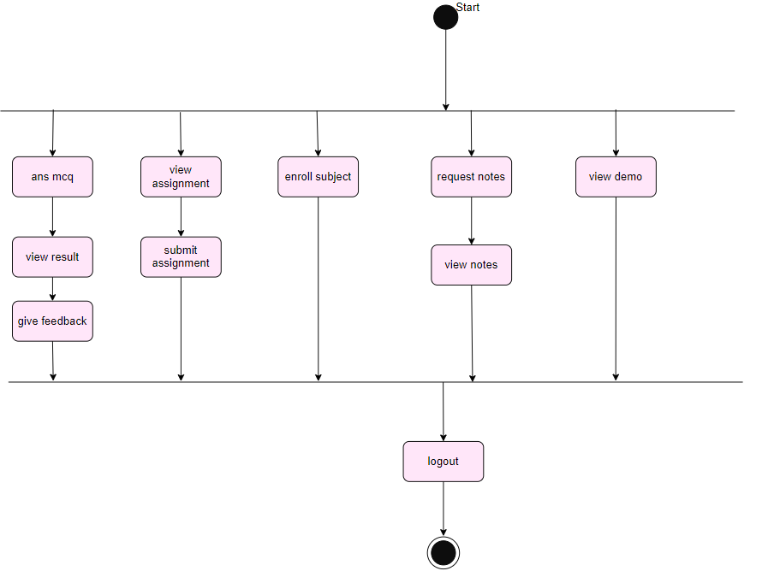

1. **Faculty**

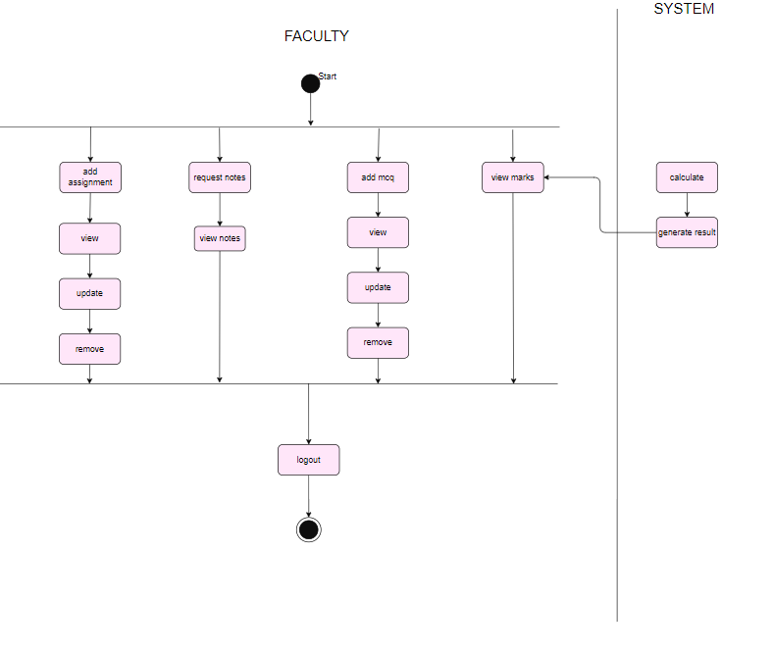

1. **Admin**

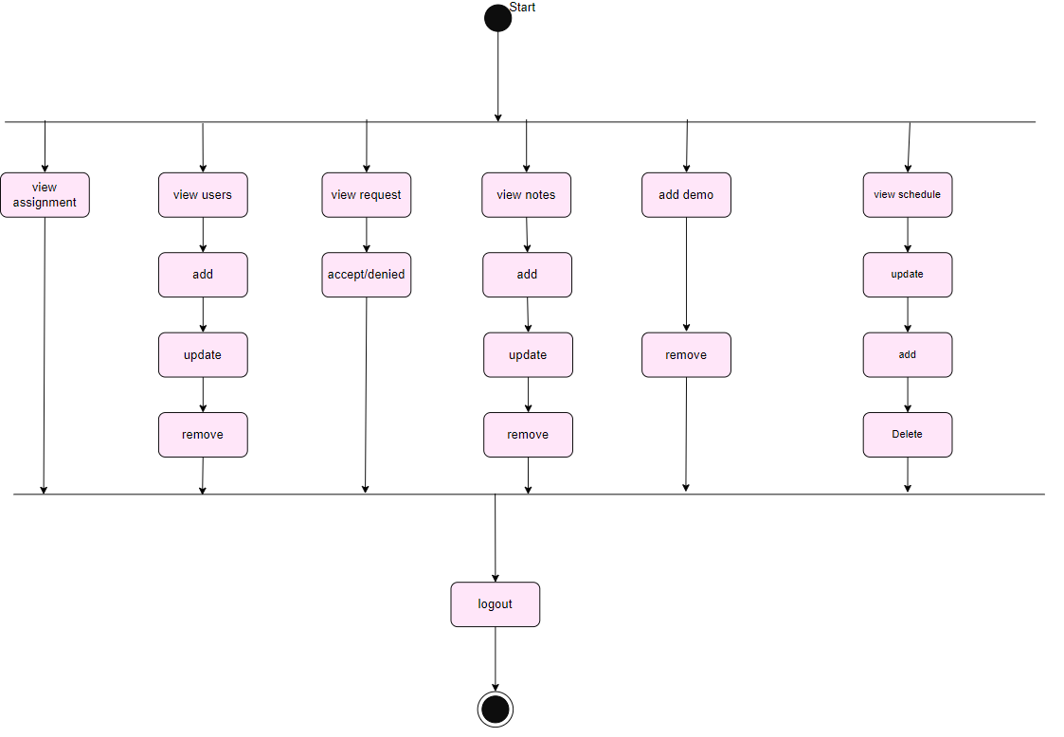

**3.3. Entity Relationship Diagram**

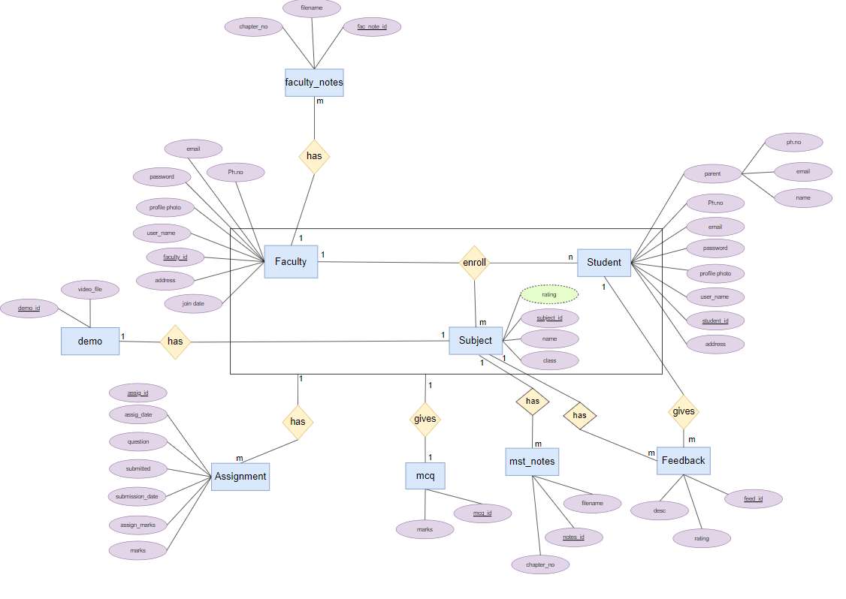

**Chapter 4:**

**SYSTEM IMPLEMENTATION**

**4.1. Back-end Software Tools**

**● XAMPP**

XAMPP is a free and open-source cross-platform web server solution stack package, consisting mainly of the Apache HTTP Server, MySQL database, and interpreters for scripts written in the PHP and Perl programming languages. We used XAMPP in our project to host the database operation of the system. XAMPP server is used to facilitate the storing, retrieving of student, subject, course data from the application to the database.

**● MySQL**

MySQL is a relational database management system based on SQL – Structured Query Language. MySQL sever has been used as a backend database tool in our Edusense Learning Academy project to store details of student, subject, course, Quiz, Assignment in a central location through query language.

**● PHP**

PHP stands for Hypertext Pre-processor. PHP is a server scripting language and a powerful tool for making dynamic and interactive Web pages. PHP is used in Edusense Learning Academy project to provide the backend support for our web application. PHP is used to validate data in the website. It is used to retrieve, store data from/to the server.

**4.1. Front-end Software Tools**

**● HTML**

HTML (Hypertext Markup Language) is the code that is used to structure a webpage and its content. HTML has been used to develop the Edusense Learning Academy project by donating structural semantics for text such as headings, paragraphs, lists, links, quotes and other items.

**● Bootstrap**

Bootstrap is a free front-end framework (HTML and CSS) for faster and easier web development. We have embedded Bootstrap in Edusense Learning Academy web application, to make it responsive so the layout of the webpages can be adjusted dynamically, taking into account the characteristics of the device used (desktop, tablet, mobile phones).

**● jQuery**

jQuery is a JavaScript library designed to simplify HTML DOM tree traversal and manipulation, as well as event handling, CSS animation, and Ajax. Minor use of jQuery has been implemented in the system. jQuery plugins are embedded in our web application to support the use. jQuery is used in transition of images on a home page.

**● JavaScript**

JavaScript is an object-oriented computer programming language commonly used to create interactive effects within the web browsers. We have use JavaScript in Edusense Learning Academy web application to facilitate the transition and sliders in our web application.

We have used JavaScript commonly in combination with HTML, CSS. Validations in our pages are done using JavaScript.

**● Cascading Style Sheet (CSS)**

Cascading Style Sheet (CSS) is a style sheet language used for describing the presentation of a document written in a markup language. CSS has been embedded in Edusense Learning Academy web application to give a uniformed look and style to all the pages and make it attractive. CSS is used in a web application to give our login a uniform and attractive look.

**4.3. Middleware and Auxiliary Software Tools**

* **Visual Studio**

An integrated development environment (IDE) is a feature rich program that supports many aspects of software development. We have used visual studio to edit, debug and build code.

* **Google Chrome**

Googles browser Chrome combines sophisticated technology with the simple UI, to create a faster, safer and easier browsing experience.

The developer tools feature of Google Chrome proved to be helpful. This tool was used to debug any errors or to make any changes to the code when the webpage was displayed on the screen.

* **Microsoft word**

Microsoft word is a geographical word processing program that users can type with. The documentation for our project is entirely done using Microsoft Word. We have used this application to type, design and modify the data that has to be printed for the documentation.

**4.4. Hardware and Software Requirements**

➔ **Hardware requirement**

● **Processor:** Pentium Dual-core Processor

● **FSB Speed:** 533MHz to 1066 MHz

● **Max. CPU Clock rate:** 1.3GHz to 1.3GHz to 3.4GH

● **RAM:** 2GB

➔ **Software requirement**

**● OS:** Window XP or Higher version

**● Hard disk:** Minimum 40 GB hard disk

**Chapter 5:**

**TESTING AND VALIDATION**

**Chapter 6:**

**USER MANUAL**

**Chapter 7:**

**CONCLUSION**

**7.1. Conclusion**

Edusense Learning Academy project was a great source of knowledge for us. This Edusense Learning Academy project has been computed successfully and was also tested successfully. This system has the required options, which can be utilized by the user to perform the desired operations. The system is user friendly, portable and flexible for further enhancement.

The completion of this project has given us the satisfaction that the problems/limitations which occurred in the existing system will not be faced now. The new system is more efficient and quicker in providing services.

**Chapter 8:**

**REFERENCES**

**8.1. References**

* **Websites**

1. [**http://www.google.com**](http://www.google.com)
2. [**http://www.w3schools.com**](http://www.w3schools.com)
3. [**http://www.wikipedia.org**](http://www.wikipedia.org)
4. [**http://www.stackoverflow.com**](http://www.stackoverflow.com)
5. [**http://www.github.com**](http://www.github.com)
6. [**http://www.tutorialspoint.com**](http://www.tutorialspoint.com)
7. [**http://www.cssportal.com**](http://www.cssportal.com)
8. [**http://www.php.net**](http://www.php.net)

**Chapter 9:**

**APPENDIX**

**9.1. Gantt Chart**

**Chapter 9:**

**APPENDIX**