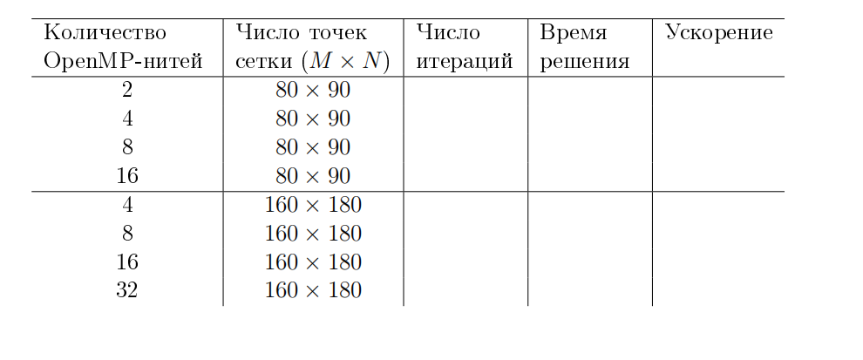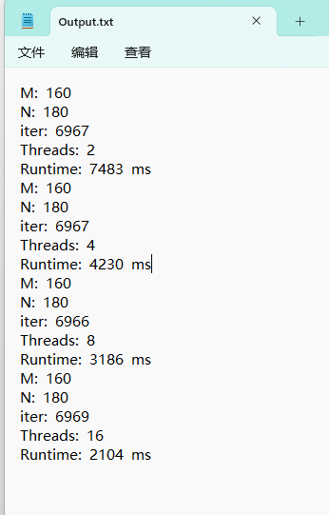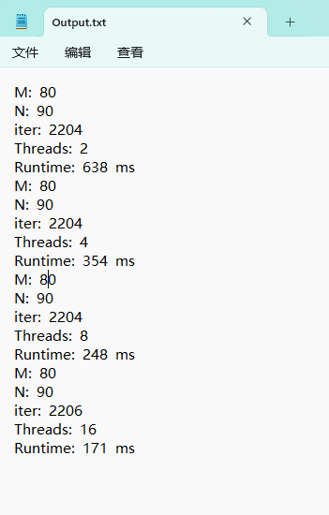
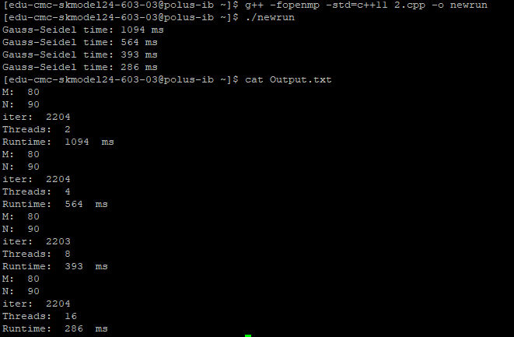
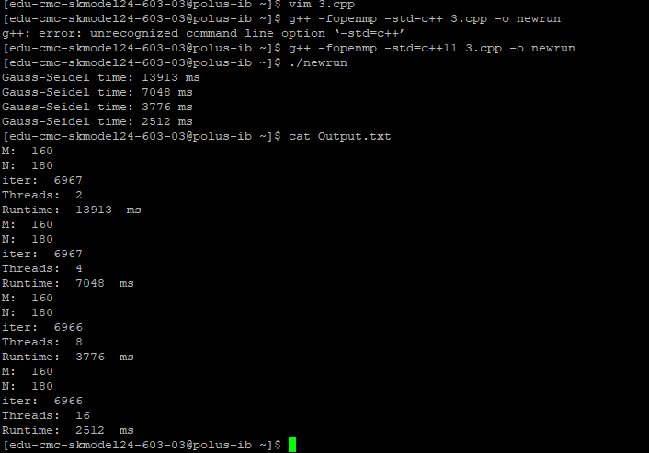
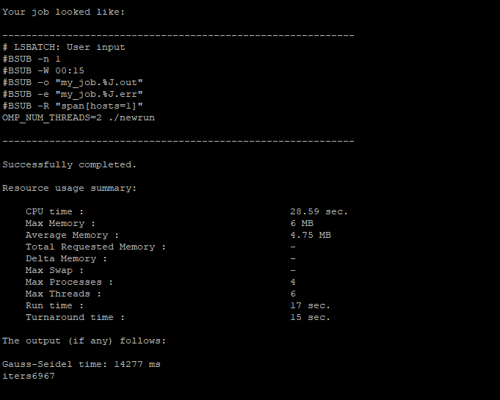
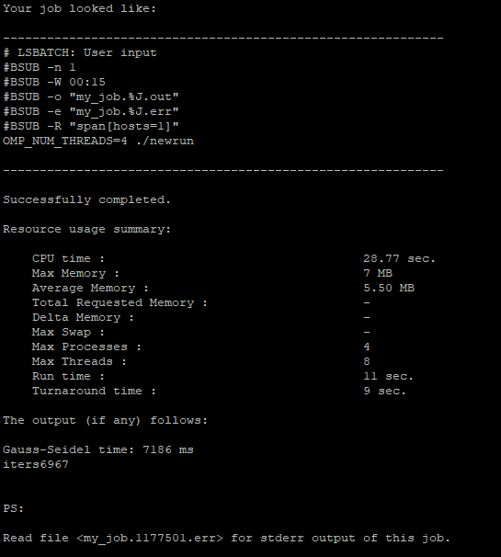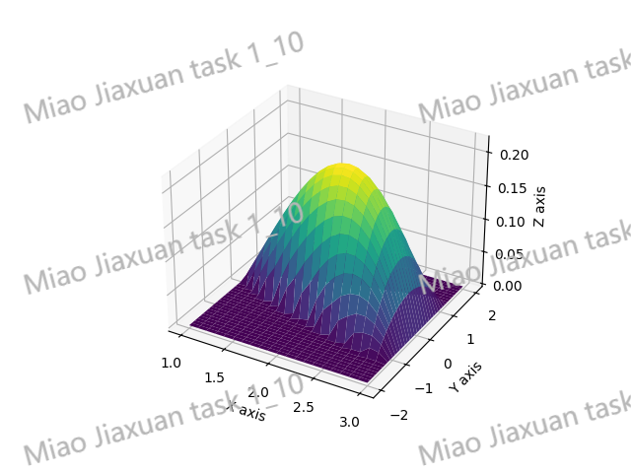
#include <iostream>
#include <vector>
#include <cmath>
#include <chrono>
#include <omp.h>
#include <fstream>

using namespace std;
const double M = 80;
const double N = 90;
const double xmin = 1.0, xmax = 3.0;
const double ymin = -2.0, ymax = 2.0;
const double hx = /*0.025*//*0.0125*/(xmax - xmin) / M;
const double hy = /*0.04*/(ymax - ymin) / N;
const double tolerance = 1e-6;
const double epsilon = 0.01;

int nx = static_cast<int>((xmax - xmin) / hx) + 1;
int ny = static_cast<int>((ymax - ymin) / hy) + 1;
bool isInside(double x, double y) {
return (x * x - 4 * y * y > 1 && x < 3);
}
double ly(double x, double y) {
if (isInside(x - 0.5 * hx, y + 0.5 * hy) && isInside(x - 0.5 * hx, y - 0.5 * hy)) {
return hy;
}
if (!isInside(x - 0.5 * hx, y + 0.5 * hy) && !isInside(x - 0.5 * hx, y - 0.5 * hy)) {
return 0;
}
if (isInside(x - 0.5 * hx, y + 0.5 * hy) && !isInside(x - 0.5 * hx, y - 0.5 * hy)) {
return abs(-sqrt(((x - 0.5 * hx) * (x - 0.5 * hx) - 1) / 4) - (y + 0.5 * hy));
}
if (!isInside(x - 0.5 * hx, y + 0.5 * hy) && isInside(x - 0.5 * hx, y - 0.5 * hy)) {
return abs(sqrt(((x - 0.5 * hx) * (x - 0.5 * hx) - 1) / 4) - (y - 0.5 * hy));
}
}

double lx(double x, double y) {
if (isInside(x - 0.5 * hx, y - 0.5 * hy) && isInside(x + 0.5 * hx, y - 0.5 * hy)) {
return hx;
}
if (!isInside(x - 0.5 * hx, y - 0.5 * hy) && !isInside(x + 0.5 * hx, y - 0.5 * hy)) {
return 0;
}
if (isInside(x - 0.5 * hx, y - 0.5 * hy) && !isInside(x + 0.5 * hx, y - 0.5 * hy)) {
return abs(3.0 - (x - 0.5 * hx));
}
if (!isInside(x - 0.5 * hx, y - 0.5 * hy) && isInside(x + 0.5 * hx, y - 0.5 * hy)) {
return abs(sqrt(1 + 4 * (y - 0.5 * hy) * (y - 0.5 * hy)) - (x + 0.5 * hx));
}
}

//void gaussSeidel(vector<vector<double>>& u, vector<vector<double>> A, vector<vector<double>> B, vector<vector<double>> F) {
// bool converged = false;
//
// while (!converged) {
// converged = true;
// #pragma omp parallel for collapse(2) reduction(&:converged)
// /*#pragma omp parallel num_threads(4)*/
// for (int i = 1; i < nx - 1; ++i) {
// for (int j = 1; j < ny - 1; ++j) {
// double x = xmin + i * hx;
// double y = ymin + j * hy;
// double u_old = u[i][j];
// u[i][j] = (u[i + 1][j] * A[i + 1][j] / pow(hx, 2) +
// u[i - 1][j] * A[i][j] / pow(hx, 2) +
// u[i][j + 1] * B[i][j + 1] / pow(hy, 2) +
// u[i][j - 1] * B[i][j] / pow(hy, 2)+
// F[i][j])
// / ((A[i + 1][j] + A[i][j]) / pow(hx, 2) + (B[i][j + 1] + B[i][j]) / pow(hy, 2));
//
// if (fabs(u[i][j] - u_old) > tolerance) {
// converged = false;
// }
//
// }
// }
// }
//}
void gaussSeidel(vector<vector<double>>& u, vector<vector<double>>& A, vector<vector<double>>& B, vector<vector<double>>& F,int &iter) {
bool converged = false;
double hx2_inv = 1.0 / pow(hx, 2);
double hy2_inv = 1.0 / pow(hy, 2);

while (!converged) {
converged = true;

#pragma omp parallel
{
bool local_converged = true;
#pragma omp for collapse(2)
for (int i = 1; i < nx - 1; ++i) {
for (int j = 1; j < ny - 1; ++j) {
double x = xmin + i * hx;
double y = ymin + j * hy;

double u_old = u[i][j];
double Ai_next = A[i + 1][j] * hx2_inv;
double Ai = A[i][j] * hx2_inv;
double Bj_next = B[i][j + 1] * hy2_inv;
double Bj = B[i][j] * hy2_inv;

u[i][j] = (u[i + 1][j] * Ai_next +
u[i - 1][j] * Ai +
u[i][j + 1] * Bj_next +
u[i][j - 1] * Bj +
F[i][j])
/ (Ai_next + Ai + Bj_next + Bj);

if (fabs(u[i][j] - u_old) > tolerance) {
local_converged = false;
}
}
}
#pragma omp critical
converged &= local_converged;
}
iter++;
}
}
void saveToCSV(const vector<vector<double>>& u, const string& filename) {
ofstream file(filename);

if (file.is_open()) {
for (int i = 0; i < nx; ++i) {
for (int j = 0; j < ny; ++j) {
file << u[i][j];
if (j < ny - 1) {
file << ",";
}
}
file << endl;
}
file.close();
cout << "Matrix saved to " << filename << endl;
}
else {
cerr << "Failed to open file: " << filename << endl;
}
}

int main() {
vector<vector<double>> u(nx, vector<double>(ny, 0.0));
vector<vector<double>> A(nx, vector<double>(ny, 0.0));
vector<vector<double>> B(nx, vector<double>(ny, 0.0));
vector<vector<double>> F(nx, vector<double>(ny, 0.0));
vector<vector<double>> w(nx, vector<double>(ny, 0.0));

for (int i = 0; i < nx; ++i) {
for (int j = 1; j < ny; ++j) {
A[i][j] = ly(xmin + i * hx, ymin + j * hy) / hy + (1 - ly(xmin + i * hx, ymin + j * hy) / hy) / epsilon;
B[i][j] = lx(xmin + i * hx, ymin + j * hy) / hx + (1 - lx(xmin + i * hx, ymin + j * hy) / hx) / epsilon;
if (isInside(xmin + i * hx, ymin + j * hy)) {
F[i][j] = 1.0;
}

}
}
vector<int> thread_counts = { 2, 4, 8, 16 };
std::ofstream outFile("Output.txt");
for (int threads : thread_counts) {
vector<vector<double>> u1 = u;
vector<vector<double>> A1 = A;
vector<vector<double>> B1 = B;
vector<vector<double>> F1 = F;
int iter = 0;
omp_set_num_threads(threads);
auto start = chrono::high_resolution_clock::now();
gaussSeidel(u1, A1, B1, F1, iter);
auto end = chrono::high_resolution_clock::now();
/* for (int i = 0; i < nx; ++i) {
for (int j = 0; j < ny; ++j) {
if (isInside(xmin + i * hx, ymin + j * hy)) {
cout << u[i][j] << " ";
w[i][j] = u[i][j];
}
else { cout << 0 << " "; }
}
cout << endl;

}*/

/*saveToCSV(w, "result.csv");*/
auto duration = chrono::duration_cast<chrono::milliseconds>(end - start);
cout << "Gauss-Seidel time: " << duration.count() << " ms" << endl;
outFile << "M: " << M << endl;
outFile << "N: " << N << endl;
outFile << "iter: " << iter << endl;
outFile << "Threads: " << threads << endl;
outFile << "Runtime: " << duration.count() << " ms" << endl;
}
outFile.close();
return 0;
}

