Analyzing Key Factors for Increasing University Applications: A Focus on Institution Type, Acceptance, and Enrollment Rates

#### **Introduction**

The goal of the study is to pinpoint the main variables affecting how many applications colleges receive. Information was gathered from 777 universities in the US, including both public and private ones. Acceptance rates, enrollment rates, and institution status (private vs. public) are among the factors included in the dataset. To provide colleges with useful information to boost application rates, the main objective is to investigate the connections between these variables and the volume of applications.

**Summary Statistics**

Summary Statistics for Number of Applications received

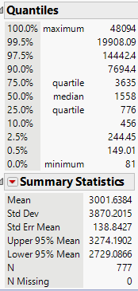

Summary Statistics for Private and public Universities

Public Universities Private Universities

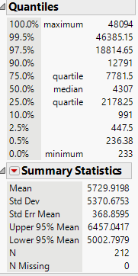 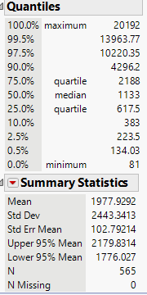

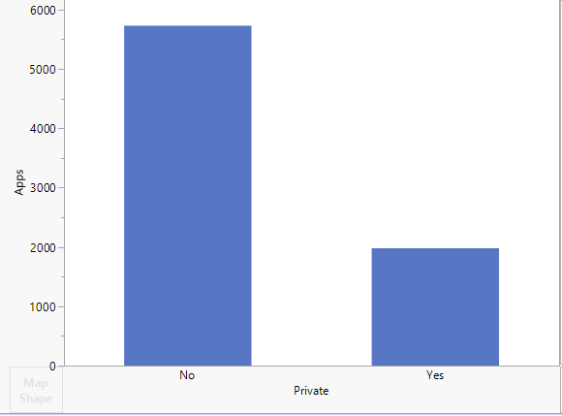

#### **Methods**

##### **Study Design**

This analysis employs multiple linear regression models to evaluate the relationships between the number of applications (Apps) and explanatory variables:

1. Quantitative: Accept (number of accepted students) and Enroll (number of enrolled students).
2. Qualitative: Private (university status as public or private).
3. Interaction Terms: Accept*Enroll.
4. Quadratic Terms: Accept*Accept and Enroll*Enroll.

##### **Statistical Approach**

1. **Model 1**: A quantitative model with Accept and Enroll as predictors.
   1. Purpose: To determine how acceptance and enrollment rates affect the number of applications.
2. **Model 2**: Includes the categorical variable Private alongside Accept and Enroll.
   1. Purpose: To investigate the effect of university type (public/private) on applications.
3. **Model 3**: Explores quadratic and interaction terms for the quantitative predictors.
4. Purpose: To capture any nonlinear relationships between Accept and Enroll and their interactions.

All models were evaluated using the following:

* **Goodness-of-Fit Metrics**: R-squared and Adjusted R-squared values.
* **Statistical Significance**: p-values for predictors to assess their contribution.
* **Residual Analysis**: To verify model assumptions.

JMP was used for data analysis and visualization.

**Results**

**Model 1**: Quantitative Variables

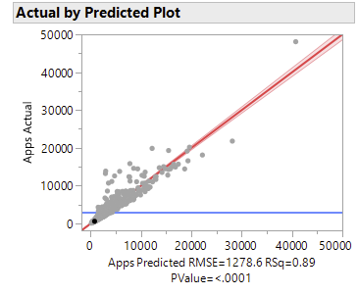

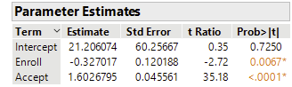

$$E(Apps)=β0​+β1​x_{1}+β2​x_{2}$$

* $E(Apps):$ Expected mean of applications received.
* $β_{0}$**​:** Intercept (21.206), representing the baseline number of applications when both predictors (Accept and Enroll) are zero.
* $β_{1}$**:** Coefficient (1.6027) estimating the increase in applications per additional accepted student (p < 0.0001).
* $β_{2}$**:** Coefficient (−0.3270) estimating the decrease in applications per additional enrolled student (p = 0.0067).

Analysis of Variance Test (F-Test):

* **F-Ratio:** 3168.032
* **P-Value:** < 0.0001
* Null Hypothesis $\left(H_{0}\right): β_{1}= β_{2}=0$
* Alternative Hypothesis $\left(H_{A}\right):$ At least one $β ≠0$.
* At the 5% significance level, $H_{0}$ ​ is rejected, providing strong evidence that at least one model coefficient is non-zero. This confirms the model's statistical usefulness for predicting the number of applications received.

R-Squared and Adjusted R-Squared

of the variation in applications is explained by the model.

$R_{adj}^{2}=0.8908:$ After adjusting for sample size and degrees of freedom, 89.08% of the variation is explained.

**Model 2**: Quantitative and Qualitative Variables

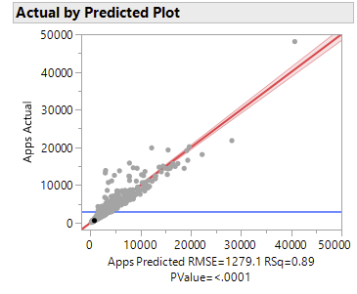

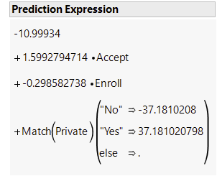

$$E\left(y\right)= β_{0}+ β_{1}x_{1}+ β_{2}x_{2}+ β_{3}x_{3}$$

* $E(y):$ Expected mean of applications received.
* $β_{0}​$**:** Intercept (−10.999), representing the baseline for public universities when other predictors are zero.
* $β_{1}​x_{1}$**​:** Coefficient (1.5993), estimating the increase in applications per additional accepted student (p < 0.0001).
* $β_{2}​x_{2}$**​:** Coefficient (−0.2986), estimating the decrease in applications per additional enrolled student (p < 0.0001).
* $β_{3}​x_{3}$**​:** Coefficient (37.181), representing the advantage in applications received by private universities compared to public universities.

Analysis of Variance (F-Test):

* F-Ratio: 2110.356
* P-Value: < 0.0001
* Null Hypothesis $\left(H_{0}\right): β_{1}= β_{2}= β_{3}=0$
* Alternative Hypothesis $\left(H_{A}\right):At least one β ≠0$.
* At the 5% significance level, $H_{0}$ is rejected. The model is statistically useful for predicting applications received.

R-Squared and Adjusted R-Squared

* of the variation in applications is explained by the model.
* $R_{Adj}^{2}=8.908:$ After adjusting for sample size and degrees of freedom, 89.08% of the variation is explained.

**Model 3**: Second order regression model of the two quantitative factors Acceptance and Enrollment

Equation for the second order regression model : $E\left(y\right)= β_{0}+β_{1}x_{1}+β_{2}x_{2}+β_{3}x_{1}x_{2}+β_{4}x_{1}^{2}+β_{5}x_{2}^{2}$

$E\left(y\right)$: Expected mean of Applications received.

$β_{0}$: Intercept.

$β_{1}x_{1}$: $β$ estamite of number of applications Accepted.

$β_{2}x_{2}$: $β$ estimate of number of applications Enrolled.

$β_{3}x_{1}x_{2}$: $β$ estimate interaction of number of accepted and number applications Enrolled.

$β_{4}x_{1}^{2}$: $β$ estimate interaction of number of applications Accepted.

$β_{5}x_{2}^{2}$: $β$ estimate interaction of number of applications Enrolled.

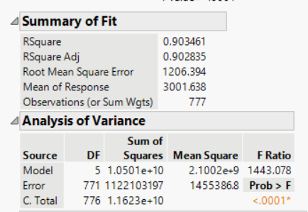

Analysis of Variance test (F-tetst)

F Raito = 1443.078

Pvalue < 0.0001

$H_{0}: β_{1}, β_{2},β_{3},β_{4},β_{5} ≠0 H_{A}: At least β_{1}, β_{2},β_{3},β_{4} or β_{5}=0$

($H_{0}$) Initial hypothesis is rejected. At 5% significance level, there is strong evidence that at least one of the model coefficients is non-zero. This model is statistically useful for predicting the number of applications received.

T-test for Betas

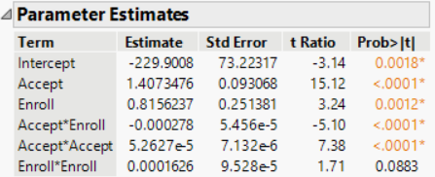

t-ratio = -5.10

Pvalue < 0.0001

$$H_{0}: β_{3}=0 H_{A}: β_{3}<0$$

($H_{0}$) Initial hypothesis is rejected. At 5% significance level, there is strong evidence that the number of applications accepted interacts negatively with the number of applications enrolled. The applications increase slowly per unit increase in number of applications accepted and fastly per unit per unit increase in number of applications enrolled.

$$H_{0}: β_{4}=0 H_{A}: β_{4}<0$$

T-ratio = 7.38

Pvalue < 0.0001

($H_{0}$) Initial hypothesis is rejected. At 5% significance level, there is strong evidence to conclude that the number of applications is increasing slowly per unit increase in number of applications accepted.

$H_{0}: β_{5}=0 H_{A}: β_{5}<0$

T-ratio = 1.71

Pvalue = 0.0883

($H_{0}$) () Initial hypothesis failed to be rejected. At 5% significance level, there is strong evidence to conclude that the number of applications is increasing slightly fast per unit increase in number of applications enrolled.



$R^{2}$ =0.9035: This shows that %90 of the sample variation in number of applications received is explained by the model.

$R_{adj}^{2}$ =0.9028: This shows that %90 of the sample variation in number of applications received is explained by the model after adjusting sample size and degree of freedoms.

Model 4 : Regression Analysis model for Number of Application received with qualitative predictor of Public/private indicator.

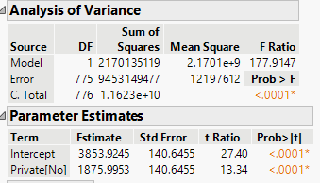

Analysis of Variance test (F-test)

$$H_{0}: β_{1}=0 H_{A}: β_{1}≠0$$

($H_{0}$) Initial hypothesis is rejected. At 5% significance level, there is strong evidence of the difference between the predicted number of applications received depending on the Public/private indicator, thus Public/private indicator is useful predictor of number of applications received.

**Conclusion**

This report focused on how different factors affect the number of applications universities receive. Multiple regression analysis used to show the important patterns of what causing numbers of application received increase or decrease. There were three main predictors used from the dataset, Number of applications accepted, Number of applications enrolled and Private/public indicators. Number of applications accepted, and Number of applications enrolled are quantitative parameters of this problem. Both parameters are chosen stronger positive correlations.

Acceptance rates (how many students are admitted) have a positive effect on applications.

Enrollment rates (how many students choose to attend) have a negative effect on applications.

When comparing public and private universities in the second model, private universities were shown to attract more applications.

The third model added more complex analysis, showing that:

Applications increase at a slower rate as acceptance rates grow.

Applications increase faster as enrollment rates grow, showing a tricky relationship between the two.

The fourth model confirmed that whether a university is public or private is an important factor in predicting applications, with private universities having an advantage.

The accuracy of these models was very high (over 89%), meaning the predictions are reliable. Tests also showed that the factors used in the models were important for explaining differences in application numbers.

In summary, this study gives useful advice to universities on how to increase applications. By adjusting acceptance and enrollment rates and considering whether they are public or private, universities can better compete in attracting students. Future research could look at other factors, like location or reputation, to improve predictions even more.